CenturyLink

931 14th Street, Suite 1230

Denver, Colorado 80202

303-992-5832

June 6, 2017

Steven King
Executive Director and Secretary
1300 S. Evergreen Park Dr. S.W.
P.O. Box 47250
Olympia, Washington 98504-7250

Re: Submission ID No. 6652, Advice No. WA 17-09A for United Telephone Company of the Northwest

Dear Mr. King:

United Telephone of the Northwest d/b/a CenturyLink is filing the attached revised CONFIDENTIAL Workpaper in response to a request by the staff at the Utilities and Transportation Commission. The original CONFIDENTIAL Workpaper was filed on May 31, 2017 as part of the sixth step in implementing the “Transitional Intrastate Access Service” reductions mandated by the Federal Communications Commission's November 18, 2011 Report and Order and Further Notice of Proposed Rulemaking in WC Docket Nos. 10-90, etc. (FCC 11-161).

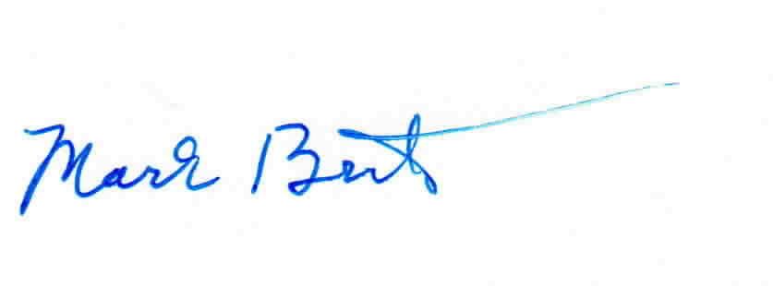
Sincerely,

Mark Brinton
Manager Regulatory Operations
Office: (303) 992-5832
e-mail: Mark.Brinton@CenturyLink.com

