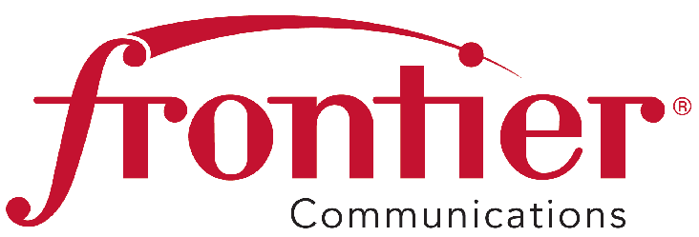
9260 E. Stockton Blvd.
Elk Grove, CA 95624
January 27, 2015

Mr. Dave Danner
Executive Director and Secretary
Washington Utilities and Transportation Commission
1300 S. Evergreen Park Drive SW
P.O. Box 47250
Olympia, WA 98504-7250

RE: Docket UT-150061, 2015 Lifeline ETCs’ Annual Filings to the Federal Communications Commission Pursuant to 47 C.F.R. § 54.416 (b)

Dear Mr. Danner:

Frontier Communications Northwest Inc (Study Area Codes 522449 and 522416) hereby provides a copy of its Annual Lifeline Eligible Telecommunications Carrier Certification FCC Form 555 in compliance with 47 CFR 54.416 as adopted by the Federal Communication Commission (FCC) in its Lifeline Reform Order, FCC 12-11, released February 6, 2012.

Section 54.416(b) requires eligible telecommunication carriers (ETCs) to annually provide the results of their re-certification efforts performed pursuant to Section 54.410 (f) to the FCC and the Universal Service Administrative Company (USAC). ETCs are also required to provide the results of their re-certification efforts to state commissions and relevant tribal governments.

If you have any questions, please contact me at (916) 686-3588 or by email at joe.chicoine@ftr.com.
Respectfully Submitted,

/S/

Joe Chicoine
Manager, Regulatory Compliance and Reporting

Enclosures
cc: Jack Phillips

