March 24, 2010

VIA FIRST CLASS AND ELECTRONIC MAIL
David Danner
Executive Director and Secretary
Washington Utilities and Transportation Commission
1300 S. Evergreen Pk. Dr. S.W.
PO Box 47250
Olympia, WA 98504-7250

Re: Puget Sound Energy
Docket No. UE-100382 Electric Conservation Service Tracker, Schedule 120
Docket No. UG-100383 Gas Conservation Service Tracker, Schedule 120

Dear Mr. Danner:

OPOWER Inc. (“OPOWER” f.k.a. Positive Energy) thanks the Commission for the opportunity to participate in these proceedings. OPOWER is an energy efficiency software company working with utilities to engage customers and motivate large-scale reduction in residential energy consumption. We work with twenty-six utilities in twelve states across the country. Our clients include large investor-owned utilities, moderately sized municipal utilities, and small cooperatives. In each deployment, OPOWER’s Home Energy Reporting platform is achieving measurable, cost-effective energy savings. Indeed, in a recent visit to OPOWER’s offices, President Barack Obama praised behavior-based efficiency: "The work you do here...is making homes more energy efficient, it's saving people money, it's generating jobs and it's putting America on the path to a clean energy future."

We submit these comments to assist the Commission in its examination of whether, among other issues, it is appropriate to allow Puget Sound Energy, Inc. (“PSE”) to use conservation tariff funds to deploy behavior-based programs on a broader scale. In light of questions raised about OPOWER’s approach to energy savings, these comments explain that:

(1) OPOWER’s behavior-based programs empower consumers with useful information;
(2) These programs have generated measurable, verified results;
(3) Experimental Design allows for accurate measurement of behavior-based savings; and
(4) Leading states are including behavior-based programs in their efficiency portfolios

- OPOWER’s behavior-based programs empower consumers with useful information.

Human behavior is the single largest untapped efficiency resource. The reason is straightforward – behavior impacts almost every facet of energy use in the home or business. A customer’s efficient furnace only delivers energy savings if the thermostat is set correctly. The value of an energy star washing machine is reduced if the consumer views the “Energy Star” label as a license to use the hot cycle. Often, the only way for renters to realize meaningful energy savings is to adjust their behavior. Behavior-based programs address this problem by motivating customers to take actions that result in measurable, large-scale energy savings.

OPOWER’s specific approach to behavior-based efficiency is organized around two concepts – first motivating behavior change, and then providing relevant, targeted information to the motivated consumer. Combining utility supplied data with third party sources of information, our program translates individual usage patterns into meaningful insights coupled with targeted action steps.

Critically, OPOWER’s Home Energy Reports, provide recipients with a context for understanding their energy use. OPOWER does this by dynamically creating a 100-home comparison group for each enrolled home. Home comparison groups are defined by a number of customizable variables, including square footage, heating type (gas or electric), and proximity (e.g., within 0.25 miles. Years of behavioral science research have demonstrated that peer based comparisons is a highly motivating way to present information. A sample neighbor comparison module is shown below.

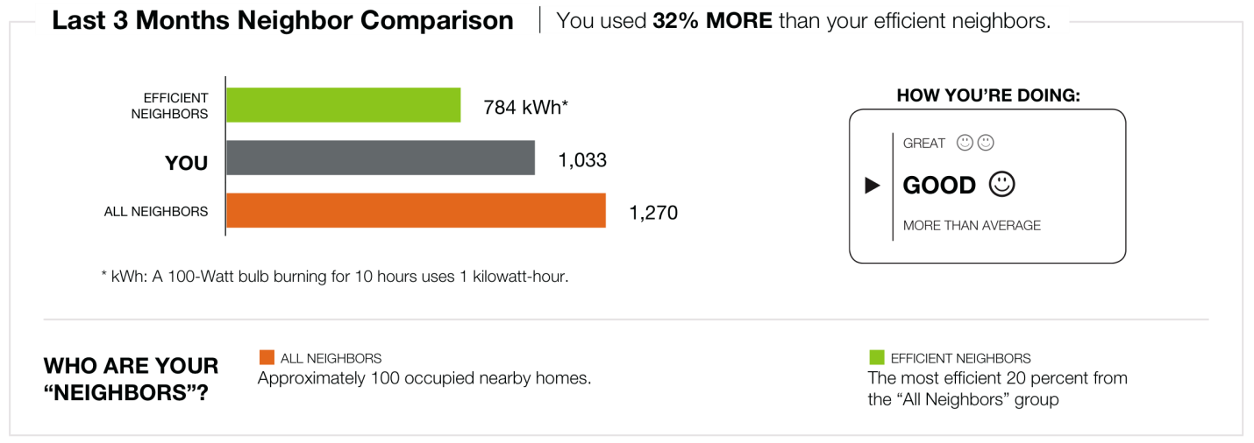

Second, customers receive individually targeted savings tips based on their individual energy usage patterns, housing characteristics, and demographics. Instead of presenting customers with a thick booklet of ideas on how to save energy, OPOWER presents customers with only the most relevant and immediately actionable suggestions on how to save. For example, OPOWER would not suggest that a renter insulate his apartment, but might recommend smart thermostats to owner-occupied homes with high heating bills.

This program is able to turn small changes into large scale efficiency because of an “opt out” program design with an emphasis on mailed reporting. Mailed reports enable OPOWER to engage the majority of targeted customers and enable the delivery of large-scale energy savings – this has proven to be true even in the most computer-savvy parts of Washington. By using mail, OPOWER’s messaging reaches all demographic groups, including low income and elderly populations. Mailed reports under the utility brand create the opportunity for a high participation rate (estimated to be as high as 85% in one study), which means that small savings on a per household basis add up to significant savings in aggregate.

- Behavior-based programs generate measureable, verified results.

OPOWER’s behavior-based approach has been consistently effective. Results have been particularly strong with Puget Sound Energy, in light of the fact that Puget Sound households receive information about both gas and electric consumption in a single report. Puget Sound Energy households are saving an average of 187 kwh and 11.2 therms per year, the equivalent of 1.7% and 1.2% of their overall consumption. Moreover, these savings have been increasing as the program matures. Savings for the first six months of the program were 1.15% for electricity and 0.87% for natural gas; for the last six months savings have been 2.04% and 1.43% for electricity and natural gas, respectively.
Figure 1 shows the consistency of savings that OPOWER utility partners achieve through Home Energy Reporting:

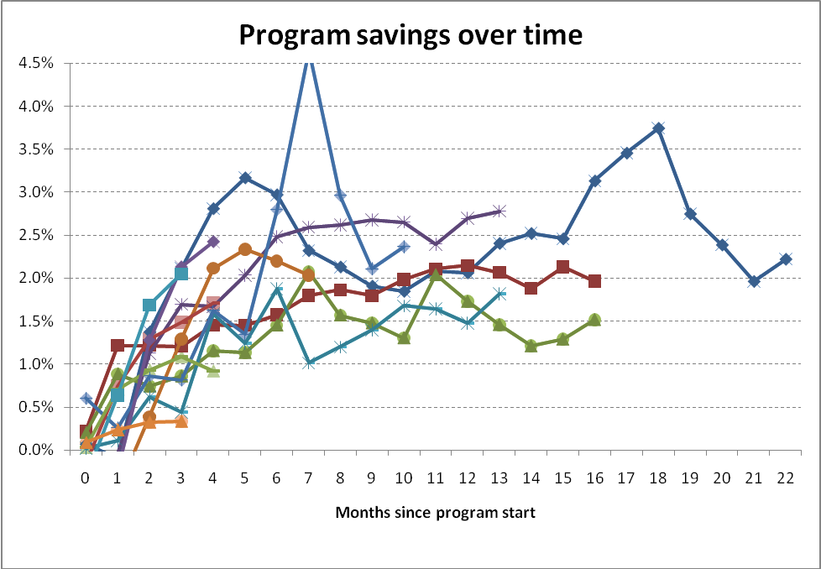

Critically, and contrary to Public Counsel’s assertions in its letter of March 19, 2010 submitted under this docket, these results have been independently verified. Summit Blue, an industry leading evaluation firm, has verified OPOWER’s impact in Sacramento. Professor Ian Ayers, of Yale University, has verified OPOWER’s impact with Puget Sound. Professor Hunt Allcott, of the Massachusetts Institute of Technology, has verified OPOWER’s savings with Connexus Energy. Moreover, Professor Allcott and Professor Sendhil Mullainathan, of Harvard University, recently published a peer reviewed discussion of OPOWER’s approach in Science, the leading journal of the natural sciences. Each evaluation has come to the same, simple conclusion: OPOWER’s behavior-based programs are a significant and cost-effective source of energy savings.

OPOWER welcomes further evaluation of its program with Puget Sound Energy, and, if necessary and appropriate, is willing to contribute to the cost of such evaluation.

- Experimental Design allows for accurate measurement of behavior-based savings

OPOWER’s use of experimental design has led to clean, easily verified results. In each deployment, OPOWER has used a simple test and control methodology to measure the impact of behavioral messaging. This methodology is explicitly endorsed in the California Evaluators Protocols and the guidelines for the National Action Plan for Energy Efficiency (which was jointly produced by the US Department of Energy and the Environmental Protection Agency). By using test and control groups, OPOWER is able to isolate and cleanly evaluate the impact of behavioral messaging.

For example, consider OPOWER’s first, and longest running, deployment, with Sacramento Municipal Utility District (“SMUD”). Together with OPOWER, SMUD launched its behavior-based program to 35,000 homes, while maintaining a 50,000 home control group. The two groups were randomly selected and had no statistically significant difference in their energy consumption prior to deployment. Since deployment, the impact has been clear – over twenty months, behavior-based messaging has decreased consumption by 2.5% in the test group. Because the groups are, in the aggregate, identical—save for the fact that one group receives OPOWER’s reports while the other does not—the difference in energy savings may safely be attributed to behavioral messaging.

- Any potential double-counting of behavior-based savings with savings partly stemming by other programs can be addressed using standard measurement procedures.

OPOWER recognizes that correct attribution of these savings is critical to the fair accounting of portfolio efficiency standards and offers the following protocol for addressing double-counting related issues. For most efficiency programs, double-counting can be addressed through these steps: (1) Measure program participation in treatment and control groups; (2) Attribute savings coming from any additional program participation (vs. control group) in the treatment group (e.g. exercising a rebate) to the programs that finance the rebate – not to the behavioral program.

  - Measure program participation in treatment and control groups

There are two ways to establish other program participation across the population participating in the behavioral program. The correct method depends on whether or not the program is individually tracked.

    - Individually tracked programs

Individually tracked programs are programs for which the utility can track specific customer participation. This scenario covers the vast majority of programs implemented in the residential sector and range from air conditioner rebates to home energy surveys. To avoid ‘double-counting’, utilities simply must continue to track the participation in these programs on an individual household basis, and the difference in frequency of participation can be compared from the treatment to the control. Then the utility may choose to either (a) subtract the deemed savings from the additional installed measures in the treatment group, or (b) add the costs of the additional installed measures to the cost of the behavior change program and count the savings.

    - Non-Individually tracked programs

In the case of “upstream” subsidies, such as CFL programs, the method to assess ‘double-counting’ is to perform surveys that measure the increase in the installation of the subsidized measures in both the treatment and control groups. The survey should be done in a statistically rigorous fashion, as outlined in the California Protocols. Once these rates of use are established, the energy savings stemming from the increase in installed measures in the treatment group can then be accounted for in the same fashion increases from individually tracked programs are handled.

  - Measurement of overlap effect

Experimental design allows for a clear view of the impact that behavior-based programs have on other efficiency measures and limits the potential for double-counting. For example, if 100 homes in the control group install efficient furnaces, and 120 homes in the treatment group do the same, the savings from the additional 20 furnaces installed will be reflected in the overall energy savings reported by the behavioral program, but can be easily identified, allowing the Commission to account for those energy savings accordingly, i.e. attributed to either the behavioral program or the furnace rebate program, but not both.

Figure 2 illustrates an example in which the reports lead to increased participation in utility programs. The savings generated from installations that occur in both groups (“A” and “B” in the figure) cancel each other out and are not reflected in overall savings measured as the difference in energy use between the treatment and control groups. However, the incremental installations that occurred as a result of receiving the behavior-based program (“C”) do show up in the overall savings estimates. The total kWh or therms associated with the incremental installations can be estimated using the deemed savings for each type of installed measure. This process can be repeated across each type of measure offered by the utility.

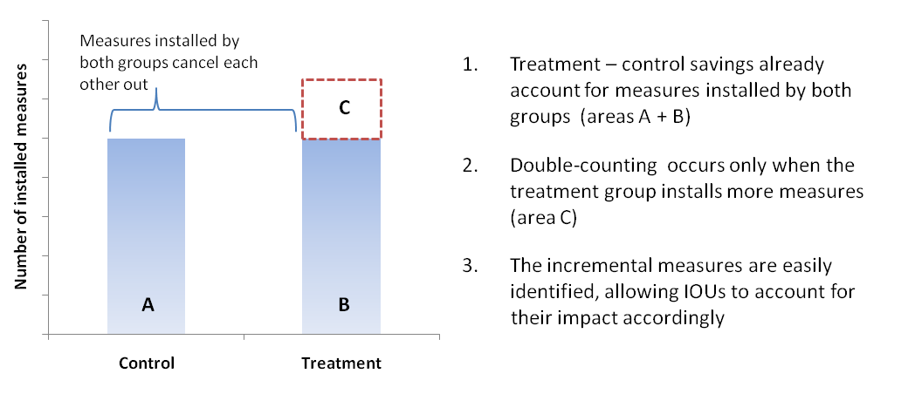
Figure 2: Procedure to avoid double-counting

Because of the experimental approach used for program design and measurement, the potential for double-counting is limited to the difference in participation between the two groups, not the absolute level of participation. Thus IOUs must decide how to account for this component (“C”) in their internal accounting.

- Leading states are including behavior-based programs in their efficiency portfolios.

The strong, verified results from these large-scale pilots have been central to the support of regulatory authorities in several states for utility filings that include large behavior-based savings. So far, decision makers in Massachusetts, Minnesota, and now California have supported utilities in including behavior-based programs as part of a broad energy efficiency portfolio.

- Massachusetts – The Massachusetts Department of Energy Resources (“DOER”) is allowing IOUs in Massachusetts to count savings generated by OPOWER’s program towards their state-mandated energy savings targets. In a filing approving these goals, the DOER noted that “one successful organization upon whose work the Program Administrators [utilities] would like to build is Positive Energy [now OPOWER], a corporation that is committed to persuading consumers to save energy through a combination of technology, analytic direct marketing, and behavioral science.” In total, OPOWER’s programs will account for 24% of the residential efficiency portfolio for electric consumption and 20% for gas.

Savings claimed for OPOWER’s program by National Grid (MA)

 | Total kWh saved | Number of Households | Total Annual kWh saved per HH
2010 | 26,000,000 | 100,000 | 260 kWh
2011 | 52,000,000 | 200,000 | 260 kWh
2012 | 74,520,000 | 300,000 | 248 kWh

- Minnesota – Minnesota’s OES has approved two of the state’s largest utilities, Centerpoint Energy and Minnesota Energy Resources Corporation (MERC) to count savings generated by OPOWER’s programs to their state-mandated energy efficiency targets.

Savings claimed for OPOWER’s program by Centerpoint Energy (MN)

 | Total Mcf Saved | Number of Households | Total Annual Mcf saved per Household
2010 | 85,250 | 50,000 | 1.71 Mcf
2011 | 127,875 | 75,000 | 1.71 Mcf
2012 | 139,035 | 100,000 | 1.71 Mcf

After reviewing filings including OPOWER’s program, OES was effusive in its praise of behavior-based programming:

OES Staff are pleased to see that CPE [Centerpoint Energy] will be starting the Residential Home Energy Reports project in 2010. Recent evaluations of programs across the country and in Minnesota suggest that home energy reports are a cost-effective way to educate customers and encourage energy saving behavior. CPE plans to include 225,000 residential customers, approximately 30 percent of the Company’s residential customers, in this program by the third year of its triennial plan. This project is also expected to be one of the largest drivers of new energy savings in the Company’s Residential Segment. CPE’s program provider, Positive Energy [now OPOWER], reports that customers receiving a home energy report typically reduce their energy use by 1.5 to 3 percent. Based on this information, the Company estimates that households receiving home energy reports will reduce their energy use by 1.55 percent or 1.71 MCF annually. OES Staff believe that this is a reasonable assumption at this time. In future filings, the energy savings claimed by the Company should reflect the actual energy savings associated with the project based on measurement and verification by Positive Energy [now OPOWER].

- California – Earlier this month, the California Public Utilities Commission issued a proposed decision allowing California’s investor owned utilities to “count” savings achieved through behavior based programs, like OPOWER’s. The Commission noted that experimental design, as described above, “is well equipped to deal with most of the analytical issues raised by the overlap of the savings targeted by comparative energy use reports.” A final decision is expected in April.

- Conclusion

With more than a year of results in Washington, and nearly two-years of results from comparable deployments, behavior-based programs are now a proven, measureable efficiency resource. Moreover, because the program has a single-year measure life, and results are measured after they are achieved, the risk of expansion is borne entirely by Puget Sound Energy and OPOWER. OPOWER urges the Commission to support behavior-based energy efficiency programs and to reward Puget Sound Energy for piloting this approach.

President Barack Obama, March 5, 2010, available at: http://www.whitehouse.gov/the-press-office/remarks-president-clean-energy-jobs
McKinsey and Company. Unlocking Energy Efficiency in the US Economy. Page 22
Summit Blue. Impact Evaluation of OPOWER SMUD Study. September 2009. <http://www.opower.com/LinkClick.aspx?fileticket=naU7NN5-430%3d&tabid=72> In its letter of March 19, 2010, Public Counsel missed this critical point. There is no question that a 1.5% percent energy savings is an individual home is not particularly significant. Behavior-based programs, however, are demonstrated to save an average of 1.5% percent per home.
Summit Blue. Impact Evaluation of OPOWER SMUD Study. September 2009. <http://www.opower.com/LinkClick.aspx?fileticket=naU7NN5-430%3d&tabid=72>
Ayres, Ian. Evidence from Two Large Field Experiments that Peer Comparison Feedback Can Reduce Residential Energy Usage. July 2009. Available online at: <http://papers.ssrn.com/sol3/papers.cfm?abstract_id=1434950>
Alcott, Hunt. Social Norms and Energy Conservation. February 2010. Availabe online at: <http://web.mit.edu/allcott/www/Allcott%202010%20-20Social%20Norms%20and%20Energy%20Conservation.pdf>
Alcott, Hunt and and Sendhil Mullainathan. Behavior and Energy Policy. Science. March 2010. Available online at: <http://web.mit.edu/allcott/www/Allcott%20and%20Mullainathan%202010%20-%20Behavioral%20Science%20and%20Energy%20Policy.pdf> Note: While Summit Blue was paid for its evaluation of the SMUD program, neither Professor Ayers, nor Professor Allcott, nor Professor Mullainathan has received compensation of any sort from OPOWER or Puget Sound Energy.
The California Evaluation Framework: Project Number: K2033910 (June 2004), Page 137.
Massachusetts Joint Statewide Three-Year Electric Efficiency Plan: 2010-2012. Page 238
Minnesota Office of Energy Security. Proposed Decision. October 2009. Page 23. Behavior-based programming was approved in the Final Decision dated November 23, 2009.
California Public Utilities Commission, Proposed Decision, March 9, 2010, available at http://docs.cpuc.ca.gov/efile/PD/114662.pdf.

