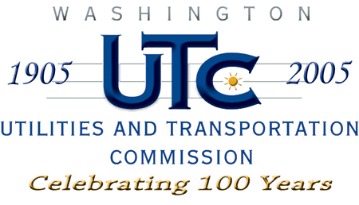

Memorandum
March 11, 2009

To: TR-061548 - File

From: Kathy Hunter, Transportation Safety Compliance Manager

Subject: TR-061548 City of Pacific
Grade Crossing Protective Fund (GCPF) Project - 3rd Avenue Crossing

On December 27, 2007, the Washington Utilities and Transportation Commission (Commission) awarded a GCPF grant totaling $20,000 for a proposal to narrow a roadway and add sidewalks to enhance pedestrian safety at the 3rd Avenue railroad crossing in the city of Pacific. Total project costs are estimated at $20,000.

On March 11, 2009, the applicant, city of Pacific submitted a request for reimbursement in the amount of $20,000 pursuant to commission order. The actual total project costs for the sidewalk and bicycle lane crossing are $980,238.29. The city of Pacific will pay the costs over $20,000. On February 20, 2009, commission staff conducted a site visit and verified that the project is completed according to the specifications outlined in the order approving the grant.

Please close this docket.

