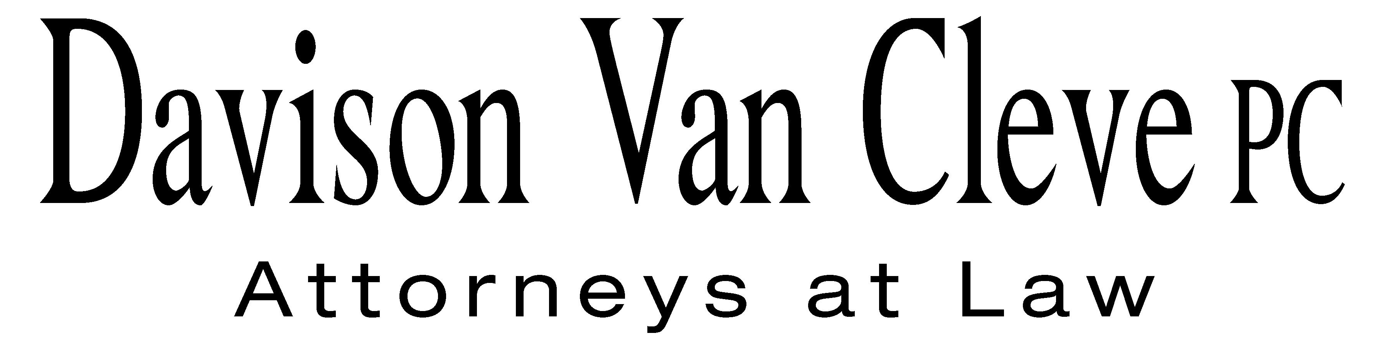
TEL (503) 241-7242 ● FAX (503) 241-8160 ● mail@dvclaw.com
Suite 400
333 SW Taylor
Portland, OR 97204

April 20, 2010

Via Email

Carole J. Washburn
Secretary
Washington Utilities and Transportation Commission
PO Box 47250
1300 S Evergreen Park Drive SW
Olympia, WA 98504-7250

Re: In the Matter of the General Rate Increase to Recover Increased Electric Cost.

Docket No. UE-100467

Dear Ms. Washburn:

Enclosed please find the corrected Petition to Intervene of the Industrial Customers of Northwest Utilities, originally filed on April 13, 2010.

Thank you for your assistance.

Sincerely yours,

/s/ Martin H. Patail
Martin H. Patail
Enclosures

cc: Service List

CERTIFICATE OF SERVICE

I hereby certify that I have this day served the foregoing documents upon all parties of record in this proceeding by emailing a copy to each individual’s last-known address, as listed below.
DATED this 20th day of April, 2010.
Davison Van Cleve, P.C.

/s/ Martin H. Patail
Martin H. Patail

AVISTA CORPORATION  DAVID MEYER  PO BOX 3727  SPOKANE WA 99220-3727  dmeyer@avistacorp.com | AVISTA CORPORATION  KELLY NORWOOD  RATES AND REGULATION  1411 E. MISSION  SPOKANE WA 99220
NORTHWEST INDUSTRIAL GAS USERS  PAULA E PYRON  EXECUTIVE DIRECTOR  4113 WOLF BERRY COURT  LAKE OSWEGO OR 97035-1827  ppyron@nwigu.org  CABLE HUSTON BENEDICT HAAGENSEN & LLOYD  CHAD M STOKES  1001 SW 5TH STE 2000  PORTLAND OR 97204  cstokes@cablehuston.com  GREG J TRAUTMAN  ASSISTANT ATTORNEY GENERAL  WUTC  PO BOX 40128  OLYMPIA, WA 98504 gtrautma@wutc.wa.gov | CABLE HUSTON BENEDICT HAAGENSEN & LLOYD  TOMMY A BROOKS  1001 SW 5TH STE 2000  PORTLAND OR 97204-1136  tbrooks@cablehuston.com  MICHAEL FASSIO  ASSISTANT ATTORNEY GENERAL  WUTC  PO BOX 40128  OLYMPIA, WA 98504 MFassio@utc.wa.gov  OFFICE OF THE ATTORNEY GENERAL  SIMON FFITCH  PUBLIC COUNSEL  800 FIFTH AVENUE STE 2000  SEATTLE WA 98104-3188  simonf@atg.wa.gov

