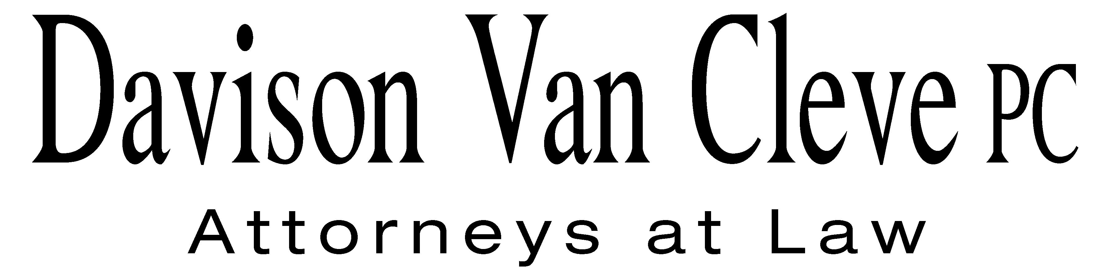
TEL (503) 241-7242 ● FAX (503) 241-8160 ● mail@dvclaw.com
Suite 400
333 SW Taylor
Portland, OR 97204

February 9, 2012

Via Email and Federal Express

Honorable Judge Marguerite Friedlander
Administrative Law Judge Division
Washington Utilities and Transportation Commission
PO Box 47250
1300 S Evergreen Park Drive SW
Olympia, WA 98504-7250

Re: In the Matter of WUTC v. Puget Sound Energy, Inc
Docket Nos. UE-111048/UG-111049

Dear Judge Friedlander:

Enclosed please find the original and eighteen (18) copies of the Motion for Leave to File Late Exhibit on behalf of the Industrial Customers of Northwest Utilities in the above-referenced matter. Please also find the Commission’s eleven (11) copies of the cross examination exhibit and updated cross examination exhibit lists.

If you have any questions or concerns, please do not hesitate to contact our office. Thank you for your assistance.

Sincerely yours,

/s/ Sarah A. Kohler
Sarah A. Kohler

Enclosures
cc: Service List

CERTIFICATE OF SERVICE

I hereby certify that I have this day served the foregoing Motion, Exhibit, and Exhibit List upon all parties of record in this proceeding by mailing a copy thereof in a sealed, first-class postage prepaid envelope to each individual’s last-known address, as listed below.
DATED this 9th day of February, 2012.
Davison Van Cleve, P.C.

/s/ Sarah A. Kohler
Sarah A. Kohler

Robert D Cedarbaum  Assistant Attorney General  WUTC  PO Box 40128  Olympia, WA 98504-0128  bcedarba@wutc.wa.gov | Donna Barnett  Perkins Coie, LLP  10885 N.E. Fourth Street STE 700  Bellevue, WA 98004-5579  dbarnett@perkinscoie.com
Simon ffitch  Office of the Attorney General  800 Fifth Avenue STE 2000  Seattle, WA 98104-3188  simonf@atg.wa.gov | Chad Stokes  Cable Huston Benedick Haagensen & Lloyd, LLP  1001 SW 5th Avenue STE 2000  Portland, OR 97204  cstokes@cablehuston.com
Jason Kuzma  Perkins Coie, LLP  10885 N.E. Fourth St. STE 700  Bellevue, WA 98004-5579  JKuzma@perkinscoie.com | Sheree Carson  Perkins Coie, LLP  10885 N.E. Fourth Street STE 700  Bellevue, WA 98004-5579  scarson@perkinscoie.com
Kurt J Boehm  Boehm, Kurtz & Lowry  36 E. Seventh St. STE 1510  Cincinnati, OH 45202  kboehm@BKLlawfirm.com | Donald W Schoenbeck  RCS, Inc.  900 Washington Street STE 780  Vancouver, WA 98660  dws@r-c-s-inc.com
David S Johnson  NW Energy Coalition  811 1st Ave STE 305  Seattle, WA 98104  david@nwenergy.org | Kristen Boyles  NW Energy Coalition  705 Second Ave. STE 203  Seattle, WA 98104  kboyles@earthjustice.org
Damon E Xenopoulos  Brickfield, Burchette, Ritts & Stone, P.C.  1025 Thomas Jefferson Street NW; Eighth Floor-West Tower  Washington, DC 20007  dex@bbrslaw.com | Gloria Smith  SIERRA CLUB  85 Second Street FL 2  San Francisco, CA 94105  gloria.smith@sierraclub.org
Shaun C Mohler  Brickfield, Burchette, Ritts & Stone, P.C.  1025 Thomas Jefferson Street NW; Eighth Floor-West Tower  Washington, DC 20007  shaun.mohler@bbrslaw.com | Ronald L Roseman  Attorney At Law  2011 - 14th Avenue East  Seattle, WA 98112  ronaldroseman@comcast.net
Tommy A Brooks  Cable Huston Benedick Haagensen & Lloyd, LLP  1001 SW 5th Avenue STE 2000  Portland, OR 97204-1136  tbrooks@cablehuston.com | John Cameron  Davis Wright Tremaine  1300 S W Fifth Ave STE 2300  Portland, OR 97201  johncameron@dwt.com
Norman Furuta  Associate Counsel  Department of the Navy  1455 Market Street STE 1744  San Francisco, CA 94103-1399  norman.furuta@navy.mil | Craig Gannett  Davis Wright Tremaine  1201 Third Avenue STE 2200  Seattle, WA 98101-3045  craiggannett@dwt.com
Travis Ritchie
Attorney
SIERRA CLUB
85 Second Street FL 2
San Francisco, CA 94105
travis.ritchie@sierraclub.org

