BEFORE THE WASHINGTON UTILITIES AND TRANSPORTATION COMMISSION

In the Matter of the Joint Application of  QWEST COMMUNICATIONS INTERNATIONAL INC. AND CENTURYTEL, INC.  For Approval of Indirect Transfer of Control of Qwest Corporation, Qwest Communications Company LLC, and Qwest LD Corp. |  | DOCKET NO. UT-100820  QWEST’S AND CENTURYLINK’S JOINT OPPOSITION TO THE LATE FILED PETITIONS TO INTERVENE OF CBEYOND AND SPRINT

Summary
- The Commission should deny the petitions to intervene on the basis that they are late filed without good cause, and further because the Sprint Nextel petition fails to meet the requirements of the rule with regard to the intervenor’s interest in the proceeding and willingness to proceed without broadening the scope of the docket.

Discussion
- On April 22, 2010, Qwest Communications International Inc. and CenturyTel, Inc. (herein, “Joint Applicants”) publicly announced their plan to merge. The event was widely reported in financial and telecommunications publications, and was confirmed by the filing of an 8K merger agreement with the Securities and Exchange Commission on that same date.
- In Washington, Joint Applicants filed an application with the Commission for approval of the transaction on May 13, 2010, resulting in this docket being opened. On May 18, 2010 the Commission published a Notice of Prehearing Conference announcing a prehearing conference to be held on June 1, 2010.
- Consistent with the Commission’s procedural rules, the Notice stated that the deadline for intervention was June 1, 2010. Thereafter, ten (10) companies or entities timely petitioned to intervene, or appeared at the prehearing conference to request intervention. The intervenors were the DoD/FEA, tw telecom, XO, Covad, Integra, Comcast, Level 3, PacWest, 360networks, and Charter. All petitions were granted, and shortly thereafter Comcast withdrew its petition.
- On June 10, 2010, Cbeyond Communications LLC (“Cbeyond”) filed a late-filed petition to intervene in this proceeding.
- On June 11, 2010, Sprint Nextel Corporation (formerly Sprint Corporation) d/b/a Sprint PCS, SprintCom, Inc., Sprint Spectrum, L.P., and WirelessCo., L.P. (collectively "Sprint Nextel"), filed a late-filed petition to intervene.
- Based on available information, Joint Applicants oppose the petitions. The petitions, which merely state that the late-filing parties were unaware of the prehearing conference, do not establish good cause for the late filing. Further, Sprint Nextel’s petition does not state a legitimate interest in the proceedings, and further states that it wishes to address issues that are beyond any reasonable scope of the merger proceeding, and appears instead to be a back-door challenge to access charges.
- WAC 480-07-355(b) addresses the requirements for a late filed petition to intervene. “Any petition to intervene made after the deadline for filing or presenting the petition is a ‘late-filed petition to intervene.’ The commission will grant a late-filed petition to intervene only on a showing of good cause, including a satisfactory explanation of why the person did not timely file a petition.”
- Both petitions utterly fail to provide a satisfactory explanation of why the intervenor did not timely file. Ten other entities, represented by various in-house and outside counsel, were all able to ascertain the date of the Washington prehearing conference and submit petitions to intervene prior to the date of the prehearing conference. Indeed, Cbeyond’s outside counsel in this case also represents one of the other timely intevenors, Level 3.
- Furthermore, in light of the significant publicity surrounding the merger announcement, and the long history of Washington Commission proceedings addressing mergers, it is inconceivable that the late intervenors were not aware of, or could not have been aware, with the exercise of reasonable efforts, of the Washington proceeding. And, although Cbeyond is a relatively new entrant in Washington, Sprint Nextel has many years of experience in the state, and was only very recently a party to its own proceeding, known colloquially as the “Sprint spinoff” in Docket No. UT-051291.
- As such, the Commission’s rule, if it is to have any effect, must be applied in this case with the result of denying the petitions. The intervenors have not shown good cause for late filing, and have not even attempted to provide a satisfactory explanation as to why they apparently took no steps to make themselves aware of the Washington proceedings, which were widely known to other parties.
- WAC 480-70-355(1)(c) requires that a petition to intervene must disclose, among other things, the petitioner's interest in the proceeding, and the petitioner's position(s) with respect to the matters in controversy. WAC 480-07-355(1)(c)(iv) requires the petitioner to state whether the petitioner proposes to broaden the issues in the proceeding and, if so, a statement of the proposed issues and an affidavit or declaration that clearly and concisely sets forth the facts supporting the petitioner's interest in broadening the issues.
- WAC 480-07-355(4) provides that the Commission may dismiss an intervenor from a proceeding if the Commission determines at any time that the intervenor has no substantial interest in the proceeding, or that the public interest will not be served by the intervenor's continued participation. Read together, these provisions may reasonably be interpreted to require that the petition show, at the outset, that it has a substantial interest in the proceedings.
- Sprint Nextel’s petition fails in two material respects. In an attempt to establish an interest in the proceeding, Sprint claims that it is a registered competitive local exchange company (Sprint petition at paragraph 3). The Sprint entities identified in the petition to intervene are not, contrary to Sprint’s statements, actually registered CLECs in Washington.
- Further, Sprint will broaden the issues in this case without properly seeking leave to do so. Sprint states that “Sprint Nextel is concerned that the combined companies will not provide access services at appropriate rates, terms and conditions given the size and scope of the merged company.” This statement suggests that Sprint wants to address overall access charge levels post-merger. This issue does not pertain to the issue of whether the combination of the two companies, especially when the regulated operating companies will remain separate, is consistent with the public interest. Joint Applicants should not, in this proceeding, have to defend against a thinly veiled access charge complaint in addition to addressing the legitimate public interest issues directly associated with the merger. Sprint Nextel’s comments in the Commission’s USF proceeding, Docket No. UT-100562 provide ample evidence that Sprint Nextel can pursue access charge issues in that proceeding, and they should not be permitted to leverage an intervenor position in this docket, and potentially delay the proceedings, by raising those issues here.

Conclusion
- The Joint Applicants therefore ask the Commission to deny both late-filed petitions.
Respectfully submitted this 16th day of June, 2010.
CENTURYLINK QWEST
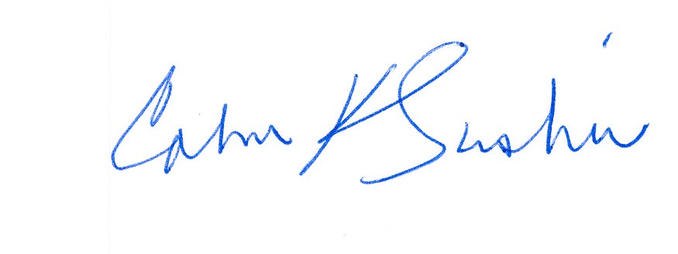
__________________________ ___________________________
Calvin K. Simshaw Lisa A. Anderl (WSBA # 13236)
CenturyLink Qwest Law Department
805 Broadway 1600 – 7th Ave., room 1506
Vancouver, WA 98660 Seattle, WA 98191
calvin.simshaw@centurylink.com lisa.anderl@qwest.com

Among others, The Wall Street Journal, Associated Press, Bloomberg, Dow Jones, The New York Times Dealbook, and Financial Times.
Those entities are Sprint Nextel Corporation (formerly Sprint Corporation) d/b/a Sprint PCS, SprintCom, Inc., Sprint Spectrum, L.P., and WirelessCo., L.P. These carriers are not listed as registered competitive local exchange carriers in Washington, according to the Commission’s website.
http://www.wutc.wa.gov/RMS2.nsf/177d98baa5918c7388256a550064a61e/cc3a93b7220c8bd08825773f005bd420!OpenDocument

