July 1, 2015

VIA ELECTRONIC FILING SYSTEM

Washington Utilities & Transportation Commission
1300 S. Evergreen Park Drive SW
Olympia, WA 98504-7250

RE: FCC Form 481 Confidential Financial Information Subject to Washington Code 480-07-160

Westgate Communications LLC dba WeavTel, a privately-held rate of return carrier receiving high cost support, has electronically submitted FCC Form 481 to the Commission with redacted financial data and confidential information compliance with 47 C.F.R. §§ 54.313 and 54.422. WeavTel also files its confidential and redacted copies with the Washington Utilities & Transportation Commission and requests that this filing be treated confidentially. Please be advised that a native version of the files is not available.

Please feel free to contact me with any questions regarding this particular matter.

Sincerely,
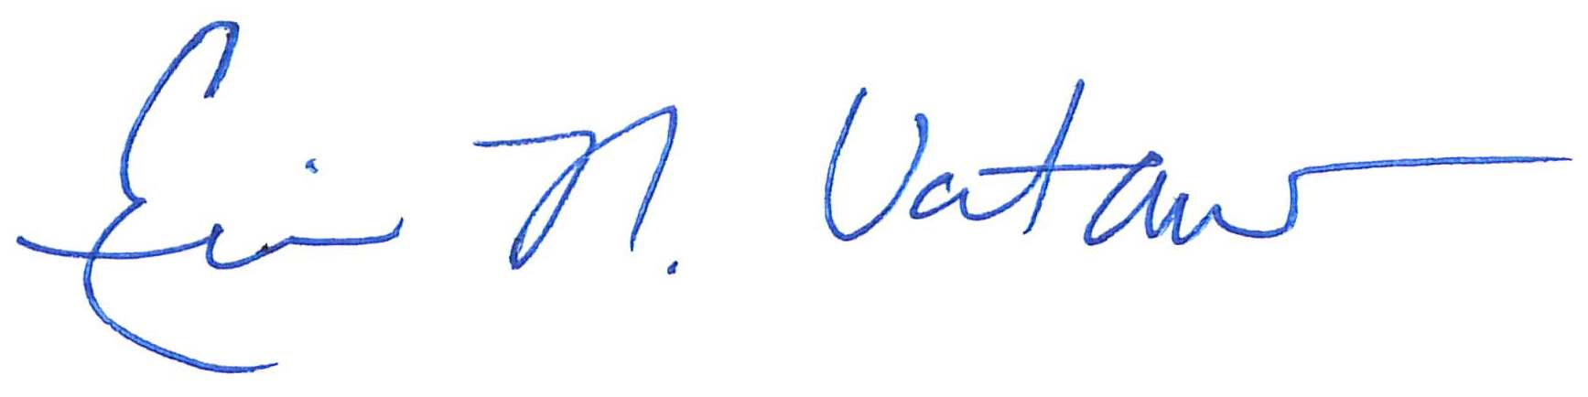
Eric N. Votaw, Senior Manager for
Moss Adams LLP
Enclosures

