CONFIDENTIAL FILING

August 30, 2016

VIA ELECTRONIC FILING SYSTEM

Mr. Steven V. King, Acting Executive Director and Secretary
Washington Utilities and Transportation Commission
1300 South Evergreen Park Drive SW
Olympia, WA 98504-7250

RE: 2017 Petition to Receive USF Support Replacement Page 5

Dear Mr. King:

MASHELL TELECOM, INC. DBA RAINIER CONNECT (“MASHELL”), a privately-held rate of return carrier receiving high cost support, has electronically submitted a 2017 Petition to Receive USF Support to the Commission with redacted financial data. Attached is a replacement page 5 for the USF Petition. MASHELL respectfully provides the Commission with its confidential financial data so that all its reporting obligations are satisfied.

Please feel free to contact me with any questions regarding this particular matter.

Sincerely,

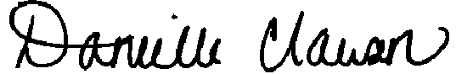
Danielle Clause, Controller
For Mashell Telecom Inc. dba Rainier Connect
Enclosures

