Avista Corp.
1411 East Mission P.O. Box 3727
Spokane, Washington 99220-0500
Telephone 509-489-0500
Toll Free 800-727-9170

July 31, 2017

Steven V. King
Executive Director and Secretary
Washington Utilities & Transportation Commission
1300 S. Evergreen Park Drive S. W.
P.O. Box 47250
Olympia, Washington 98504-7250

Re: Docket No. UE-160071 & UG-160072 – Avista Utilities Q2 2017 Fee-Free Payment Program Report

Dear Mr. King,

On March 24, 2016 the Commission issued Order 01 in Docket UE-160071 and UG-160072 approving Avista Corporation’s, dba Avista Utilities (Avista or Company) petition for an order authorizing accounting and ratemaking treatment of its residential fee-free payment program. In its petition, the Company sought to defer the costs associated with offering the fee-free payment for up to 36 months from the time the program went into effect. The fee-free payment program was successfully launched on February 19, 2017.

In its petition, the Company agreed to provide updates to the Commission every three months about the program’s progress. For purposes of reporting, the Company will be providing updates that coincide with the quarters of the calendar year.

Avista’s residential fee-free payment program encompasses previous methods of payments that were assessed a fee or not available. The program includes the following payment methods and channels:
- Credit and debit card payments made through a Customer Service Representative (CSR), through the Company’s Integrated Voice Recognition (IVR) system, through its website as a one-time guest payment, through its website as an authenticated user, and for Automatic Payment Service (APS) payments.
- Automated Clearing House (ACH) payments made through a CSR, through the Company’s IVR system, and through its website as a one-time guest payment.

Prior to the launch of the program, customers could pay free of charge by ACH through the Company’s website as an authenticated user and for APS payments. Also, prior to the launch of the program APS payments were limited to only ACH payment methods.

The following table represents the residential payment information for the Company’s Washington customers by month:
Table No. 1
Payments | January | February | March | April | May | June
Total Payments | 211,354 | 195,100 | 219,350 | 197,865 | 208,024 | 196,474
Fiserv Payments | - | 28,632 | 99,327 | 91,729 | 98,919 | 90,186
Fee-Free Fiserv | - | 8,156 | 25,092 | 23,209 | 25,499 | 26,905
Kubra Fee-Free Equivalent* | 18,542 | 11,498 | - | - | - | -
Total Fee-Free | 18,542 | 19,654 | 25,092 | 23,209 | 25,499 | 26,905
Fee-Free Payments as % of Total | 8.8% | 10.1% | 11.4% | 11.7% | 12.3% | 13.7%
*Kubra Fee-Free Equivalent – these payments represent the Kubra payments received from February 1st – 18th that would have come through the fee-free payment program. Kubra did not process APS payments, which Fiserv now does, including the ability for customers to sign up for APS by credit or debit card.

Table No. 2 below includes additional detail on certain payment channels. This information is highlighted to monitor trends in customers’ payment behavior.

Table No. 2
Payment Method | January | February | March | April | May | June
APS by ACH | 27,456 | 28,800 | 33,623 | 31,753 | 36,823 | 30,790
APS by Debit or Credit Card | - | 31 | 464 | 939 | 1,669 | 1,903
Total APS Payments | 27,456 | 28,831 | 34,087 | 32,692 | 38,492 | 32,693
Total Card Payments | 17,364 | 18,223 | 22,967 | 21,361 | 23,482 | 24,450
CSR Payments | 4,450 | 5,228 | 6,718 | 5,225 | 5,339 | 5,474
IVR Payments | 6,113 | 6,243 | 7,378 | 6,586 | 6,960 | 7,612
Mailed & Lobby Payments | 60,295 | 51,927 | 60,837 | 53,288 | 53,808 | 55,153
Pay Station Payments | 12,119 | 10,998 | 11,861 | 10,387 | 10,349 | 9,872
Web Based Payments | 54,456 | 49,371 | 51,037 | 47,152 | 48,048 | 44,328

Chart No. 1 below displays the payment trends from Table No. 2.
Chart No. 1
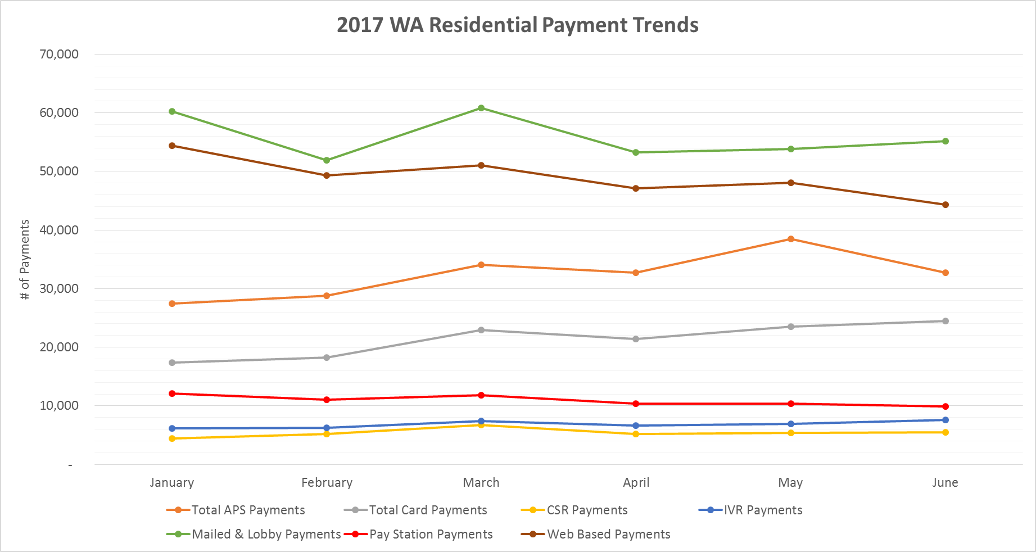

For historical comparison purposes, Table No. 3 displays residential payment data from 2015 and 2016. The column labeled “Payments Subject to Convenience Fee” represents the payments that were previously charged a fee and no longer do through the Company’s fee-free payment program.

Table No. 3
Year | # of Residential Payments | Payments Subject to Convenience Fee | % of Total
2015 | 2,435,536 | 163,570 | 6.72%
2016 | 2,474,632 | 191,720 | 7.75%

Chart No. 2 graphically shows the trend in fee-free payments in 2017 compared to the historical annual average in 2015 and 2016.
Chart No. 2
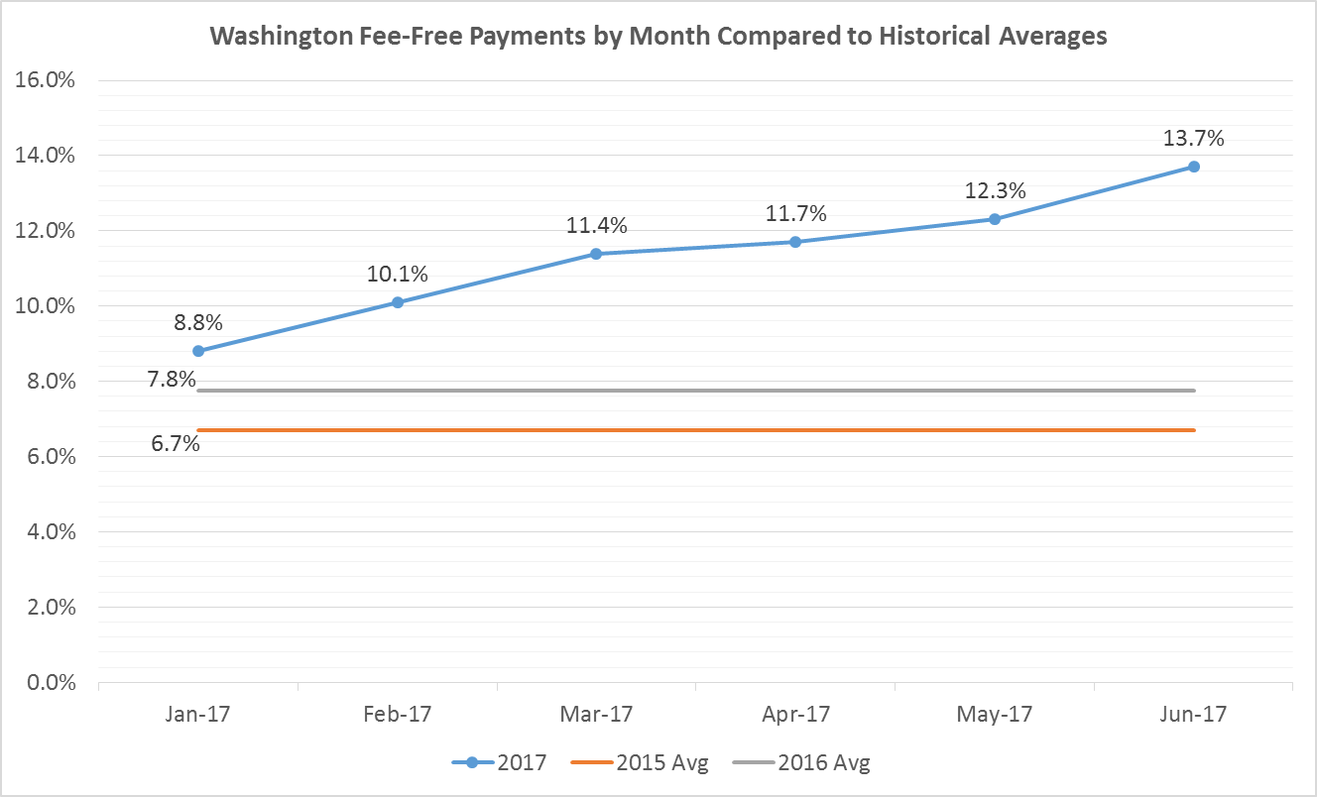

The Company continues to work through the invoice and reconciliation process with Fiserv. To date it has paid invoices for February and March. For these two months the Company has paid and deferred $50,085.35 for customer transactions through the fee-free payment program.

Please direct any questions regarding this report to Shawn Bonfield at 509-495-2782 or shawn.bonfield@avistacorp.com or myself at 509-495-4975 or linda.gervais@avistacorp.com

Sincerely,

Linda Gervais

Sr. Manager Regulatory Policy
Avista Utilities

