 | 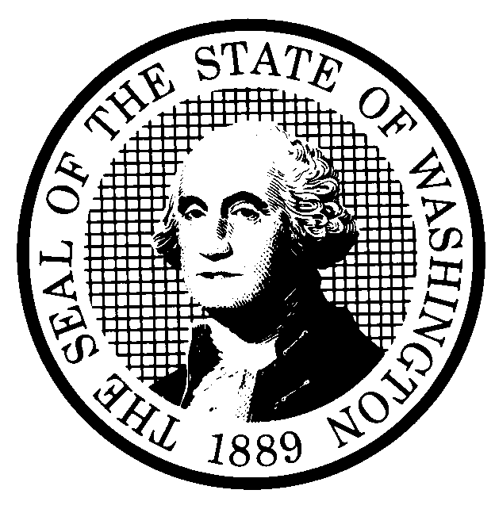 | EXPEDITED RULE MAKING |  |  |  |  | CR-105 (June 2004)  (Implements RCW 34.05.353)  EXPEDITED RULE MAKING ONLY
 | Agency: Washington Utilities & Transportation Commission
Title of rule and other identifying information: (Describe Subject)
The rulemaking would revise adoption-by-reference dates in Title 480 of the WAC to incorporate the most recent versions of adopted federal rules and other adopted publications and correct reference, grammatical, and punctuation errors.

Commission Docket A-060475 Affected WAC chapters include: 480-04; 480-14; 480-15; 480-70; 480-73; 480-90; 480-100; 480-120; and 480-121. Please refer to attachment A for a list of the specific rules affected and the proposed changes.

NOTICE
THIS RULE IS BEING PROPOSED UNDER AN EXPEDITED RULE-MAKING PROCESS THAT WILL ELIMINATE THE NEED FOR THE AGENCY TO HOLD PUBLIC HEARINGS, PREPARE A SMALL BUSINESS ECONOMIC IMPACT STATEMENT, OR PROVIDE RESPONSES TO THE CRITERIA FOR A SIGNIFICANT LEGISLATIVE RULE. IF YOU OBJECT TO THIS USE OF THE EXPEDITED RULE-MAKING PROCESS, YOU MUST EXPRESS YOUR OBJECTIONS IN WRITING AND THEY MUST BE SENT TO
Name: Executive Secretary, Docket No. A-060475
Agency: Washington Utilities and Transportation Commission
Address: P.O. Box 47250, Olympia, WA 98504-7250

AND RECEIVED BY (Date) July 24, 2006

Purpose of the proposal and its anticipated effects, including any changes in existing rules:

This proposal would revise the adoption-by-reference dates to reflect the current version of adopted material and make other minor administrative changes in Title 480 WAC.

Reasons supporting proposal:

The Commission adopts by reference several parts in Title 18; Title 40; Title 47; and Title 49 of the Code of Federal Regulations and other state rules and national standards. Commission rules need to reflect the most current versions of the adopted material.

 | Statutory authority for adoption: RCW 80.01.040, RCW 80.04.160,  RCW 81.04.160 and RCW 34.05.353 |  |  |  |  | Statute being implemented:
Is rule necessary because of a:  Federal Law?  Federal Court Decision?  State Court Decision?  If yes, CITATION: |  |  | Yes  Yes  Yes | No  No  No | CODE REVISER USE ONLY  Filed with the Code Reviser’s Office  May 24, 2006, 11:06 a.m.  WSR 06-11-174
DATE
May 24, 2006
NAME (TYPE OR PRINT)
Carole J. Washburn
SIGNATURE

TITLE
Executive Secretary

(COMPLETE REVERSE SIDE)
Name of proponent: (person or organization) Washington Utilities and Transportation Commission |  |  |  | Private  Public  Governmental
Name of agency personnel responsible for:
 | Name | Office Location | Phone
Drafting.......... Sharyn Bate, Regulatory Analyst |  | 1300 S. Evergreen Park Drive SW, Olympia, WA 98504-7250 | (360) 664-1295
Implementation. Carole J. Washburn,  Executive Secretary |  | 1300 S. Evergreen Park Drive SW, Olympia, WA 98504-7250 | (360) 664-1295
Enforcement. Carole J. Washburn,  Executive Secretary |  | 1300 S. Evergreen Park Drive SW, Olympia, WA 98504-7250 | (360) 664-1295
Agency comments or recommendations, if any, as to statutory language, implementation, enforcement, and fiscal matters:
None

