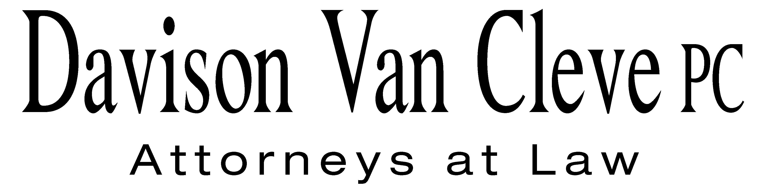
TEL (503) 241-7242 ● FAX (503) 241-8160 ● mail@dvclaw.com
Suite 400
333 SW Taylor
Portland, OR 97204

June 27, 2011

Via Email and Federal Express

Mr. David E. Danner
Executive Director & Secretary
Washington Utilities and Transportation Commission
PO Box 47250
1300 S Evergreen Park Drive SW
Olympia, WA 98504-7250

Re: In the Matter of WUTC v. Avista Corporation

Docket No. UE-110876

Dear Mr. Danner:

Enclosed please find the original and sixteen (16) copies of signature pages to Protective Order No. 3 of Melinda J. Davison, S. Bradley Van Cleve, Irion A. Sanger, Jesse E. Cowell, Donald W. Schoenbeck, Robynn Woodbury, Michael Gorman, James Leyko, and Ellen Blumenthal on behalf of the Industrial Customers of Northwest Utilities in the above-referenced docket.

If you have any questions or concerns, please do not hesitate to contact our office. Thank you for your assistance.

Sincerely yours,

/s/ Sarah A. Kohler
Sarah A. Kohler

Enclosures

cc: Service List

CERTIFICATE OF SERVICE

I hereby certify that I have this day served the foregoing documents upon all parties of record in this proceeding by mailing a copy thereof in a sealed, first-class postage prepaid envelope to each individual’s last-known address, as listed below.
DATED this 27th day of June, 2011.
Davison Van Cleve, P.C.

s/ Sarah A. Kohler
Sarah A. Kohler

Charles M Eberdt  The Energy Project  3406 Redwood Ave  Bellingham, WA 98225  CHUCK_EBERDT@oppco.org | David S Johnson  NW Energy Coalition  811 1st Ave STE 305  Seattle, WA 98104  david@nwenergy.org
Sarah A Shifley  Office of the Attorney General  800 5th Ave STE 2000  Seattle, WA 98104-3188  Sarah.Shifley@atg.wa.gov | Chad M Stokes  Cable Huston Benedick Haagensen & Lloyd, LLP  1001 SW 5th Avenue STE 2000  Portland, OR 97204  cstokes@cablehuston.com
Ronald L Roseman  Attorney At Law  2011 - 14th Avenue East  Seattle, WA 98112  ronaldroseman@comcast.net | Don Trotter  Assistant Attorney General  WUTC  PO Box 40128  Olympia, WA 98504-0128  dtrotter@utc.wa.gov
Michael Early  Executive Director  Industrial Customers of Northwest Utilities  1300 SW 5th Ave. STE 1750  Portland, OR 97201  mearly@icnu.org | Tommy A Brooks  Cable Huston Benedick Haagensen & Lloyd, LLP  1001 SW 5th Avenue STE 2000  Portland, OR 97204-1136  tbrooks@cablehuston.com
Paula E Pyron  Executive Director  NORTHWEST INDUSTRIAL GAS USERS  4113 Wolf Berry Court  Lake Oswego, OR 97035-1827  ppyron@nwigu.org | Danielle Dixon  Senior Policy Associate  NORTHWEST ENERGY COALITION  811 1st Avenue STE 305  Seattle, WA 98104  danielle@nwenergy.org
David Meyer  Avista Corporation, d/b/a Avista Utilities  PO BOX 3727  Spokane, WA 99220-3727  dmeyer@avistacorp.com | Kelly Norwood  Vice President  Avista Corporation, d/b/a Avista Utilities  1411 E. Mission  Spokane, WA 99220  kelly.norwood@avistacorp.com
Donald W Schoenbeck
RCS, Inc.
900 Washington Street STE 780
Vancouver, WA 98660
dws@r-c-s-inc.com

