Centralia/Chehalis
Emergency Response Plan

Table of Contents

Centralia/Chehalis
Users Guide 2
How it will be served 3
Regular business hours 3
After hours 3
Floods 3

PSE Staff
Who reside in Centralia/Chehalis 4
Who work in Centralia/Chehalis 4

Maps
Directions to Centralia Base 5
City Map Centralia 6
Gas Operations Map Key Centralia 7
Plat Map Key Centralia 8
Directions to Chehalis 9
City Map Chehalis 10
Gas Operations Map Key Chehalis 11
Plat Map Key Chehalis 12

Service Provider
Roles and Responsibilities 13

Users Guide

Dispatch
PSE Staff 4
City Map Centralia 6
Gas Operations Map Key Centralia 7
Plat Map Key Centralia 8
City Map Chehalis 10
Gas Operations Map Key Chehalis 11
Plat Map Key Chehalis 12
Roles and responsibility of Service Providers 13

First Responders
PSE Staff 4
City Map Centralia 6
Gas Operations Map Key Centralia 7
Plat Map Key Centralia 8
City Map Chehalis 10
Gas Operations Map Key Chehalis 11
Plat Map Key Chehalis 12
Roles and responsibility of Service Providers 13

CFS
PSE Staff 4
City Map Centralia 6
Gas Operations Map Key Centralia 7
Plat Map Key Centralia 8
City Map Chehalis 10
Gas Operations Map Key Chehalis 11
Plat Map Key Chehalis 12
Roles and responsibility of Service Providers 13

Gas Control
PSE Staff 4
City Map Centralia 6
Gas Operations Map Key Centralia 7
Plat Map Key Centralia 8
City Map Chehalis 10
Gas Operations Map Key Chehalis 11
Plat Map Key Chehalis 12
Roles and responsibility of Service Providers 13

Emergency Response Plan

Centralia/Chehalis

How Centralia/Chehalis will be served

Regular business hours:
During regular business hours we will utilize employees who are working in Centralia/Chehalis. This could include Gas First Response, SC&P, or Infrasource personnel.

After Hours:
We have identified those gas employees that live in and in close proximity to Centralia/Chehalis. Outside of normal business hours we will contact the Gas First Response employees who live in Centralia/Chehalis. (If these employees know they will be unavailable they will notify Dispatch). If the resident employees are not available, we will notify the staff identified that lives near Centralia/Chehalis, if that fails, we will move First Responders per the standard callout process, which dispatch the closest GFR personnel to the problem.

Floods:
Lewis County has had numerous 100-year floods in the past several years; this area is prone to flooding. This area may be closed to any traffic except for emergency vehicles and local traffic. In the past I-5 has been shut down. During flooding, the best way to get there may be through Littlerock or Bucoda. The Cities of Centralia, Chehalis and Lewis Co. generally inform PSE of any wash outs or any other road problems. Portions of the distribution system may need to be shut down in case of flooding.

Alternative Access:
If access by conventional means is unavailable, you may be able to deliver personnel and materials to the Centralia/Chehalis area by helicopter. The System Manager XXXXXXX, XXXXXXXXXXXX or XXXXXXXXXXXX on duty should be called to arrange helicopter support.

Public
Version

PSE staff who reside in Centralia/Chehalis

XXXXXXXXXXXX (Gas)
XXXXXXXXX
Centralia, WA 98531
Home phone: XXXXXXXXXXXX
Cell Phone: XXXXXXXXXXXX
Pager: XXXXXXXXXXXX

XXXXXXXXXX (Gas)
XXXXXXXXXXX
Centralia, WA 98531
Home: XXXXXXXXXXXX
Pager: XXXXXXXXXXXX
Cell: XXXXXXXXXXXX

XXXXXXXXX (Gas)
XXXXXXXXXXXXXX
Chehalis, WA 98532
Home phone: XXXXXXXXXXXX
Cell phone: XXXXXXXXXXXX
Pager: XXXXXXXXXXXX

XXXXXXXXXXX (Gas)
XXXXXXXXXXXXXXXXX
Olympia, WA 98579
Home phone: XXXXXXXXXXXX
Cell phone: XXXXXXXXXXXX
Pager: XXXXXXXXXXXX

PSE staff who Work in Centralia/Chehalis

XXXXXXXXX (Gas)
XXXXXXXXXXXXXX
Chehalis, WA 98532
Home phone: XXXXXXXXXXXX
Cell phone: XXXXXXXXXXXX
Pager: XXXXXXXXXXXX

Public
Version
Directions/Centralia Operating Base
(From Olympia)
xxxxxxxxxxxxxxxxxxxxxxxxxxxxxxxxxxxxxxxxxxxxxxxxxxxxxxxxxxxxxxxxxxxxxx
xxxxxxxxxxxxxxxxxxxxxxxxxxxxxxxxxxxxxxxxxxxxxxxxxxxxxxxxxxxxxxxxxxxxxx
xxxxxxxxxxxxxxxxxxxxxxxxxxxxxxxxxxxxxxxxxxxxxxxxxxxxxxxxxxxxxxxxxxxxxx
xxxxxxxxxxxxxxxxxxxxxxxxxxxxxxxxxxxxxxxxxxxxxxxxxxxxxxxxxxxxxxxxxxxxxx
xxxxxxxxxxxxxxxxxxxxxxxxxxxxxxxxxxxxxxxxxxxxxxxxxxxxxxxxxxxxxxxxxxxxxx
xxxxxxxxxxxxxxxxxxxxxxxxxxxxxxxxxxxxxxxxxxxxxxxxxxxxxxxxxxxxxxxxxxxxxx
xxxxxxxxxxxxxxxxxxxxxxxxxxxxxxxxxxxxxxxxxxxxxxxxxxxxxxxxxxxxxxxxxxxxxx
xxxxxxxxxxxxxxxxxxxxxxxxxxxxxxxxxxxxxxxxxxxxxxxxxxxxxxxxxxxxxxxxxxxxxx
xxxxxxxxxxxxxxxxxxxxxxxxxxxxxxxxxxxxxxxxxxxxxxxxxxxxxxxxxxxxxxxxxxxxxx
xxxxxxxxxxxxxxxxxxxxxxxxxxxxxxxxxxxxxxxxxxxxxxxxxxxxxxxxxxxxxxxxxxxxxx
Total Estimated Driving Time from Olympia: 31 minutes
Total Distance: Approximately 28 miles
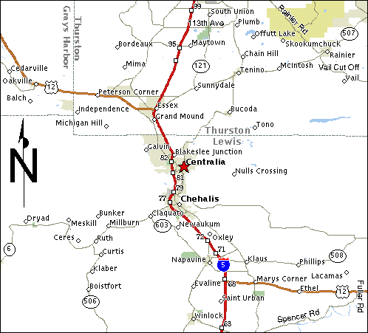
Public
Version
City Map
Centralia

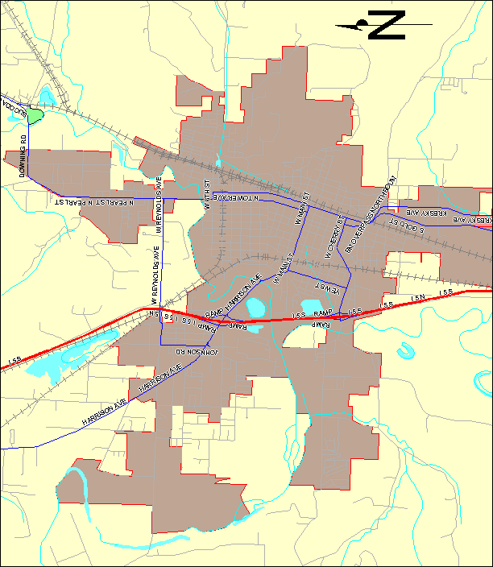
Operations Map Key
Centralia
REDACTED

Confidential per
WAC 480-07-160
Public
Version
Plat Map Key
Centralia
REDACTED

Public
Version
Confidential per
WAC 480-07-160
Directions/Chehalis
(From Olympia)
xxxxxxxxxxxxxxxxxxxxxxxxxxxxxxxxxxxxxxxxxxxxxxxxxxxxxxxxxxxxxxxxxxxxxx
xxxxxxxxxxxxxxxxxxxxxxxxxxxxxxxxxxxxxxxxxxxxxxxxxxxxxxxxxxxxxxxxxxxxxx
xxxxxxxxxxxxxxxxxxxxxxxxxxxxxxxxxxxxxxxxxxxxxxxxxxxxxxxxxxxxxxxxxxxxxx
xxxxxxxxxxxxxxxxxxxxxxxxxxxxxxxxxxxxxxxxxxxxxxxxxxxxxxxxxxxxxxxxxxxxxx
Total Estimated Driving Time from Olympia: 32 minutes
Total Distance: 30.71 miles

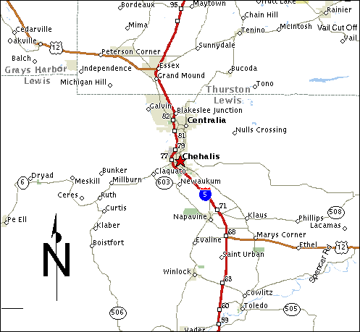
Public
Version

City Map
Chehalis

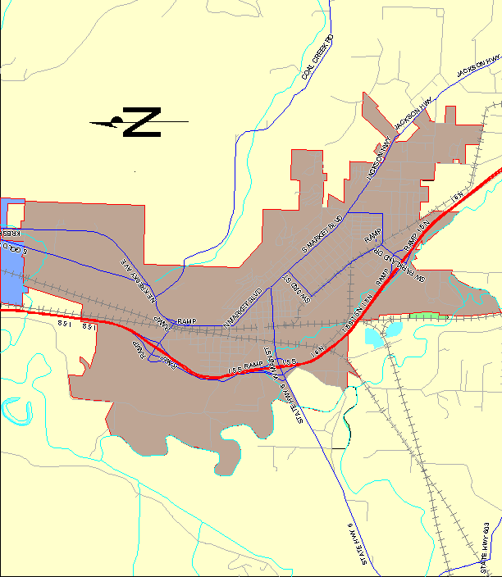
Operations Map Key
Chehalis

REDACTED

Public
Version

Plat Map Key
Chehalis

REDACTED

Confidential per
WAC 480-07-160
Public
Version

Roles and Responsibilities of the Service Providers

Infrasource Contractors (IFS) performs the installation of new customer construction on both residential and commercial gas services. They perform gas system upgrades and replacements, as well as, gas system operation and maintenance. In addition, IFS responds to breaks at the request of PSE Gas Dispatch.

