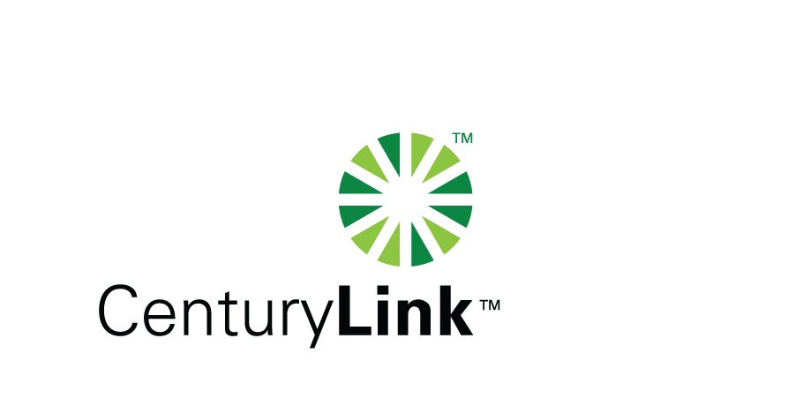

October 18, 2011

David Danner, Executive Director & Secretary
Washington Utilities & Transportation Commission
1300 S Evergreen Park Drive, SW
Olympia, Washington 98504-7250

Re: Washington Customer Service Guarantee Program (“CSGP”) Service Quality Reports - 3rd Quarter 2011
United Telephone Company of the Northwest d/b/a CenturyLink
CenturyTel of Washington d/b/a CenturyLink
CenturyTel of Inter-Island d/b/a CenturyLink
CenturyTel of Cowiche d/b/a CenturyLink
Redacted and Confidential

Dear Mr. Danner:

Attached are the 3rd Quarter 2011 CSGP Service Quality Reports, redacted and confidential versions, for United Telephone Company of the Northwest d/b/a CenturyLink; CenturyTel of Washington d/b/a CenturyLink; CenturyTel of Inter-Island d/b/a CenturyLink; CenturyTel of Cowiche d/b/a CenturyLink. These are new quarterly service quality reports for the CenturyLink ILECs that will be filed in conjunction with Docket No. UT-100820 Merger Condition No. 17 until the conclusion of the AFOR proceedings.

Should you have any questions, please contact Mark Reynolds at (206) 345-1568 or by e-mail at mark.reynolds3@centurylink.com.

Sincerely,

Mark Reynolds

Enclosures: 3rd Quarter CSGP Service Quality Reports, redacted and confidential versions, for United Telephone Company of the Northwest d/b/a CenturyLink; CenturyTel of Washington d/b/a CenturyLink; CenturyTel of Inter-Island d/b/a CenturyLink; CenturyTel of Cowiche d/b/a CenturyLink

