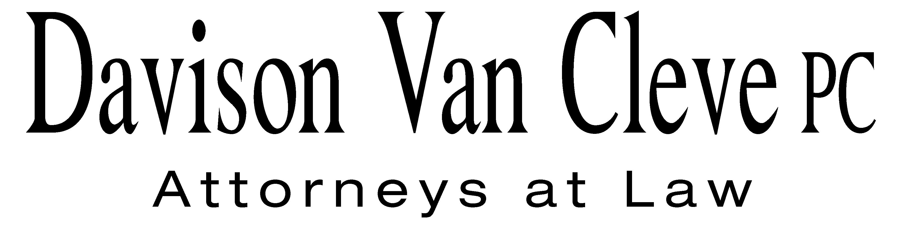
TEL (503) 241-7242 ● FAX (503) 241-8160 ● mail@dvclaw.com
Suite 400
333 SW Taylor
Portland, OR 97204

April 13, 2010

Via Email and Federal Express

Carole J. Washburn
Secretary
Washington Utilities and Transportation Commission
PO Box 47250
1300 S Evergreen Park Drive SW
Olympia, WA 98504-7250

Re: In the Matter of the General Rate Increase to Recover Increased Electric Cost.

Docket No. UE-100467

Dear Ms. Washburn:

Enclosed please find an original and twelve (12) copies of the Petition to Intervene of the Industrial Customers of Northwest Utilities.

Additionally, please find an original and twelve (12) copies of the Notice of Appearance of S. Bradley Van Cleve and Irion Sanger on behalf of the Industrial Customers of Northwest Utilities.

Thank you for your assistance.

Sincerely yours,

/s/ Martin H. Patail
Martin H. Patail
Enclosures

cc: Service List

CERTIFICATE OF SERVICE

I hereby certify that I have this day served the foregoing documents upon all parties of record in this proceeding by mailing a copy thereof in a sealed, first-class postage prepaid envelope to each individual’s last-known address, as listed below.
DATED this 13th day of April, 2010.
Davison Van Cleve, P.C.

/s/ Martin H. Patail
Martin H. Patail

AVISTA CORPORATION  DAVID MEYER  PO BOX 3727  SPOKANE WA 99220-3727  dmeyer@avistacorp.com | AVISTA CORPORATION  KELLY NORWOOD  RATES AND REGULATION  1411 E. MISSION  SPOKANE WA 99220
NORTHWEST INDUSTRIAL GAS USERS  PAULA E PYRON  EXECUTIVE DIRECTOR  4113 WOLF BERRY COURT  LAKE OSWEGO OR 97035-1827  ppyron@nwigu.org  CABLE HUSTON BENEDICT HAAGENSEN & LLOYD  CHAD M STOKES  1001 SW 5TH STE 2000  PORTLAND OR 97204  cstokes@cablehuston.com  GREG J TRAUTMAN  ASSISTANT ATTORNEY GENERAL  WUTC  PO BOX 40128  OLYMPIA, WA 98504 gtrautma@wutc.wa.gov | CABLE HUSTON BENEDICT HAAGENSEN & LLOYD  TOMMY A BROOKS  1001 SW 5TH STE 2000  PORTLAND OR 97204-1136  tbrooks@cablehuston.com  MICHAEL FASSIO  ASSISTANT ATTORNEY GENERAL  WUTC  PO BOX 40128  OLYMPIA, WA 98504 MFassio@utc.wa.gov  OFFICE OF THE ATTORNEY GENERAL  SIMON FFITCH  PUBLIC COUNSEL  800 FIFTH AVENUE STE 2000  SEATTLE WA 98104-3188  simonf@atg.wa.gov

