BEFORE THE WASHINGTON
UTILITIES AND TRANSPORTATION COMMISSION

In the Matter of the Joint Application of )
Verizon Communications Inc. and )
Frontier Communications Corporation )
For An Order Declining to Assert ) Docket No. UT-090842
Jurisdiction Over, or, in the Alternative, )
Approving the Indirect Transfer of )
Control of Verizon Northwest Inc. )

ANSWER TO BCAW PETITION FOR INTERLOCUTORY REVIEW
- Pursuant to WAC 480-07-810(3), Verizon Communications Inc. (“Verizon”) and Frontier Communications Corporation (“Frontier”) (collectively, “Applicants”) hereby answer the Petition for Interlocutory Review of the Broadband Communications Association of Washington (“BCAW”) filed on August 6, 2009 (“Petition”). The limitation of BCAW’s intervention petition in Order 02 issued on July 28, 2009 (“Prehearing Conference Order” or “Order”) was appropriate, and should not be disturbed by the Commission.
- The Prehearing Conference Order found that BCAW’s participation in this docket is to be “limited to its members’ interests as wholesale customers of Verizon.” Prehearing Conference Order at 3. The limitation was necessary as any interests of BCAW’s members as unregulated “competitors” of Verizon Northwest Inc. (“Verizon Northwest”) are insufficient for intervention under Washington law and Commission precedent. Under Cole v. Washington Util. & Transp. Comm’n (“Cole”), the Commission “has no authority to consider the effect of a regulated utility upon a nonregulated business.” 79 Wn.2d 302, 306 (1971). Thus, as the Prehearing Conference Order correctly found, the BCAW’s stated interest that “several of [its] members compete with Verizon in the provision of local and long distance voice services in the state of Washington” (Petition to Intervene of BCAW filed on June 30, 2009 at 2) does not provide it sufficient grounds to intervene in this docket since those voice services are provided through Voice-Over-Internet-Protocol (“VOIP”) technologies unregulated by the Commission.
- The Petition gives the impression that Cole is an outdated decision decided on narrow facts. That is not the case. Cole is routinely relied upon by the Commission to reject intervention petitions of other companies in merger proceedings such as this one. For example, in the GTE/Bell Atlantic merger docket, the Commission rejected the attempted intervention of Supra Telecommunications & Information Systems, Inc. (“Supra”) because it was an “unregulated potential competitor” of GTE and Bell Atlantic. It found as much because although Supra planned to provide telecommunications services to Washington residents at some future time, it was not yet registered with the Commission to provide telecommunications services to Washington residents. Second Supplemental Order on Petitions to Intervene, Docket No. UT-981367 (June 22, 1999) at 3; see also Second Supplemental Order on Prehearing Conference, Docket Nos. UE-951270, -960195 (1996) (describing the Cole standard that “unregulated potential competitors of a regulated company do not have a substantial interest in the outcome of its proceedings” in a merger proceeding involving Puget Sound Power & Light Company and Washington Natural Gas Company).
- Similarly, BCAW members that compete with Verizon for local and long distance voice services do not do so through services regulated by Commission-registered entities. They do so through VOIP services unregulated by the Commission. Indeed, BCAW did not address the registration status of any of its members in its Petition, nor did it attempt to dispute the notion that the relevant voice services provided by its members are not regulated by the Commission.
- Instead, BCAW claims that Cole analysis is altered because the Applicants have raised issues on benefits from the transaction that will extend to areas unregulated by the Commission, such as broadband deployment. See Petition at 3-4. This claim misses the point. Issues regarding how the public might benefit from the transaction, including in areas over which the Commission lacks jurisdiction, differ from the impact of the transaction on unregulated competitors. Such an impact on unregulated competitors remains outside the scope of the proceeding, and thus a stated interest based on such unregulated competition (“several of [its] members compete with Verizon in the provision of local and long distance voice services in the state of Washington”) is insufficient for intervention. Accordingly, the limitation of BCAW’s participation in this docket described in the Order was appropriate.
- And it is not as though BCAW’s intervention petition was denied: the petition was granted to the extent it focuses on the purchase by BCAW members of regulated wholesale services from Verizon in Washington. The Order simply proscribed BCAW from participating on the basis of being an unregulated competitor of the regulated entity (Verizon Northwest) that is the subject of the proposed transaction, a prohibition mandated by Cole and Commission precedent.

- Wherefore, the Commission was right to limit BCAW’s intervention in this docket, and that decision should not be altered.
Respectfully submitted this 14th day of August, 2009,

VERIZON COMMUNICATIONS INC.
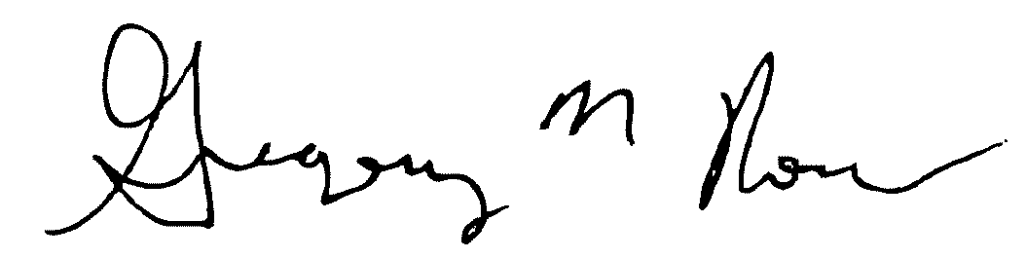
By: _______________________________________________
Gregory M. Romano, WSBA # 38544
General Counsel – Northwest Region
Verizon
1800 41st Street, WA0105GC
Everett, Washington 98201
Tel: 425-261-5460
Fax: 425-252-4913
gregory.m.romano@verizon.com

FRONTIER COMMUNICATIONS CORPORATION
By: _______________________________________________
Charles L. Best, WSBA # 31943
Attorney at Law
1631 NE Broadway # 538
Portland, Oregon 97232-1425
Tel: 503-287-7160
Fax: 503-287-7160
chuck@charleslbest.com

