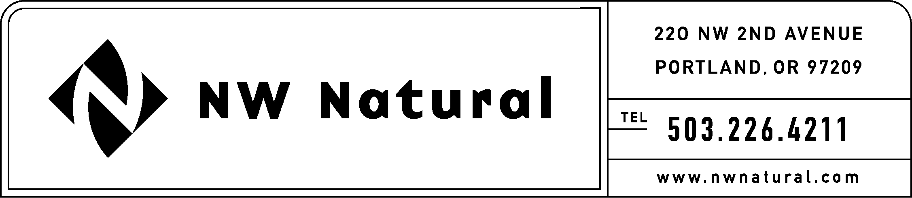
GAIL HAMMER
Rates and Regulatory Affairs
Phone: 503.226.4211 ext. 5865
Fax: 503.721.2516
gail.hammer@nwnatural.com

June 28, 2016

VIA ELECTRONIC FILING AND US MAIL

Steven King, Executive Director and Secretary
Washington Utilities and Transportation Commission
1300 S. Evergreen Park Drive, S.W.
P.O. Box 47250
Olympia, Washington 98504-7250

RE: UG-151776, NW Natural’s Draft 2016 Integrated Resource Plan

NW Natural Gas, dba NW Natural (“NW Natural” or the “Company”), herein files its Draft 2016 Integrated Resource Plan (IRP) in Docket No. UG-151776. Enclosed please find an original and three copies.

Appendix 3 to the Company’s Draft 2016 IRP contains confidential information and is provided separately under the protections granted in WAC 480-07-160.

Please contact me should you have questions or require additional information.

Sincerely,
/s/ Gail Hammer
Gail Hammer
NW Natural

Enclosures

