December 7, 2011

UTC STAFF COMMENTS ON AVISTA’S
REPORT IDENTIFYING ITS
TEN-YEAR ACHIEVABLE CONSERVATION POTENTIAL AND ITS
BIENNIAL CONSERVATION TARGET
PURSUANT TO RCW 19.285.040 AND WAC 480-109-010

DOCKET UE-111882

On November 1, 2011, Avista Corporation (Avista or Company) filed its biennial conservation plan (BCP) with the Washington Utilities and Transportation Commission (Commission). The report is required by RCW 19.285.040, WAC 480-109-010, and Order 01 in Docket UE-100176. As part of the BCP, Avista identified a range for its biennial conservation target pursuant to WAC 480-109-010(2)(c) and RCW 19.285 (Energy Independence Act or EIA). The Company also provided a business plan for conserving electricity and natural gas through energy efficiency measures deployed in 2012.

Staff has reviewed the BCP and has several comments and recommendations regarding the filing. The main focus of Staff’s review has been to verify that the ten-year conservation potential and biennial conservation target comply with the EIA and that Avista developed targets using methodology consistent with the Northwest Power Planning and Conservation Council (NWPCC). In evaluating Avista’s 2012 business plan, Staff’s investigation focused on the program budgets and cost effectiveness of programs that will deliver conservation savings. Staff has also reacted to new considerations introduced by Avista.

In summary, Staff recommends that the Commission approve ten-year and biennial conservation targets subject to the conditions attached to these comments. Staff further recommends that the Commission accept Avista’s electric demand side management (DSM) business plan and defer discussion of natural gas DSM matters until Avista and Staff have an opportunity to address certain issues arising in this filing.

Ten-year and Biennial Conservation Target

As required by RCW 19.285.040, Avista has filed its proposed achievable cost-effective conservation potential or “target.” It consists of conservation potential from two major areas. The first major area represents conservation savings from the delivery of end-use efficiency measures, achieved, for example, by paying an incentive to customers who chose a high efficiency appliance over a standard efficiency model. Avista developed this potential by retaining a third party expert, Global Energy Partners (Global), to produce a Conservation Potential Assessment (CPA). The second major source of achievable conservation represents savings resulting from upgrades to Avista’s distribution system, achieved, for example, by adding equipment to Avista’s power lines that allow for better regulation of the voltage levels.

Within the CPA for end-use measures, Avista separates its proposed target into a range bound at the top by the maximum achievable potential (MAP) and at the bottom by a realistic achievable potential (RAP). To develop the MAP and RAP figures, Global calculated Avista’s technical and economic potential levels to determine what amount of savings is available in the service territory and what amount of savings is cost effective. The process started with customer class usage data. Global then combined additional utility data with information from secondary sources to develop the baseline forecast for energy use so that it could then model adoption of energy efficiency measures. MAP represents the portion of economic savings Avista’s market would accept. RAP represents the portion of MAP that can be expected to be achieved through a utility delivered conservation program in Avista’s market.

Like the Global CPA, the NWPCC determines a regional level of cost effective conservation by modeling adoption of conservation measures. Also like Global, the NWPCC assumes that the regional market will adopt cost effective conservation measures over a timeline depicted by measure ramp rates. Unlike the final step in Global’s CPA to determine the RAP, however, the NWPCC does not attribute conservation adoption to any particular delivery method or rationale. In other words, it does not matter for the purposes of a NWPCC regional savings estimate if an individual adopts a conservation measure on his or her own accord, in response to a government tax incentive, or as the result of a utility-sponsored program. The implication of this approach is that strict application of NWPCC methodology for purposes of target setting would require that Avista set a target based on the higher MAP and not the lower RAP because the RAP focuses only on savings delivered through utility programs. However, strict application would result in the undesirable consequence of making Avista accountable for all conservation delivered in its service territory regardless of the cause of its implementation. Staff believes that it is in the public interest to make Avista accountable only for the delivery of conservation savings within the utilities control. Accordingly, Staff believes that RAP represents a minimum level of acceptable performance with respect to the delivery of end-use conservation measures.

Using both the RAP and MAP conservation potential estimates, Avista has requested a range target as permitted by WAC 480-109-010(2)(c). Staff agrees with Avista’s proposition that RAP and MAP represent a reasonable basis on which to base a savings range. However, Staff observes that no consequences exist in Avista’s regulatory framework for exceeding the range’s upper boundary. As a result, Staff evaluation of the target range has largely focused on the lower boundary where failure to meet that level would result in penalties for the purposes of RCW 19.285.060(1).

Based on a combination of end-use conservation and distribution efficiency, Staff recommends the following biennial conservation target and ten-year achievable conservation potential:

 | Biennial Targets |  | Ten-Year Potential
 | Low range (MWh) | High range (MWh) | Low range (MWh) | High range (MWh)
End-use efficiency | 76,202 | 137,410 | 529,114 | 1,079,345
Distribution efficiency | 32,387 | 60,147 | 71,539 | 102,199
Aggregate BCP Target | 108,589 | 197,557 | 600,653 | 1,181,544

Staff recommends approval of a ten-year conservation potential ranging from 600,653 to 1,181,544 MWh. Staff also recommends approval of biennial conservation target ranging from 108,589 to 197,557 MWh.

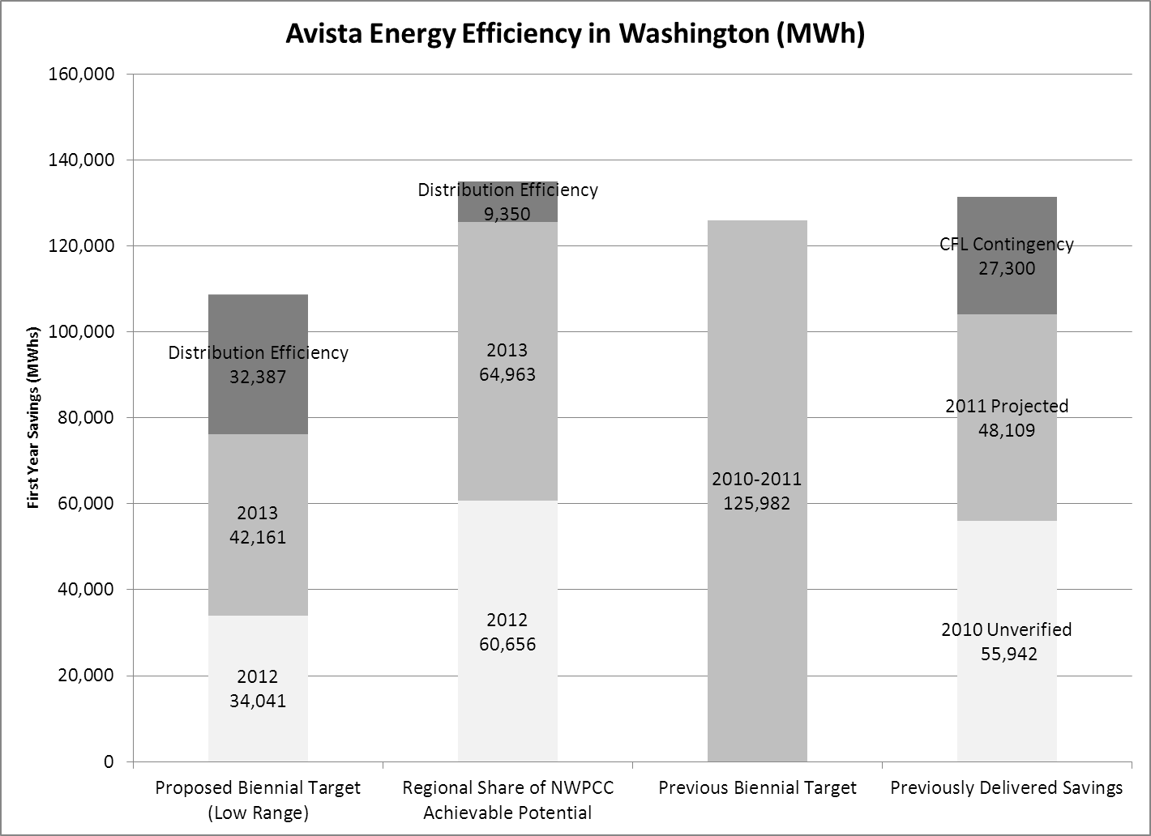

Recommended Conditions for the 2012-2013 Biennium

WAC 480-109-010(4)(c) provides:
c) Upon conclusion of the commission review, the commission will determine whether to approve, approve with conditions, or reject the utility’s ten-year achievable conservation potential and biennial conservation target.

Staff recommends that the Commission approve the target subject to conditions. Avista’s previous target was approved subject to conditions appearing in Order 01 of UE-100176 or the “conditions list” during the prior biennium. Based on Staff’s experience working with the Company during the biennium, Staff believes the public interest was well served by the conditions list. As an attachment to these comments, Staff has provided conditions that the Commission should apply to Avista for the coming biennium. It incorporates some language and terms from the prior conditions list. However, the structure and format of the conditions is based on commitments and conditions proposed by Avista starting on page 36 of its BCP.

2012 DSM Business Plan

Avista’s target represents an aggregate figure that Avista can achieve using an eligible measure. The description of these eligible measures appears in the Company’s 2012 DSM Business Plan or Appendix A to the BCP. Under this business plan, Avista expects to spend $17 million for electric conservation on a system basis (Idaho and Washington) in 2012 and achieve a total resource cost (TRC) benefit cost ratio of 1.37. Within this budget, Avista has identified 12 nonresidential and 20 residential programs with a combined system (Washington and Idaho) program budget of $11.3 million. Also included is a Northwest Energy Efficiency Alliance (NEEA) budget of $2.16 million, and expected EM&V and conservation infrastructure expected at $3.5 million. Staff believes that this proposal is reasonable and in the public interest. As a result, Staff recommends that the Commission accept Avista’s electric DSM budget.

Avista included information related to natural gas DSM in the 2012 DSM Business Plan. As part of this presentation, Avista anticipates that its natural gas DSM portfolio will exhibit a 0.58 TRC benefit cost ratio for 2012. Staff believes that the ongoing long-term operation of a DSM portfolio below a TRC benefit cost ratio of 1.0 does not serve the public interest. Accordingly, Staff expects Avista to improve this ratio by reducing program costs, clearly establishing why a sub 1.0 TRC is in the public interest, or by curtailing non cost effective programs. Because the EIA does not contemplate natural gas DSM programs, Staff does not perceive a need to recommend Commission action with respect to Avista’s DSM at this time. With additional time to work with the Company, Staff and stakeholders expect that they will soon have a recommendation to address the concerns identified with respect to Avista’s natural gas DSM.

2012 EM&V Plan

Appendix B contains Avista’s evaluation measurement and verification (EM&V) plan. It follows the EM&V framework established in 2010. As part of this plan, Avista budgets approximately $1.2 million for Washington EM&V in 2012 or 7.1 percent of its Washington budget. Staff expects that this percentage will fall in future years as programs become better understood and as one-time projects are completed, such as the CFL mail distribution program.

For its distribution efficiency program, Avista states in the BCP that the Regional Technical Forum (RTF) has developed an EM&V protocol for distribution efficiency. The Company has also stated that it has engaged Washington State University to provide a recommended approach to EM&V for distribution efficiency. Staff does not view this as third party verification of distribution savings. However, Staff does not perceive a need to address distribution savings specifically with an EM&V condition because Staff’s proposed condition requiring third party verification of the electric portfolio provides adequate assurances of third party measurement for this area. In Staff’s view a third party could not verify the overall electric portfolio without substantial investigation into distribution savings because distribution savings represents such a large portion of electric savings.

Advisory Group Meetings Summaries

Appendix C of the BCP contains a chart of issues presented to Avista’s advisory groups during the development of the BCP. Staff has no comment on the list other than the recognition that both Avista and Staff were well served by these advisory group meetings. The conditions attached to this recommendation contain provisions for ongoing stakeholder involvement but are not as prescriptive as the conditions list from the prior biennium.

Locked UES

Appendix D contains Avista’s Locked Unit Energy Savings (UES) for prescriptive conservation measures. By attaching this list, Avista had sought Commission approval to deem savings levels for the conservation measures appearing on the list. Unfortunately, Staff did not have sufficient time to review and resolve issues contained in the list sufficiently to recommend approval. Accordingly Staff recommends a condition that states that the Commission is not obligated to accept the UES presented in this filing. The condition appears in the attachment to this filing.

Staff recommendations for future periods

During the 2010-2011 biennium, Avista estimated its ten-year and biennial conservation potential using a calculated share of NWPCC’s regional savings estimate for the Sixth Power Plan. Staff views Avista’s departure from this calculation method favorably because Staff regards the CPA as a more precise estimate of the conservation potential in Avista’s service territory. However, Staff notes that the CPA for the current biennium defined conservation potential in terms of theoretical conservation measures and not Avista’s operational measures. Accordingly, a mismatch remains between Avista’s calculation of its target and the savings it calculates for achievement of the target. Therefore, while Staff did not include a provision in its recommended conditions for a CPA to inform the 2014-2015 biennium, Staff recommends that the Company eliminate this mismatch by developing a target that is calculated using operationally defined conservation measure savings levels.

Conclusion

Staff recommends that the Commission approve ten-year and biennial conservation targets subject to the conditions attached to these comments. Staff further recommends that the Commission accept Avista’s electric demand side management (DSM) business plan and defer discussion of natural gas DSM matters until Avista and Staff have an opportunity to address certain issues arising in this filing.
Attachment to Staff Comments

The following provisions represent Staff’s recommended conditions for the 2012-2013 biennium.
10-Year and Biennial Conservation Target Approval
- Avista Corporation’s (Avista or Company) Ten-Year Achievable Conservation Potential and Biennial Conservation Target ranges identified in Staff Comments to the Company’s Biennial Conservation Plan(BCP), are approved pursuant to RCW 19.285.040(1)(e) and WAC 480-109-010(4)(c).

- Nothing within this Order:

  - Relieves Avista of the sole responsibility for complying with RCW 19.285, which requires Avista to use methodologies consistent with those used by the Pacific Northwest Electric Power and Conservation Planning Council (“Council”), and WAC 480-109.
  - Affects Avista’s delivery of natural gas demand side management (DSM) programs.
  - Displaces any aspect of Order 5 in Docket s UE-110876 and UG-110877 granting a joint motion for clarification on forum for resolution of DSM prudence.

- Avista has identified a number of potential conservation measures as qualifying measures in its BCP. The Commission is not obligated to accept savings identified in the Biennial Conservation Plan for purposes of compliance with RCW 19.285. Avista must demonstrate the prudence and cost-effectiveness of its conservation programs to the Commission after the savings are achieved. See RCW 19.285.040(1)(d).

Advisory Group
- Avista must convene its Advisory Group of external stakeholders at least four times per year for review of, and to gain input on, programmatic topics. Avista must consult with its Advisory Group between July 1, 2013 and October 31, 2013 to identify achievable conservation potential for 2014-2023 and set biennial targets for the 2014-2015 biennium to facilitate completion of its 2014-2023 10-year conservation potential analysis by November 1, 2013.

Avista DSM Programs
- Avista must maintain its conservation tariffs, with program descriptions, on file with the Commission. Program details about specific measures, incentives, and eligibility requirements must be included in the tariffs.

- Avista must submit demand side management annual budgets to the Advisory Group and to the Commission no later than November 1 of each year, included with its Annual Business Plan filing. Avista must provide its proposed budget in a detailed format with a summary page indicating the proposed budget and savings levels for each electric conservation program, and subsequent supporting spreadsheets providing further detail for each program and line item shown in the summary sheet.

- Avista must offer a mix of tariff-based programs that ensure it is serving each customer class, including programs targeted to the low-income subset of residential customers.

- Modifications to programs or additional programs must be filed with the Commission as revisions to tariffs or as revisions to Avista’s DSM Business Plan, as appropriate.

- When Avista proposes a new program, it must present it to the Advisory Group for comment with program details conceptually defined. After consultation with the Advisory Group in accordance with paragraph above, Avista must file a revision to its DSM Business Plan in this Docket.

Reporting and Tracking
- Avista will file the following with Commission:

  - The 2013 DSM Business Plan, containing any changes to program details and an annual budget will be filed by November 1, 2012.
  - The 2012 Annual Report on Conservation Acquisition, including an evaluation of cost effectiveness and comparing budgets to actual, will be filed by June 1, 2013.
  - Avista must file by July 1, 2012, to maintain or revise its cost recovery tariffs, with requested effective date of on or before September 1, 2012.
  - A Biennial Conservation Plan including revised program details and program tariffs, together with identification of 2014-2023 achievable conservation potential will be filed by November 1, 2013, requesting an effective date of on or before January 1, 2014.
  - A 2012-2013 Two Year Report on Conservation Acquisition Achievement, will be filed by June 1, 2014. This Report shall include the results of an independent third-party verification of electric portfolio savings for the biennium.

Evaluation Measurement &Verification (EM&V)
- The Company must apply, as the primary cost effectiveness test, the TRC test as modified by the Council. The Council-modified calculation of TRC includes quantifiable non-energy benefits, a risk adder, and a 10 percent conservation benefit adder that increases the avoided costs by 10 percent. The Council generally does not include a net-to-gross adjustment. In addition to the Council-modified TRC, Avista must provide calculations of the Program Administrator Cost test (also called the Utility Cost test), Ratepayer Impact Measure test, and Participant Cost test. Overall conservation cost-effectiveness will be evaluated at the electric portfolio level. Costs included in the electric portfolio level analysis include conservation-related administrative costs. Avista must continue to evaluate measure and program level cost tests.

- Avista may use the Council’s Regional Technical Forum’s (“RTF’s”) unit energy savings (UES)—or “deemed” savings—for reporting savings from prescriptive measures. The RTF maintains a Web site at http://www.nwcouncil.org/energy/rtf/.

If Avista utilizes savings amounts for prescriptive programs that have not been established by the RTF, such estimates must be based on a rigorous evaluation performed by a third-party evaluator. Avista will present such estimates to the Advisory Group for comment, with an explanation as to why Avista believes the evaluation is more appropriate for Avista’s program and service territory than the RTF estimate. Rigorous third-party impact evaluation of an Avista prescriptive measure may occur during a previous biennium so long as the evaluation is documented in Avista’s Technical Reference Manual (TRM).

- Avista must provide opportunities for the Advisory Group to review the evaluation, measurement and verification protocols.

- Avista must spend a reasonable proportion of its conservation budget on evaluation, measurement, and verification (EM&V), including a reasonable proportion on independent, third-party EM&V. Avista must perform EM&V annually on a multi-year schedule of selected programs such that, over the EM&V cycle, all major programs are covered. The EM&V function includes impact, process, market and cost test analyses. The results are intended to verify the level at which claimed energy savings have occurred, evaluate the existing internal review processes, and suggest improvements to the program and ongoing EM&V processes. An annual independent, third-party EM&V report involving analysis of both program impacts and process impacts, for those programs reviewed in that year, will be part of the Annual Report on Conservation Acquisition. As noted above, the Biennial Report shall include an independent third-party verification of portfolio savings.

- Avista may spend up to ten (10) percent of its conservation budget on programs whose savings impact has not yet been measured, if the overall electric portfolio of conservation passes the TRC test as modified by the Council. These programs may include educational, behavior change, and pilot projects.

Cost Recovery
- Avista will seek to recover the future year’s budgeted expenses, and any variances between budgeted and actual income and expenditures during the previous period, in an annual filing to be made by July 1st, with rates to be effective on September 1st. The funds collected through the rider will be used to implement the conservation programs contained in this BCP and their administrative costs.

- Recovery for Each Customer Class — Rate spread and rate design must match Avista’s underlying base volumetric rates.

RCW 19.825.040 provides in part: 1) Each qualifying utility shall pursue all available conservation that is cost-effective, reliable, and feasible. (a) By January 1, 2010, using methodologies consistent with those used by the Pacific Northwest electric power and conservation planning council in its most recently published regional power plan, each qualifying utility shall identify its achievable cost-effective conservation potential through 2019. At least every two years thereafter, the qualifying utility shall review and update this assessment for the subsequent ten-year period. (b) Beginning January 2010, each qualifying utility shall establish and make publicly available a biennial acquisition target for cost-effective conservation consistent with its identification of achievable opportunities in (a) of this subsection, and meet that target during the subsequent two-year period. At a minimum, each biennial target must be no lower than the qualifying utility's pro rata share for that two-year period of its cost-effective conservation potential for the subsequent ten-year period. . . . (e) The commission may rely on its standard practice for review and approval of investor-owned utility conservation targets.
BCP page 30.
BCP page 12.
Id.
Based on 30 percent reduction from the High Range Estimate. See BCP page 35.
Avista identified 6.1 aMW (53,436 MWh) of potential savings from feeder efficiencies, 42,000 MWh from the Spokane area Smart Grid Investment Grant (SGIG) savings, and 6,763 MWh from the Pullman Smart Grid Demonstration Project (SGDP) savings over the 20 year IRP planning horizon. See page BCP page 34-35.

