 |  |  |  |  |  |  | Commission Docket No. |  |  |  |  |  |  |  | UT-030727
 |  |  |  |  |  |  | Agenda Date Assigned |  |  |  |  |  |  |  | October 11, 2006
BEFORE THE WASHINGTON UTILITIES AND TRANSPORTATION COMMISSION

LESS THAN REQUIRED NOTICE REQUESTED BY:

Verizon Northwest Inc. 313-013-420
(Utility Name) |  |  |  |  |  |  |  |  |  |  |  |  | (Utility UBI Number)
Utility proposes |  | Verizon Northwest Inc. Service Agreement |  |  |  |  |  |  |  |  |  |  | Number |  | Contract No. 1328ICB
(Contract Title)
Indicate below, or attach, an explanation of the reason the company requests permission to file the proposed provisions with less than required notice.

Verizon Northwest respectfully requests this ICB contract become effective October 12, 2006 to avoid an interruption in service to the customer. With no provision to extend the term nor a tariff service to revert to, if the Agreement is not effective on or before October 12, 2006 service would have to be disconnected because the company can not provide service without an effective contract.

David S. Valdez-VP Public Affairs, Policy and Communications  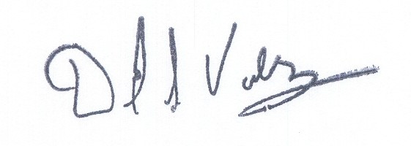 |  |  | is authorized to make filings on behalf of |  |  |  |  |  |  |  |  |  |  | Verizon Northwest Inc.
Signature and Title of Company Officer
I request these provisions become effective on |  |  |  | October 12, 2006
 |  |  |  |  |  |  |  |  | (Date)
(Signature of Authorized Agent) |  |  |  |  |  |  |  |  | (Title)
David S. Valdez
(Print Name)
( 425 ) 261-5691 |  |  |  |  | (425 ) 261-5262 |  |  |  |  |  |  | David.s.valdez@verizon.com
(Telephone Number) |  |  |  |  | (Fax Number) |  |  |  |  |  |  | (E-Mail Address)
1800 41st St. MC: WA0105RA |  |  |  |  | Everett |  |  |  |  |  |  | WA |  |  |  | 98201
(Mailing Address) |  |  |  |  | (City) |  |  |  |  |  |  | (State) |  |  |  | (Zip Code)
WASHINGTON UTILITIES AND TRANSPORTATION COMMISSION

O R D E R
The Commissioners, having determined this order is consistent with the public interest, directed the Secretary to enter this order granting the provisions requested above.
DATED and signed at Olympia, Washington, this |  |  |  |  |  | 11th |  | Day of |  |  | October, 2006
 |  |  |  |  |  |  |  |  | (Month and Year)
 |  |  |  |  |  |  |  |  | Secretary
Util LRN Form 05/16/05

