Winlock
Emergency Response Plan

Table of Contents

Winlock
Users Guide 2
How it will be served 3
Regular business hours 3
After hours 3
Floods 3

PSE Staff
Who work in Winlock 4
Live near Winlock 4

Maps
Directions 5
City Map 6
Gas Operations Map Key 7
Plat Map Key 8

Service Provider
Roles and Responsibilities 9

Users Guide

Dispatch
PSE Staff 4
Directions 5
City Map 6
Gas Operations Map Key 7
Plat Map Key 8
Roles and responsibility of Service Providers 9

First Responders
PSE Staff 4
Directions 5
City Map 6
Gas Operations Map Key 7
Plat Map Key 8
Roles and responsibility of Service Providers 9

CFS
PSE Staff 4
Directions 5
City Map 6
Gas Operations Map Key 7
Plat Map Key 8
Roles and responsibility of Service Providers 9

Gas Control
PSE Staff 4
Directions 5
City Map 6
Gas Operations Map Key 7
Plat Map Key 8
Roles and responsibility of Service Providers 9

Emergency Response Plan

Winlock

How Winlock will be served

Regular business hours:
During regular business hours we will utilize employees who are working in Winlock. This could include Gas First Response, SC&P, or Pilchuck personnel.

After Hours:
Puget Sound Energy has identified those gas employees that live in close proximity to Winlock. Dispatch will first contact the GFR staff that live near Winlock. If that fails, Dispatch will move the closest GFR personnel to the problem per the Standard Call-Out process. In the case where GFR personnel are unavailable, Dispatch will contact SC&P staff trained for First Response.

Floods:
Lewis County has had numerous 100-year floods in the past several years; this area is prone to flooding. This area may be closed to any traffic except for emergency vehicles and local traffic. In the past I-5 has been shut down. During flooding, the best way to get there may be through Littlerock or Bucoda. The City of Centralia and Chehalis as well as Lewis Co. has historically informed PSE of any wash outs or any other problems we may need to be aware of. PSE may need to isolate areas of the gas system during flooding.

Alternative Access:
If access by conventional means is unavailable, you may be able to deliver personnel and materials to the Winlock area by helicopter. The System Manager XXXXXXXX, XXXXXXXXXXXXX or XXXXXXXXXXXXX on duty should be called to arrange helicopter support.

PUBLIC VERSION

PSE staff who Work in Winlock.

XXXXXXXXXX Gas
XXXXXXXXXXXXXXX
Chehalis, WA 98532
Home phone: XXXXXXXXXXXX
Cell phone: XXXXXXXXXXXX
Pager: XXXXXXXXXXXX

PSE Staff who live near Winlock

XXXXXXXXXXXXXX Gas
XXXXXXXXX
Centralia, WA 98531
Home phone: XXXXXXXXXXXX
Cell Phone: XXXXXXXXXXXX
Pager: XXXXXXXXXXXX

XXXXXXXXXXX (Gas)
XXXXXXXXXXXX
Centralia, WA 98531
Home: XXXXXXXXXXXX
Pager: XXXXXXXXXXX
Cell: XXXXXXXXXXX

XXXXXXXXXX Gas
XXXXXXXXXXXXXXX
Chehalis, WA 98532
Home phone: XXXXXXXXXXX
Cell phone: XXXXXXXXXXX
Pager: XXXXXXXXXXX

XXXXXXXXXXX Gas
XXXXXXXXXXXXXXXXXXX
Olympia, WA 98579
Home phone: XXXXXXXXXXX
Cell phone: XXXXXXXXXXX
Pager: XXXXXXXXXXX

PUBLIC VERSION

Directions
(From Olympia)

XXXXXXXXXXXXXXXXXXXXXXXXXXXXXXXXXXXXXXXXXXXX
XXXXXXXXXXXXXXXXXXXXXXXXXXXXXXXXXXXXXXXXXXXXXXXXXXXXXXXXXX
XXXXXXXXXXXXXXXXXXXXXXXXXXXXXXXXXXXXXXXXXXXXXXXXXXXXXXXXXXX
XXXXXXXXXXXXXXXXXXXXXXXXXXXXXXXXXXXXXX

Total Estimated Driving Time from Olympia: 32 minutes

Total Distance: 30.71 miles
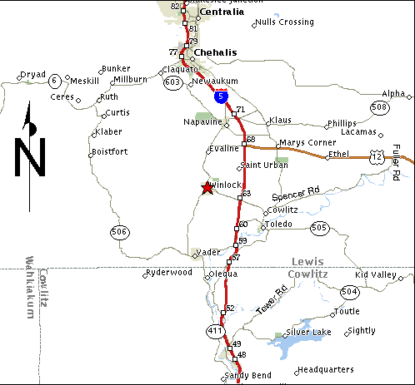

PUBLIC VERSION

City Map

Winlock

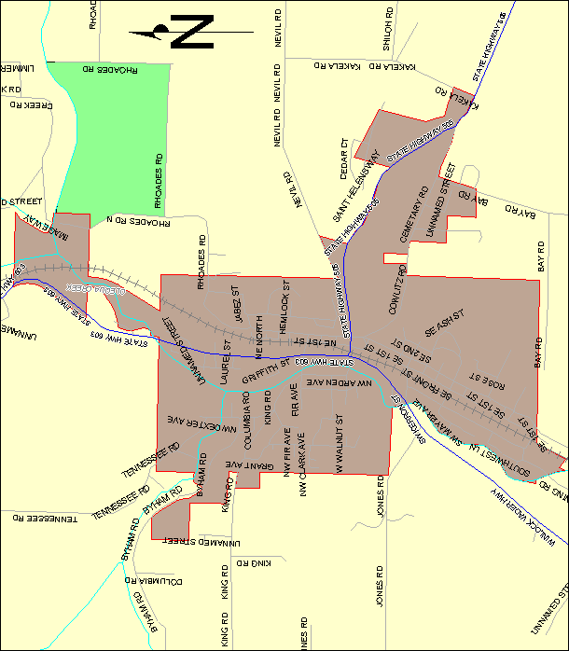

Operations Map Key

REDACTED

PUBLIC VERSION

Plat Map Key

REDACTED

PUBLIC VERSION

Roles and Responsibilities of the Service Providers

Infrasource Contractors (IFS) performs the installation of new customer construction on both residential and commercial gas services. They perform gas system upgrades and replacements, as well as, gas system operation and maintenance. In addition, (IFS) responds to breaks at the request of PSE Gas Dispatch.

