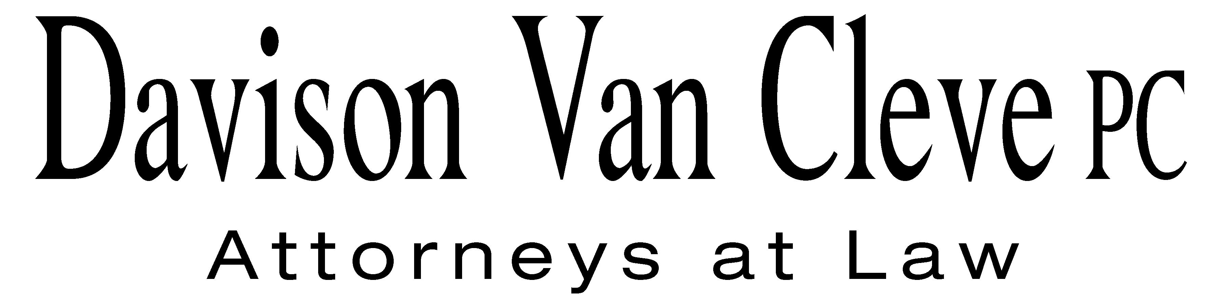
TEL (503) 241-7242 ● FAX (503) 241-8160 ● mail@dvclaw.com
Suite 400
333 S.W. Taylor
Portland, OR 97204

January 20, 2012

Executive Director and Secretary
Washington Utilities and Transportation Commission
PO Box 47250
1300 S. Evergreen Park Drive, SW
Olympia, WA 98504-7250

Re: WUTC v. PacifiCorp d/b/a Pacific Power & Light Company,

Consolidated Docket Nos. UE-111048/UG-111049

Dear Executive Director:

Enclosed please find the original and three (3) copies of the Response to the Bench’s Requests 4 and 5 for Information on behalf of the Industrial Customers of Northwest Utilities.

Thank you for your assistance.

Sincerely yours,

/s/ Sarah A. Kohler
Sarah A. Kohler

Enclosures

