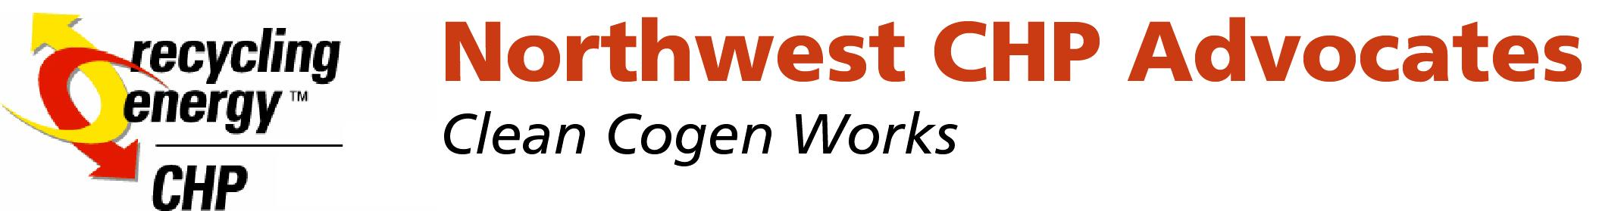

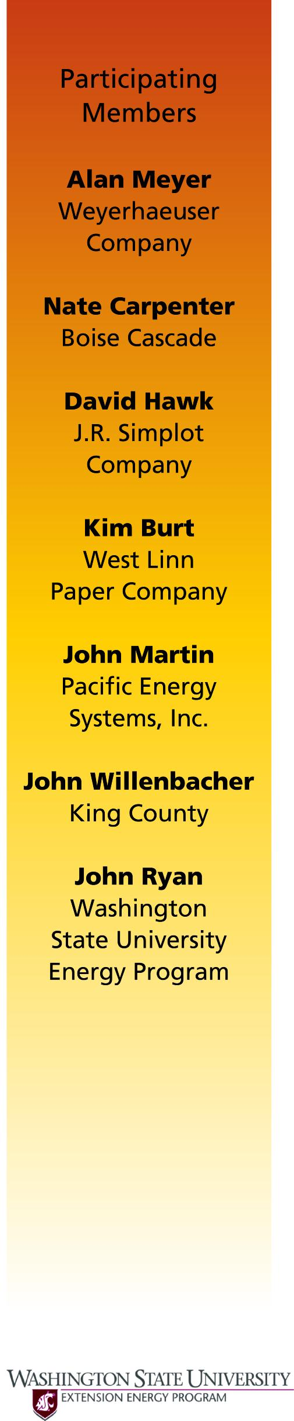February 8, 2006

Washington Utility and Transportation Commission
1300 S. Evergreen Park Dr. SW
Olympia, Washington 47250

Re: Chapter 480-107 WAC Rulemaking
Docket No. UE-030423

Dear Ms. Washburn,

We appreciate the WUTC's strong requirement language for utilities to purchase from Qualifying Facilities. We do appreciate the obligation for utilities to file full data to support their avoided costs is a step in the right direction.

However, the avoided cost language continues to give an option to purchaser not to acquire cogeneration by using their “least cost alternative” criterion. Without strong avoided cost language that will raise avoided costs which recognize the triple benefits of cogeneration (1/3 more energy efficient, ½ less emissions, and no transmission costs), the likely impact of these new rules will be minimal.

We believe that imputed debt should not be included in a utility's cost calculations. We recommend that a rigorous investigation on this credit risk issue be completed before including these costs.

We support commencing an investigation as to why Washington State is 31st among states in cogeneration capacity. No significant cogeneration has been built in many years in our state. We recommend that the WUTC gather evidence on why no cogeneration facilities have been built and to recommend ways to take remedial action.

Thank you for the opportunity to comment on these very important rules.

Sincerely ,

John J. Ryan
On Behalf of the NW CHP Advocates
and NW Regional CHP Assessment Center
O: 360 956-2123
Fax: 360 236-2123

