Toledo

Emergency Response Plan

Table of Contents

Toledo
Users Guide 2
How it will be served 3
Regular business hours 3
After hours 3
Floods 3

PSE Staff
Who work in Toledo 4
Live near Toledo 4

Maps
Directions 5
City Map 6
Gas Operations Map Key 7
Plat Map Key 8

Service Provider
Roles and Responsibilities 9

Users Guide

Dispatch
PSE Staff 4
Directions 5
City Map 6
Gas Operations Map Key 7
Plat Map Key 8
Roles and responsibility of Service Providers 9

First Responders
PSE Staff 4
Directions 5
City Map 6
Gas Operations Map Key 7
Plat Map Key 8
Roles and responsibility of Service Providers 9

CFS
PSE Staff 4
Directions 5
City Map 6
Gas Operations Map Key 7
Plat Map Key 8
Roles and responsibility of Service Providers 9

Gas Control
PSE Staff 4
Directions 5
City Map 6
Gas Operations Map Key 7
Plat Map Key 8
Roles and responsibility of Service Providers 9

Emergency Response Plan

Toledo

How Toledo will be served

Regular business hours:
During regular business hours we will utilize employees who are working in Toledo. This could include Gas First Response, SC&P, or Infrasource Contractors (IFS) personnel.

After Hours:
We have identified those gas employees that live in close proximity to Toledo. Outside of normal business hours Dispatch will first contact the GFR staff that live near Toledo. If that fails, Dispatch will move the closest GFR personnel to the problem per the Standard Call-Out process. In the case where GFR personnel are unavailable, Dispatch will contact SC&P staff trained for First Response.

Floods:
Lewis County has had numerous 100-year floods in past years; this area is prone to flooding. This area may be closed to any traffic except for emergency vehicles and local traffic. In the past I-5 has been shut down. During flooding, the best way to get there may be through Littlerock or Bucoda. The City of Centralia and Chehalis as well as Lewis Co. has historically informed PSE of any wash outs or any other problems we may need to be aware of. PSE may need to isolate areas of the gas system during flooding.

Alternative Access:
If access by conventional means is unavailable, you may be able to deliver personnel and materials to the Winlock area by helicopter. The System Manager XXXXXXX, XXXXXXXXXXXX or XXXXXXXXXXXX on duty should be called to arrange helicopter support.

PUBLIC VERSION

PSE staff who Work in Toledo

XXXXXXXXXXX Gas
XXXXXXXXXXXXXXXX
Chehalis, WA 98532
Home phone: XXXXXXXXXXXX
Cell phone: XXXXXXXXXXXX
Pager: XXXXXXXXXXXX

PSE Staff who live near Toledo
XXXXXXXXXXXXXX Gas
XXXXXXXXXX
Centralia, WA 98531
Home phone: XXXXXXXXXXXX
Cell Phone: XXXXXXXXXXXX
Pager: XXXXXXXXXXXX

XXXXXXXXXXXX (Gas)
XXXXXXXXXXXXXX
Centralia, WA 98531
Home: XXXXXXXXXXXX
Pager: XXXXXXXXXXXX
Cell: XXXXXXXXXXXX

XXXXXXXXXXX Gas
XXXXXXXXXXXXXXXX
Chehalis, WA 98532
Home phone: XXXXXXXXXXXX
Cell phone: XXXXXXXXXXXX
Pager: XXXXXXXXXXXX

XXXXXXXXXXXXX Gas
XXXXXXXXXXXXXXXXXXXX
Olympia, WA 98579
Home phone: XXXXXXXXXXXX
Cell phone: XXXXXXXXXXXX
Pager: XXXXXXXXXXXX

PUBLIC VERSION

Directions
(From Olympia)
XXXXXXXXXXXXXXXXXXXXXXXXXXXXXXXXXXXXXXXXXXXXXXXXXXXXXXXXXXXX
XXXXXXXXXXXXXXXXXXXXXXXXXXXXXXXXXXXXXX
XXXXXXXXXXXXXXXXXXXXXXXXXXXXXXXXXXXXXXXXXXXXXXXXXXXXXXXXXXXX
XXXXXXXXXXXXXXXXXXXXXXXXXXXXXXXXXXXXXXXXXXXXXXXXXXXXXXXXXXXX
XXXXXXXXXXXXXXXXXXXXXXXXXXXXXXXXXXXX

Total Estimated Driving Time from Olympia: 54 minutes
Total Distance: 48.36 miles
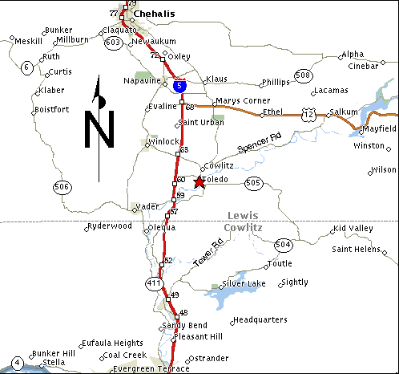
PUBLIC VERSION
City Map
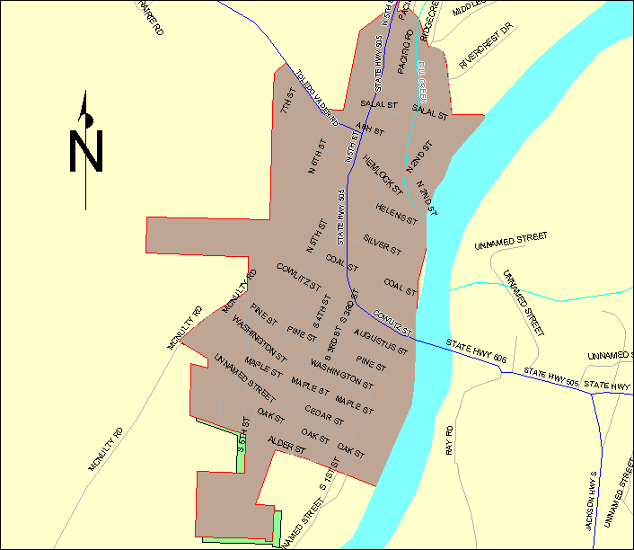
Operations Map Key

REDACTED

PUBLIC VERSION
Plat Map Key

REDACTED

PUBLIC VERSION
Roles and Responsibilities of the Service Providers

Infrasource Contractors (IFS) performs the installation of new customer construction on both residential and commercial gas services. They perform gas system upgrades and replacements, as well as, gas system operation and maintenance. In addition, Infrasource Contractors (IFS) responds to breaks at the request of PSE Gas Dispatch.

