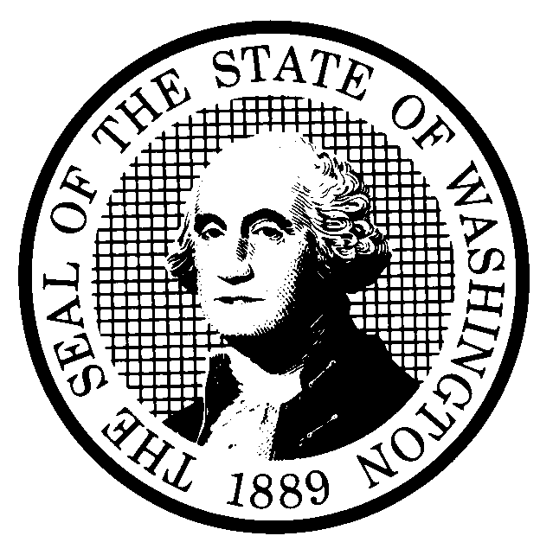 | PROPOSED RULE MAKING |  |  |  |  | CR-102 (June 2004)  (Implements RCW 34.05.320)  Do NOT use for expedited rule making
Agency: Washington Utilities and Transportation Commission
Preproposal Statement of Inquiry was filed as WSR 05-10-100 ; or  Expedited Rule Making--Proposed notice was filed as WSR ; or  Proposal is exempt under RCW 34.05.310(4). |  |  |  |  |  |  | Original Notice  Supplemental Notice to WSR  Continuance of WSR
Title of rule and other identifying information: (Describe Subject) Chapter 480-123 – Universal Service

Docket UT-053021 – Eligible Telecommunications Carrier (ETC) designation and certification.
Hearing location(s):  Commission Hearing Room  Second floor, Chandler Plaza  1300 S. Evergreen Park Drive SW  Olympia, WA 98504-7250  Date: May 18, 2006 Time: 1:30 P.M. |  |  |  | Submit written comments to:  Name: Carole J. Washburn  Address: Washington Utilities and Transportation Commission  P.O. Box 47250  Olympia, WA 98504-7250  e-mail records@wutc.wa.gov Please include “Docket UT-053021” in your comments.  fax (360)586-1150 by (date) May 3, 2006
Assistance for persons with disabilities: Contact
Mary De Young by May 16, 2006
TTY (360) 586-8203 or (360) 664-1133
Date of intended adoption: May 31, 2006
(Note: This is NOT the effective date)
Purpose of the proposal and its anticipated effects, including any changes in existing rules: The commission has jurisdiction to designate certain common carriers as eligible telecommunications carriers (ETCs) so the carriers may receive federal universal service support funds. An ETC may request that the commission certify to the Federal Communications Commission (FCC) that the ETC is using federal support only for the intended purposes. The proposed rules delete the current rule that addresses certification to the FCC (WAC 480-120-399(2)). The proposed rules establish the requirements for designation as an ETC and create requirements for reporting and certification for those ETCs that request commission certification to the FCC that the ETC has used federal universal service support only for the intended purposes. The proposed rules will enable the commission to provide oversight of the use of federal universal service support funds.

Proposed rule topics:
WAC 480-123-020 - Definitions
WAC 480-123-030 – Contents of petition for designation as an eligible telecommunications carrier (ETC)
WAC 480-123-040 – Approval of petitions for ETC designation
WAC 480-123-050 – Revocation of ETC designation
WAC 480-123-060 – Annual certification of ETCs
WAC 480-123-070 – Annual certifications and reports
WAC 480-123-080 – Annual plan for universal service support expenditures
WAC 480-123-999 – Adoption by reference

Reasons supporting proposal: The FCC has requested state commissions adopt rules for ETC designation and certification that will result in oversight of the use of federal universal service support by ETCs. The proposed rules respond to that request.

Reasons supporting proposal:
Statutory authority for adoption: RCW 80.01.040; 80.04.160; 80.36.600; 80.36.610. |  |  |  | Statute being implemented: N/A
Is rule necessary because of a:  Federal Law?  Federal Court Decision?  State Court Decision?  If yes, CITATION: |  | Yes  Yes  Yes | x No  x No  x No |  | CODE REVISER USE ONLY  Filed with the Code Reviser’s Office  March 31, 2006, 11:39 a.m.  WSR 06-08-056
DATE
March 31, 2006
NAME (type or print)
Carole J. Washburn
SIGNATURE

TITLE Executive Secretary

(COMPLETE REVERSE SIDE)
Agency comments or recommendations, if any, as to statutory language, implementation, enforcement, and fiscal matters:

Name of proponent: (person or organization) Washington Utilities and Transportation Commission |  |  | Private  Public  Governmental
Name of agency personnel responsible for:
 | Name | Office Location | Phone
Drafting................. Bob Shirley |  | 1300 Evergreen Park Drive SW, Olympia, WA 98504-7250 | (360) 664-1292
Implementation….. Carole J. Washburn |  | 1300 Evergreen Park Drive SW, Olympia, WA 98504-7250 | (360) 664-1174
Enforcement.......... Carole J. Washburn |  | 1300 Evergreen Park Drive SW, Olympia, WA 98504-7250 | (360) 664-1174
Has a small business economic impact statement been prepared under chapter 19.85 RCW?
Yes. Attach copy of small business economic impact statement.

A copy of the statement may be obtained by contacting:

Name: Washington Utilities and Transportation Commission
Address: Records Center, Docket No. UT-053021
1300 S. Evergreen Park Drive S.W.
Olympia, WA 98504-7250
phone (360) 664-1234
fax (360)586-1150
e-mail records@wutc.wa.gov
No. Explain why no statement was prepared.

Is a cost-benefit analysis required under RCW 34.05.328?

Yes A preliminary cost-benefit analysis may be obtained by contacting:
Name:
Address:

phone ( )
fax ( )
e-mail

No: Please explain: The proposed rules are not significant legislative rules of the sort referenced in RCW 34.05.328(5).

