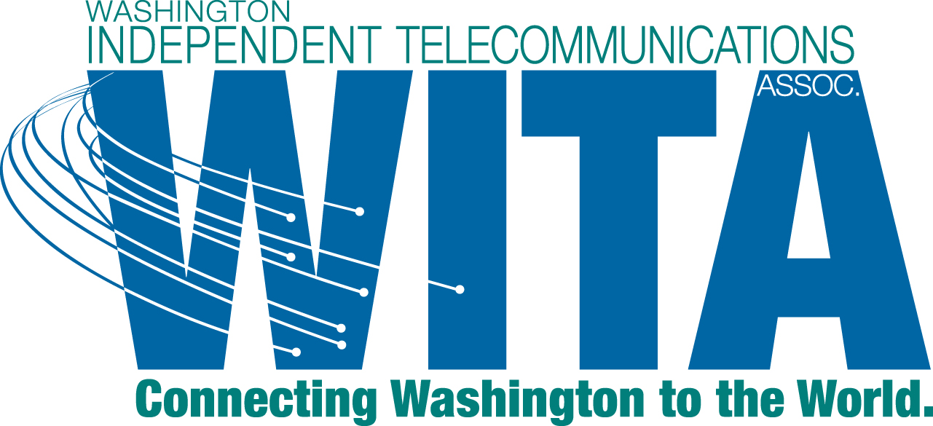

January 22, 2013

David Danner, Executive Director and Secretary
Washington Utilities and Transportation Commission
1300 S. Evergreen Park Drive SW
Olympia, WA 98504-7250

Re: UT-120451 - Comments of the Washington Independent Telecommunications Association

Dear Mr. Danner:

On December 20, 2012, the Washington Utilities and Transportation Commission (Commission) issued a Notice of Opportunity to Submit Written Comments on Supplemental Proposal (Notice) in the above referenced docket. The Notice set the date of submitting comments as January 22, 2013. The Washington Independent Telecommunications Association (WITA) is pleased to be able to submit these comments to the Notice.

WITA's c comments will be short and to the point. WITA supports the proposed revisions contained in the Notice and the Supplemental CR-102. The proposed rule provides flexibility to each local exchange company in meeting the responsibility to provide a directory to its customers. This flexibility is appreciated by WITA's members.

Thank you for the opportunity to submit these comments.

Sincerely,

CenturyLink will be providing its own comments and is not included in these comments.

