ASSOCIATION OF OIL PIPE LINES
Suite 604
1101 Vermont Avenue, N.W.
Washington, D.C. 20005-3521

MICHELE F. JOY TELEPHONE (202) 408-7970
GENERAL COUNSEL FAX (202) 408-7983

EMAIL mjoy@aopl.org

April 9, 2003

Carole J. Washburn, Secretary
Washington Utilities and Transportation Commission
1300 South Evergreen Park Drive S.W.
Olympia, WA 98504-7250

Re: Docket No. TO-030288, Consider a Rulemaking Procedure to Establish a New Chapter Applicable to the Economic Regulation of Hazardous Liquid Pipeline Companies Regulated as Common Carriers by the Commission

Dear Ms. Washburn:

The Association of Oil Pipelines (“AOPL”) is a national trade organization whose members are crude oil and refined petroleum products pipeline companies. AOPL’s members provide both interstate and intrastate transportation throughout the United States, including in Washington State. AOPL is submitting these preliminary comments on behalf of its member pipeline companies in response to the Notice of Opportunity to File Written Comments (“Notice”) in Docket No. TO-030288. AOPL’s comments are preliminary of necessity, since the Commission has not yet published draft proposed rules to pertain to oil pipelines.

The Commission’s Notice states that rules may be considered for “pipeline companies regulated as common carriers by the Commission.” AOPL presumes that such regulations would be limited to, at most, pipeline companies that provide intrastate transportation subject to the Commission’s rate regulation under applicable state laws and not to pipelines operating in Washington State that are engaged entirely in interstate commerce. Such a limitation would be in keeping with established precedent regarding the jurisdiction of state regulatory authorities on the one hand and federal regulatory authorities on the other.

AOPL is aware that the Commission has another rulemaking underway, in Docket No. A-021178, in which the Commission has formulated draft proposed rules for other entities subject to its jurisdiction, such as natural gas companies and electric companies. The Commission may have different, and perhaps broader, statutory authority to regulate these entities than it has for oil pipelines. Thus, it may not be appropriate to adopt substantially the same regulatory requirements for oil pipelines as the Commission may implement for other regulated industries. AOPL urges the Commission to carefully consider the differences in the entities subject to its jurisdiction and the scope of the statutory authority provided to it with respect to each type of entity when formulating any proposed draft regulations to apply to oil pipelines.

AOPL welcomes the opportunity to submit these brief preliminary comments to the Commission at this time. It will carefully review any draft proposed regulations the Commission issues and provide additional comments if appropriate.

Very truly yours,

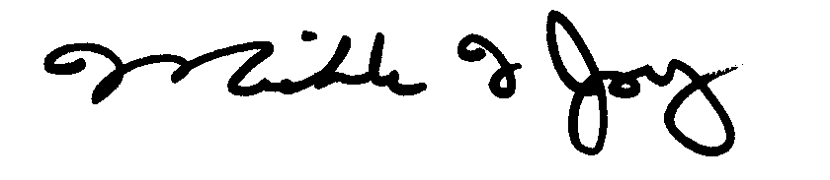
Michele F. Joy
General Counsel

