James F. Williams
phone: 206.359.3543
fax: 206.359.4543
email: jwilliams@perkinscoie.com
May 8, 2017

VIA WEB PORTAL

Steven V. King, Executive Director and Secretary
Washington Utilities and Transportation Commission

1300 S. Evergreen Park Dr. SW

P.O. Box 47250

Olympia, Washington 98504-7250
Re: Washington Utilities and Transportation Commission v. Puget Sound Energy
Docket No. PG-160924
Dear Mr. King:
Enclosed for filing is Puget Sound Energy’s (“PSE”) Response Testimony of Cathy A Koch and Duane A. Henderson. Enclosed is:
- 160924-CAK-1T-PSE-5-8-17.pdf
- 160924-CAK-1T-PSE-5-8-17.doc
- 160924-CAK-2-PSE-5-8-17.pdf
- 160924-CAK-2-PSE-5-8-17.doc
- 160924-CAK-3-PSE-5-8-17.pdf
- 160924-CAK-3-PSE-5-8-17.doc
- 160924-DAH-1T-PSE-5-8-17.pdf
- 160924-DAH-1T-PSE-5-8-17.doc
- 160924-DAH-2-PSE-5-8-17.pdf
- 160924-DAH-2-PSE-5-8-17.doc
- Certificate of Service.
Please do not hesitate to contact me if you have any questions.
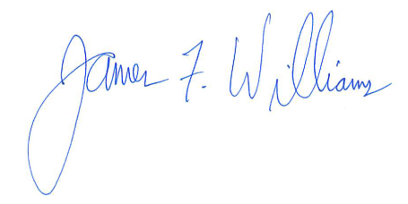
Very truly yours,
James F. Williams
Enclosures
cc: All parties

