BEFORE THE WASHINGTON

UTILITIES AND TRANSPORTATION COMMISSION

CITY OF KENNEWICK,  Petitioner,  v.  PORT OF BENTON, TRI-CITY & OLYMPIA RAILROAD COMPANY, BNSF RAILWAY COMPANY, AND UNION PACIFIC RAILROAD,  Respondents.  . . . . . . . . . . . . . . . . . . . . . . . . . . . . . . . . | )  )  )  )  )  )  )  )  )  )  )  )  ) | DOCKET TR-130499  ORDER 03  FINAL ORDER GRANTING PETITION FOR ADMINISTRATIVE REVIEW

BACKGROUND

- On April 8, 2013, the City of Kennewick filed with the Washington Utilities and Transportation Commission (Commission) a petition to construct a highway-rail grade crossing at Center Parkway, Kennewick, Washington and remove an existing railroad siding. On May 31, 2013, the City of Richland petitioned to intervene in support of the petition.

- Three railroad companies move trains on the subject track, which is owned by the Port of Benton. Burlington Northern Santa Fe Railway Company (BNSF) and Union Pacific Railroad Company (UPRR) filed waivers of hearing stating their agreement to the proposed crossing. The third railroad company that operates on these tracks, Tri-City & Olympia Railroad (TCRY), answered Kennewick’s petition and requested a hearing. TCRY opposes the petition.

- Commission Staff filed a memo on May 5, 2013, recommending that the Commission set this matter for hearing. The Commission conducted a prehearing conference on June 4, 2013, and on June 7, 2013, entered Order 01-Prehearing Conference Order; Notice of Hearing. Order 01 set a procedural schedule allowing three rounds of pre-filed testimony. The cities of Kennewick and Richland (collectively “Cities”) filed direct testimony and exhibits on September 3, 2013. Staff filed responsive testimony supporting the petition on October 1, 2013. TCRY filed opposing testimony on October 2, 2013. Finally, the Cities and TCRY filed rebuttal testimony and exhibits on October 23, 2013.

- The Commission conducted evidentiary hearings on November 19-20, 2013, and a public comment hearing on November 20, 2013, in Richland, Washington before Administrative Law Judge Adam Torem. Judge Torem performed a site visit and toured the area on November 21, 2013. The parties simultaneously filed written post-hearing briefs on December 20, 2013.

- The Commission entered its Initial Order on February 25, 2014, denying Kennewick’s petition. Kennewick and Richland filed a joint Petition for Administrative Review on March 18, 2014. The Cities ask for oral argument, which we find unnecessary to resolve their Petition for Administrative Review. Denying the Cities’ request for oral argument causes them no prejudice.

- TCRY filed an answer on March 27, 2014, opposing the joint petition. Staff also filed an answer on March 27, 2014, reiterating its support for the Cities’ petition for authority to construct the subject rail crossing, but addressing the Cities’ alternative arguments about the impact of the Growth Management Act (GMA) and the application of chapter 81.53 RCW to code Cities. Staff disagrees with the city on the application of both the GMA and RCW 35A.11.020 to its petition.

- On April 1, 2014, Kennewick and Richland filed a “Reply in Support of Commission Review.” TCRY filed a motion to strike the reply on April 3, 2014, arguing it failed to satisfy the requirements for such a pleading under WAC 480-07-825(a) and is procedurally deficient because the Cities did not seek leave to file a reply as required under WAC 480-07-825(5)(b). On April 4, 2014, the Cities filed a response to TCRY’s motion to strike. The Commission grants TCRY’s motion and will not consider the Cities’ reply.

- APPEARANCES. P. Stephen DiJulio and Jeremy Eckert, Foster Pepper PLLC, Seattle, represent the Cities. Paul J. Petit, Richland, represents respondent TCRY. Steven W. Smith, Assistant Attorney General, Olympia, represents the Commission’s regulatory staff (Commission Staff or Staff).

DISCUSSION

I. Description of Proposed At-Grade Railroad Crossing

- The proposed crossing would be built at the intersection of an extension of Center Parkway in the City of Kennewick, and two tracks owned by the Port of Benton. The location and configuration of the proposed site are illustrated in Figure 1.

FIGURE 1
PROJECT LOCATION MAP
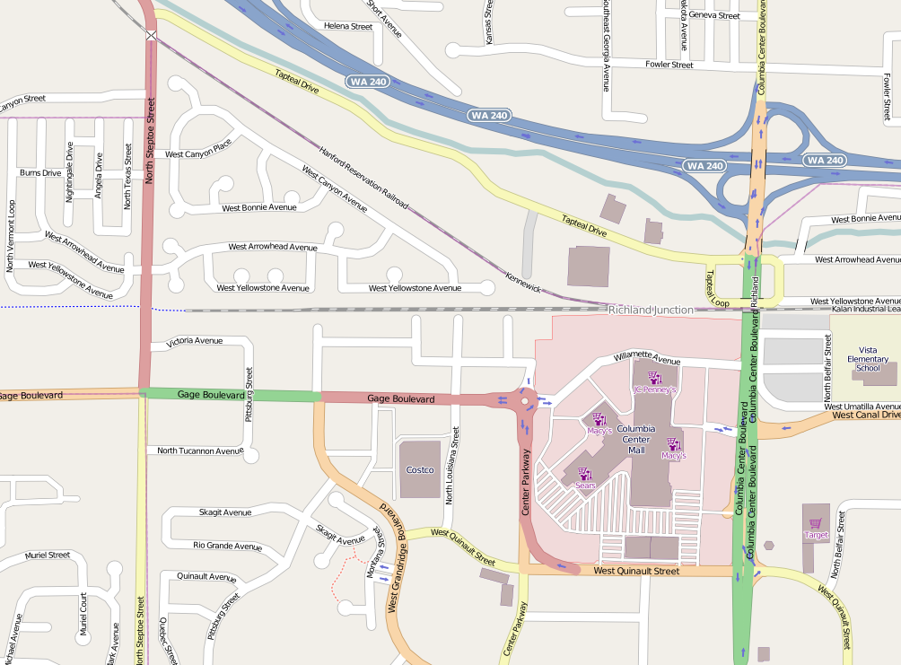

The Center Parkway extension would be from an existing roundabout in Kennewick, where the parkway intersects Gage Boulevard, continuing north to Tapteal Drive, a one-mile stretch of road connecting North Steptoe Street to the west, with Columbia Center Boulevard to the east, in Richland. There is a “T” intersection at both ends of this short roadway. There is an at-grade crossing on North Steptoe Street and a grade-separated crossing at Columbia Center Boulevard.

- Tri-City and Olympia Railroad, BNSF Railway, and Union Pacific Railroad all operate trains over the so-called Hanford Reservation tracks at this location. Tri-City and Olympia Railroad uses a short, parallel spur at Richland Junction for switching and storage of rail cars, and opposes the Cities’ petition, arguing the crossing would interfere with its operations. Both tracks are owned by the Benton County Port Authority. BNSF and UPRR have moved their switching operations since the Commission denied an earlier petition to open a crossing in this location and do not oppose the Cities’ current petition.

II. Review of Initial Order

- The Initial Order analyzes Kennewick’s petition using the framework in a 2011 Commission initial order approving another petition for an at-grade crossing in Benton County:

The Commission, in practice, addresses two principal questions when considering whether to authorize construction of an at-grade crossing, which, by its nature, poses risks for motorists and pedestrians not present at grade-separated crossings:
- Whether a grade-separated crossing is practicable considering cost and engineering requirements and constraints.
- Whether there is a demonstrated public need for the crossing that outweighs the hazards inherent in an at-grade configuration.
We agree that we should evaluate the petition to determine whether a grade-separated crossing is practicable and whether a demonstrated public need for the crossing outweighs the hazards of an at-grade crossing. We agree with most of the Initial Order’s findings and conclusions on these questions, but we conclude that a broader public need than the public safety concerns the parties advocate supports the petition.

- Grade Separation and Inherent Risk
- No one contests on review the Initial Order’s finding that it is physically and financially impractical to build a grade-separated crossing in this instance:

The amount and character of travel on the railroad and on Center Parkway do not justify grade separation. Further, there is no evidence in the record disputing the engineering infeasibility of constructing a grade-separated crossing at Center Parkway. Finally, there is no serious dispute in the record that a grade-separated crossing would be tremendously more expensive than the proposed at-grade crossing. Therefore, considering engineering requirements and cost constraints, the Commission determines that a grade-separated crossing is not practicable at Center Parkway.
- The Cities, however, propose to build an at-grade crossing designed to mitigate the inherent dangers to vehicles and pedestrians by using active warning devices and taking other measures. Specifically, the Cities propose to install advanced signage, flashing lights, an audible bell, automatic gates, and a raised median strip designed to prevent drivers from going around lowered gates, as illustrated below in Figure 2.

FIGURE 2
AT-GRADE CROSSING CONFIGURATION
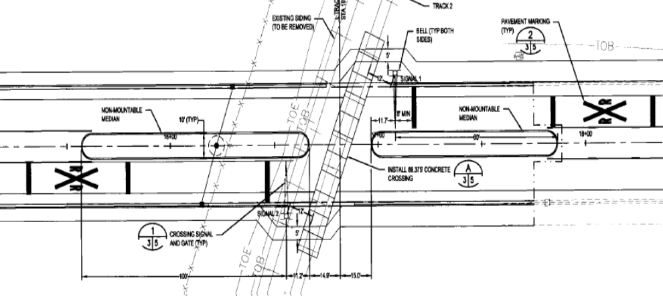

- Taken together, these measures significantly reduce the risks to motorists who might, in the absence of these measures, make inopportune efforts to cross the tracks when trains are present. Even imprudent drivers will be effectively barred from crossing the tracks when the gates are closed next to concrete barrier medians. These same measures reduce the risk to pedestrian and bicyclist traffic by alerting prudent travelers when it is unsafe for them to cross the tracks and making it more difficult for them to pass.

- Public Safety Need
- The Initial Order determines that the Cities failed to carry their burden to show a “public need” for the crossing that outweighs the hazards inherent in the at-grade configuration that are present despite the relatively low-level risk of an accident. To establish public need petitioners must provide evidence of public benefits, such as improvements to public safety or improved economic development opportunities.

- Petitioners challenge this conclusion, focusing almost exclusively on asserted public safety benefits, largely in the form of improved response times from two local fire stations to the point where the planned Center Parkway extension would intersect Tapteal Drive. In other words, the Cities’ principal claim of improved public safety is that emergency responders could get to a single point on a one-mile long, two-lane collector roadway with a “T” intersection at both ends more quickly than they can today. In addition, there is some evidence that completion of this project would reduce traffic on other roadways in the vicinity, relieving congestion and potentially reducing accidents. The Initial Order analyzes the evidence on this issue in detail that does not bear repeating here. It is sufficient for us to observe that we agree with the analysis, the findings, and the conclusion reached in the Initial Order that the benefits to public safety alleged by the Cities are too slight on their own to support the petition, even though the inherent risks are mitigated to a large extent by the project design.

- If the feasibility of grade separation and public safety as a component of public need were our only concerns, we would end our discussion here and sustain the Initial Order. However, having studied the full record, we find reason to analyze this matter outside the narrow constraints of these two questions. We address in the next section of this Order an additional point of decision that we find determinative.

- Broader Public Need

- The Cities argue that state agencies are mandated to comply with local land use plans adopted under the Growth Management Act (GMA). They contend that their regional comprehensive planning process “mandates” the Center Parkway crossing in order for them to achieve their stated levels of service for emergency response times and traffic flow at signalized intersections. According to the Cities, the GMA prohibits the Commission from evaluating public need, alternatives for opening a proposed railroad crossing, or even whether the proposed crossing will function in the matter claimed by the Cities. As the Initial Order observes:

Taken to its logical end point, the Cities’ argument would require the Commission to approve any at-grade crossing planned for in a local jurisdiction’s comprehensive planning process.

The Initial Order rejects the Cities’ legal argument that the GMA somehow controls our determination of their petition under RCW 81.53for authority to construct the subject railroad crossing.

- We agree with the Initial Order’s determination that the GMA does not relieve the Commission from its statutory obligation to regulate public safety at rail crossings, including the one proposed here. The two statutes do not conflict with each other and the integrity of both statutes within the overall statutory scheme is preserved by reading the GMA together and in harmony with RCW 81.53. The Initial Order ends its discussion of this issue without considering how this harmony should be achieved in the context of the facts presented in this case. We find it necessary to undertake this analysis on review.

- The proposed extension of Center Parkway has been part of Richland’s and Kennewick’s transportation planning for some time. As summarized in the introduction to the Center Parkway Extension and Railroad Crossing Traffic Study completed for the city in March 2013 by JUB Engineers, Inc.:

For several years the City of Richland has pursued the extension of Center Parkway to connect Gage Boulevard on the south to Tapteal Drive on the north. This effort has been challenging because of existing railroad lines that operate parallel to and in between Gage Boulevard and Tapteal Drive. There are multiple purposes for connecting Center Parkway which include:

• Complete a grid network of functionally classified roadways.
• Provide relief to congested arterial facilities.
• Provide improved access to commercial areas and developable land.
• Improve emergency response times.

- Following a detailed narrative, supported by appendices, the JUB Engineers, Inc. report summarizes the study’s key findings, elaborating on the points above:

This Traffic Study has been performed to describe the efforts put forth by the City of Richland and the City of Kennewick to complete a roadway network that includes the extension of Center Parkway in order to accommodate growth in the region. Four primary objectives have been discussed that document the needs and benefits of extending Center Parkway between Gage Boulevard and Tapteal Drive that include:

• Complete a grid network of functionally classified roadways -The completion of Center Parkway north of Gage Boulevard is merely one step of many to complete both a functionally classified network and a north-south component of a grid system to provide safe efficient movement of traffic into this area of the region.
• Provide relief to congested arterial facilities -Center Parkway has been planned to provide relief to both Columbia Center Boulevard as well as Steptoe Street, consistent with the philosophy of providing collector roadways parallel and in between arterial roadways.
• Provide improved access to commercial areas and developable land - nearly 60 developable acres of commercial land between the railroad and SR 240 which has desirable visibility will have improved access and will gain the synergy that commercial areas often seek.
• Improve emergency response times - a significant area will have improved emergency response times, some with nearly a 30% reduction.

Economic Development

- We determine that the Commission should consider public need for the proposed at-grade railroad crossing in the broader context of the several purposes discussed in the JUB transportation study, rather than with the narrower focus that the parties, and consequently the Initial Order, place on public safety. It is particularly important to give weight to the economic development interests considering that the Center Parkway extension would conveniently connect existing, complementary commercial developments in Richland and Kennewick, and would promote development of 60 acres of currently vacant commercial real estate along Tapteal Drive in Richland, as shown below in Figure 3.

FIGURE 3
DEVELOPMENT AND DEVELOPMENT POTENTIAL
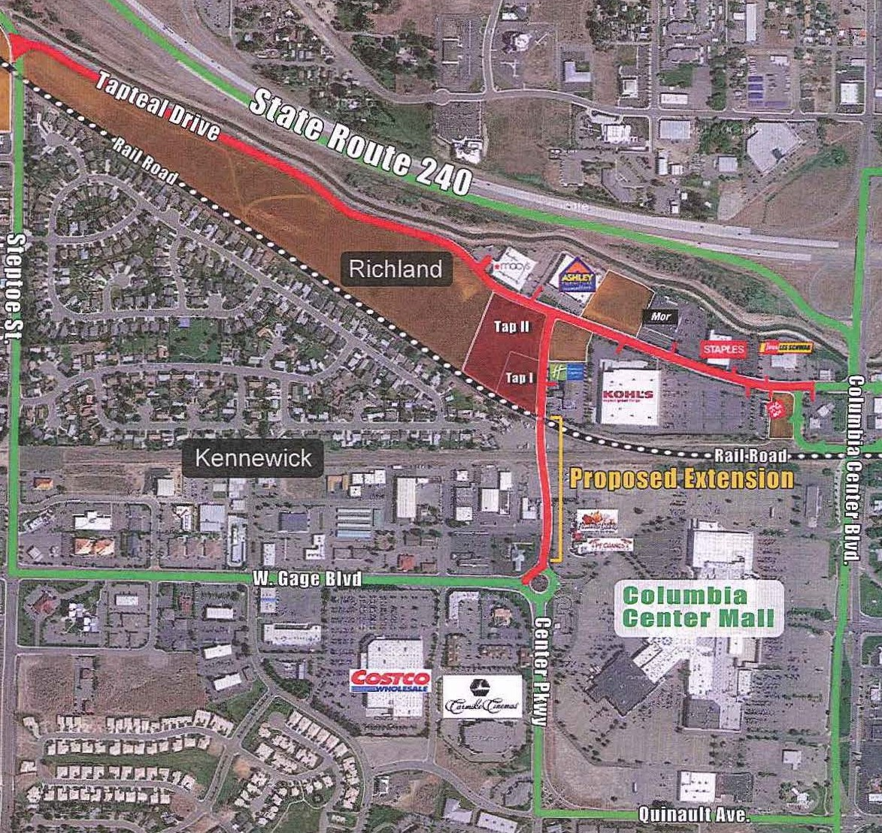

- The potential for additional development in this area is underscored by a public comment filed in this proceeding by a landowner, Preston K. Ramsey III, writing on behalf of FBA Land Holdings. FBA Land Holdings owns two undeveloped parcels bordered on the north by Tapteal Drive and on the west by the proposed Center Parkway Extension. These are labeled “Tap I” and “Tap II” in Figure 3. Mr. Ramsey comments that:

The proposed street extension of Center Parkway across railroad tracks currently leased by TCRY literally would create a new bridge between two highly interdependent communities in terms of transportation, economics, land use as well as the traffic patterns and habits of the approximate 25,000 people who live, work and otherwise travel through this area daily.

- Similarly, another public comment filed by Brian Malley, Executive Director of the Benton-Franklin Council of Governments, the Metropolitan Planning Organization for the Tri-City metropolitan area, emphasizes community expectations with respect to the proposed Center Parkway extension:

In addition to easing congestion, this proposed link provides connectivity to two adjacent retail areas that are separated only by the tracks that divide them. The Tri-City area has, and continues to, grow at impressive rates. Planning and encouraging alternate modes, such as bike/ [pedestrian]/ transit will be a crucial step toward alleviating future congestion. At this time, there simply is no option between these two retail areas that does not require the use of a car to negotiate the roadways to travel between. Additionally, a connection in this location may well contribute to the tax base, as Tapteal area businesses have suffered through marginal access for years, with no reasonable link to the adjacent retail areas to the south.

Deference to Local Government

- In addition to economic benefits, the Commission as a matter of policy should give some deference to the Cities’ transportation and land use planning goals, as these are matters of local concern and within the jurisdictional authority of the Cities. Indeed, it is worth considering that if the City of Richland was the petitioner for this project, instead of Kennewick, it would be exempt from the Commission’s jurisdiction. RCW 81.53.240 exempts first-class cities from the at-grade crossing petition process. The City of Richland is a first-class city. This exemption has been present in the law in one form or another since 1909. It is reasonable to infer its passage into law was largely a reflection of the state Constitution giving deference to local jurisdictions on matters that are deemed best left to local control. Planning and designing intra-urban transportation networks that will best serve the public’s needs in the jurisdictional boundaries of the state’s larger Cities fall squarely into this category. Although Kennewick is not legally exempt from our jurisdiction, it is consistent with legislative policies implementing Constitutional home rule that the Commission give significant weight to the evidence concerning the Cities’ perspective that the Center Parkway extension is important to transportation planning and economic development in both jurisdictions.

- There is additional public comment in the record of this proceeding from various community leaders that focuses on these points and illustrates the local importance of recognizing the broader public policy environment. Carl F. Adrian, president of the Tri-City Development Council, for example, comments that:

This at-grade railroad crossing on Center Parkway is a well-planned necessary component of our region's transportation system. The project will dramatically improve traffic movement between two important and growing commercial areas in Richland and Kennewick.

. . . Completion of Center Parkway between Tapteal Drive and Gage Boulevard is a long-standing element of a carefully developed transportation system plan. That planning has included careful consideration of the safety implications in the planned road and at-grade railroad crossing.

- Comments from the Tri-City Regional Chamber of Commerce and the Port of Kennewick also support the proposed project on the bases that it is an important feature in a long-planned transportation network that will contribute to commercial development while reducing traffic congestion and promoting public safety in the project vicinity.

III. Conclusion

- The Initial Order fairly weighs the evidence and argument presented in the post-hearing briefs, and reaches a legally sustainable result. The Cities’ almost exclusive focus on improved response times for first responders on a point-to-point basis as the principal benefit demonstrating “public need” does not weigh persuasively against even the demonstrated low level of “inherent risk” at the proposed crossing. Nor are the Cities’ legal arguments that their comprehensive planning processes under the Growth Management Act mandate Commission approval persuasive. However, considering evidence the parties largely ignored that shows additional public benefits in the form of enhanced economic development opportunities, and considering the broader public policy context that gives a degree of deference to local jurisdictions in the areas of transportation and land use planning, we determine that the Cities’ petition for administrative review should be granted and their underlying petition for authority to construct the proposed at-grade crossing should be approved.

FINDINGS AND CONCLUSIONS

- We endorse certain of the findings and conclusions in the Initial Order, and restate them below. In addition, we modify certain of the Initial Order’s findings and conclusions to make them consistent with the discussion in this Order. Finally, we add new findings and conclusions based on our de novo review of the record.

- (1) The Washington Utilities and Transportation Commission is an agency of the State of Washington, vested by statute with authority to regulate railroad crossings, and has jurisdiction over the parties and subject matter of this proceeding.

- (2) The City of Kennewick is a governmental entity authorized by law to petition the Commission pursuant to RCW 81.53.020 for authority to construct an at-grade railroad crossing where it is not practicable to construct a grade-separated crossing and there is a public need for such a crossing that outweighs its inherent risks.

- (3) Res judicata does not bar the Commission from ruling on the Cities’ petition because it is sufficiently different from the City of Kennewick’s prior petition.

- (4) Comprehensive planning under the Growth Management Act does not relieve the Cities from complying with RCW 81.53. The Commission, however, considers the Cities’ planning as part of the policy context in which it evaluates a proposed at-grade rail crossing in the commercial center of the urban area.

- (5) A grade-separated crossing at the proposed project site is not practicable because of engineering requirements and cost constraints.

- (6) The risks of an accident at the proposed crossing are relatively low considering current and projected train traffic, predicted levels of vehicle traffic, and engineering plans that include active warning devices and other safety measures.

- (7) The Center Parkway extension may assist the Cities’ emergency responders by providing an alternative route for responding to incidents in the vicinity of Columbia Center Mall, when trains are not blocking the intersection.

- (8) The Center Parkway extension, including the proposed at-grade railroad crossing, is a long-planned and important component of the Cities’ transportation system. The project will improve traffic movement between two important and growing commercial areas in Richland and Kennewick, thus promoting economic development.

- (9) The record includes substantial competent evidence showing sufficient public need to outweigh the inherent risks presented by the proposed at-grade crossing.

- (10)The Commission should grant the City of Richland’s and City of Kennewick’s petition for authority to construct an at-grade crossing at the proposed extension of Center Parkway.

ORDER

THE COMMISSION ORDERS:

- (1) The Petition for Administrative Review filed by the City of Kennewick and joined in by the City of Richland is granted.

- (2) The Initial Order entered in this proceeding on February 25, 2014, is reversed to the extent it would deny the City of Kennewick’s petition to construct a highway-rail grade crossing at Center Parkway, Kennewick, Washington. The Commission authorizes construction of the proposed crossing.

- (3) The Commission retains jurisdiction to enforce the terms of this order.

Dated at Olympia, Washington, and effective May 29, 2014.

WASHINGTON UTILITIES AND TRANSPORTATION COMMISSION

DAVID W. DANNER, Chairman

PHILIP B. JONES, Commissioner

JEFFREY D. GOLTZ, Commissioner

NOTICE TO PARTIES: This is a Commission Final Order. In addition to judicial review, administrative relief may be available through a petition for reconsideration, filed within 10 days of the service of this order pursuant to RCW 34.05.470 and WAC 480-07-850, or a petition for rehearing pursuant to RCW 80.04.200 and WAC 480-07-870.

Contrary to what the Cities argue in their response to TCRY’s motion, the Commission’s procedural rules are not mere technicalities. Those who elect to practice before the Commission are expected to be familiar with and adhere to its procedural rules. Not only did the Cities fail to seek leave to file a reply, the reply itself does not meet the substantive requirements for such a pleading. It does not cite new matters raised by TCRY’s answer and state why those matters were not reasonably anticipated or explain satisfactorily why a reply is necessary, all as required by the Commission’s rule governing replies.
In formal proceedings, such as this, the Commission’s regulatory staff participates like any other party, while the Commissioners make the decision. To assure fairness, the Commissioners, the presiding administrative law judge, and the Commissioners’ policy and accounting advisors do not discuss the merits of this proceeding with the regulatory staff, or any other party, without giving notice and opportunity for all parties to participate. See RCW 34.05.455.
When the Cities petitioned to open a crossing at this same location in 2007, Tri-City and Olympia Railroad, BNSF and UPRR opposed the two petitions, which were consolidated for hearing. Staff also opposed the earlier petitions. At that time, there were four tracks and all three railroad companies conducted switching operations in the vicinity of the Richland Junction. The Commission denied the petitions in a single order. See City of Kennewick v. Union Pacific Railroad, Docket TR-040664,Order 06 and Docket TR-050967, Order 02, Initial Order Denying Petition[s] (January 26, 2007). The Initial Order in these dockets became final by operation of law on February 15, 2007.
Benton County v. BNSF Railway Company, Docket TR-100572, Order 06 - Initial Order Granting Benton County’s Petition for an At-Grade Railroad Crossing, Subject to Conditions, ¶ 29 (Feb. 15, 2011) (citing: In re Town of Tonasket v. Burlington Northern Railroad Company, Docket TR-921371 (December 1993) and Burlington Northern Railroad Company v. City of Ferndale, Docket TR-940330 (March 1995). This Initial Order became final by operation of law on March 8, 2011.
Initial Order ¶ 50.
This illustration shows the removal of the 1900 foot siding track. However, in the face of Tri-City and Olympia Railroad’s opposition, Staff’s analysis of the site and consideration of its proposed safety features assumes that the second track remains in operation. Ms. Hunter testifies: The active warning devices consisting of advanced pavement markings and warning signs, gates and lights, and a traffic island that will act as a median separator, provide an adequate level of safety at the proposed crossing. In addition, the train and vehicle speeds and the volume of train and vehicle traffic at the site of the proposed crossing are fairly low, making the possibility of an accident less likely than crossings with higher speeds or increased traffic. Exh. No. KH-1T at 23:15-20.
Mr. Jeffers, a professional engineer, calculated the predicted accident rate to be 0.145 per year or 1 accident per 6.9 years. Exh. No. KMJ-1T at 7:11-20. The USDOT Accident Prediction Formula standard for requiring a grade-separated crossing is 0.5 accident per year. Exh. No. KH-1T at 11:18-20.
The planned road extension includes sidewalks and bike paths on both sides so it is clear some such traffic is expected. However, there is some evidence that pedestrian and bicycle traffic is expected to be light, and no evidence to the contrary. See Exh. No. KH-1T at 24:1-7.
See Benton County v. BNSF Railway Company, Docket TR-100572, Order 06, Initial Order Granting Benton County’s Petition for an At-Grade Railroad Crossing, Subject to Conditions ¶¶ 33-37 (Feb. 15, 2011).
Petitioners’ Post-Hearing Brief at 7-12. The Cities cite specifically to RCW 36.70A.103’s mandate that “[s]tate agencies shall comply with the local comprehensive plans and development regulations and amendments thereto adopted pursuant to this chapter.” Id. at 8, n. 29.
Petitioners’ Post-Hearing Brief, at 9-11.
Initial Order ¶ 42.
Philippides v. Bernard, 141 Wn.2d 376, 385, 88 P.2d 939 (2004), citing State v. Wright, 84 Wn.2d 645, 650, 529 P.2d 453 (1974) (“In ascertaining legislative purpose, statutes which stand in pari materia are to be read together as constituting a unified whole, to the end that a harmonious, total statutory scheme evolves which maintains the integrity of the respective statutes.”).
In considering petitions for administrative review, the Commission conducts de novo review of the issues decided in an initial order. See RCW 34.05.464(4) ( “The reviewing officer shall exercise all the decision-making power that the reviewing officer would have had to decide and enter the final order had the reviewing officer presided over the hearing”).
The Center Parkway extension project has been included in the Cities’ comprehensive planning process since 2006. The proposed at-grade Center Parkway Crossing has been identified as an essential public facility in (1) the City of Richland Comprehensive Plan, (2) the City of Kennewick Comprehensive P1an, and (3) the Regional Transportation P1an. The proposed project has received funding from the State through the Washington State Community Economic Revitalization Board, the Surface Transportation Program Regional Competitive Fund, and the Transportation Improvement Board. Petition for Admin. Rev. at 19:2-9.
Exh. KJ-5 at page 1 of JUB Traffic Study.
Id. at page 14 of JUB Traffic Study.
Public Comment Exhibit (Written comment submitted December 9, 2013).
Public Comment Exhibit (Written comment submitted November 20, 2013).
The Cities note in their petition for administrative review that: The Petitioners do not waive any jurisdictional argument regarding the Cities' exemption from this petition process. RCW 81.53.240 exempts first-class cities from the at-grade crossing petition process. The City of Richland is a first-class city, and the City of Kennewick is a code city. State law provides that code cities have the same authority as first-class cities. RCW 35A.11.020: "The legislative body of each code city shall have all powers possible for a city or town to have under the Constitution of the state, and not specifically denied to code cities by law." Nevertheless, the Petitioners believe UTC review and approval worthwhile. Petition for Administrative Review at 8, footnote 30. Staff argues that because RCW 81.53.240 is a limitation on Commission jurisdiction, not a grant of authority to first-class cities, RCW 35A.11.020 does not apply. We see no need to resolve this legal argument in this case. We consider the underlying purpose of the exemption as part of the policy context in which the Commission should evaluate the evidence.
The Washington Constitution, adopted in 1889, directed the legislature to provide for the incorporation of cities and established that cities with population of 20,000 or more could frame a charter for their own government. Wash. Const., Art. XI, Sec. 10. The 1890 legislature established a classification scheme and provided that charter cities are “first class cities” with the broad powers generally associated with “home rule” concepts. Efforts toward greater local self-government powers as the state has become more urban led to amendment of the state Constitution in 1964, lowering the population threshold for charter cities to 10,000 and to legislation in 1994 that similarly lowered the population threshold for first class city designation to 10,000. See Amendment 40, Wash. Const., Art. XI, Sec. 10 and; RCW 35.01.010. In 1967, the legislature enacted a new municipal code (Ch. 119, Laws of 9167, Ex. Sess.), effective July 1, 1969, that gave cities the option of becoming a “code city” with generally the same powers as first class cities. See RCW 35A.11.020. Kennewick is such a code city.
Wash. Const., Art. XI, Sec. 10 (cities and towns with population greater than 20,000 could frame a charter for their own government). Amendment 40, in 1964, allowed any city with 10,000 or more inhabitants to frame a charter, subject to the state’s general laws. In this sense, RCW 81.53.240, is consistent with the general scheme of government in Washington that gives broad “home rule” powers to first class cities.
Richland’s population is greater than 50,000 and that of Kennewick greater than 75,000. The Tri-cities metropolitan area, including Pasco and surrounding urban and suburban areas is more than 250,000.
Public Comment Exhibit (Written comment submitted November 20, 2013).
Id. (Tri-City Regional Chamber of Commerce written comment submitted November 25, 2013; Port of Kennewick written comment submitted December 6, 2013).

