Supplemental Statement for the

Washington Utilities and Transportation Commission

On Docket # TR-021465

Locomotive Remote Control Regulation

Submitted by

Washington State Legislative Board
Brotherhood of Locomotive Engineers

April 3, 2003

On March 11, 2003, the Federal Railroad Administration issued a “news release” that the railroads argued on March 19, 2003, preempted Washington State from formulating regulations on remote control operation in Washington. This news release was received too late for an informed BLE response on March 19, 2003. The BLE appreciates this opportunity provided by the WUTC to discuss the FRA statement and challenge the railroads’ conclusion that this statement constitutes negative preemption based on that late FRA statement.
In part one below, WSLB-BLE addresses the issue of negative preemption raised by the carriers from the March 11, 2003 FRA statement. In Part two below, WSLB-BLE provides information requested by WUTC on two questions raised at the March 19, 2003 workshop. Finally, WSLB-BLE addresses safety issues raised during the ongoing debate of RCL operation in Washington State.

Negative Preemption

“Negative preemption” might be said to be an “affirmative” action by the Federal government that concludes that no regulation is necessary after an investigation and analysis of the issue is concluded. “When the FRA examines a safety concern regarding an activity and affirmatively decides that no regulation is needed, this has the effect of being an order that the activity is permitted.” (7th Circuit, see Norfolk & Western Ry. V. Public Util. Commission)

In the Wisconsin case (7th Circuit Court of Appeals), the court stated “The plaintiffs seem to argue that because the FRA is aware of one-person operations and has not proscribed them it must necessarily approve them as safe. This does not follow. Such a position gives too much weight to agency in action. The record shows unequivocally that the FRA is aware that the railroad industry uses one person crews for some over-the-road operations. And it shows that the FRA has not prohibited this practice, although it currently has the matter under consideration. But what the record does not show is that the FRA has considered the issue and affirmatively decided not to regulate such operations. Only this sort of affirmative decision preempts state requirements.”

In the case of remote control operations, the railroads argue that the news release of March 11, 2003, provides this affirmative decision that no regulation is necessary. However, federal regulations do not permit FRA to establish "denial by implication." 49 CFR §211.11 (b), entitled "Processing of petitions for rulemaking - Grants," provides that if the Administrator determines that "rulemaking is justified, he initiates a rulemaking procedure." Conversely, subsection (c) provides that if the Administrator determines that "rulemaking is not justified, he denies the petition" and then notifies the petitioner of the
denial. These regulations plainly establish the only manner in which an FRA denial (negative preemption) can occur; they do not provide for "denial by implication." On November 17, 2000, the Brotherhood of Locomotive Engineers petitioned the FRA for regulations of remote control operations (see appendix A). The FRA received this request in accordance with 49 CFR §211.11.

On January 16, 2001, acting FRA Administrator John Wells sent then-BLE
President Dubroski a letter regarding the BLE's petition (see Appendix B). Wells' letter notes that the July 2000 technical conference was held to "help FRA decide whether to issue guidelines for RCL use," yet in the next paragraph states that FRA "intends to consider your [BLE] petition in accordance with FRA's rules of practice" and that "we expect to grant or deny the petition within six months of the receipt date." The FRA never responded as promised to the BLE petition for regulation as prescribed by 49 CFR §211.11. In addition, the BLE petition for regulation remains “pending” in an ongoing, open docket: FRA-2000-8422.

Further evidence of agency inaction may be found from the effort by the FRA to collect data on remote control safety. Although FRA called for accident and incident reporting of remote control accidents in the 2001 guidelines, these regulations do not take effect until May 1, 2003. All accidents and incidents documented by the BLE are not recognizable in FRA statistics. This documents agency inaction, not affirmative decision making.

The FRA states, “Our commitment remains to proceed cautiously, closely monitoring the use of remote control technology. If we identify safety problems associated with this technology, we will move quickly to mitigate those safety risks, using the full range of enforcement and regulatory measures at our disposal.” This is not an affirmative statement concluding no remote control regulation is necessary as provided for in 49 CFR §211.11, rather it is a statement of inaction in the face of numerous accidents and incidents across the United States and in Washington State.

Contrary to the position of the railroads, the FRA has not negatively preempted state regulation by affirmatively concluding no remote control regulation is necessary. Rather, the record indicates that the FRA has subjected the citizens of the United States to a spectacle of bureaucratic inactivity and Railroad experimentation. The record shows that the FRA continues to consider the matter of remote control regulation with the same ponderous bureaucratic measure of solicitous behavior that will ensure job security and agency inaction. As the 7th Circuit Court ruled in the Wisconsin case, an affirmative decision to negatively preempt regulation does not exist. The FRA contends that they are continuously monitoring and delaying an affirmative action on remote control regulation.

The FRA has the opportunity to close this debate with minimal agency action. Continued inaction permits the States to “adopt or continue in force a law, regulation, or order related to railroad safety until the Secretary of Transportation prescribes a regulation or issues an order covering the subject matter of the State requirement.” In order to take this action, however, the FRA must first document the safety of remote control technology.

How can the FRA draw any conclusions about remote control safety in the United States when its own criteria for gathering that data does not take effect until May 1, 2003? Even then, data will accrue over an extended period of time. Accidents, injuries, amputations, even the death in Syracuse, New York, have all been in vain because the FRA has not been properly gathering this information for effective analysis as promised in the FRA guidelines. No amount of bluster or pontification can replace the documented inaction of the Federal Railroad Administration on remote control.

Washington citizens, people in Seattle, Tacoma, Everett, Spokane, Pasco and Vancouver, deserve better safety than the inaction of the FRA. The Congress of the United States recognized the inattention to essentially local safety issues from federal agencies and granted the states authority to act in those instances. Even if a court decides that FRA inaction is an affirmative conclusion of the remote control issue, the “essentially” local safety issues raised in the BLE petition permit the State to “adopt or continue in force an additional or more stringent law, regulation or order related to railroad safety.” BLE recommendations provide solutions based upon local issues in the heart of Washington’s major cities. These essentially local safety issues were identified using a criteria elaborated at the WUTC workshop on March 19, 2003. The recommendations are compatible with existing laws, regulations, or orders of the United States. The recommendations do not unreasonably burden interstate commerce in as much as they are derived from the FRA guidelines that the railroads and the FRA contend they are already observing. The BLE looks forward to engaging the WUTC on the criteria the State of Washington has historically employed to ascertain essentially local safety hazards in Washington State under USC §20106.

Finally, what difference exists between today and when the WUTC passed WAC 480-62-320? Why was the issue of preemption not argued when the State of Washington first regulated remote control operation? Is the State of Washington prepared to accept without argument that remote control regulation is preempted though the legislature and the citizens of Washington as well as the law of Washington State in WAC 480-62 says otherwise? Did the legislature intend for the State to repudiate railroad safety when it passed RCW 81.104.120 that states in part “the utilities and transportation commission shall maintain safety responsibility for passenger rail service operating on freight rail lines?”

The citizens of Washington are petitioning for redress in accordance with our rights under the constitution and laws of Washington State. We ask your help to make trains safe in Washington State for railroad workers and the citizens of Washington State.

Requests for Information from the Commission Staff

On March 19, 2003, commission staff requested additional information from the WSLB-BLE on the following questions:

- Would Locomotive Remote Control technology effectively be banned if the WSLB-BLE proposal addressing “Main line passenger rail protection” be enacted?

And,

- What is the actual language on crossing protection from the FRA-2001-01 guidelines on crossing protection?

WSLB-BLE responds to these requests below.

First, with respect to the Main line passenger rail protection recommendations, FRA guidelines explicitly suggest that RCL operations should not be made on main lines nor should they be used in passenger operations. “The safety advisory on RCL was specifically written to address yard-switching operations only. The advisory does not address RCL technology used in train operations.” (See FRA policy statement March 11, 2003.) Also, “C. Operating Practices f. Passenger trains should not be operated by use of remote-control device.” (FRA 2001-01 Guidelines) Further, “except for minimal light freight movements within the immediate vicinity of yard areas, FRA does not believe that the current state of RCL technology or the current state of RCL operator training programs are suitable to support RCL operations on main tracks.”(See WSLB-BLE Submission to the WUTC of February 26, 2003, appendix F)

From this background, the WSLB-BLE proposed a regulation for mainline passenger rail protection that incorporated the requirement of the Washington legislature in RCW 81.104.20 for the WUTC to address passenger rail safety on freight rail lines. In addition, the WSLB-BLE proposal drew on the FRA guidelines that suggest no or little mainline operation of RCL technology. Further, the suggested recommendation drew on past practice of the WUTC to suggest derail protection at safety sensitive railroad locations.

Contrary to the railroad protestation that this suggested regulation would effectively “ban” RCL operations; this suggested regulation would minimally impact any rail operation in Washington State. Neither the Union Pacific Railroad nor any terminal or short line railroads in Washington operates regularly scheduled passenger service. Further, on those BNSF lines where this suggested regulation would be effective, FRA is already recommending “no or minimal” use of RCL technology. BNSF asserts compliance with this guideline, thus there could be no or minimal impact to rail operations in Washington State.

This suggested regulation would however, measurably increase the safety level for passenger rail service in Washington. This might avoid the potentially catastrophic accident that was suggested by the February 3, 2003, incident that happened in Seattle, WA, on BNSF track which narrowly averted involving an Amtrak passenger train. This minor regulatory suggestion would seriously address WUTC direction from the Legislature of Washington in RCW 81.104.120.

Second, the railroads asked where in the guidelines crossing protection was addressed by the Federal Railroad Administration. To understand the WSLB-BLE suggested regulation on crossing protection, certain passages from the guidelines and subsequent statements are relevant.

The guidelines state, “FRA’s first priority in assessing RCL operations is to ensure that these operations pose not threat to railroad workers or the general public.”(See FRA 2001-01 guidelines, emphasis added) Further, FRA guidelines identify “manufacturers, labor organizations, railroads and their associations” as participants in the hearing process. FRA does not identify any citizen groups represented in the hearing process. FRA goes on to list the various concerns of the participants but notably excludes the concerns of the general public. Specifically, FRA ignores railroad/highway crossing protection. FRA does address trespass protection by suggesting the use of warning signs. (See FRA 2001-01 guidelines F. Notification of RCL use and protection of workers)

On October 10, 2002, the FRA stated in a letter to the AAR that “Remote cameras should not be relied upon to protect RCL movements over highway-railroad grade crossings until it can be determined that the same level of safety can be maintained as is currently afforded using conventional methods of protection and that the operations are in accordance with applicable railroad safety regulations.” (see WSLB-BLE Submission to the WUTC of February 26, 2003, appendix F, emphasis added)

From these FRA recommendations and goals, WSLB-BLE proposed that the WUTC adopt crossing protection that would provide a safe location for railroad workers and provide a 180 degree view until the crossing is occupied by the train or engine. This is the effective level of crossing protection “currently afforded using conventional methods of protection.” Previous to remote control operations, this was the unstated protection provided to the general public in conventional railroad operations when the cab of a locomotive was occupied. Further, in trailing point movements, this is the level of protection that was afforded using conventional methods of protection.

The railroads argued that this was a new definition of crossing protection. Only when the locomotive cab is unoccupied does the explicit language of the protection become necessary to ensure the existing level of railroad crossing protection remains intact. Railroad concerns to the contrary, this is the existing practice in conventional railroad operations that the general public has been acclimated to expect. It is not the definition of railroad operating practice at railroad crossings that is new; rather it is the railroads desire to abdicate responsibility for public safety at railroad crossings that is new. The citizens of Washington expect, as does the FRA, that the same level of safety can be maintained as is currently afforded using conventional methods of protection.

Safety

Finally, the railroads objected to an assumption in the workshop that RCL is less safe than conventional railroad operation. The railroads argue that safety has improved with RCL operation. The BNSF claims in its submission that remote control has been “operated since inception without mishap” in Washington State, (see BNSF/UPRR submission dated February 27, 2003). Who are the people of Washington to believe?

- On February 3, 2003 and on February 22, 2003 BNSF had remote control incidents in Seattle, Washington. One nearly collided with an AMTRAK passenger train. One involved hazardous materials. Information on both incidents was provided to the WUTC.
- Industry safety analyses are based on various measures that do not meet the standards of FRA reporting. Conclusions from these reports are not independently verifiable. (see Ricci, 2002, provided in WSLB-BLE submission to WUTC dated February 26, 2003)
- The FRA has said, “The FRA has closely monitored the use of the technology industry-wide… Based on safety data gathered to date, there is nothing to indicate that remote control operations should be banned from use.” Yet the FRA states that the mandatory reporting code procedures for collecting accident/incident data for RCL operation do not take effect until May 1, 2003. What data has the FRA based its safety conclusions on? BLE data supports a conclusion that this operation may be unsafe.
- Much attention has been placed on Canadian operation of remote control. However there are various differences. Remote control in Canada is used inside yards and in hump facilities. Operation is generally restricted from mainlines. Changes in operation require a coordinated process between government, management, and labor. This is entirely contrary to the US experience in remote control operation where operations have been extended to main-line operations and both the railroads and the FRA have refused to discuss the safety concerns of locomotive engineers or the general public. Canadian remote control safety information does not provide a microcosm of US remote control operations. These are apples and oranges arguments.
- Much evidence has been presented by the industry touting the safety improvements from improved communications. The railroads cite the SOFA report as a call for improved communications. All five of the SOFA report recommendations called for improving communication between crewmembers (intra-group) and between railroad workers (inter-group) in some fashion or another. RCL operations do not improve communication methods intra-group since changing the size of the group is not determinative of effective intra-group communication. Rather changes in group size often results in new communication problems in the group’s process. (see Ricci, 1997, unpublished dissertation) Reducing group size or eliminating membership to improve communication patterns has been identified as a dysfunctional though often repeated solution in group process. Only in retrospect does the group realize that the source of the communication problem still resides in the group even after the scapegoated member has been (figuratively speaking) killed off.

Conclusions

There are assumptions within the federal government and railroad industry that railroad workers are not able to accept. For example, the railroads and the FRA guidelines work from an assumption that RCL operations should be “at least as safe” as conventional operations. For railroad workers, this assumption provides for on average 25 fellow railroad worker deaths annually in the United States. If the railroads and the FRA are moving toward new technology for safety reasons, that effort might at least resolve to reduce the fatality rate. The Syracuse, NY, fatality debunks this railroad industry assertion for RCL operations.

The railroads argue from this assumption of “at least as safe” when they suggest that the Shelton accident “could not have been prevented by an occupied cab.”(See BNSF/UPRR submission dated February 27, 2003, p.8)

Yet, in the past 25 years, this accident did not occur at this location. There has not been a runaway train that careened out of control through downtown Shelton striking a semi-truck and damaging another vehicle and a guard station without any warning whatsoever to the city or the innocent citizens of Washington State. This is a brave new world of railroad operation in Washington; it is not accurate to make a comparison between 150 years of railroad operation, and the new operations that railroads are foisting on America’s cities and towns without any consideration for local safety needs. WSLB-BLE looks forward to working through RCL safety issues in Washington State with the WUTC.
Appendix A 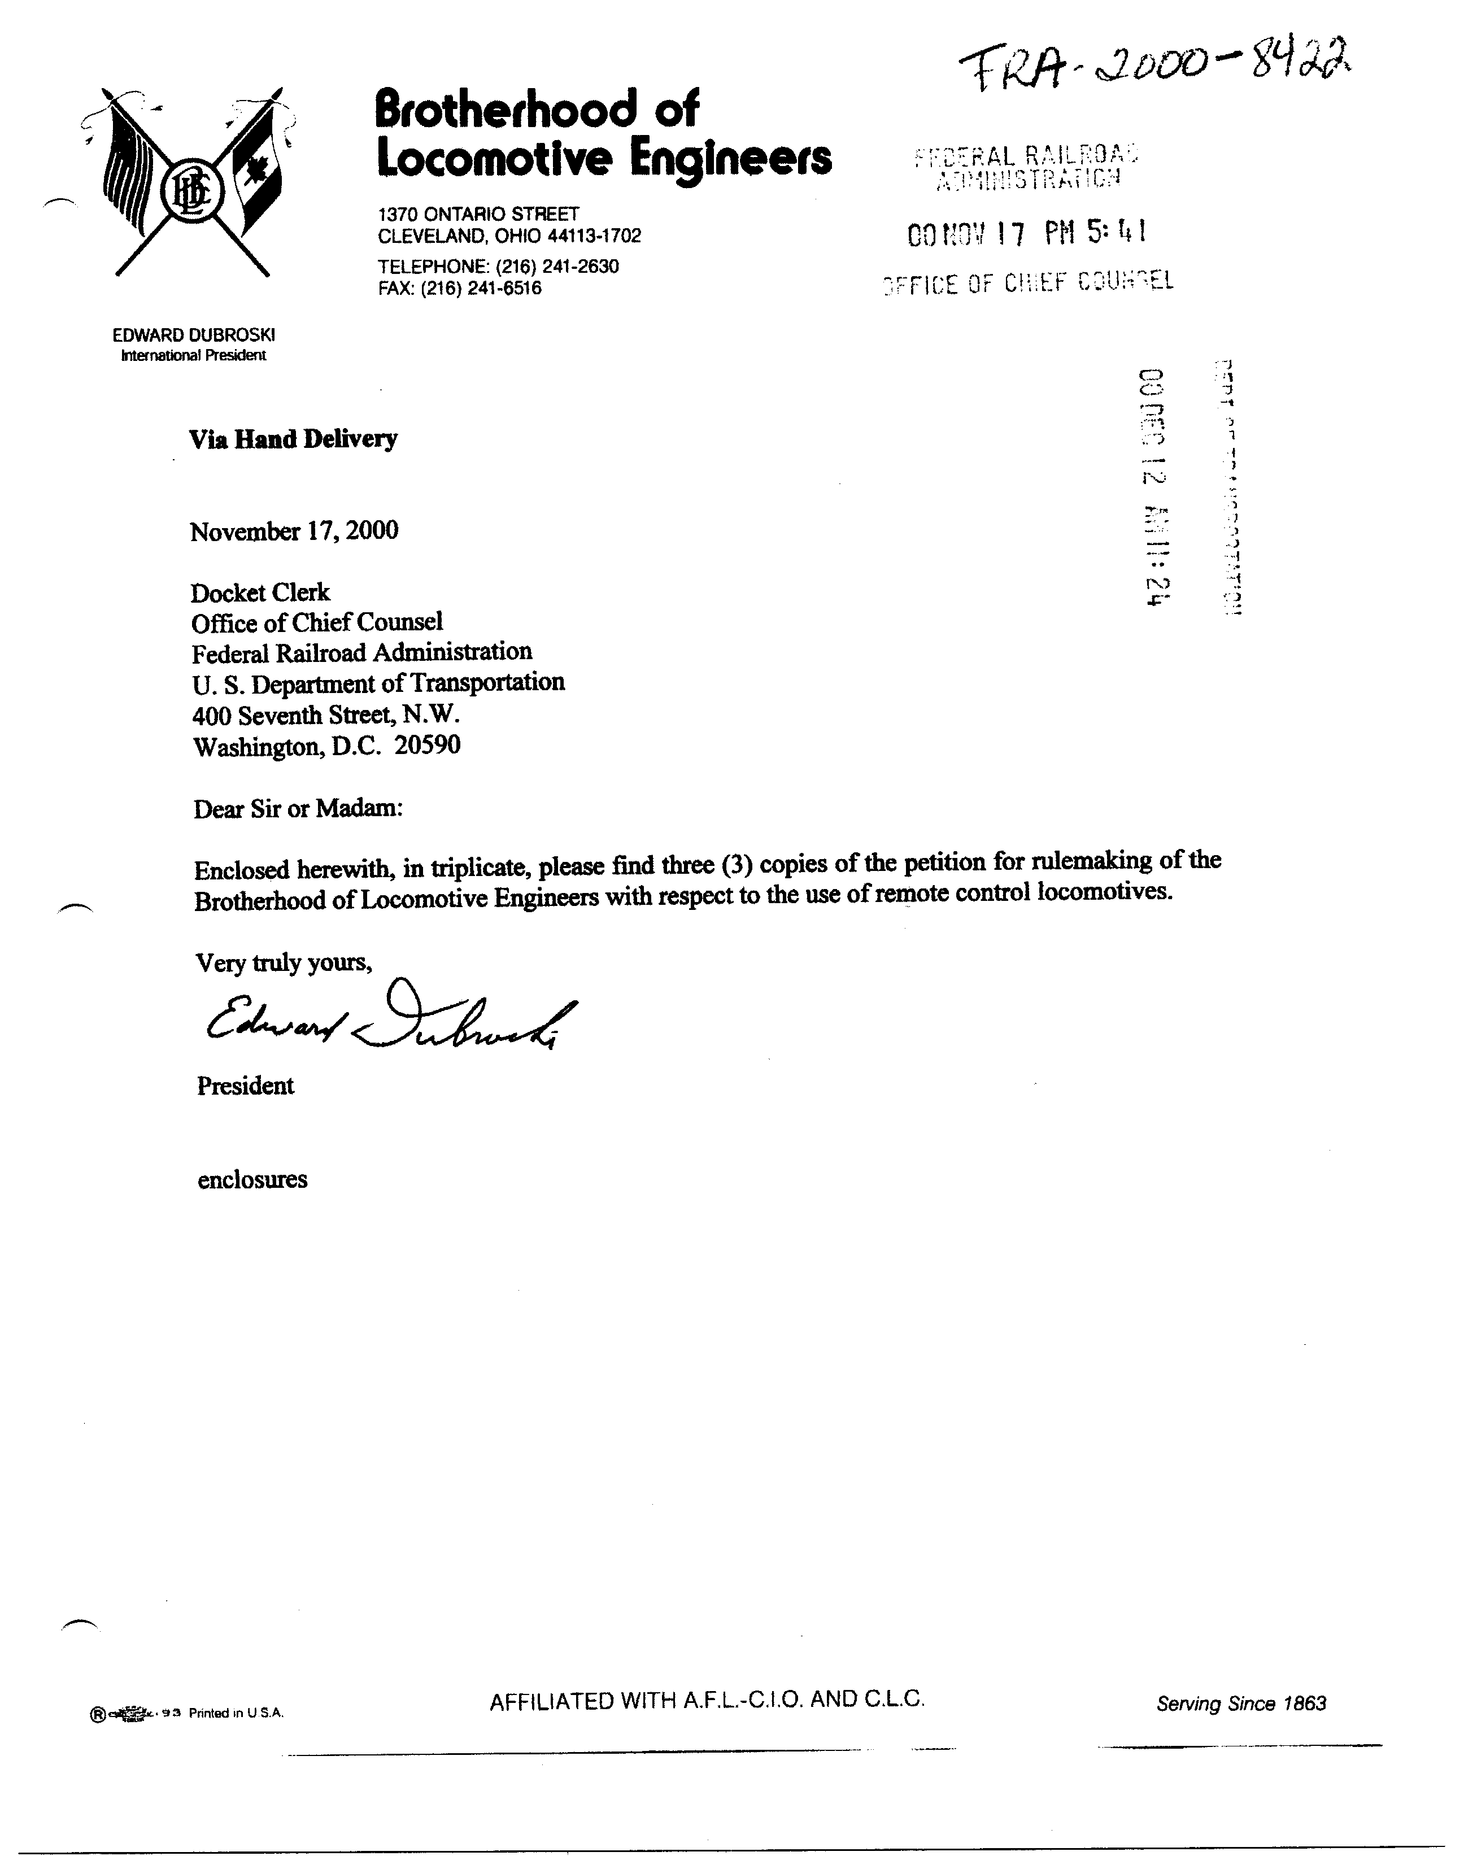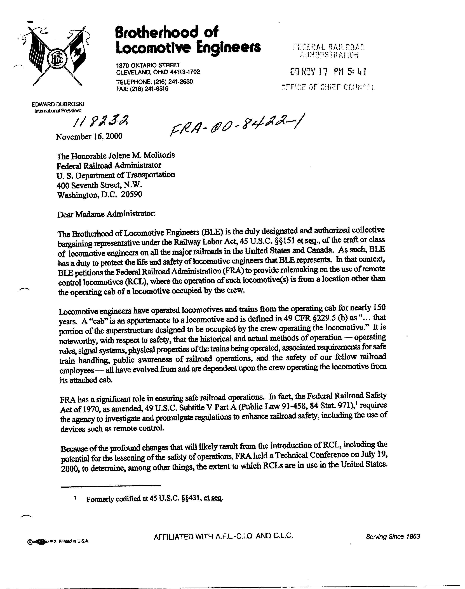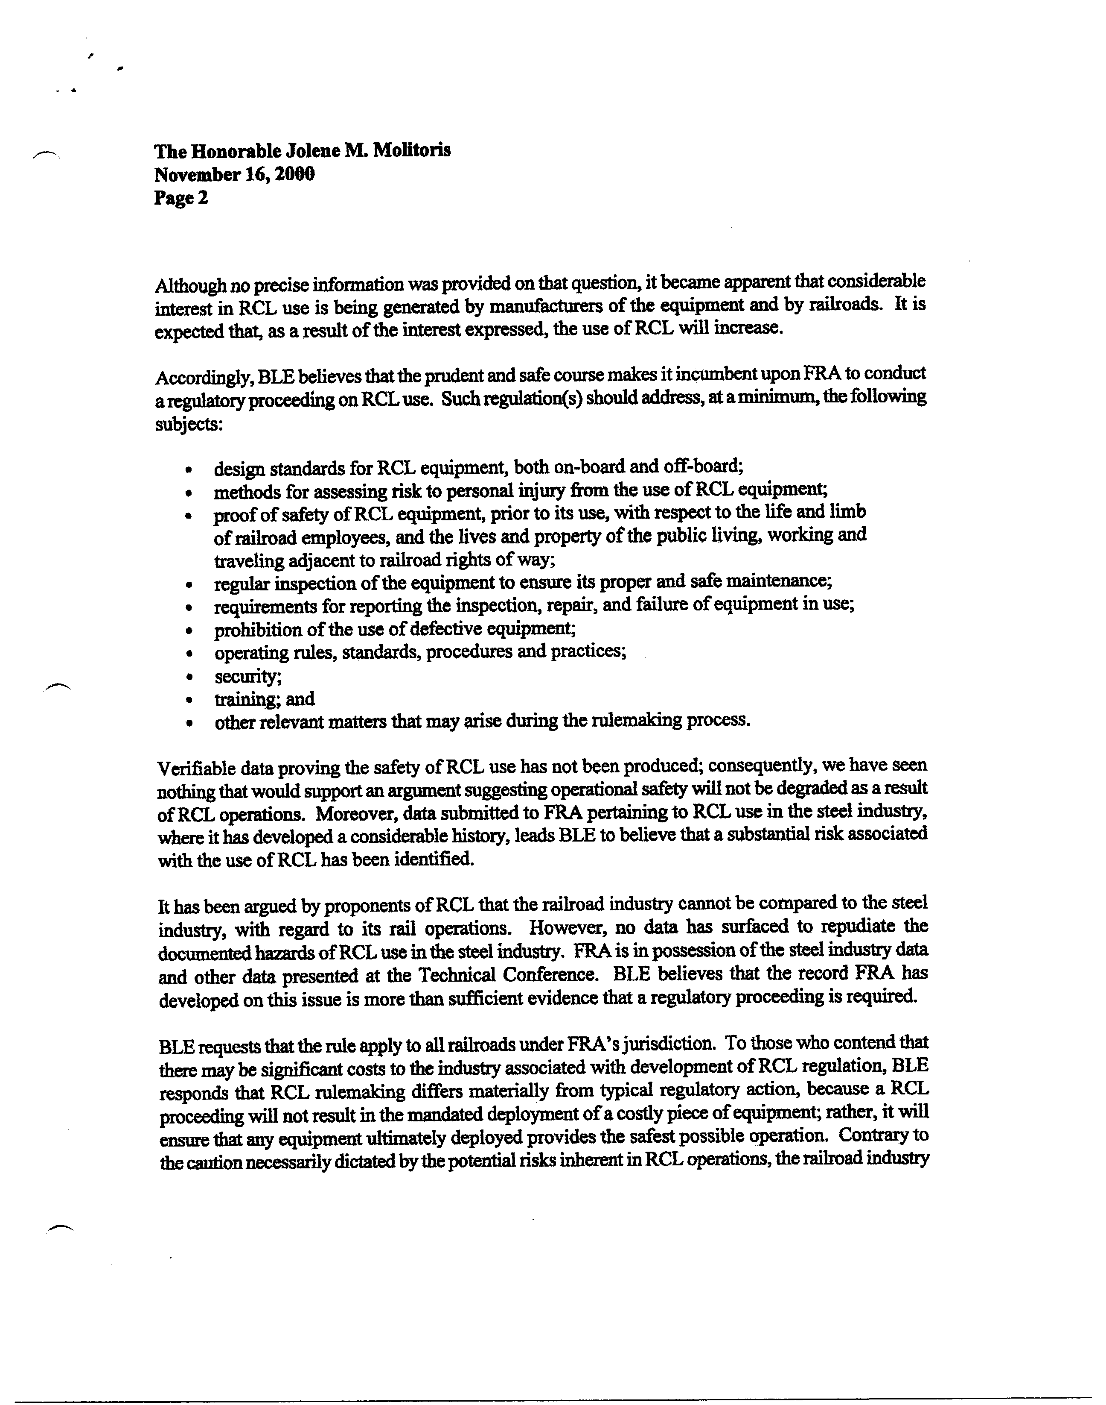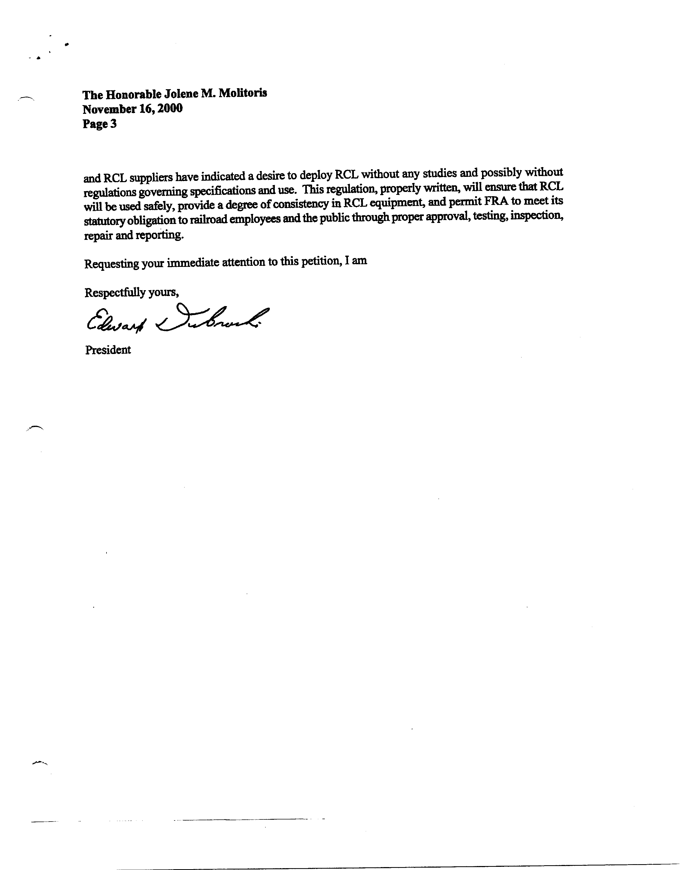
Appendix B
