PacifiCorp
Location of Marengo II Wind Plant

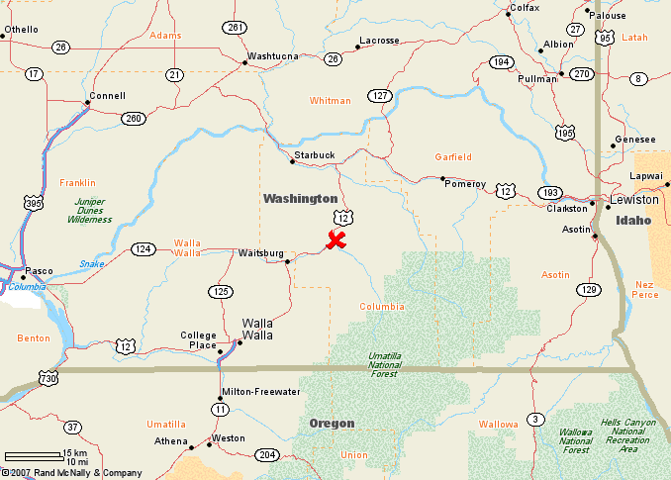
Marengo II Wind Plant
70.2 MW
39 Vestas 1.8 MW turbines

