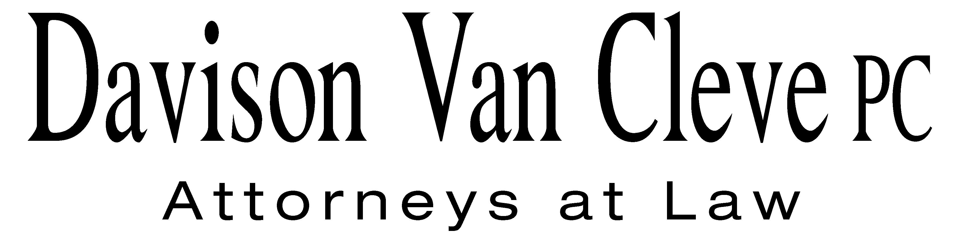
TEL (503) 241-7242 ● FAX (503) 241-8160 ● mail@dvclaw.com
Suite 400
333 SW Taylor
Portland, OR 97204

April 18, 2012

Via Federal Express and Electronic Mail

Mr. David E. Danner
Executive Director and Secretary
Washington Utilities & Transportation Commission
1300 S. Evergreen Park Drive S.W.
Olympia, WA 98504

Re: In the Matter of WUTC v. Avista Corporation

Docket Nos. UE-120436

Dear Mr. Danner:

Enclosed please find an original and twelve (12) copies of the Notice of Appearance on behalf of the Industrial Customers of Northwest Utilities in the above-referenced matter.

Thank you for your assistance. If you have any questions, please do not hesitate to give me a call.
Sincerely yours,

/s/ Sarah A. Kohler
Sarah A. Kohler

Enclosures
cc: Service List
CERTIFICATE OF SERVICE

I hereby certify that I have this day served a copy of the foregoing Notice of Appearance on behalf of the Industrial Customers of Northwest Utilities upon the parties, shown below, listed on the official service list in Docket No. UE-120436 by causing the same to be mailed, postage-prepaid, via U.S. Mail.
DATED at Portland, Oregon, this 18th day of April, 2012.
Davison Van Cleve, P.C.

/s/ Sarah A. Kohler
Sarah A. Kohler

Kelly Norwood, Vice President  Avista Corporation, d/b/a Avista Utilities  1411 E. Mission  Spokane, WA 99220  kelly.norwood@avistacorp.com | Don Trotter  Assistant Attorney General  WUTC  PO Box 40128  Olympia, WA 98504-0128  dtrotter@utc.wa.gov
Simon ffitch  Office of the Attorney General  800 5th Ave STE 2000  Seattle, WA 98104-3188  simonf@atg.wa.gov | David Meyer  Avista Corporation, d/b/a Avista Utilities  PO BOX 3727  Spokane, WA 99220-3727  dmeyer@avistacorp.com
Lisa Gafken
Assistant Attorney General
Office of the Attorney General
1400 S. Evergreen Park Dr SW
Olympia, WA 98504-0128
lisa.gafken@atg.wa.gov

