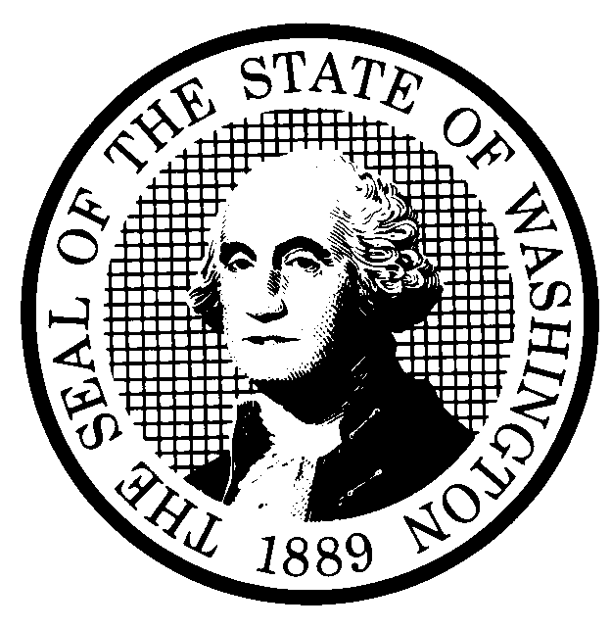 | PROPOSED RULE MAKING |  |  |  |  | CR-102 (June 2004)  (Implements RCW 34.05.320)  Do NOT use for expedited rule making
Agency: Washington Utilities and Transportation Commission
X Preproposal Statement of Inquiry was filed as WSR 01-17-048 ; or  Expedited Rule Making--Proposed notice was filed as WSR ; or  Proposal is exempt under RCW 34.05.310(4). |  |  |  |  |  |  | X Original Notice  Supplemental Notice to WSR  Continuance of WSR
Title of rule and other identifying information: Chapter 480-93 WAC, Gas Companies-Safety, WUTC Docket No. UG-011073

Hearing location(s):  Commission Hearing Room 206  2nd Floor, Chandler Plaza Building  1300 So. Evergreen Park Dr. SW  Olympia, WA 98504-7250 |  |  |  | Submit written comments to:  Name: Carole J. Washburn, Executive Secretary  Address: P.O. Box 47250, Olympia, WA 98504-7250 or  e-mail records@wutc.wa.gov  fax (360) 586-1150 by (date) August 27, 2004  Please include Docket No. UG-011073 in your communication.
Assistance for persons with disabilities:
Contact Mary DeYoung

by Monday, October 25, 2004
TDD (360) 586-8203 or (360) 664-1133
Date of intended adoption: October 27, 2004 Time: 9:30 a.m.
(Note: This is NOT the effective date)
Purpose of the proposal and its anticipated effects, including any changes in existing rules:

The proposed rules are intended to implement the requirements of Executive Order 97-02, requiring agencies to review significant rules for need; effectiveness and efficiency; clarity; intent and statutory authority; cost and fairness. The proposal repeals some of the existing rules that are no longer necessary, adds rules to clarify existing federal rules which the Commission adopts by reference, and includes new rules that are more stringent than federal rules, such as adding “new construction” as an activity included as a covered task. The proposed rules include new rules for defining “timeframes” used throughout the chapter, and addressing protection of exposed plastic pipe. A more detailed description of the proposed rules, by rule, is included in Attachment A to this form.

Reasons supporting proposal: The proposed rules are necessary and reasonable to ensure the safety of gas pipeline operations and to promote safety for the citizens of Washington state from the hazards of gas pipeline operations. In addition, a review of the existing rules and the Commission’s experience in inspecting pipeline facilities in the state has shown a need for consistency in practices among companies, as well as clarity, and to define the meaning of terms used in federal and state rules. Some of the proposed rules apply more stringent requirements than existing federal rules to address concerns the Commission has identified in its experience in inspecting pipeline facilities.

Statutory authority for adoption: RCW 80.01.040, RCW 80.04.160, and RCW 80.28.210. |  |  |  | Statute being implemented: N/A
Is rule necessary because of a:  Federal Law?  Federal Court Decision?  State Court Decision?  If yes, CITATION: |  | Yes  Yes  Yes | X No  X No  X No  X No |  | CODE REVISER USE ONLY  Filed with the Code Reviser's Office  July 21, 2004, 9:14 a.m.  WSR 04-15-141
DATE
July 21, 2004
NAME (type or print)
Carole J. Washburn
SIGNATURE

TITLE
Executive Secretary
(COMPLETE REVERSE SIDE)
Agency comments or recommendations, if any, as to statutory language, implementation, enforcement, and fiscal matters:
None

Name of proponent: Washington Utilities and Transportation Commission |  |  | Private  Public  X Governmental
Name of agency personnel responsible for:
 | Name | Office Location | Phone
Drafting..............Sondra Walsh, Senior Policy Strategist |  | 1300 S. Evergreen Park Drive SW, Olympia, WA 98504 | (360) 664-1286
Implementation..Carole J. Washburn, Executive Secretary, |  | 1300 S. Evergreen Park Drive SW, Olympia, WA 98504 | (360) 664-1174
Enforcement......Carole J. Washburn, Executive Secretary, |  | 1300 S. Evergreen Park Drive SW, Olympia, WA 98504 | (360) 664-1174
Has a small business economic impact statement been prepared under chapter 19.85 RCW?
X Yes. A copy of the small business economic impact statement is attached as Attachment B to this form.

A copy of the statement may be obtained by contacting:
Name: Washington Utilities and Transportation Commission
Address: Records Center, Docket No. UG-011073
1300 S. Evergreen Park Dr. S.W.
P.O. Box 47250
Olympia, WA 98504-7250
phone (360) 664-1286
fax (360) 664-1150
e-mail swalsh@wutc.wa.gov
No. Explain why no statement was prepared.

Is a cost-benefit analysis required under RCW 34.05.328?

Yes A preliminary cost-benefit analysis may be obtained by contacting:
Name:
Address:

phone ( )
fax ( )
e-mail

X No: Please explain: The Commission is not any agency to which RCW 34.05.328 applies. The proposed rules are not significant legislative rules of the sort reference in RCW 34.05.328(5).

ATTACHMENT A TO CR-102
WUTC Rulemaking Docket No. UG-011073

NOTE: This attachment summarizes, by rule, the changes made to existing rules, as well as any new rules proposed for chapter 480-93 WAC:

WAC 480-93-002: Proposal deletes this rule and incorporates language in WAC 480-93-007.
WAC 480-93-005: The proposed rule modifies the existing rule by eliminating definitions not pertinent to the Commission’s jurisdiction, clarifying terms used throughout the chapter, such as “operator,” adding a definition for the term “business district,” and adding a definition for the term “Master Meter,” as is defined in 49 CFR §191.3.
WAC 480-93-007: A new proposed rule incorporating language from WAC 480-93-002.
WAC 480-93-008: A new proposed rule that addresses applicability of the rules.
WAC 480-93-009: A new proposed rule that provides for severability of rules.
WAC 480-93-010: Proposal deletes this rule and incorporates language in WAC 480-93-999.
WAC 480-93-012: A new proposed rule that specifies timeframes identified in various rules.
WAC 480-93-015: The proposed rule requires “sniff tests” be conducted at least once monthly and equipment used to perform the test be calibrated in accordance with manufacturer’s recommendation. If there is no manufacturer’s recommendation, equipment must be tested at least annually.
WAC 480-93-017: Re-written for clarity.
WAC 480-93-018: Includes a requirement that pipeline companies update records within six months of completion of construction activity and make them available to company operation personnel.
WAC 480-93-020: This rule is re-written for clarity and incorporates the requirements of WAC 480-93-030.
WAC 480-93-030: Proposal deletes this rule and incorporates language in WAC 480-93-020.
WAC 480-93-040: Re-written for clarity.
WAC 480-93-080: The proposed rule changes the re-qualification requirement for Appendix C welders from 1 year to 6 months, and requires that welders carry identification cards. The rule also disallows Appendix C welders from welding high pressure, large diameter pipes.
WAC 480-93-082: Proposal deletes this rule.
WAC 480-93-100: The proposed rule requires companies to identify emergency valves, install such valves in business districts, and near churches, schools, hospitals and emergency buildings, and maintain a written maintenance program detailing the valve selection process, when they will be inspected, and maintenance and operating procedures.
WAC 480-93-110: The proposed rule requires companies to maintain detailed written cathodic protection (CP) procedures. In addition, the rule has been re-written to clarify state and federal requirements, and adds remedial action timeframes. In addition, the proposed rule requires companies to have a written internal CP program that includes monitoring, and that CP tests be taken when steel pipe is exposed. The proposed also requires annual monitoring of pipelines that are less than 10 feet in length and have been CP protected due to corrosion or leakage, rather than every 10 years as required by federal rules.
WAC 480-93-111: Proposal deletes this rule and incorporates language in WAC 480-93-110.
WAC 480-93-112: Proposal deletes this rule and incorporates language in WAC 480-93-110.
WAC 480-93-115: Re-written for clarity.
WAC 480-93-120: Proposal deletes this rule and incorporates language in WAC 480-93-124.
WAC 480-93-124: The proposed rule requires companies to place markers at all railroad, road, irrigation, and drainage ditch crossings, river crossings, creeks, and at all fence lines where a pipeline crosses private property, or where a pipeline or pipeline facility is exposed. In addition the proposed rule requires companies to replace markers within 45 days of discovery. Companies must also maintain records that identify class locations and where markers are required.

WAC 480-93-130: Proposal deletes rule.
WAC 480-93-140: The proposed rule requires companies to follow the manufacturer’s recommended installation and maintenance practices of service regulators to insure proper and safe operation. In addition, companies must verify the set points at the initial turn-on.
WAC 480-93-150: Proposal deletes rule.
WAC 480-93-155: Re-written for clarity.
WAC 480-93-160: Re-written for clarity.
WAC 480-93-170: Re-written for clarity.
WAC 480-93-175: Re-written for clarity.
WAC 480-93-178: A new proposed rule that requires companies to monitor above-ground temporary installations of plastic pipe. In addition, a new requirement is proposed to keep pipe separated from other utilities when buried, requires a weak-link when pulling pipe so it isn’t damaged, and has a maximum ultraviolet light exposure limit.
WAC 480-93-180: Re-written for clarity.
WAC 480-93-183: Proposal deletes rule.
WAC 480-93-184: Proposal deletes rule.
WAC 480-93-185: Re-written for clarity.
WAC 480-93-186: The proposed rule requires companies to fix leaks and not regrade leaks numerous times. When a leak has been regraded and the same leak is later found at a more severe grade, the leak must be repaired.
WAC 480-93-18601: Re-written for clarity.
WAC 480-93-187: Re-written for clarity.
WAC 480-93-188: The proposed rule specifies that companies must follow the manufacturer’s recommendation for calibration, and if an instrument does not have a manufacturer’s recommendation for calibration, then it must be calibrated once each month. In addition, Section (3)(a) of the rule has been modified to require gas leak surveys in “business districts,” as defined in WAC 480-93-005.
WAC 480-93-190: Proposal deletes rule and incorporates language in WAC 480-93-200.
WAC 480-93-200: The proposed rule incorporates WAC 480-93-190. The rule is re-written for clarity and consistency with federal regulations, requires drug and alcohol forms be submitted to the Commission, changes the telephonic incident reporting requirement for more serious incidents from six to two hours and reporting for other reportable incidents from six to twenty-four hours. In addition, companies must submit daily reports of construction and repair activities.
WAC 480-93-210: Proposal deletes rule.
WAC 480-93-220: Proposal deletes rule.
WAC 480-93-223: Re-written for clarity.
WAC 480-93-230: Re-written for clarity.
WAC 480-93-240: Proposal makes no change to this rule.
WAC 480-93-999: Re-written to incorporate accurate references. This rule reflects each regulation or standard the Commission is adopting, the effective date of the regulation or standard, the place within the Commission’s rules the regulation or standard is referenced, and the availability in which the regulation is found. The Commission adopts by reference the definition of the term “covered task” in 49 CFR § 192.801(b), but adds “new construction” to the definition.

