Sub-Loop – V6.0

History Log (Link blue text to: Replace Existing Download With Attached History Log Sub-Loop)

Product Description
There are four product offerings with Sub-Loop: the Unbundled Feeder Loop (UFL), the Unbundled Distribution Loop (UDL), the Unbundled Intra-Building Cable (IBC) and Unbundled Campus Wire, which is only available in Nebraska.
The UFL is the F1 or Feeder portion of an unbundled loop that originates at the Qwest Central Office and ends at the Feeder Distribution Interface (FDI), which is also known as the Serving Area Interface (SAI). The UDL is the F2 or Distribution portion of an Unbundled Loop from the FDI to the Network Interface Device (NID) (Link blue text to http://www.qwest.com/wholesale/pcat/nid.html) on the end-user premises. The IBC is a Qwest provided distribution facility from a Multi- Tenant Environment (MTE) terminal, inside or attached to a MTE building, to the demarcation point (typically the NID) at the end-user premises inside the same building. Campus Wire is a Qwest provided distribution facility from a Qwest detached terminal serving a single piece of property that contains multiple buildings, i.e. a campus environment. The IBC originates at the Qwest owned building terminal and extends to the Qwest demarcation point.
By establishing a FCP (Link blue text to: http://www.qwest.com/wholesale/pcat/fcp.html) at an accessible terminal, you can obtain access to the UDL, UFL and Campus Wire. Access to IBC is gained by obtaining an established Multi-Tenant Environment - Point of Interconnection (MTE-POI) arrangement. (Link blue text to: http://www.qwest.com/wholesale/pcat/mtepoi.html)
In Colorado, you may reserve UFL and UDL Sub-Loop elements at the time you establish your FCP. See the FCP (Link blue text to: http://www.qwest.com/wholesale/pcat/fcp.html) web page for more information about the Colorado Sub-Loop Reservation Process.
The four Sub-Loop product offerings are:
- UFL
- Digital Service, Level 1 (DS1) Capable
- UDL
- 2-Wire
- 2-Wire Non-Loaded
- 4-Wire
- 4-Wire Non-Loaded
- Intra-Building Cable
- Campus Wire (Only available in Nebraska)
DS1 Capable UFL is a digital transmission path that is provisioned from a Qwest Central Office Network Interface, which consists of a Digital Signal Cross-connect, Level1 (DSX-1) panel or equivalent, to the FDI located at the FCP. The DS1 Capable UFL transports bi-directional DS1 signals with a nominal transmission rate of 1.544 Mbps.
The 2-Wire UDL is a Qwest provided facility from the Qwest FCP at the FDI to the demarcation point or NID at the end-user premises. The Two-Wire UDL includes, but is not limited to, distribution facilities that serve MTEs. The 2-Wire UDL is suitable for local exchange type services within the analog voice frequency range of 300 to 3000 Hz. Access is obtained at the FDI through an established FCP arrangement, and at the end-user premises through the NID. (Link blue text to http://www.qwest.com/wholesale/pcat/nid.html)
The 2-Wire Non-Loaded UDL is a Qwest provided facility from the Qwest FCP to the end-user's NID. It is a metallic, wire cable pair with no load coils, and, depending on the service you intend to transmit on the 2-Wire Non-Loaded UDL, some limited lengths of bridge tap.
The 2-Wire Non-Loaded UDL has the following characteristics:
- Metallic facilities only, no carrier segments
- No load coils or build out capacitance
- Tolerant of some bridge tap
- The 2-Wire Non-Loaded UDL may contain a mixture of cable gauges.
Access is obtained at the FDI through an established FCP arrangement.
The 4-Wire UDL is a Qwest provided facility from the Qwest FCP at the FDI to the NID at the end-user premises.
The 4-Wire UDL has the following characteristics:
- Metallic facilities only on carrier segments
- Tolerant of some bridge tap
- Loop may contain a mixture of cable gauges.
Access is obtained at the FDI through an established FCP arrangement.
The 4-Wire Non-Loaded UDL is a Qwest provided facility from the Qwest FCP to the end-user's NID. It is a metallic, wire cable pair with no load coils, and depending on the service you intend to transmit on the 4-Wire Non-Loaded UDL, some limited lengths of bridge tap.
The 4-Wire Non-Loaded UDL has the following characteristics:
- Metallic facilities only, no carrier segments
- No load coils or build out capacitance
- Tolerant of some bridge tap
- The 4-Wire Non-Loaded UDL may contain a mixture of cable gauges.
Access is obtained at the FDI through an established FCP arrangement.
The IBC is a Qwest provided 2-Wire or 4-Wire facility that extends from a MTE terminal, or other accessible terminal that services a single building, to the end-users NID. (Link blue text to: http://www.qwest.com/wholesale/pcat/nid.html) This Sub-Loop element applies when Qwest owns the IBC.
Campus Wire (Only available in Nebraska) is a Qwest provided 2-Wire or 4-Wire, Loaded or Non-Loaded facility that extends from a detached terminal serving a single piece of property that contains multiple buildings, i.e. a campus environment.
The Campus Environment is an environment in which end-users (voice, video and data) are spread out over a broad geographic area, as in a university, hospital, medical center, prison and apartment or business complex. There may be several communications providers. The area may be served by a FDI or by a direct office feed.
Campus Wire extends from the detached terminal to the end-users NID on that property. You obtain access to the Campus Wire at the detached terminal by establishing a FCP (Link blue text to: http://www.qwest.com/wholesale/pcat/fcp.html) arrangement.

Product Diagram
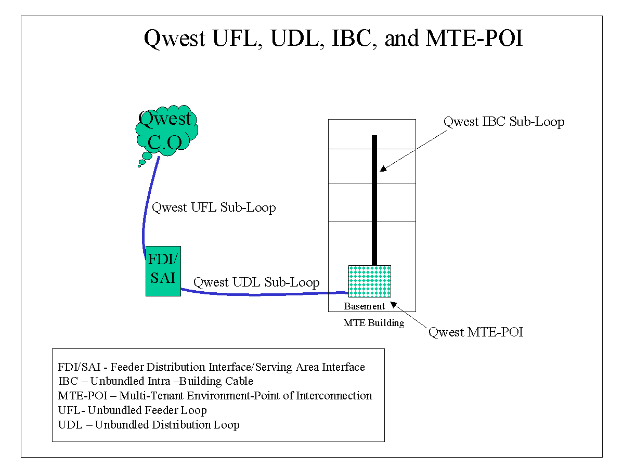
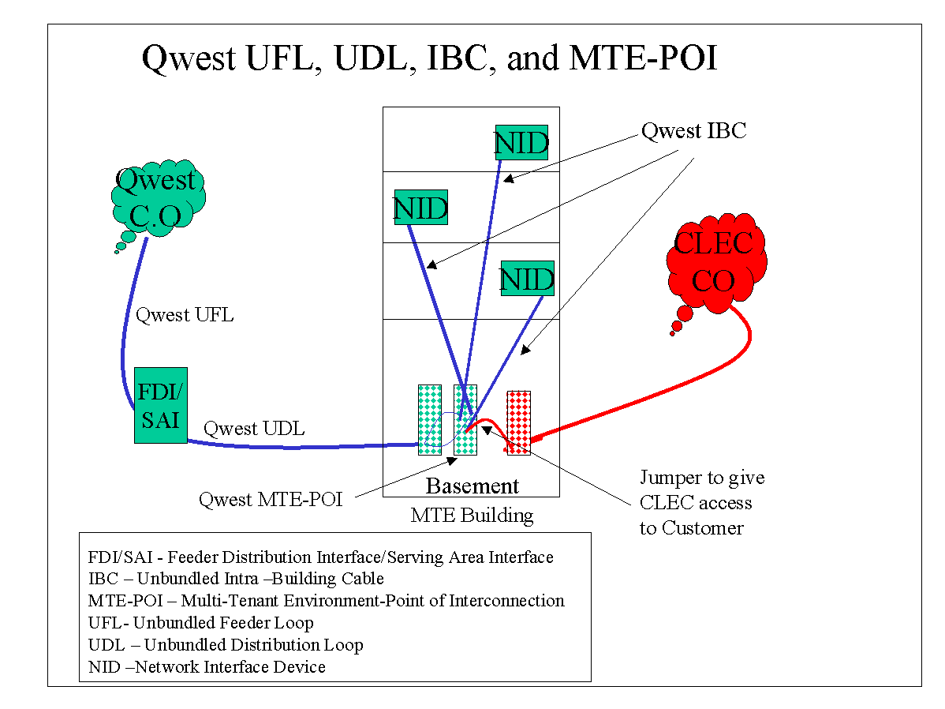

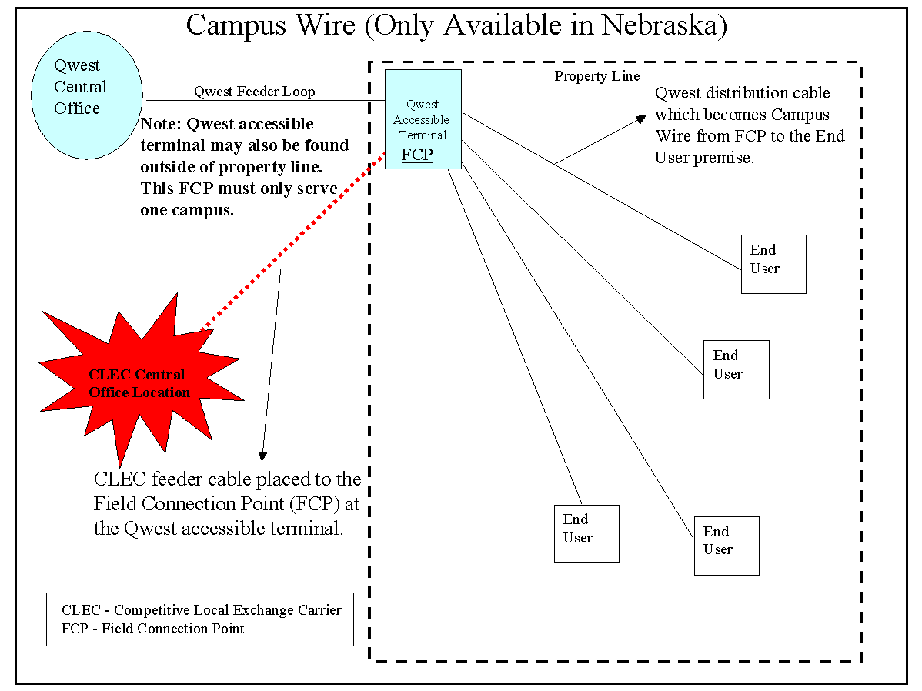

Availability
Sub-Loop is available where facilities exist throughout Qwest’s 14-state local service territory. (Link blue text to: http://www.qwest.com/wholesale/pcat/territory.html) Campus Wire is only available in Nebraska. The Sub-Loop Reservation Process is only available in Colorado.

Terms and Conditions
Before submitting UFL Sub-Loop requests, you must have an established Central Office collocation (Link blue text to: http://qwest.com/wholesale/pcat/collocation.html) that serves the accessible terminal where your FCP will be established.
You must have an established FCP at the accessible terminal (FDI) prior to submitting UDL Sub-Loop requests. (Link blue text to: http://qwest.com/wholesale/pcat/fcp.html)
You must have an established FCP at the detached terminal that serves the campus you intend to serve prior to ordering Campus Wire. Additionally, the FCP and the detached terminal must serve only a single campus and not buildings on other pieces of property.
When you access a MTE Terminal for IBC, you should adhere to generally accepted best engineering practices in accordance with industry standards. You are required to clearly label the cross-connect wires you use. Your wiring should be neatly dressed. See Qwest’s Standard MTE Terminal Access Protocol for detailed information. (Link blue text to the following document: “Qwest’s Standard MTE Terminal Access Protocol”)
You may access the MTE Terminal at the MTE -POI (Link blue text http://www.qwest.com/wholesale/pcat/mtepoi.html) as a test access point for IBC Sub-Loop.
You must provide the necessary space and meet all premises requirements described in Technical Publication 77405. (Link blue text to: http://www.qwest.com/techpub/77405/77405.pdf)

Technical Publications
Technical requirements, including Network Channel/Network Channel Interface (NC/NCI) codes are specified in Technical Publication 77405. (Link blue text to: http://www.qwest.com/techpub/77405/77405.pdf)

Pricing

Rate Structure
Recurring charges bill on a month-to-month basis; term contracts are not available. These charges are applicable to both converted and new circuits.
Non-recurring UFL, UDL, IBC, and Campus Wire installation charges are assessed. For IBC and Campus Wire, installation charges apply for the first and each additional installation at the MTE or campus. See the FCP (Link blue text to: http://www.qwest.com/wholesale/pcat/fcp.html) web page for more information about non-recurring charges for the Reservation Process, which is available only in Colorado.
Interconnection Tie Pair (ITP) monthly charges are applicable to UFL. Pricing information is available in the SGAT, Exhibit A for the relevant state. (Link blue text to: http://www.qwest.com/about/policy/sgats)
One -month minimum billing, contract termination liability and associated contract charges for the product from which the loop is being converted will apply and will be assessed to the end-user as described in the Local Exchange Tariff for the applicable state. (Link blue text to: http://tariffs.qwest.com:8000/)

Rates
Rates are available in Exhibit A or the specific rate sheet in your Interconnection Agreement.

Tariffs, Regulations, and Policies
Information is available in the state specific Tariffs/Catalogs/Price Lists. (Link blue text to: http://tariffs.qwest.com:8000/)
Access to the UFL, UDL and Campus Wire Sub-Loop is at the FDI or any other technically feasible point through the establishment of a FCP. Access to the IBC is at the MTE-POI. (Link blue text to: http://www.qwest.com/wholesale/pcat/mtepoi.html) If access is requested at a point other than the FDI, MTE-POI or any other technically feasible point, the request should be submitted using BFR Process. (Link blue text to: http://www.qwest.com/wholesale/preorder/bfrsrprocess.html)
Any technically feasible non-standard sub-loops will be handled through the Special Request Process. (Link blue text to http://www.qwest.com/wholesale/preorder/bfrsrprocess.html)
Directory Listings are not part of the Sub-Loop product offering.

Optional Features
There are no optional features available with Sub-Loop.

Features/Benefits
Features | Benefits
Flexibility to order portions of the loop. | The Sub-Loop product allows you to access Qwest owned portions of unbundled loops at the Central Office and/or at accessible terminals in the outside plant of the unbundled loop. This product can be used for multiple applications.

Applications
Sub-Loops can be used in conjunction with your facilities to provide services to end-users. These Sub-Loops free you from having to install the entire loop facilities required to reach the end-user’s location.

Implementation

Product Prerequisites
If you are a new Competitive Local Exchange Carrier (CLEC) and are ready to enter the interconnection business with Qwest, please view the Getting Started for Facility-Based CLECs web page. (Link blue text to: http://www.qwest.com/wholesale/clecs/clec_index.html) If you are an existing CLEC wishing to amend your Interconnection Agreement or your New Product Questionnaire, you can find additional information in the Negotiations Template Agreement web page. (Link blue text to: http://www.qwest.com/wholesale/clecs/negotiations.html)
Campus Wire, which is only available in Nebraska, requires a signed amended Interconnection Agreement with provisions and rates for Campus Wire.
To reserve Sub-Loop Elements in Colorado, you will need to have provisions for the Reservation Process amended your Interconnection Agreement.
A MTE-POI (Link blue text to http://www.qwest.com/wholesale/pcat/mtepoi.html) is required for accessing the IBC from a MTE Terminal. You must create the cross-connect field at the building terminal that will allow connection of your facilities to IBC at the MTE-POI. The MTE-POI is the demarcation point between your facilities and Qwest’s facilities.
A FCP (Link blue text to: http://www.qwest.com/wholesale/pcat/fcp.html) is required for accessing UFL, UDL or Campus Wire.

Pre Ordering
Qwest strongly recommends use of Pre-Ordering functionality to assist in achieving increased service order flow through and accuracy that will result in reduced Local Service Request (LSR) rejects.
The Interconnect Mediated Access (IMA) User’sGuide specifically details the information applicable to Pre-Ordering functions. (Link blue text to: http://www.qwest.com/wholesale/ima/gui/imauser.html ) Additional Pre-Ordering information is described in the Pre-Ordering Overview (Link blue text to: http://www.qwest.com/wholesale/clecs/preordering.html and in the Unbundled Local Loop web page. (Link blue text to: http://www.qwest.com/wholesale/pcat/unloop.html)
The Raw Loop Data (RLD) tools provide the physical characteristics of the facility at either the wire center level or at the individual loop level. Data available includes the physical characteristics by segment:
- CLLI Code
- Load Coils
- Bridge Tap
- Wire Gauge
- Cable and Pair make-up
- Spare Facility
There are two RLD tools, an IMA tool and a web-based Wire Center tool.
- The Wire Center RLD tool provides the physical characteristics of the facilities for an entire Wire Center. The wire center raw loop data is presented as a comma delimited file and needs to be downloaded into a database or spreadsheet to analyze the individual facilities. Contact your Qwest Service Manager to request an ID, which will be required to obtain the digital certificate e required to access this tool. You will need to provide the names and telephone numbers of your employees that will be accessing the tool. After your Qwest Service Manager has notified you that the necessary access permissions have been established, and provided you with your ID you may then initiate the digital certification process. (Link blue text to: http://ecom.uswest.com
- The IMA RLD tool provides loop specific information. This tool also enables you to obtain the physical characteristics of facilities. Information regarding the IMA RLD tool is described in the IMA User’s Guide. (Link blue text to: http://www.qwest.com/wholesale/ima/gui/imauser.html)
The loop qualifications tools should be used prior to submitting a LSR. Use of these tools can greatly reduce LSR rejects by ensuring the types of facilities requested are available prior to placing an order. Based on the physical characteristics, you can determine if the facility needs to be conditioned, i.e., the removal of load coils or bridged tap, which will assist you in identifying the appropriate ordering intervals, described in the Service Interval Guide (SIG). (Link blue text to: http://www.qwest.com/wholesale/guides/sig/index.html)
The IMA Loop Qualification and Raw Loop Data-CLEC Job Aid (Link blue text to: http://www.qwest.com/wholesale/training/desc_imaloopqualjobaid.html) is a web based training course designed to provide valuable information and instructions on how to use the IMA based loop qualification tools and interpret the information provided.

Ordering
The IMA User’s Guide specifically details the information applicable to ordering functions. (Link blue text to: http://www.qwest.com/wholesale/ima/gui/imauser.html) Additional ordering information is located in the Ordering Overview. (Link blue text to: http://www.qwest.com/wholesale/clecs/ordering.html)
Valid Network Channel/Network Channel Interface (NC/NCI) codes are required on all Sub-Loop requests. Information regarding NC/NCI codes is located in Technical Publication 77405. (Link blue text to: http://www.qwest.com/techpub/77405/77405.pdf)
Campus Wire does not carry its own NC/NCI codes. You will need to use the NC/NCI codes applicable to the UDL. Enter in the Remarks field of the LSR form that you are ordering Campus Wire and also enter the NC/NCI codes for the UDL in the appropriate fields. For example, when you order Campus Wire on a 2-Wire Non-Loaded UDL, enter the following information:
- In the Remarks field on the LSR form: “Campus Wire – On a 2-Wire Non-Loaded UDL.
- In the NC field on the LSR form: Enter the NC code for 2-Wire Non-Loaded UDL.
- In the NCI field on the LSR form: Enter the NCI code for 2-Wire Non-Loaded UDL.
- In the Sec NCI field on the LSR form: Enter the Sec NCI code for 2-Wire Non-Loaded UDL.
Provisioning interval guidelines are described in the Service Interval Guide (SIG). (Link blue text to: http://www.qwest.com/wholesale/guides/sig/index.html)
A Design Layout Report (DLR) can be requested for the UFL to determine if the loop will meet the technical parameters of the service being provided. The DLR provides information on items such as loop gauge make-up, bridge tap and the loop’s total length. Your engineers will need to determine if the available loop falls within the technical requirements of the service you intend to transport over the loop. Information about requesting DLRs is described in the Provisioning and Installation Overview. (Link blue text to: http://www.qwest.com/wholesale/clecs/provisioning.html)
A DLR is not applicable for UDL, IBC or Campus Wire, as they are non-design services.
Circuit Identification numbers are assigned by Qwest upon receipt for Sub-Loop requests. The Circuit Identification number is provided to you on the Firm Order Confirmation (FOC). Information describing Circuit Identification number format is available in Unbundled Local Loop General Information. (Link blue text to: http://www.qwest.com/wholesale/pcat/unloop.html)
A Qwest technician dispatch is required on UFL, UDL and Campus Wire Sub-Loop new service requests. For IBC, you may dispatch a technician to run a jumper between your Sub-Loop elements and Qwest’s Sub-Loop elements, or you may request that a Qwest technician run a jumper to make a connection at the MTE-POI. (Link blue text to: http://www.qwest.com/wholesale/pcat/mtepoi.html)
For access to IBC prior to the completion of the MTE-POI (Link blue text http://www.qwest.com/wholesale/pcat/mtepoi.html) inventory process, you are required to submit a LSR, but need not include the meet point information or await completion of LSR processing by Qwest before securing access. Qwest will
- Secure the meet point information (You will obtain meet point information from the Alternate Point of Termination (APOT) provided you upon completion of the MTE –POI process. Information on the APOT is also known as Connecting Facility Assignment, meet point, circuit identifying, etc.)
- Assign the meet point information starting with the highest termination and moving toward the lowest termination. For example, if you order a 100 pair termination at the MTE-POI and submit a LSR for IBC without the meet point information, Qwest will assign the termination pairs starting with 100, then 99, 98, 97, etc.
After you receive APOT for the MTE-POI, then all subsequent LSRs for IBC at the same MTE must contain the meet point information at the time the LSR is submitted. Qwest shall be entitled to charge for IBC as of the time that you submitted the LSR.
Orders should be placed using IMA (Link blue text to: http://www.qwest.com/wholesale/ima/gui/index.html), or faxed to (888) 796-9089.
Local Number Portability (LNP) (Link blue text to: http://www.qwest.com/wholesale/pcat/lnp.html) can be ordered with IBC, UDL and Campus Wire, which is available only in Nebraska.
Directory Listings are not part of the Sub-Loop product offering.
Sub-Loop orders are placed using the LSR, End User (EU) and Service (LS) forms. The Loop Services with Number Portability (LSNP) form is used in place of the LS form if the request involves Local Number Portability (LNP). Detailed information regarding LSR field entry requirements is described in the IMA User’s Guide. (Link blue text to: http://www.qwest.com/wholesale/ima/gui/imauser.html) and in the LSOG – LSR web page (Link blue text to: http://www.qwest.com/wholesale/clecs/lsog.html)
Valid LSR ACT (activity) types for UFL are:
- C = Change
- D = Disconnect
- M = Inside Move
- N = New Installation
Valid LSR ACT (activity) types for UDL, IBC and Campus Wire are:
- C = Change
- D = Disconnect
- M = Inside Move
- N = New Installation
- T = Outside Move
- V = Conversion As Specified
The valid REQTYP is ‘AB’ unless the request involves LNP; then the REQTYP is ‘BB’. LNP is not applicable on UFL.
To connect to IBC at the MTE-POI:
- If you want to run the jumper, you need to state that information in the Remarks field of the LSR form. (Link blue text to: http://www.qwest.com/wholesale/clecs/lsog.html)
- If you want Qwest to run the jumper, you need to provide meet point information from the APOT form on the LSR form in the Remarks field of the LSR form.
Some of the more common information required on Sub-Loop LSR request includes:
- NC and NCI codes
- CFA for UFL requests
- Desired Due Date
- Secondary Location Information
- Contact Information
- Information from the APOT form (i.e., CFA, meet point, cable pair)
An APOT form is provided to you as part of the Collocation (Link Blue text to: http://www.qwest.com/wholesale/pcat/collocation.html), FCP (Link Blue Text to http: http://qwest.com/wholesale/pcat/fcp.html) and MTE-POI (Link Blue Text to http://qwest.com/wholesale/pcat/mtepoi.html) hand-off process.
If you relate Purchase Order Numbers (PON) and associate orders to a Project Identification Code in the PROJECT field on the LSR form, or if the LQTY field on the LS form has 25 or more loops from the same CSR, the request will be handled as a project by the Center responsible for handling your account. The installation guidelines for the project are negotiated on an Individual Case Basis (ICB) based on the request. The main point of contact for the project will be your Qwest Service Manager. (Link blue text to: http://www.qwest.com/wholesale/clecs/accountmanagers.html)
Standard intervals and critical dates are described in the Service Interval Guide. (Link blue text to: http://www.qwest.com/wholesale/guides/sig/index.html)

Provisioning
Provisioning information and design requirements are available in Technical Publication 77405. (Link blue text to: http://www.qwest.com/techpub/77405/77405.pdf) General provisioning information is located in the Provisioning and Installation Overview. (Link blue text to: http://www.qwest.com/wholesale/clecs/provisioning.html)
Firm Order Confirmation (FOC) intervals are available in the Service Interval Guide (SIG). (Link blue text to: http://www.qwest.com/wholesale/guides/sig/index.html) Additional information about FOC is available in the Provisioning and Installation Overview. (Link blue text to: http://www.qwest.com/wholesale/clecs/provisioning.html)
A DLR will be provided for UFL when requested on the LSR form. Information describing DLR viewing options is available in the Provisioning and Installation Overview. (Link blue text to: http://www.qwest.com/wholesale/clecs/provisioning.html)
A jeopardy occurs on an LSR order request if a condition exists that threatens timely completion. Jeopardy codes are described in the Provisioning and Installation Overview. (Link blue text to: http://www.qwest.com/wholesale/clecs/provisioning.html)
Sub-Loop is provided where existing facilities are available. If no facilities can be found, and there is No Planned Engineering Job, the LSR will be rejected for a No Facilities reason and the order cancelled. Your Qwest Service Manager (Link blue text to: http://www.qwest.com/wholesale/clecs/accountmanagers.html) should be contacted if you are requesting CLEC Requested UNE Construction (Link blue text to: http://www.qwest.com/wholesale/clecs/crunec.html) per the terms and conditions of your Interconnection Agreement. Information regarding reject codes is available in the Ordering Overview. (Link blue text to: http://www.qwest.com/wholesale/clecs/ordering.html) Refer to SGAT for the relevant state for options available to you when facilities are not available. (Link blue text to: http://www.qwest.com/about/policy/sgats)
The Basic Installation option is available for Sub-Loops. For an existing end-user, the Basic Installation option is the ‘lift and lay’ procedure. In this scenario the Qwest technician ‘lifts’ the loop from its current termination and ‘lays’ it on a new termination connecting to the CLEC. Test results are not provided to the CLEC. Detailed information about this option is located in the SGAT for the relevant state or your Interconnection Agreement. (Link blue text to: http://www.qwest.com/about/policy/sgats)
Loss and Completion Reports are based on loss and gain account activity. Information regarding Completion notification, including Loss and Completion Reports, is described in the Provisioning and Installation Overview. (Link blue text to: http://www.qwest.com/wholesale/clecs/provisioning.html)

Maintenance and Repair
Information is available in the Maintenance and Repair Overview. (Link blue text to: http://www.qwest.com/wholesale/clecs/maintenance.html)

Billing
The account will be established in Customer Records and Information System (CRIS) effective with the completion date of the conversion order and/or new service request. Charges will be billed on a CRIS Summary Bill on a month-to-month basis; term contracts are not available. Charges for circuits are itemized by Circuit Identification number on the CRIS Summary Bill, at the sub account level. Information regarding Circuit Identification number format is described in the Ordering section of the Unbundled Local Loop General Information web page. (Link blue text to: http://www.qwest.com/wholesale/pcat/unloop.html) Information regarding the CRIS Summary Bill, Inquiry and Disputes is described in the Billing Information – Customer Records and Information System web page. (Link blue text to: http://qwest.com/wholesale/clecs/cris.html)

Training

Qwest 101 "Doing Business With Qwest"
- This introductory instructor-led training course is designed to teach the CLEC and Reseller how to do business with Qwest. It will provide a general overview of products and services, Qwest billing and support systems, processes for submitting service requests, reports, and web resource access information. Click here to learn more about this course and to register. (Link blue text to: http://www.qwest.com/wholesale/training/ilt_desc_qwest_101.html)

Unbundled Network Elements (UNE-Loop, UNE-Switch, UDIT)
- This is a self-directed, web-based training course that provides participants with an overview level of knowledge of the Unbundled Network Elements (UNEs) product and it's features. Participants will learn about three specific elements: Unbundled Switch (UBS) Elements, Unbundled Loop (UBL) Elements, and Unbundled Dedicated Interoffice Transport (UDIT). Click here to learn more about this course and to register. (Link blue text to: http://www.qwest.com/wholesale/training/wbt_desc_une.html)

Unbundled Network Element - Switching (UBS)
- This is a self-directed, web-based training course that provides you with an overview of the Unbundled Network Element- Switching (UBS) product and its features. Upon completion of this training course, you should be able to explain the function and features of the UBS product including Line Ports and Unbundled Trunk Ports. Additionally you will be able to define ordering guidelines, mediated access, UBS rate elements and the public 911/E911 database. Click here to learn more about this course and register. (Link blue text to: http://www.qwest.com/wholesale/training/wbt_desc_ubs.html)
Unbundled Loop Elements (ULE)
- This is a self-directed, web-based training course that provides you with an overview of the Unbundled Loop Elements (ULE) product and features. . Upon completion of this training course you should be able to explain ULE function and features, describe loops over IDLC and cable unloading, describe bridged-tap removal, and explain Network Interface Devices (NID). Click here to learn more about this course and register. (Link blue text to: http://www.qwest.com/wholesale/training/wbt_desc_ubl.html)
Unbundled Dedicated Interoffice Transport (UDIT)
- This is a self-directed, web-based training course that provides you with an overview of the Unbundled Dedicated Interoffice Transport (UDIT) product and its features. Upon completion of this training course you should be able to explain the function, features, terms and conditions of UDIT, E-UDIT, D-UDIT, M-UDIT, Multiplexing and UCCRE. Additionally you will be able to describe UDIT rate elements and the ordering process. Click here to learn more about this course and for registration information. (Link blue text to: http://www.qwest.com/wholesale/training/wbt_desc_udit.html)

IMA "Hands On"
- This introductory course teaches the participant how to use Qwest's IMA Graphical User Interface (GUI) to order wholesale products and enter and view repair data. This class is interactive using software demonstration and hands-on practice to familiarize the participant with the IMA GUI system. Click here to learn more about this course and to register. (Link blue text to: http://www.qwest.com/wholesale/training/ilt_desc_ima_handson.html)
View additional Qwest courses by clicking on Course Catalog. (Link blue text to: http://www.qwest.com/wholesale/training/coursecatalog.html)

Contacts
Qwest contact information is identified in the Wholesale Customer Contacts web page. (Link blue text to: http://www.qwest.com/wholesale/clecs/escalations.html)

Frequently Asked Questions (FAQs)
- How do I know what kind of Sub-Loop I should order?
If you provide your own distribution facilities to a Qwest accessible terminal, you may order UFL to connect your distribution facilities to your Central Office collocation. This means that you are providing the distribution facilities between the end user to the interconnection point at the FCP.
You may choose to order only UDL if you want to provide your own feeder to the Qwest accessible terminal. This means that you are providing the feeder facilities between your Central Office or equipment location to the interconnection point at the FCP.
- Can I provide high-speed services using Sub-Loops?
Yes, you can purchase UDL, IBC and Campus Wire, which is only available in Nebraska, to the end-user for the purpose of providing high speed data service.
How do I advise Qwest whether I want to run a jumper or I want Qwest to run a jumper when ordering IBC Sub-Loop?
If you want to run the jumper, you need to state that information on the LSR form. (Link blue text to: http://www.qwest.com/wholesale/clecs/lsog.html) If you want Qwest to run the jumper, you need to provide meet point information on the LSR form. In addition, when Qwest is required to run the jumper, the intervals identified in the SIG shall apply.

Last Update: April 5, 2002
META Tags: Unbundled Distribution Loop, Unbundled Feeder Loop, UDL, UFL, F1, F2, HC--, HCD-, HCE-, HCF-, HCG-, HCJ-, HCZ-, LX--, Inside Wire.

