WN U-2

Original Sheet No. 1134-A

PUGET SOUND ENERGY
NATURAL GAS SCHEDULE NO. 134
Pipeline Integrity Program
(Continued)

Section 3: Program Cap

Total capital expenditures during a program year will not exceed $25 million without prior
Commission approval. Capital expenditures which exceed the total approved program year amount by greater than 10% will not be allowed recovery under the program without separate
Commission approval.

Section 4: Adjustment Rates

MONTHLY RATE:
Schedule 16 $ 0.05 per mantle
Schedules 23 $ 0.00239 per therm
Schedules 31 and 31T $ 0.00211 per therm
Schedules 41 and 41T $ 0.00104 per therm
Schedules 85 and 85T $ 0.00033 per therm
Schedules 86 and 86T $ 0.00053 per therm
Schedules 87 and 87T $ 0.00023 per therm
Special Contracts $ 0.00023 per therm

Section 5: Termination

The program will remain in effect through October 31, 2016, or until such other time as the
Commission may approve.

Section 6: Adjustments

Rates in this schedule are subject to conditions and adjustment as set forth in Schedule No. 1 and to adjustment by other adjusting or supplemental schedules, when applicable.

Section 7: General Rules and Regulations

Service under this schedule is subject to the rules and regulations contained in Company's tariff.

(N)
|
|
|
|
|
|
|
|
|
|
|
|
|
|
|
|
|
|
|
|
|
|
|
|
|
|
|
|
|
|
|
|
|
|
|
|
(N)

Issued: April 26, 2011 Effective: August 1, 2011
Advice No.: 2011-12

Issued By Puget Sound Energy
By: | 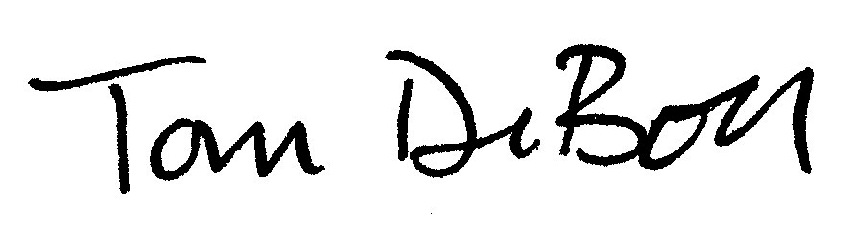 | Tom DeBoer Title: Director, Federal & State Regulatory Affairs

