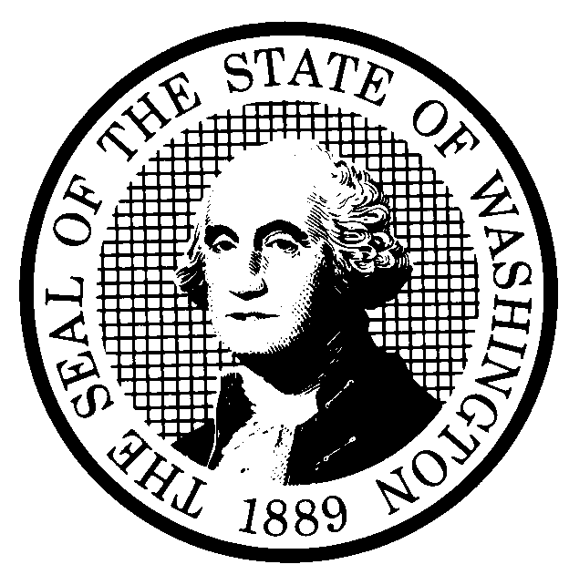 | PROPOSED RULE MAKING |  |  |  |  | CR-102 (June 2004)  (Implements RCW 34.05.320)  Do NOT use for expedited rule making
Agency: Washington Utilities and Transportation Commission
Preproposal Statement of Inquiry was filed as WSR # 03-09-070; or  Expedited Rule Making--Proposed notice was filed as WSR FORMTEXT ; or  Proposal is exempt under RCW 34.05.310(4). |  |  |  |  |  |  | Original Notice  Supplemental Notice to WSR #05-20-094  Continuance of WSR
Title of rule and other identifying information: Chapter 480-107 WAC, Electric Companies-purchases of electricity from qualifying facilities and independent power producers and purchases of electrical savings from conservation suppliers. These rules state requirements that electric companies must follow when acquiring new resources. The supplemental notice would revise rules noticed at WSR # 05-20-094, relating to purpose and scope of chapter, definitions, the solicitation process, contents of the solicitation, pricing and contracting procedures, avoided cost schedules, obligations of generating facilities to the utility, interconnection costs, and conditions for purchase of electrical power or savings from a utility, a utility’s subsidiary or affiliated interest.

Docket No. UE-030423.
Hearing location(s):  Commission Hearing Room  Second Floor, Chandler Plaza,  1300 S. Evergreen Park Drive SW  Olympia, WA 98504-7250 |  |  |  | Submit written comments to:  Name: Carole Washburn,  Address: Washington Utilities and Transportation Commission  PO Box 47250  Olympia, WA 98504-7250  e-mail records@wutc.wa.gov. Please, include: “Docket No. UE-030423” in your comments.  fax (360) 586-1150 by February 8,, 2006
Date: February 22,2006 Time: 2:30 PM |  |  |  | Assistance for persons with disabilities: Contact  Mary De Young by February 17, 2006  TTY (360) 586-8203 or (360) 664-1133
Date of intended adoption: February 22, 2006
(Note: This is NOT the effective date)
Purpose of the proposal and its anticipated effects, including any changes in existing rules:
This supplemental proposal would revise most sections in Chapter 480-107 WAC.

Affected WACS are: (See attached rules)

Reasons supporting proposal: Language is proposed that would constitute a substantial change from the Supplemental CR-102 proposal at WSR # 05-20-094. The revisions proposed in this Supplemental CR-102 would include correction of the table of contents to make it consistent with the chapter, deletion of the obligation of an electric utility to adjust price by operating performance adjustments if a qualifying or generating facility agrees to operate under economic dispatch, substituting estimated avoided cost schedules for avoided cost schedules, eliminating the requirement that for projects of one megawatt or less the basis for the price offered will be the avoided cost specified in the current utility tariff, and establishing that the obligations of generating facilities to utilities listed in proposed WAC 480-107-085 are minimum obligations.

Statutory authority for adoption:  RCW 80.01.040 and RCW 80.04.160. |  |  |  | Statute being implemented: N/A
Is rule necessary because of a:  Federal Law?  Federal Court Decision?  State Court Decision?  If yes, CITATION: |  | Yes  Yes  Yes | X No  X No  X No |  | CODE REVISER USE ONLY  Filed with the Code Reviser  January 18, 2006, 10:07 a.m.  WSR 06-03-127
DATE
January 18, 2006
NAME (type or print)
Carole J. Washburn
SIGNATURE

TITLE
Executive Secretary

(COMPLETE REVERSE SIDE)
Agency comments or recommendations, if any, as to statutory language, implementation, enforcement, and fiscal matters:
None.

Name of proponent: (person or organization) Washington Utilities and Transportation Commission |  |  | Private  Public  Governmental
Name of agency personnel responsible for:
 | Name | Office Location | Phone
Drafting............... Graciela Etchart |  | 1300 S. Evergreen Pk Drive SW, Olympia, WA 98504 | (360) 664 1310
Implementation.... Carole Washburn |  | 1300 S. Evergreen Pk Drive SW, Olympia, WA 98504 | (360) 664 1174
Enforcement.........Carole Washburn |  | 1300 S. Evergreen Pk Drive SW, Olympia, WA 98504 | (360) 664 1174
Has a small business economic impact statement been prepared under chapter 19.85 RCW?
Yes. Attach copy of small business economic impact statement.

A copy of the statement may be obtained by contacting:
Name:
Address:

phone ( )
fax ( )
e-mail
No. Explain why no statement was prepared.

The proposed corrections and changes to rules will not result in or impose an increase in costs. Because there will not be any increase in costs resulting from the proposed rule changes, an SBEIS is not required under RCW 19.85.030 (1)

Is a cost-benefit analysis required under RCW 34.05.328?

Yes A preliminary cost-benefit analysis may be obtained by contacting:
Name:
Address:

phone ( )
fax ( )
e-mail

No: Please explain: The proposed rules are not significant legislative rules of the sort referenced in RCW 34.05.328(5).

