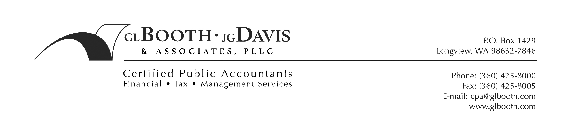
November 19, 2019

Executive Secretary
Washington Utilities and Transportation Commission
P O Box 47250
Olympia, WA 98504-7250

Dear Executive Secretary:

This filing is submitted by Waste Control, Inc., G-101.

This filing includes the workpapers updated for corrections as requested by staff for Docket Number TG-190903. Please do not re-docket.

If you have questions regarding this filing, please contact me or Joe Willis. Joe may be reached at Waste Control, Inc.; phone (360) 425-4302 and email jwillis@wcrecycling.com. My telephone number is (360) 425-8000 and my email address is jdavis@boothdavis.com.

Very truly yours,

GL BOOTH · JG DAVIS & ASSOCIATES, PLLC

Jacqueline Davis

Jacqueline Davis, CPA

cc: Cowlitz County Council, Chair
Clark County Council, Chair
Skamania County Council, Chair
City of Castle Rock, Mayor
City of Kalama, Mayor

