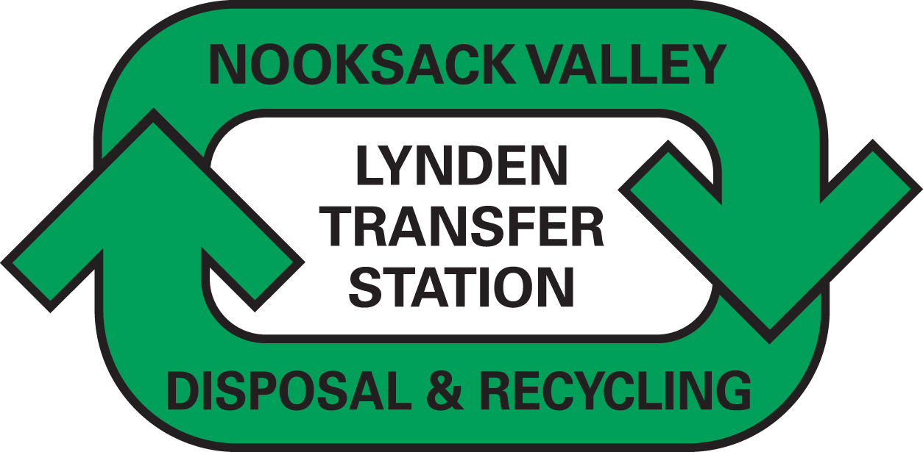
Steven King, Executive Director and Secretary
Washington Utilities and Transportation Commission
1300 South Evergreen Park Drive SW
P.O. Box 47250
Olympia, WA 98504-7250 December 10, 2014

FOR DOCKET # TG-143874 - DO NOT RE-DOCKET

Dear Secretary King,

Attached please find a replacement page for the above docket, as requested by staff.

The contact person for this submittal is: Calvin Den Hartog
P.O. Box 267, Lynden, WA 98264
Phone: (360) 354-3400 Fax: (360) 354-3288
Email: Calvin_NVD@msn.com

Sincerely,

Calvin Den Hartog
General Manager

