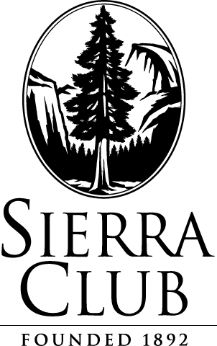

January 17, 2011

BY E-MAIL AND U.S. MAIL

Mr. David Danner
Executive Director and Secretary
Washington Utilities and Transportation Commission
1300 S. Evergreen Park Drive SW
P.O. Box 47250
Olympia, WA 98504-7250

Re: Puget Sound Energy, Inc.
Dockets UE-111048 and UG-111049 (consolidated)

Dear Mr. Danner:

Attached please find the CONFIDENTIAL and REDACTED versions of the Cross-Answering Testimony of Ezra D. Hausman, Ph.D., filed on behalf of Sierra Club in Dockets UE-111048 and UG-111049 (consolidated). This document and associated exhibits have been filed through the Washington UTC Electronic Filing portal and 19 copies have been sent to the Records Department via U.S. Mail. Copies have also been sent via electronic mail and first class mail to the attached service list.

Sincerely,

/s/ James Giampietro____________________
James Giampietro
Sierra Club Environmental Law Program
85 Second Street, 2nd Floor
San Francisco, CA 94105
(415) 977-5638
james.giampietro@sierraclub.org

cc: Service List

