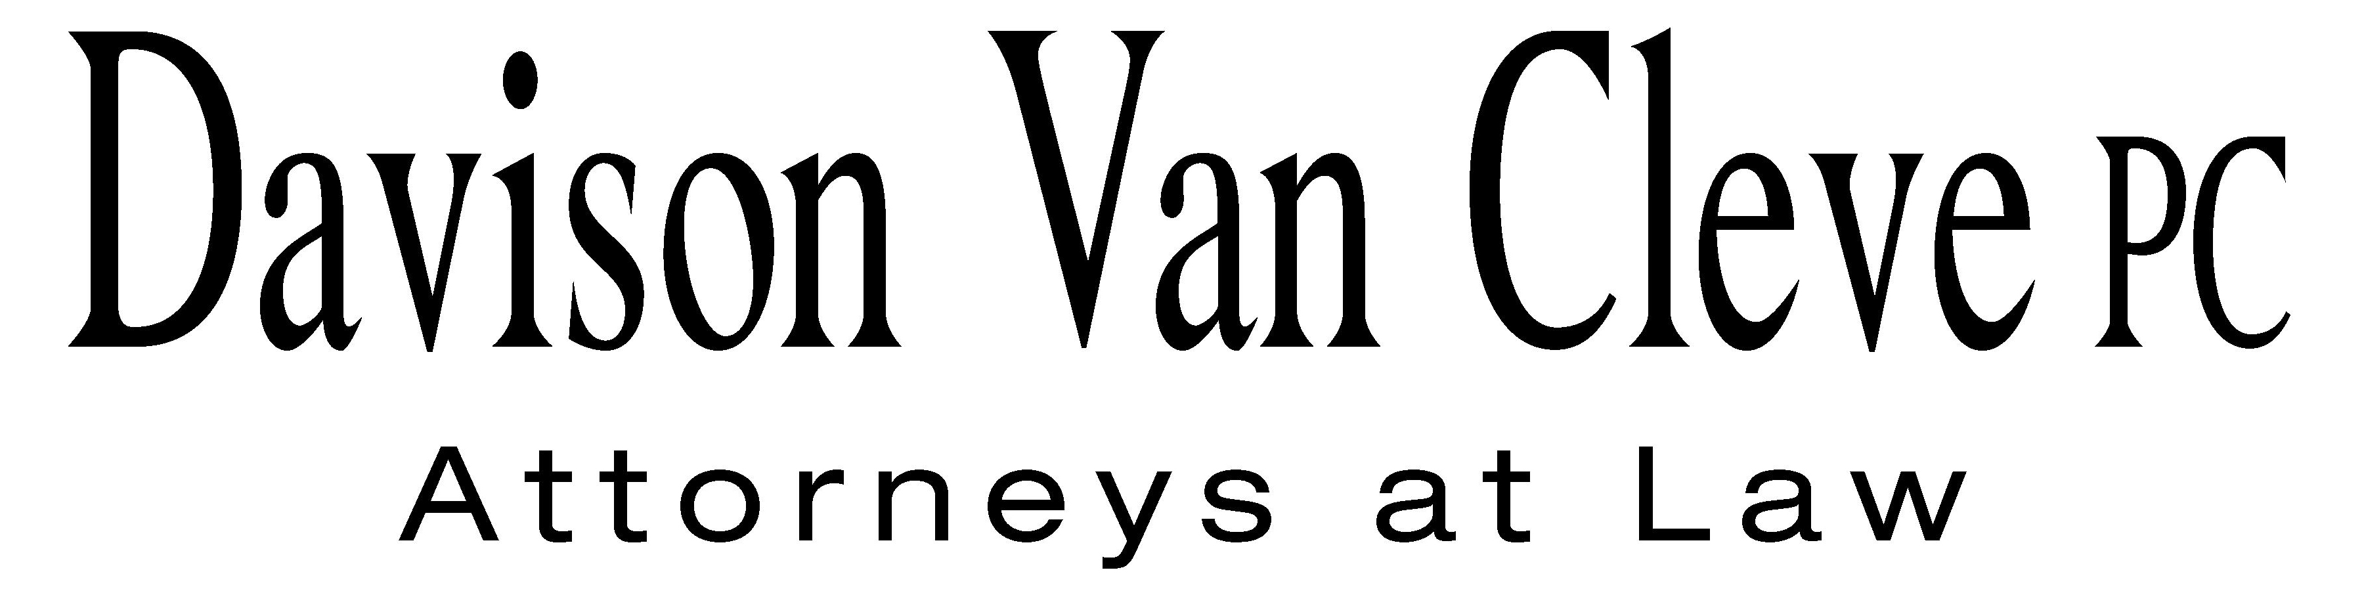
TEL (503) 241-7242 ● FAX (503) 241-8160 ● mail@dvclaw.com
Suite 400
333 SW Taylor
Portland, OR 97204

March 12, 2013

Via Email and Federal Express

Mr. Steven V. King
Acting Executive Director
Washington Utilities & Transportation Commission
1300 S. Evergreen Pk. Dr. S.W.
P. O. Box 47250
Olympia, WA 98504-7250

Re: In the Matter of PUGET SOUND ENERGY and NW ENERGY COALITION’S Petition for an Order Authorizing PSE to Implement Electric and Natural Gas Decoupling Mechanisms and to Record Accounting Entries Associated with the Mechanisms
Docket Nos. UE-121697/UG-121705

Dear Mr. King:

Enclosed please find an original and twelve (12) copies of the Motion to Compel of the Industrial Customers of Northwest Utilities. Please also find an original and twelve (12) copies of the Declaration of Melinda J. Davison and Exhibits A, B, and C.

Thank you for your assistance.

Sincerely yours,

/s/ Sarah A. Kohler
Sarah A. Kohler
Enclosures

cc: Service List

CERTIFICATE OF SERVICE

I hereby certify that I have this day served the foregoing documents upon all parties of record in this proceeding by mailing a copy thereof in a sealed, first-class postage prepaid envelope to each individual’s last-known address, as listed below.
DATED this 12th day of March, 2013.
Davison Van Cleve, P.C.

/s/ Sarah A. Kohler
Sarah A. Kohler

PUGET SOUND ENERGY  KEN JOHNSON  PO BOX 97034 PSE-08N  BELLEVUE WA 98009-9734  ken.s.johnson@pse.com | PERKINS COIE  SHEREE CARSON  10885 N.E. FOURTH STREET STE 700 BELLEVUE WA 98004-5579  scarson@perkinscoie.com
WASHINGTON UTILITIES & TRANSPORTATION COMMISSION  DON TROTTER  PO BOX 40128  OLYMPIA, WA 98504  dtrotter@utc.wa.gov | NW ENERGY COALITION  TODD TRUE  AMANDA GOODIN  705 Second Avenue STE 203  Seattle, WA 98104  ttrue@earthjustice.org  agoodin@earthjustice.org
NW ENERGY COALITION  811 1st Ave STE 305  Seattle, WA 98104 | CHAD STOKES  Cable Huston Benedick Haagensen & Lloyd, LLP  1001 SW 5th Avenue STE 2000  Portland, OR 97204  cstokes@cablehuston.com
NORTHWEST INDUSTRIAL GAS USERS  ED FINKLEA  326 Fifth Street  Lake Oswego, OR 97034  efinklea@nwigu.org | THE KROGER CO.  1014 Vine Street  Cincinnati, OH 45202
KURT J BOEHM  JODY KYLER  Boehm, Kurtz & Lowry  36 E. Seventh St. STE 1510  Cincinnati, OH 45202  kboehm@BKLlawfirm.com  kyler@BKLlawfirm.com | QUALITY FOOD CENTERS, INC.  10116 N.E. 8th Street  Bellevue, WA 98004
FRED MEYER STORES, INC.  3800 Southeast 2nd Street  Portland, OR 99202 | SALLY BROWN  Assistant Attorney General  WUTC  PO Box 40128  Olympia, WA 98504-0128
KEVIN HIGGINS  Energy Strategies LLC  215 South State Street STE 200  Salt Lake City, UT 84111 | GREG TRAUTMAN  Assistant Attorney General  WUTC  PO Box 40128  Olympia, WA 98504-0128

