June 30, 2015

VIA ELECTRONIC FILING SYSTEM

Washington Utilities & Transportation Commission
1300 S. Evergreen Park Drive SW
Olympia, WA 98504-7250

RE: FCC Form 481 Confidential Financial Information Subject to Washington Code 480-07-160

Pend Oreille Telephone Company, a privately-held rate of return carrier receiving high cost support, has electronically submitted FCC Form 481 to the Commission with redacted financial data and confidential information compliance with 47 C.F.R. §§ 54.313 and 54.422. Pend Oreille Telephone also files its copies with the Washington Utilities & Transportation Commission and requests that this filing be treated confidentially.

Please feel free to contact me with any questions regarding this particular matter.

Sincerely,
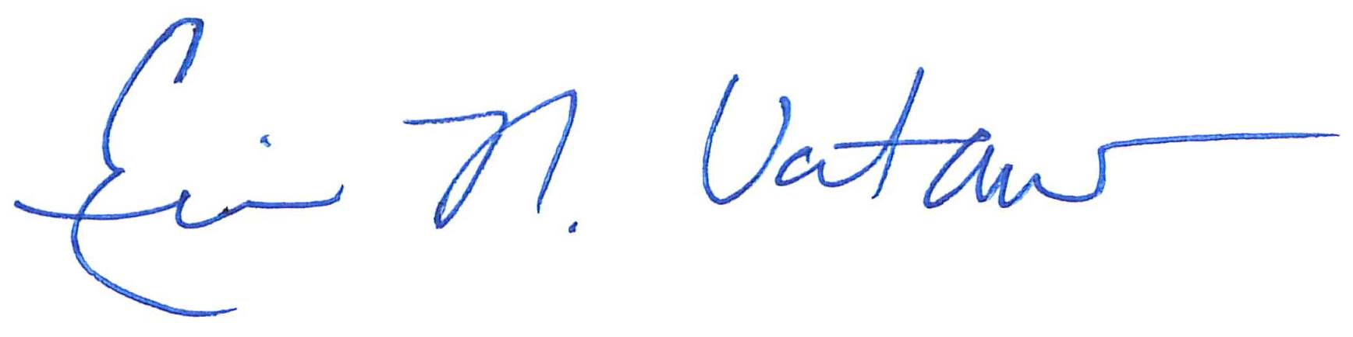
Eric N. Votaw, Senior Manager for
Moss Adams LLP
Enclosures

