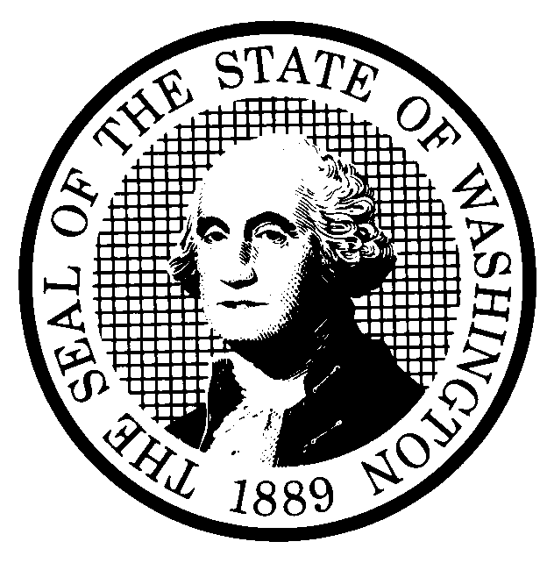 | PROPOSED RULE MAKING  (RCW 34.05.320) |  |  |  |  |  |  |  |  | CR-102 (7/22/01)  Do NOT use for expedited  rule making
Agency: Washington Utilities & Transportation Commission |  |  |  |  |  |  |  |  |  | x Original Notice
x Preproposal Statement of Inquiry was filed as WSR 01-12-053; or  Expedited Rule Making -- Proposed notice was filed as WSR ; or  Proposal is exempt under RCW 34.05.310(4). |  |  |  |  |  |  |  |  |  | Supplemental Notice  to WSR  Continuance of WSR
(a) Title of rule: (Describe Subject)
The proposed rules would reorganize and revise chapter 480-04 WAC Public Access to Information and Documents, and would repeal and replace chapter 480-09 WAC Procedure with a new chapter 480-07 WAC Procedure.

Purpose: See (j) below.

Other identifying information: Docket No. A-010648

(b) Statutory authority for adoption: RCW 80.01.040, RCW 80.04.160, and RCW 81.04.160 |  |  |  |  |  |  |  |  | Statute being implemented:
(c) Summary: See (j) below.
Reasons supporting proposal:
(d) Name of Agency Personnel Responsible for: |  |  |  |  | Office Location |  |  |  |  |  | Telephone
1. Drafting............... Dennis J. Moss, Senior Review Judge, 1300 S. Evergreen Park Drive S.W., Olympia, WA 98504 360-664-1164

2. Implementation....Carole J. Washburn, Secretary, 1300 S. Evergreen Park Drive S.W., Olympia, WA 98504 360-664-1174

3. Enforcement........Carole J. Washburn, Secretary, 1300 S. Evergreen Park Drive S.W., Olympia, WA 98504 360-664-1174

(e) Name of proponent (person or organization):  Washington Utilities and Transportation Commission |  |  |  |  |  |  |  |  |  |  | Private  Public  x Governmental
(f) Agency comments or recommendations, if any, as to statutory language, implementation, enforcement and fiscal matters: None

(g) Is rule necessary because of:  Federal Law?  Federal Court Decision?  State Court Decision? |  | Yes  Yes  Yes |  | x No  x No  x No |  | If yes, ATTACH COPY OF TEXT  Citation:
(h) HEARING LOCATION: |  |  |  |  |  |  | Submit written comments to:
Commission Hearing Room 206  Second Floor, Chandler Plaza Building  1300 S. Evergreen Park Drive S.W.  Olympia, WA 98504 |  |  |  |  |  |  | Carole J. Washburn, Secretary, P. O. Box 47250, Olympia, WA 98504 or  E-mail to <records@wutc.wa.gov>. Please include Docket No. A-010648 in your communication  FAX (360) 586-1150 By September 10, 2003
Date: September 24, 2003 Time: 9:30 AM |  |  |  |  |  |  | DATE OF INTENDED ADOPTION: September 24, 2003
Assistance for persons with disabilities: Contact  Mary DeYoung by September 19, 2003 |  |  |  |  |  |  | CODE REVISER USE ONLY
TDD (360) 586-8203 or (360) 664-1133 |  |  |  |  |  |  | Filed with the Code Reviser's Office  August 20, 2003
NAME (TYPE OR PRINT)  CAROLE J. WASHBURN |  |  |  |  |  |  | 11:00 a.m.  WSR 03-17-100
SIGNATURE

TITLE  SECRETARY |  |  | DATE  8/20/2003
(COMPLETE REVERSE SIDE)
(j) Short explanation of rule, its purpose, and anticipated effects:

The proposal would reorganize and revise chapter 480-04 WAC to make the rules governing public access to Commission information and documents easier for members of the public to use and understand.

The proposal would repeal and replace chapter 480-09 WAC, the Commission’s procedural rules, with a new chapter 480-07 WAC that is better organized, easier to understand, and easier to use. New chapter 480-07 WAC also eliminates some rules, and includes revisions to existing rules and new rules that reflect practices the Commission and those who do business with the Commission recognize as improving and streamlining procedures for formal proceedings and informal interaction between the Commission and members of the public.

Both chapters are revised consistent with the requirements of Executive Order No. 97-02 regarding regulatory improvement. Thus, the proposed revisions reflect the Executive Order's criteria of need, effectiveness and efficiency, clarity, intent and statutory authority, coordination, cost, and fairness.
Does proposal change existing rules? | x YES NO | If yes, describe changes:
The affected WACs are:
See (j) above.

(k) Has a small business economic impact statement been prepared under chapter 19.85 RCW?
Yes. Attach copy of small business economic impact statement.
A copy of the statement may be obtained by writing to:

telephoning: ( )
faxing: ( )
x No. Explain why no statement was prepared

The proposed rules streamline the processes by which persons conduct business with the Commission. Because there will not be any increase in cost resulting from the proposed rules, an SBEIS is not required.

(l) Does RCW 34.05.328 apply to this rule adoption? Yes x No
Please explain:
The Commission is not an agency to which RCW 34.05.328 applies. The proposed rules are not significant legislative rules of the sort referenced in RCW 34.05.328(5).

