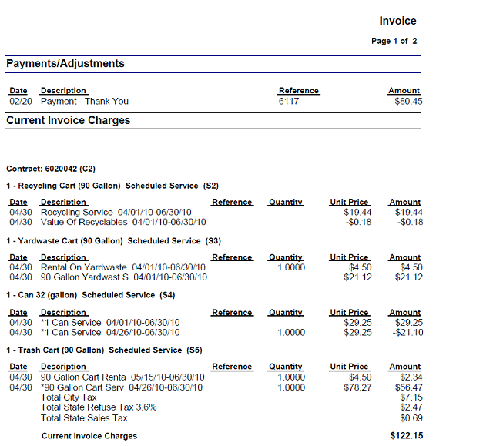
Post “Full Charge” Billing Example
- For cancelled service (cancelled on 4/26/10) shows original quarterly rate for full billing period and then a pro-rated credit for cancelled service beginning on cancellation date.
- For new service shows full quarterly rate and pro-rated charge from start date to end of billing cycle.

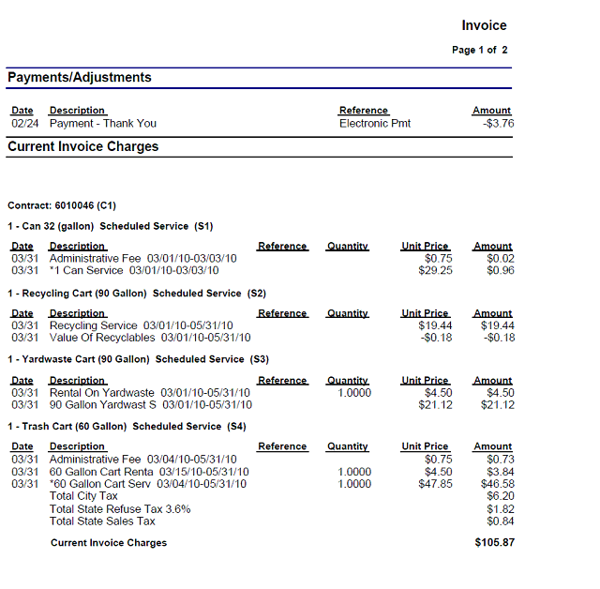
- For cancelled service (cancelled on 3/3/10) shows original quarterly rate for full billing period and a pro-rated charge from start of billing period to cancellation date.
- For new service shows full quarterly rate and pro-rated charge from start date to end of billing cycle.

Pre “Full Charge” Billing Example

