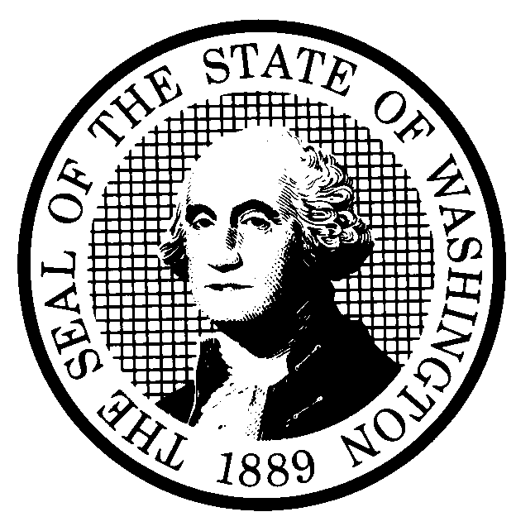 | PREPROPOSAL STATEMENT OF INQUIRY |  | CR-101 (June 2004)  (Implements RCW 34.05.310)  Do NOT use for expedited rule making
Agency: Washington Utilities and Transportation Commission

Subject of possible rule making: This rulemaking inquiry would review WAC 480-120-450, Enhanced 9-1-1 (E911), obligations of local exchange companies, to consider, among other things, amendment of the current rule, or adoption of additional rules to address the allocation of Enhanced 911 implementation costs between local exchange telecommunications companies and Public Safety Answering Points. Docket No. UT-041629.
Statutes authorizing the agency to adopt rules on this subject: RCW 80.01.040, RCW 80.04.160.
Reasons why rules on this subject may be needed and what they might accomplish: On September 9, 2004, the E911 Emergency Division (EMD) of the Military Department filed a petition to amend WAC 480-120-450. The EMD petition asked the Commission to amend the rule to establish a uniform demarcation point in the E911 network for carrier cost recovery from Public Safety Answering Points (PSAPs). On October 29, 2004, the Commission denied the petition because EMD’s petition did not provide sufficient information, including proposed rule language, to initiate a rulemaking under RCW 34.05.320. Instead, the Commission indicated that it would explore the questions raised by EMD’s petition by filing a CR-101, Preproposal Statement of Inquiry, with the Code Reviser. Review of the current rule and consideration of additional rules on this subject could, among other things, establish a uniform method of allocating E-911 implementation costs between local exchange carriers and PSAPs.
Identify other federal and state agencies that regulate this subject and the process coordinating the rule with these agencies: Military Department, Emergency Management Division.
Process for developing new rule (check all that apply):
Negotiated rule making
Pilot rule making
Agency study
Other (describe)
The Commission anticipates one or more workshops.
How interested parties can participate in the decision to adopt the new rule and formulation of the proposed rule before publication:
(List names, addresses, telephone, fax numbers, and e-mail of persons to contact; describe meetings, other exchanges of information, etc.)
Interested persons may file written comments by December 10, 2004, with the Secretary, Washington Utilities and Transportation Commission, P.O. Box 47250, 1300 S. Evergreen Park Drive, S.W., Olympia, Washington, 98504-7250; Telephone (360) 664-1234; Facsimile (360) 586-1150. Comments may also be provided by e-mail to records@wutc.wa.gov>. For specific information regarding opportunities for written comment and to ensure receipt of further information concerning this rulemaking, please see the attachment to this form.
The Commission anticipates that it will host a stakeholder workshop on the subject of this rulemaking.
DATE  November 12, 2004 |  | CODE REVISER USE ONLY
CAROLE J. WASHBURN |  | Filed with the Code Reviser’s Office  November 12, 2004, 10:55 a.m.  WSR 04-23-051
SIGNATURE
TITLE
Executive Secretary
WASHINGTON UTILITIES AND TRANSPORTATION COMMISSION
CR-101 - ATTACHMENT
DOCKET NO. UT-041629

(e) Interested persons may contact the Secretary, Washington Utilities and Transportation Commission, P. O. Box 47250, Olympia, Washington, 98504-7250, 360-664-1174 (Fax: 360-586-1150).

WRITTEN COMMENTS
Written comments may be submitted to the Commission at the address given above and should be filed with the Commission no later than Friday, December 10, 2004.
Electronic copies. The Commission requests that comments be provided in electronic format to enhance public access, for ease of providing comments, to reduce the need for paper copies, and to facilitate quotations from the comments. Comments may be submitted by electronic mail to the Commission’s Records Center at records@wutc.wa.gov. Please include:

- The docket number of this proceeding (UT-041629)
- The commenting party’s name
- The title and date of the comment or comments

An alternative method for submitting comments may be by mailing/delivering an electronic copy on a 3 ½ inch, IBM-formatted, high-density disk, in .pdf Adobe Acrobat format or in Word 97 or later. Include all of the information requested above. The Commission will post on the Commission’s web site all comments that are provided in electronic format. The web site is located at http://www.wutc.wa.gov/041629. If you are unable to file your comments electronically or to submit them on a disk, the Commission will always accept a paper document.

Opportunity for further comment is anticipated. Information about the schedule and other aspects of the rulemaking, including comments, will be posted on the Commission’s web site as it becomes available. If you wish to receive further information on this rulemaking you may (1) call the Commission’s Records Center at 360-664-1234, (2) e-mail the Commission at <records@wutc.wa.gov>, or (3) mail written comments to the address above to the attention of Carole J. Washburn, Secretary. When contacting the Commission, please refer to Docket No. UT-041629 to ensure that you are placed on the appropriate service list. Questions may be addressed to Rebecca Beaton at (360) 664-1287 or e-mail at rbeaton@wutc.wa.gov.

TO CONTINUE RECEIVING NOTICES AND INFORMATION ABOUT THIS RULEMAKING -- The Commission wants to ensure its mailings are sent to persons who are interested in the topic and want to receive that information. ANY PERSON WHO COMMENTS will continue to receive notices and information. If you do not submit comments but wish to remain on the mailing list for this rulemaking, please advise the Records Center by any one of the following methods: (1) send a note with your name, address (or a copy of your mailing label), and telephone and fax numbers referencing Docket No.UT-041629, and the words "Please keep me on the mailing list"; or (2) E-mail your name, address, telephone and fax numbers, referencing Docket No. UT-041629, and the words "Please keep me on the mailing list" to <records@wutc.wa.gov>. Please note that all information in the mailings will be accessible through the Commission's Internet web site at <http://www.wutc.wa.gov/041629>. THOSE PARTIES WHO DO NOT RESPOND MAY NOT RECEIVE FURTHER MAILINGS OR INFORMATION ON THE RULEMAKING.
NOTICE

