DRAFT

Adoption by reference rulemaking - 2001

A-010827

Chapter 480-14 Motor Carriers Excluding Household Goods Carriers and Common Brokers

Repeal - Moved to WAC 480-14-999

Comments:
1. Repeal and move to 480-14-999.

Amend

WAC 480-14-040 Definitions.

As used in this chapter, the following definitions shall apply:
(1) The term "motor carrier" means "common carrier," "private carrier" and "exempt carrier," as herein defined.
(2) The term "common carrier" means any person who undertakes to transport property, including general commodities, materials transported by armored car service, and/or hazardous materials, for the general public by motor vehicle for compensation, including motor vehicle operations of other carriers by rail or water and of express or forwarding companies. For the purposes of chapter 480-12 15 WAC, the term "common carrier" also includes persons engaged in the business of transporting household goods as common carriers or of providing, contracting for, or undertaking to provide transportation of property for compensation over the public highways of the state of Washington as brokers or forwarders.
(3) The term "private carrier" means a person who, in its own vehicle, transports only property owned or being bought or sold by it in good faith and only when such transportation is purely an incidental adjunct to some established private business owned or operated by it in good
faith.
(4) The term "exempt carrier" means any person operating a vehicle exempted from certain provisions of the act under RCW 81.80.040.
(5) The terms "registered carrier" and "registered exempt carrier" have the meanings set out in WAC 480-14-290.
(6) The term "carrier of hazardous materials" means any person who transports radioactive materials, hazardous waste, hazardous materials and hazardous substances as defined in Title 49 Code of Federal Regulations. Information about 49 CFR regarding the version currently in effect and where to obtain it is set out in WAC 480-14-999.
(7) The term "carrier of general commodities" means any person transporting the property of others for compensation, except persons performing the service of transporting household goods as defined in WAC 480-12-990 15-020.
(8) The term "armored car service" means carriers transporting property of very high value (gold, silver, currency, valuable securities, jewels and other property of very high value) using specially constructed armored trucks and providing policy protection to safeguard freight while it is being transported and delivered. It also means carriers which operate ordinary equipment in the carriage of high value commodities when guards are necessary to accompany the shipment.

Comments:
1. Change in subsection (2) corrects the WAC chapter reference.
2. Change in subsection (6) adds a cross-reference to 480-14-999.
3. Change in subsection (7) corrects the WAC chapter reference.

Amend
WAC 480-14-070 Federal regulations, 49 CFR, Part 390 -- Adoption by reference General Applicability and Definitions.
(1) The provisions of Title 49, Code of Federal Regulations, Part 390, are adopted and prescribed by the commission, except carriers operating exclusively in intrastate commerce shall not be subject to the provisions of paragraph (c) of section 390.3, section 390.21, and for the purposes of application of federal regulations on intrastate commerce. Information about 49 CFR regarding the version currently in effect and where to obtain it is set out in WAC 480-14-999.
(2) With respect to section 390.5, the definitions shown for "exempt intracity zone," "farm to market agricultural transportation," "farm vehicle driver," "farmer," "private motor carrier of passengers," "private motor carrier of property," "school bus," and "school bus
operation" shall not apply.
(3) Whenever the designation "commercial motor vehicle" is used, it shall mean a motor carrier as defined in RCW 81.80.010.
(4) "Exempt motor carrier," "motor carrier," "motor vehicle," and "private carrier" shall have the meanings subjoined to them by RCW 81.80.010.
(5) Whenever the designation "director" is used it shall mean the Washington utilities and transportation commission.

Comments:
1. Section title change.
2. Change in subsection (1) adds a cross-reference to 480-14-999.

Amend
WAC 480-14-250 Insurance requirements; cause for suspension or cancellation.
(1) Requirements. Each applicant for common carrier authority, and each common carrier, shall file with the commission evidence of currently effective liability and property damage insurance written by a company authorized to write such insurance in the state of Washington, covering each motor vehicle as defined in RCW 81.80.010 used or to be
used under the permit granted.
(a) For vehicles with gross vehicle weight ratings of ten thousand pounds or more, filings shall be for the amount shown on the following table:
Category of Carrier Operation Filing Required
1. Property (nonhazardous) . . . . . . . . . . . . $750,000

2. Hazardous substances, as defined in 49 CFR 171.8 transported in cargo tanks, portable tanks, or hopper-type vehicles with capacities in excess of 3,500 water gallons; or in bulk Class A or B explosives, poison gas (Poison A), liquified compressed gas or compressed gas; or highway route controlled quantity radioactive
materials as defined in 49 CFR 173.455 . . . . . . . . . . . . $5,000,000

3. Oil listed in 49 CFR 172.101; hazardous waste, hazardous materials and hazardous substances defined in 49 CFR 171.8 and listed in 49 CFR 172.101, but not mentioned in 2. above or in 4.
below . . . . . . . . . . . . $1,000,000

4. Any quantity of Class A or B explosives; any quantity of poison gas (Poison A); or highway route controlled quantity radioactive
materials as defined in 49 CFR 173.455 . . . . . . . . . . . . $5,000,000

(b) For vehicles with gross vehicle weight ratings less than ten thousand pounds, filings shall be for the amounts shown on the following table:
Category of Carrier Operation Filing Required

1. Property (nonhazardous) . . . . . $300,000
2. Property (hazardous); any quantity of Class A or B
explosives; any quantity of poison gas (Poison A);
or highway route controlled quantity radioactive
materials as defined in 49 CFR 173.455 . . . . . . . . . . . . $5,000,000

(c) For taxicabs whose only operation subject to commission jurisdiction is the operation of small parcel general freight service under a permit issued pursuant to chapter 81.80 RCW shall comply with the provisions of RCW 46.72.040 and 46.72.050 in lieu of the above. Such carriers must comply with the reporting requirements of this section.
(d) Carriers registering under WAC 480-14-300 as registered interstate carriers may provide evidence of insurance in the amount prescribed by the Interstate Commerce Commission or its successor agency written by a company authorized to write insurance in any state.
(e) Failure to file and keep such insurance in full force and effect shall be cause for dismissal of an application or cancellation of a permit.
(f) Evidence of insurance shall be submitted either on a uniform motor carrier bodily injury and property damage liability certificate of insurance, filed in triplicate with the commission, or a written binder issued by an insurance agent or insurance company evidencing the coverages as
required above. If a binder is submitted, it shall be effective for not longer than sixty days, during which time the carrier must file the required evidence of insurance.
(2) Insurance, continuation of. Proper evidence of continued insurance shall be filed with the commission not less than ten days prior to termination date of insurance then on file in order that there shall be no question of continuous coverage as required by law.
(3) Insurance endorsement. All liability and property damage insurance policies issued to motor freight carriers shall carry a "uniform motor carrier bodily injury and property damage liability endorsement."
(4) Insurance termination. All insurance policies issued under the requirements of chapter 81.80 RCW shall provide that the same shall continue in full force and effect unless and until canceled by at least thirty days' written notice served on the insured and the Washington utilities and transportation commission by the insurance company, with the thirty days' notice to commence to run from the date notice is actually received by the commission, except for binders
which may be cancelled on ten days' written notice. Notice of cancellation or expiration shall be submitted in duplicate on forms prescribed by the commission and shall not be submitted more than sixty days before the desired termination date, except binders which may be cancelled by
written notification from the insurance agency or the insurance company on ten days' written notice. No common carrier may operate upon the public highways of this state without insurance as required in this section. The permit of any common carrier who fails to maintain evidence on file that its insurance is in current force and effect as required herein shall be suspended by operation of law beginning with the time of the failure, until the permit is canceled or the cause of the suspension is cured and the permit is reinstated. The commission will make a good
faith effort to notify carriers of impending suspension for failure to maintain evidence of insurance and will make a good faith effort to enter a timely order of suspension, but failure to do so shall not invalidate the suspension.
(5) Information about 49 CFR regarding the version currently in effect and where to obtain it is set out in WAC 480-14-999.

Comments:
1. New subsection (5) adds a cross-reference to 480-14-999.

Amend

WAC 480-14-360 Equipment -- Inspection -- Ordered out-of-service for repairs.
(1) All motor vehicles operated under chapter 81.80 RCW shall be maintained in a safe and sanitary condition. They shall at all times be subject to inspection by the commission and its duly authorized representatives who shall have power to order out of service any vehicle meeting the out-of-service criteria standards contained in the North American Uniform Out-of-Service Criteria, or which is not being operated in compliance with state laws in regard to equipment or method.
(2) Equipment standards. The purpose of this section is to identify critical vehicle inspection items and provide criteria for placing a vehicle(s) in an out-of-service category subsequent to a safety inspection. The criteria for out-of-service condition are those defined in the North American Uniform Out-of-Service Criteria. Copies of this document may be viewed at the commission branch of the Washington state library, located with the commission headquarters office, and are available from the commission upon request. Information about the North American Out-of-Service Criteria regarding the version currently in effect and where to obtain it is set out in WAC 480-14-999.
(3) Out-of-service condition. When any vehicle(s) is in out-of-service condition, no motor carrier shall require nor shall any person operate such motor vehicle declared and marked "out-of-service" until all required repairs have been satisfactorily completed.

Comments:
1. Change in subsection (2) adds a cross-reference to 480-14-999.

Amend
WAC 480-14-370 Equipment -- Drivers -- Safety.
In addition to other laws and regulations of this state, all motor vehicles operating under chapter 81.80 RCW shall comply with the following:
(1) Adoption of United States Department of Transportation motor carrier safety regulations. The rules and regulations governing motor carrier safety prescribed by the United States Department of Transportation in Title 49, Code of Federal Regulations, part 392; part 393; part 396; part 397; as well as and including all appendices and amendments thereto are adopted and prescribed by the commission to be observed by all common, private, registered, and registered exempt carriers operating under chapter 81.80 RCW. Exceptions: Carriers operating exclusively in intrastate commerce are not subject to provisions of 49 CFR, part 392.2 and with respect to 49 CFR, part 396.11, no driver vehicle inspection report need be filed if no defects are found. Information about 49 CFR regarding the version currently in effect and where to obtain it is set out in WAC 480-14-999.
(2) Whenever the designations "director, office of motor carrier safety," "director, regional motor carrier safety office," "regional highway administrator," and "federal highway administration" are used in the respective parts of Title 49, Code of Federal Regulations, as described in subsection (1) of this section, such designations for the purpose of this rule shall mean the "Washington utilities and transportation commission."
(3) Safety chains or other load fastening devices. Any motor truck, truck tractor, trailer, semi-trailer, or any combination thereof, transporting logs upon a public highway where binder devices are required, shall have the load thereon securely fastened and protected as follows:
(a) Placement and number of wrappers required on log trucks using stakes.
(i) In the hauling of one log loads, one wrapper chain or cable shall be required and it shall be secured to the rear bunk and the log shall be properly blocked or secured in a manner which will prevent it from rolling or shifting. An additional wrapper, secured to the front bunk, is optional.

(ii) In the hauling of two log loads, not less than two wrapper chains or cables shall be used to secure the load. The logs shall be properly blocked to prevent them from rolling or shifting.

Illustration of placement for two log load.
(iii) On loads consisting of three or four logs not over forty-four feet in length, the load shall be secured by not less than two properly spaced wrapper chains or cables. Ends of short logs not secured by such wrappers shall be secured with extra wrappers. If any log is over forty-four feet in length, the load shall be secured by not less than three properly spaced wrappers.
(iv) Loads consisting of five or more logs, when the logs are all seventeen feet or less in length, shall be secured by not less than two properly spaced wrappers. Loads consisting of five or more logs, when any log is over seventeen feet in length, shall be secured by not less than three properly spaced wrappers.
(b) Placement and number of wrappers required on log trucks using chock blocks.
(i) In the hauling of one log load, one wrapper chain or cable shall be required and secured to the rear bunk and the log shall be properly blocked in a manner to prevent it from rolling or shifting.
(ii) One additional wrapper chain or cable shall be required on log trucks using chock blocks over and above the requirements in (a)(iii) and (iv) of this subsection.
(c) Placement and number of wrappers required on crosswise loaded trucks, trailers, etc. In the case of short logs loaded crosswise, the following method of securing the load shall be used if the truck trailer is not provided with solid ends of a height sufficient to prevent any log in the load from rolling off: Not less than two chock blocks shall be used at each open end of the vehicle and the load shall be held with at least two wrapper chains or cables. The wrappers shall be firmly attached to the end of the truck or trailer. Rigid standards or stakes may be used in lieu of chock blocks but each such standard or stake shall be either rigidly connected to the bed of the truck or trailer or shall be placed in a tight fitting socket at least twelve inches in depth. Other means furnishing equivalent security may be acceptable.
(d) Wrapper placement. When two wrappers are required, they shall be applied within six feet of the front and rear bunks. When more than two wrappers are required, the front and back binder shall be applied within six feet of the front and rear bunks.
(e) Short logs. To properly secure short logs, binders shall be placed near the end, not less than twelve inches from the end of the log.
(f) Log on top or in outside saddle. No log loaded on top or in outside saddles of a load shall be transported unless secured by not less than two wrapper chains or cables, one of which shall be placed near each end of such log.
(g) Fasten in place. All wrappers and binders shall be fastened in place prior to tightening to prevent the displacement of logs on the top of the load.
(h) Surround load. All wrapper chains or cables, except in the case of one log loads, shall entirely surround the load. This does not apply to gut-wrappers.
(i) Gut-wrappers. Gut-wrappers, when used, shall be adjusted so as to be tightened by, but not carry the weight of the logs above them.
(j) Wrappers and binders to be placed before leaving immediate loading area. Wrappers and binders shall be placed and tightened around the completed load before the truck leaves the immediate loading area.
(k) Construction of wrappers and binders. Wrapper chains or cables, binders, fasteners, or attachments thereof, used for any purpose as required by these standards, shall have a minimum breaking strength of not less than fifteen thousand pounds and shall be rigged so that it can be safely released.
(l) Bundle straps or banding. For the purposes of this standard, applied bundle straps or banding are not acceptable as wrappers and binders.
(m) Loose ends secured. All loose ends of wrapper chains or cables shall be securely fastened so as to prevent their swinging free in a manner that will create a hazard.
(n) Trucks in sorting yards. Trucks and trailers used around sorting yards, etc., which travel at slow speeds, will not be required to use wrappers providing all logs are contained by and lie below the height of the stakes and there are no persons on the ground exposed to such traffic.
(o) Binder hook design. Binders for securing wrappers on logging trucks shall be fitted with hooks of proper size and design for the wrapper chain being used.
(p) Defective wrappers. Wrappers shall be removed from service when any of the following conditions exist:
(i) Excessively worn links on chains;
(ii) Deformed or stretched chain links;
(iii) Cracked chain links;
(iv) Frayed, stranded, knotted, or otherwise defective wire rope.
(q) Binder extensions. Pipe extension handles (swedes) for tightening or securing binders shall be limited to not longer than thirty-six inches. Care shall be taken that a sufficient amount of the pipe extends over the binder handle.
(r) Defective binders. Defective binders shall be immediately removed from service.
Note:
See the following Diagrams for illustrations of placement and number of load fastening devices.

PLACEMENT AND NUMBER OF WRAPPERS
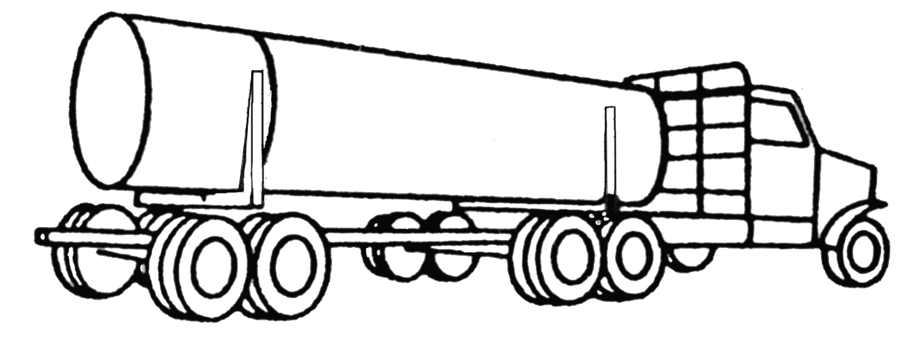

One log load

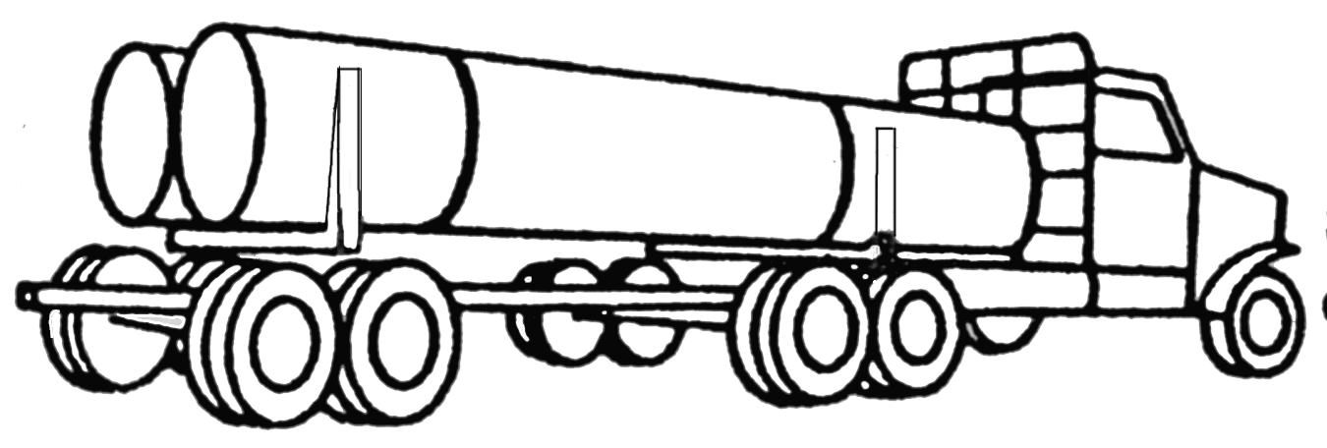

Two log load

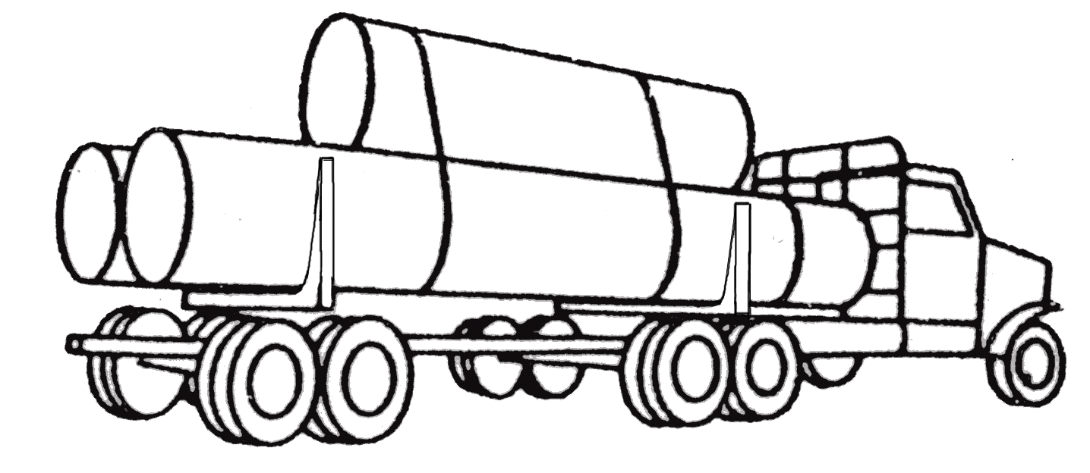

Three or four log load forty-four feet or less

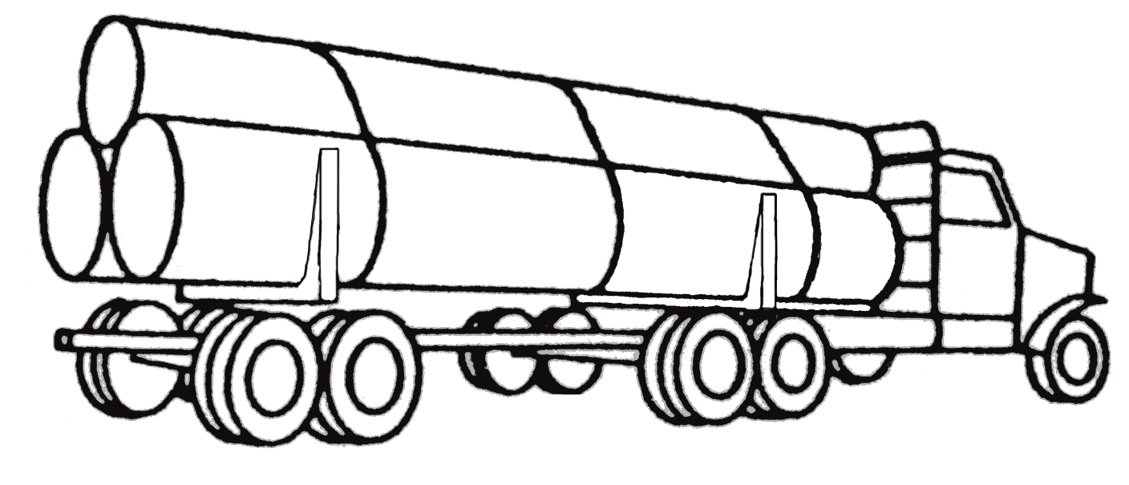

Three or four log loads more than forty-four feet

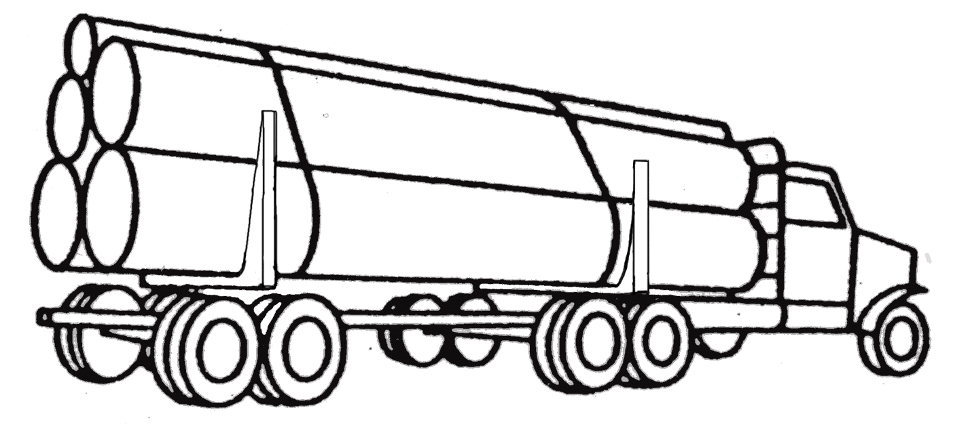

Five or six log load all logs seventeen feet or less

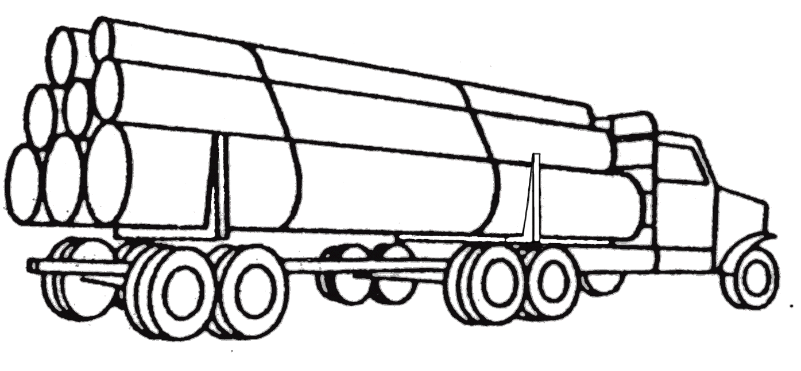

Seven or more log load all logs seventeen feet or less

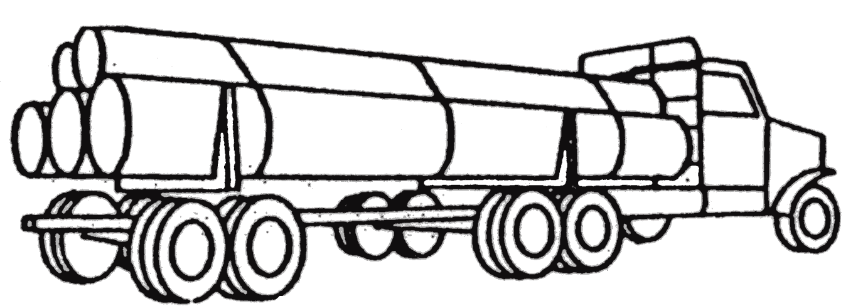

Five or more log load if any logs are more than seventeen feet

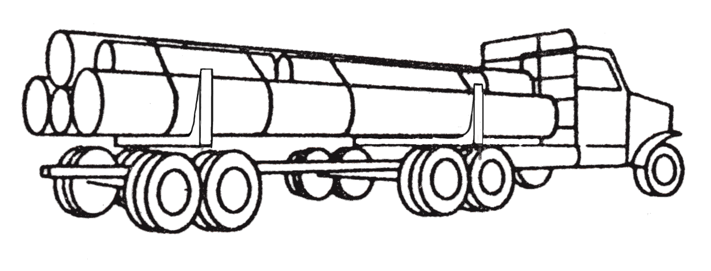

Outside logs or top logs

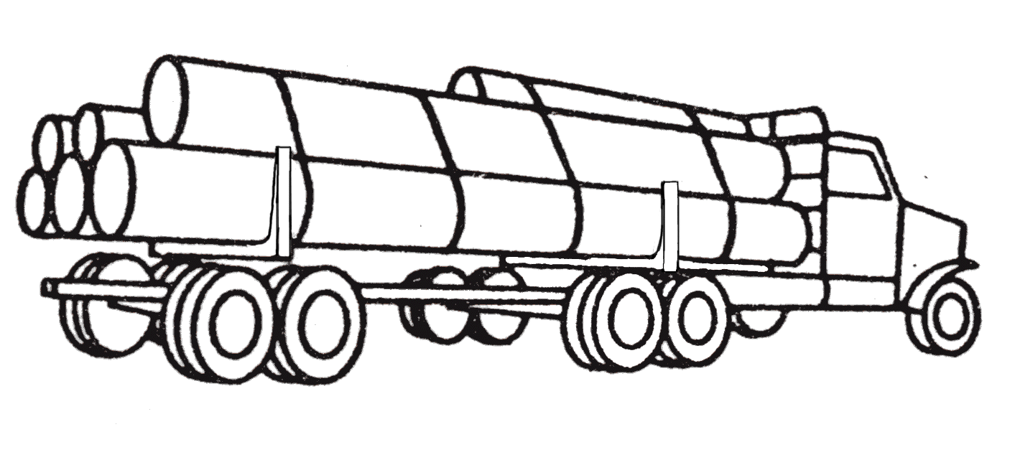 A wrapper shall be near each bunk

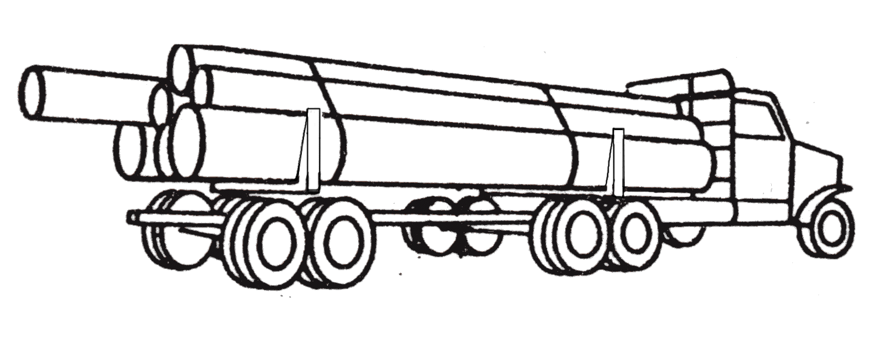Proper support for logs

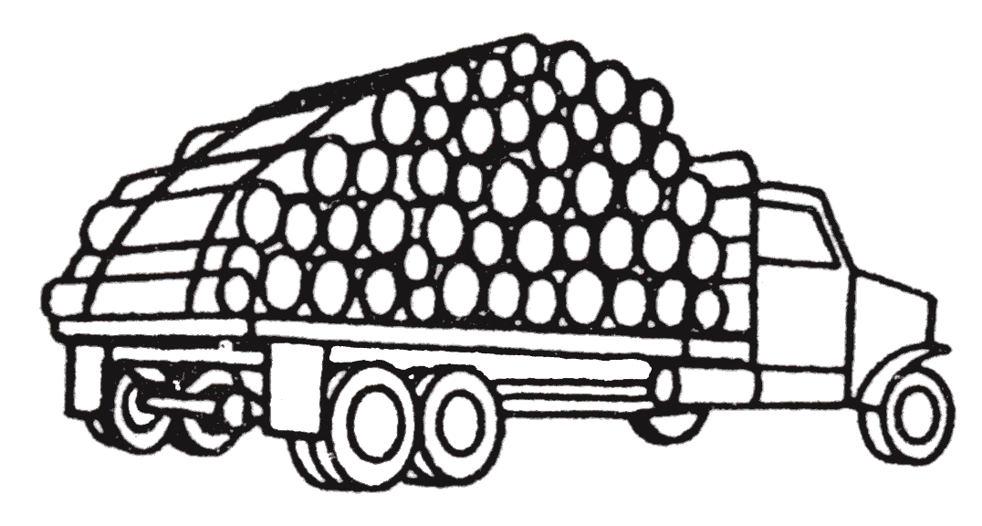 Short logs loaded crosswise

Note: All loads of logs on logging trucks equipped with chock blocks instead of stakes, shall have at least one additional wrapper over and above the requirements for trucks equipped with stakes, excepting on one and two log loads and trucks with short logs loaded crosswise.
(4) Approved load fastening devices. The following binder devices are hereby approved for purposes of transporting logs as referred to in subsection (3) of this section, provided that they meet a breaking strength of at least fifteen thousand pounds:
(a) Three-eighths inch high-test steel chain;
(b) One-half inch diameter steel cable; and
(c) Steel strapping not less than two inches by fifty one-thousandths inches in dimension.
(5) Anti-spray devices. Every vehicle shall be equipped with a device adequate to effectively reduce the wheel spray or splash of water from the roadway to the rear thereof. All such devices shall be as wide as the tires behind which they are mounted and extend downward at least to the center of the axle.
(6) Pole trailers.
(a) Welded reach extension prohibited. No motor carrier shall operate a pole trailer that has had the length of its reach extended by welding or any other means, except that a telescopic reach manufactured and designed to extend by using an inner and outer reach with securing clamp shall
be permissible. In addition to the securing clamp on a telescopic reach there must be a secondary device to keep the inner and outer reach from separating. The term "reach" as used in this rule means the steel tube that joins the axle(s) of the pole trailer to the rear of the power unit towing the trailer.
(b) Damaged reach. No motor carrier shall operate a pole trailer that has sustained cracks to the reach nor shall it be permissible to operate a trailer that has had welded repair or repair of any kind made to cracks in the reach.
(c) Empty pole trailers. Any empty pole trailer loaded upon any truck-tractor (except pole trailers that straddle the truck-tractor bunks) shall be fastened to the truck-tractor by not less than one 5/16 inch, grade seven or better chain and one tensioning or locking device in such a manner as to prevent the pole trailer from falling or shifting while in transit. The chain shall be securely fastened between the forward point on the reach tunnel and a point on the truck-tractor frame or from either axle of the pole trailer to a point directly below on the truck-tractor frame or crossmember.
(7) Qualifications of drivers. Adoption of United States Department of Transportation motor carrier safety regulations. The rules and regulations governing qualifications of drivers prescribed by the United States Department of Transportation in Title 49, Code of Federal Regulations, part 382, part 383, and part 391, as well as and including all appendices and amendments thereto, are adopted and prescribed by the commission to be observed by all common, private, registered, and registered exempt carriers operating under chapter 81.80 RCW. Information about 49 CFR regarding the version currently in effect and where to obtain it is set out in WAC 480-14-999. except Exception: Ccarriers operating exclusively in intrastate commerce:
(a) The minimum age requirement for drivers prescribed in subparagraph (1) of paragraph 391.11(b) shall be eighteen years of age.
(b) With respect to the limited exemption prescribed in section 391.61, the time period identified therein shall be the period of time prior to October 20, 1979.
(c) With respect to the limited exemptions prescribed in sections 391.65 and 391.71, the time periods identified in these sections shall have as a starting date October 20, 1979.
(d) Sections 391.21, 391.23, 391.25, 391.27, 391.31, 391.33, 391.35, and 391.37 shall not apply to a single vehicle owner driver private carrier, or to a single vehicle owner driver common carrier when operating under its own permit.
(e) Section 391.49 shall not apply when a driver has obtained from the department of licensing the proper drivers license endorsement and restrictions (if any) for the operation of the motor vehicle the person is driving.
(f) The provisions of paragraphs (a) and (b) of section 391.2, section 391.69, subparagraph (2) of paragraph 391.71(a), and subparagraph (4) of paragraph 391.71(b) shall not apply.
(g) Carriers operating vehicles with a manufacturer's gross vehicle weight rating (GVWR) of less than ten thousand pounds shall not be subject to the provisions of part 391 unless the vehicle is being used to transport hazardous materials of a type or quantity that requires the vehicle to be marked or placarded in accordance with WAC 480-14-390.
(8) Out-of-service criteria. All drivers operating motor vehicles under chapter 81.80 RCW shall do so in compliance with the safety rules and regulations defined therein. Duly authorized personnel of the commission shall have the power to order out-of-service any driver found to be operating in violation of those rules and regulations. The criteria for conditions under which a driver may be ordered out-of-service are those defined in the North American Uniform Out-of-Service Criteria on the date specified in WAC 480-14-999.Copies of this document are available from the commission upon request.

(9) Whenever the designation "director, office of motor carrier safety" is used in the respective parts of Title 49, Code of Federal Regulations, as described in subsection (6) of this section, such designation for the purpose of this rule shall mean the "Washington utilities and transportation commission," located in Olympia, Washington.

Comments:
1. Change in subsection (1) adds a cross-reference to 480-14-999.
2. Change in subsection (7) adds a cross-reference to 480-14-999.
3. Change in subsection (8) adds a cross-reference to 480-14-999.

Amend

WAC 480-14-380 Hours of service -- On duty -- Adoption of f Federal safety regulations.
The rules and regulations adopted by the United States Department of Transportation in Title 49, Code of Federal Regulations, part 395 in effect on the date specified in WAC 480-14-999 are adopted and prescribed by the commission to be observed by all common, private, registered and registered exempt carriers operating under chapter 81.80 RCW, except:
(1) A driver who is driving a motor vehicle in the hauling of logs from the point of production or in dump truck operations, exclusively in intrastate commerce, shall not drive nor be permitted to drive more than twelve hours following eight consecutive hours off duty. Such driver shall not be on duty nor be permitted to be on duty more than ninety hours in any period of seven consecutive days.
(2) A driver who is driving a motor vehicle in the hauling of agricultural products from the point of production on farms, exclusively in intrastate commerce, shall not drive nor be permitted to drive more than twelve hours following eight consecutive hours off duty. Such driver shall not be on duty nor be permitted to be on duty more than ninety hours in any period of seven consecutive days.
(3) The rules and regulations governing driver's daily logs prescribed in Title 49, Code of Federal Regulations, section 395.8 and adopted in this section, do not apply to a driver who drives exclusively in intrastate commerce and wholly within a radius of one hundred miles of the terminal or garage at which he or she reports for work, if the motor carrier who employs the driver maintains and retains for a period of one year accurate and true records showing the total number of hours of driving time and the time that the driver is on duty each day and the time at which the driver reports for, and is released from, duty each day. A tacograph showing the required driver hourly information may be substituted for the required records.
(4) Carriers operating exclusively in intrastate commerce operating vehicles with a manufacturer's gross vehicle weight rating (GVWR) of less than ten thousand one pounds shall not be subject to the provisions of part 395 unless the vehicle is being used to transport hazardous materials of a type or quantity that requires the vehicle to be marked or placarded in accordance with WAC 480-14-390.

Comments:
1. Changes title and adds a cross-reference to WAC 480-14-999.

Amend

WAC 480-14-390 Hazardous materials regulations.
(1) The rules and regulations governing hazardous materials prescribed by the United States Department of Transportation in Title 49, Code of Federal Regulations, parts 170-189, as well as and including all appendices and amendments thereto in effect on the date specified in WAC 480-14-999, are adopted and prescribed by the commission to define hazardous materials for motor vehicle transportation purposes, and to state the precautions that must be observed in storage, packaging, loading, and unloading such materials, and in maintaining, placarding, marking, and certifying motor vehicles and equipment used in transporting such materials, and in the maintenance of shipping papers prepared in conjunction with transporting such materials. The rules and regulations adopted and prescribed by this rule shall be observed by all common and registered carriers operating in this state.
(2) In addition to any accident reporting requirement now or hereafter prescribed by the commission, every common and registered carrier operating in this state who reports to the United States Department of Transportation any incidents occurring in this state involving hazardous materials, shall send a copy of any such report to the commission.
(3) Out-of-service criteria.
(a) All motor vehicles operated under chapter 81.80 RCW shall be operated in compliance with the rules and regulations governing the transportation of hazardous materials. They shall at all times be subject to inspection by the commission and its duly authorized representatives who shall have power to order out-of-service any vehicle meeting the standards set forth in this section, or is not being operated in compliance with laws in regard to equipment or method.
(b) Standards. The purpose of this section is to identify critical hazardous materials inspection items and provide criteria for placing a vehicle(s) in an out-of-service or restricted service category subsequent to an inspection. The criteria for out-of-service condition or restricted service condition are those defined in the North American Uniform Out-of-Service Criteria in effect on the date specified in WAC 480-14-999. Copies of this document are available from the commission upon request.
(i) Out-of-service condition. No motor carrier shall require nor shall any person operate a motor vehicle(s) when an out-of-service condition is found to exist. The vehicle shall not be allowed to continue in operation until the unsafe condition is corrected and the shipment thereon complies with applicable laws, rules, and regulations: Provided, That if safety may be jeopardized by an out-of-service action at the inspection site, the vehicle(s) may be escorted to a safer location.

Comments:
1. Change in subsection (1) adds a cross-reference to 480-14-999.
2. Change in subsection (7) adds a cross-reference to 480-14-999.

Amend

WAC 480-14-400 Transportation of radioactive materials -- Driving and parking rules.

(1) Attendance and surveillance of motor vehicles.
(a) Except as provided in (b) of this subsection, a motor vehicle containing an amount of radioactive material requiring highway route control pursuant to CFR part 173.403 in effect on the date specified in WAC 480-14-999 must be attended at all times by its driver or a qualified representative of the motor carrier that operates it.
(b) Subdivision (a) of this subsection shall not apply if all of the following conditions exist:
(i) The vehicle is located on the property of the motor carrier, on the property of a shipper or consignee of the radioactive material, or in a safe haven; and
(ii) The lawful bailee of the radioactive material is aware of the nature of the radioactive material the vehicle contains and has been instructed in the procedures that must be followed in emergencies; and
(iii) The vehicle is within the bailee's unobstructed field of view.
(c) For purposes of this section:
(i) A motor vehicle is attended when the person in charge of the vehicle is on the vehicle, awake, and not in a sleeper berth, or is within one hundred feet of the vehicle with an unobstructed field of view;
(ii) A qualified representative of a motor carrier is a person who:
(A) Has been designated by the carrier to attend the vehicle;
(B) Is aware of the nature of the radioactive materials contained in the vehicle;
(C) Has been instructed in the procedures to be followed in emergencies; and
(D) Is authorized to move the vehicle and has the means and ability to do so.
(d) A safe haven is an area specifically approved in writing by local, state or federal government authorities for the parking of unattended vehicles containing highway route controlled quantities of radioactive material.
(e) The rules in this section do not relieve a driver from any obligation imposed by law relating to the placing of warning devices when a motor vehicle is stopped on the public street or highway.

(2) Parking. A motor vehicle which contains an amount of radioactive material requiring highway route control must not be parked:
(a) On or within five feet of the traveled portion of a public street or highway;
(b) On private property (including premises of a fueling or eating facility) without the knowledge and consent of the person who is in charge of the property and who is aware of the nature of the hazardous materials the vehicle contains; or
(c) Within three hundred feet of a bridge, tunnel, dwelling, building, or place where people work, congregate, or assemble, except for brief periods when the necessities of operation require the vehicle to be parked and make it impracticable to park the vehicle in any other place.

Comments:
1. Change in subsection (1) adds a cross-reference to 480-14-999.

New Section

WAC 480-14-999 Adoption by reference.

In this chapter, the commission adopts by reference all or portions of regulations and standards identified below. They are available for inspection at the commission branch of the Washington state library. The publications, effective dates, references within this chapter, and availability of the resources are as follows:
(1) North American Uniform Out-of-Service Criteria (CVSA) is published by the Commercial Vehicle Safety Alliance (CVSA).
(a) The commission adopts the version in effect on April 1, 2001.
(b) This publication is referenced in WAC 480-14-360, 480-14-370 and 480-14-390.
(c) The North American Out-of-Service Criteria is a copyrighted document. Copies are available from CVSA in Bethesda, Maryland.
(2) Title 49 Code of Federal Regulations, cited as 49CFR, including all appendices and amendments is published by the United States Government Printing Office.
(a) The commission adopts the version if effect on October 1, 2000.
(b) This publication is referenced in WAC 480-14-040, 480-14-070, 480-14-250,
480-14-360, 480-14-370, 480-14-380, 480-14-390 and 480-14-400.
(c) Copies of Title 49 Code of Federal of Regulations are available from the Seattle Office of the Government Printing Office and from various third party vendors.

Comments:
1. New section created to change the section number to be consistent through out Title 480 chapters.
2. Adoption by reference dates changed.
3. Cross-references added that identify the sections within this chapter that refer to adopted material.

