BEFORE THE WASHINGTON UTILITIES AND TRANSPORTATION COMMISSION

DOCKET NO. UE-160228
DOCKET NO. UG-160229

REBUTTAL TESTIMONY OF
ELIZABETH M. ANDREWS
REPRESENTING AVISTA CORPORATION

Revised October 11, 2016 per Order No. 04

TABLE OF CONTENTS
Revised – October 11, 2016

Description Page

I. Introduction 2

II. Summary of Updated Electric and Natural Gas Revenue Requirement 6

III. Avista Updated Attrition Models 9

A. Electric Updated Attrition Models 9

B. Natural Gas Updated Attrition Models 15

IV. Avista Proposed VS. Staff Proposed Attrition Models 17

Similarities Between Avista and Staff Models 19

Differences Between Avista and Staff Models 20

Explanation of Major Differences Between Avista and Staff

Attrition Models 22

1) O&M Growth Rate 23

2) After Attrition Adjustments 26

a) Spokane River Projects 28

b) 2017 Advanced Metering Infrastructure (AMI) Project 32

c) Total Transfer to Plant by Functional Group 33

3) Regression Analysis 37

a) Granular Data 37

b) Natural Gas: Non-Linear versus Linear Regression Analysis 38

c) Other Revenue Growth 43

V. Mr. Mullins’ ICNU/NWIGU Attrition Models 44

VI. Mr. Watkins’ Distribution O&M and A&G Testimony 48

VII. Alternative of Deferred Accounting Treatment for AMI and Montana Lease 51

A. Advanced Metering Infrastructure (AMI) 52

B. Montana Riverbed Lease 53

Exhibit No.____(EMA-7) Updated 2017 Electric Attrition Study (pgs 1-13)

Exhibit No.____(EMA-8) Updated 2017 Natural Gas Attrition Study (pgs 1-14)
Exhibit No.____(EMA-9) Updated 2018 Electric Attrition Study (pgs 1-13)

Exhibit No.____(EMA-10) Updated 2018 Natural Gas Attrition Study (pgs 1-14)

Exhibit No.____(EMA-11) Montana River Hydropower Site Lease (pgs 1-15)
I. INTRODUCTION
Revised – October 11, 2016
Q. Please state your name, business address, and present position with Avista Corporation.
A. My name is Elizabeth M. Andrews. I am employed by Avista Corporation as Manager of Revenue Requirements in the State and Federal Regulation Department. My business address is 1411 East Mission, Spokane, Washington.

Q. Have you previously provided direct testimony in this Case?
A. Yes. My testimony covered the need for rate relief requested in Avista’s original filing, and summarized the Company’s 18-month rate plan for January 2017 through June 2018, based on the Company’s 2017 and 2018 electric and natural gas Attrition Studies. I also explained the on-going attrition experienced by Avista, and the importance of rate relief based on the recognition of Attrition in this case.
Q. What is the scope of your rebuttal testimony in this proceeding?
A. My testimony is provided in response to testimony of Staff and other parties in this proceeding. My rebuttal testimony explains that the Company’s request for rate relief for both electric and natural gas remains as originally filed, even though the Company’s updated electric and natural gas Attrition Studies for the 18-month rate plan (January 2017 through June 2018) produces a higher need than originally requested.
First, I summarize the updated Attrition Study results versus that originally filed by the Company, followed by a more detailed explanation of the updated Attrition Study results after reflecting corrections and updates that have been identified through the process of this case by the Company or by Staff. I then discuss the Attrition Studies proposed by Staff, explaining the similarities and differences between Staff’s and Avista’s proposed models.
Revised – October 11, 2016
Next, I provide Avista’s response to ICNU and NWIGU’s witness, Mr. Mullins, who sponsors electric and natural gas attrition studies, proposing rate reductions for both services. My testimony will explain that Mr. Mullins’ recommendations are far off the mark, and are simply not reasonable. I also respond to Public Counsel witness, Mr. Watkins, who sponsors testimony regarding Avista’s O&M and A&G expenses. I explain that his analyses are inappropriate and misleading, and do not represent Avista’s changes in overall costs in recent years.
Lastly, in response to various parties, as explained earlier in Mr. Norwood’s testimony, if the Commission decides to approve deferred accounting treatment for the 2017 costs associated with the Advanced Metering Infrastructure (AMI) project and the Montana Riverbed Lease, I explain the accounting entries that would be recorded.
Q. Would you please summarize your rebuttal testimony?
A. Yes. Below is a summary of the principle topics discussed in my rebuttal testimony:
- The Company is requesting electric rate relief of $38.6 million, effective January 1, 2017, and $10.3 million, effective January 1, 2018. Avista is not requesting rate increases beyond its originally-filed requests, even though Avista’s updated revenue requirement need based on its current electric Attrition Studies shows $40.1 million for 2017, and $10.5 million for the January to June 2018 rate periods.

- The Company is requesting natural gas rate relief of $4.4 million, effective January 1, 2017, and $941,000, effective January 1, 2018, for the 2017 and January to June 2018 rate periods. Avista is not requesting rate increases beyond its originally-filed requests, even though Avista’s updated revenue requirement need based on its current natural gas Attrition Studies shows $7.9 million for 2017, and $1.5 million for the January to June 2018 rate periods.

- The Company’s electric rate relief requested is also understated compared to the results of its Cross Check Studies, which show a greater revenue requirement need of $48.3 million and $12.5 million for the 2017 and 6-month 2018 rate periods, respectively.

- The Company’s natural gas rate relief requested is also understated compared to the results of its Cross Check Studies, which show a greater revenue requirement need of $7.1 million and $2.3 million for the 2017 and 6-month 2018 rate periods, respectively.

- Staff and Avista’s 2017 and 2018 attrition models are closely aligned, including updated results for the use of December 2015 normalized Commission Basis Results, and miscellaneous updates or corrections to various data through review and discovery in this case. In addition, both studies include 2007-2015 historical data for trending purposes, linear regression analysis for the electric models (producing practically identical results), and inclusion of an “after attrition adjustment” for certain hydroelectric projects (collectively called the Spokane River Projects) already in-service in 2016. In the end, both Staff and Avista conclude that an “Attrition Allowance” adjustment is required beyond that produced per their individual Modified Test Year Studies.

- The main differences between Avista and Staff’s electric Attrition Study results (beyond ROE) relate to three issues representing $11.5 million of revenue requirement in 2017, and $703,000 in 2018: (1) The O&M growth rate applied to operating expenses, resulting in a difference of $2.9 million in 2017, and $703,000 in 2018; (2) the use of different net rate base and expense amounts included for the Spokane River Projects in the “after attrition adjustment,” resulting in a revenue requirement difference of $4.8 million in 2017. (The Company included plant-in-service of $67.1 million for the Spokane River Projects, while Staff included only $17.5 million.); and (3) Staff’s exclusion of the 2017 Advanced Metering Infrastructure (AMI) project as an “after attrition adjustment,” resulting in an additional difference of $3.8 million of associated revenue requirement.

- The main differences between Avista and Staff’s natural gas Attrition Study results (beyond ROE) relate to three issues representing $4.2 million of revenue requirement in 2017, and $1.5 million in 2018: (1) The O&M growth rate applied to operating expenses, resulting in a difference of $552,00 in 2017, and $136,000 in 2018; (2) Staff’s use of linear regression modeling rather than non-linear modeling as applied by Avista, resulting in a difference of $2.5 million in 2017, and $1.4 million in 2018; and (3) Staff’s exclusion of the 2017 Advanced Metering Infrastructure (AMI) project as an “after attrition adjustment,” resulting in an additional difference of $1.2 million of associated revenue requirement.
Revised – October 11, 2016

- Based on the average of Staff’s 2017 and 2018 Attrition Study results, Staff has proposed a one-time rate adjustment of $25.6 million for electric and $2.1 million for natural gas, effective January 1, 2017 for the 18-month rate period (January 1, 2017 through June 30, 2018). In contrast, the Company has proposed a two-step increase of $38.6 million for electric and $4.4 million for natural gas, on January 1, 2017, and $10.3 million for electric and $941,000 for natural gas, on January 1, 2018. Staff’s proposals understate Avista’s need for rate relief during the 18-month rate period, are not reasonable based on the evidence in the record, and would not allow Avista an opportunity to earn a reasonable rate of return for the rate period.

- Representing ICNU and NWIGU, Mr. Mullins sponsors electric and natural gas Attrition Studies. Based on my review, along with the methodological issues raised by Dr. Forsyth in his rebuttal testimony, we have concluded that Mr. Mullins’ attrition studies are inconsistent in their use of trending periods and understate the growth factors for each cost category, thereby producing significantly lower revenue requirement results than are reasonable. Specifically, the Company takes issue with Mr. Mullins’ choice of years of trending data (2000-2015) and his regression trending methodology, which are inconsistently and inappropriately applied across his electric and natural gas models.

- In response to Public Counsel witness Mr. Watkins, I explain that Mr. Watkins chose selected subsets of data, related to limited portions of the Company’s operations, and then draws inferences from that data to suggest that the Company is not managing its business or controlling its costs. It is inappropriate and misleading for Mr. Watkins to use the results from a selected subset of data, and suggest that the results from that set of data are representative of the whole. For example, if he had looked at the change in Avista’s electric O&M and A&G expenses as a whole from 2014 to 2015, he would have found a growth rate of 3.9%, which is reasonable, and is dramatically below the percentage increases he presents to the Commission.

- In response to various parties, as explained by Mr. Norwood’s testimony, if the Commission decides to approve deferred accounting treatment for the 2017 costs associated with the Advanced Metering Infrastructure (AMI) project and the Montana Riverbed Lease, I provide the accounting entries that would be recorded.
Q. Are you sponsoring any exhibits to be introduced in this proceeding?
A. Yes. I am sponsoring Exhibit Nos. ___(EMA-7) through ___(EMA-10), which were prepared by me, and Exhibit No.____(EMA-11), which is a copy of the Hydropower Site Lease Agreement associated with the Montana Riverbed Lease. Exhibit Nos. ___(EMA-7) (Electric) and __(EMA-8) (Natural Gas) present the results of the Company’s 2017 updated electric and natural gas Attrition Studies. Exhibit Nos.____(EMA-9) (Electric) and ___(EMA-10) (Natural Gas) present the results of the Company’s 2018 updated electric and natural gas Attrition Studies. (The 2018 study provides the 18-month period January 2017 to June 2018 on an AMA basis, and the incremental revenue requirement above 2017 levels shown in the 2017 Studies.)

II. SUMMARY OF UPDATED ELECTRIC AND NATURAL GAS
REVENUE REQUIREMENTS

Q. Have you prepared a summary table that shows the Company’s revenue requirement need for its electric and natural gas services at this time, compared to the Company’s originally filed case?
A. Yes. In this rebuttal filing, Avista has updated its electric and natural gas revenue requirement calculations based on current information, and in response to testimonies of the parties. For this update, Avista started with its filed attrition models and methodology, and incorporated adjustments for known corrections and updates during the pendency of this case to determine the updated revenue requirements, which are shown in Table No. 1 below.

As can be seen from Table No. 1, the Company’s updated revenue requirement for both electric and natural gas, are higher than that requested by the Company in its direct filed case. For electric, the updated revenue requirement is $40.1 million in 2017 and $10.5 million for the incremental January to June 2018 rate period. This is compared to the Company’s as-filed request of $38.6 million for 2017, and $10.4 million for the incremental January to June 2018 rate period.
For natural gas, the updated revenue requirement is $7.9 million in 2017, and $1.5 million for the incremental January to June 2018 rate period. This is compared to the Company’s as-filed request of $4.4 million for 2017 and $941,000 for the incremental January to June 2018 rate period.
The updated higher revenue requirement shown in Table No. 1 further demonstrates that our as-filed revenue increases requested are reasonable, and, if anything, understated. Details regarding the Attrition model “Information Updates” in Table No. 1 above are discussed further in Section III, below.
Q. Has the Company also updated its electric and natural gas 2017 and 2018 Cross Check Studies for comparison with your Attrition Studies?
A. Yes. As sponsored and explained by Company witness Ms. Smith, those studies have also been updated and show an increase in revenue requirement, as compared to that previously filed.
Table No. 2 compares the updated electric and natural gas 2017 Cross Check Studies with the amounts requested in this case.
Table No. 2

As can be seen from Table No 2, the Company's requested electric and natural gas rate relief for the 2017 rate period is understated by $9.7 million electric and $2.7 million natural gas, compared to that expected during the 2017 rate period, per the Company’s 2017 Cross Check Studies.
Likewise, Table No. 3 compares the Company's 2018 (January to June 2018) electric and natural gas requested revenue increases versus the results of the updated electric and natural gas 2018 Cross Check Studies for the same period.
Table No. 3

As can be seen from Table No 3, the Company's requested electric and natural gas revenue increases for the January to June 2018 rate period, is understated by $2.2 million electric and $1.4 million natural gas, compared to that expected during this same period per the Company’s 2018 Cross Check Studies.

III. AVISTA UPDATED ATTRITION MODELS
Q. Following review of Staff and intervener testimony, and incorporating other changes that have occurred to date in this case, what changes has Avista incorporated into its rebuttal filing?
A. The following testimony provides explanations of the changes incorporated by Avista in its electric and natural gas revenue requirements.
A. Electric Updated Attrition Model
Table No. 4, below, shows the proposed originally-filed revenue increases requested in this case, as well as updates reflected within the Company’s updated electric Attrition Studies provided in Exhibit Nos. _(EMA-7) and __(EMA-9).
Table No. 4: Electric Attrition As Filed versus Updated

The following explanations correspond to the items in Table No. 4 above.
1. Updated Results Based on December 31, 2015 Commission Basis Report
As noted by Staff witness Mr. Hancock, Staff Data Request No. 030 asked the Company to update its electric and natural gas attrition models for both 2017 and 2018 to reflect the results of the December 31, 2015 normalized Commission Basis Report (CBR) filed with the WUTC. Mr. Hancock used the December 31, 2015 Commission Basis Report information as the “base case” to prepare his electric and natural gas Attrition Studies. Staff notes:
This change allows Staff’s attrition study models to draw from a broader dataset, thereby resulting in more accurate estimations. Additionally, including calendar-year 2015 allows the analysis to incorporate more recent results of the Company’s operations. /

The Company agrees that this information should be updated to properly reflect the most current “base case” for net plant and expense levels from which attrition model growth factors are applied.
For electric, this increased the revenue requirement result by approximately $3.5 million for the 2017 rate period, and $135,000 for the January to June 2018 rate period:
- Updating allocation factors, including the Production/Transmission (P/T) Ratio, completed annually for December results, shifted expenses and rate base from the Company’s Idaho jurisdiction to the Washington jurisdiction, and increased the revenue requirement result by an estimated $2.4 million.
- Updating for actual net plant additions and expenses through December 31, 2015, versus actual results filed as of September 30, 2015, with estimates through December 2015, added approximately $3.3 million in net rate base, and increased the Company’s revenue requirement by approximately $1.1 million in 2017, and $135,000 for the January through June 2018 rate period.
2. Removal of Proposed Existing Electric Metering Regulatory Asset & Amortization
In conjunction with the Company’s Advanced Metering Infrastructure (AMI) project, the Company included in its direct case an adjustment to reflect the removal of the estimated undepreciated value of the Company’s existing electric distribution meters. This adjustment also included the recording of a regulatory asset to reflect the deferral of these meters and a proposed fifteen-year amortization of this deferred regulatory asset.
The Company has since removed this adjustment to reflect the Commission's decision in Order 01 in Docket No. UE-160100 received after the Company’s filed case. Order 01 required, upon execution of a contract with a vendor and the Company moving forward with AMI, that the Company defer, in a regulatory asset account for later prudence determination and recovery, the remaining net book value of its existing electric meters as the meters are removed from service. Based on the authorized recording of the regulatory asset per the WUTC, the deferred regulatory asset during the 2017 and January through June 2018 rate periods on an AMA basis is not expected to be material. The Company therefore, has removed the regulatory asset balance, and removed the impact on depreciation and amortization expense. Removal of this adjustment reduces Avista's requested revenue requirement by approximately $1.1 million/.
3. Other Adjustments
Other adjustments include updates or corrections to the Company’s attrition models, provided to the parties thus far in the case. These adjustments impact the Company’s revenue requirement up and down and are provided consistent with the transparency Avista has always maintained during the processing of its general rate cases. These updates or corrections are as follows:
- Miscellaneous updates or corrections to various data through review and discovery in this case increases the electric revenue requirement by a net total of $608,000 in 2017, and $41,000 for the period January through June 2018:
  - Excise Tax Correction - In June 2016, the Company discovered it had inadvertently understated its excise tax expense for the period 2009-2015 within its normalized Commission Basis Reports by improperly removing Solar REC's paid to customers within its annual CBR "Restate Excise Tax" adjustment. The Company corrected the 2009-2015 annual CBR amounts for these errors. The impact of this correction increases the Company’s 2017 revenue requirement by $1.171 million, and $41,000 in 2018.
  - Regulatory Amortization - In response to a Staff inquiry, the Company discovered it had inadvertently removed an expiring regulatory amortization revenue related to BPA Parallel Capacity Support. The impact of this correction decreases the Company’s revenue requirement by $466,000.
  - Plant Held For Future Use - During this case, the Company discovered it had included Plant Held For Future Use for plant no longer held for future utility purposes. The impact of this update decreases the Company’s revenue requirement by $97,000.
- Spokane River Project Update - This adjustment updates the Spokane River hydroelectric projects to reflect actual transfers to plant for Nine Mile (in-service July 2016), Little Falls (in-service February 2016) and Post Falls (in-service February 2016). The impact of this update decreases the Company’s revenue requirement by $267,000.
- Cost of Debt Update – This adjustment reflects an update to Cost of Debt from 5.51% to of 5.594%. In August 2016 Avista priced $175,000,000 First Mortgage Bonds due in 2051 (35 years), through a private placement offering with the bonds to be funded and issued in December 2016. Including the cost of hedges, the all-in-rate is 5.63% over the 35-year period. This revises the Company's Rate of Return (ROR) from 7.64% to 7.68%. The impact of this update increases the Company’s revenue requirement by $624,000 and an incremental amount of $8,000 in 2018.
- Update AMI in-service date and costs in 2017 – This adjustment updates the “After Attrition Adjustment AMI Capital Project 2017” for the revised in-service date of the Meter Data Management system planned to be completed in July 2017 and revisions to meter installations during 2017. The impact of this update decreases the Company’s revenue requirement by $1.85 million. These updates and the amount of AMI investment included in the Company’s case are discussed by Ms. Rosentrater and Ms. Schuh within their respective rebuttal testimonies.

The net impact of all electric “Information Updates” included in the electric updated Attrition Studies as described above, totals $1.5 million in 2017 and $184,000 for January to June 2018. These updates increased the Company’s need from $38.6 million to $40.1 million in 2017, and an incremental increase from $10.3 million to $10.5 million for the January to June 2018 rate period. As noted above, the updated revenue requirement is provided for informational purposes only. The Company is not otherwise requesting a higher increase than its original filing.
B. Natural Gas Updated Attrition Model
Table No. 5, shows the proposed originally-filed revenue requirement, and revenue increases requested in this case, as well as updates reflected within the Company’s updated natural gas Attrition Studies provided in Exhibit Nos. _(EMA-8) and __(EMA-10).
Table No. 5: Natural Gas Attrition As Filed versus Update

The following explanations correspond to the items in Table No. 5 above.
1. Updated Results Based on December 31, 2015 Commission Basis Report
Consistent with the updated electric Attrition Studies discussed above, Staff witness Mr. Hancock and Avista updated the natural gas attrition models for both 2017 and 2018 to reflect the results of the December 31, 2015 normalized Commission Basis Report (CBR) filed with the WUTC.
For natural gas, this increased the revenue requirement result by approximately $4.4 million in 2017, and $595,000 for January through June 2018, based on the following items:
- Updating Jurisdictional allocation factors between Washington and Idaho, completed annually for December results, increased the revenue requirement result by an estimated $1.2 million in 2017, and $595,000 for the January through June 2018 rate period.
- Updating for actual net plant additions through December 31, 2015, versus actual results filed as of September 30, 2015, with estimates through December 2015, added approximately $9.4 million in net rate base, or $900,000 in additional revenue requirement. In addition, increases in expenses updated through December 31, 2015 (e.g. atmospheric testing and leak survey expenses) increased expense $1.8 million. These updates increased the Company’s revenue requirement result by approximately $2.7 million.
- Model error – After filing the Company’s direct case the Company discovered it had failed to update its natural gas electronic model, tab labeled "Reg Amort and Other RB", to reflect 2015 data. Correctly updating this tab increased the overall revenue requirement $494,000.

2. Other Adjustments
Other adjustments include updates or corrections to the Company’s attrition models, provided to the parties thus far in the case. These adjustments impact the Company’s revenue requirement up and down and are provided consistent with the transparency Avista has always maintained during the processing of its general rate cases. These updates or
corrections are as follows:
- Cost of Debt Update – Consistent with the electric model updates, this adjustment reflects an update to Cost of Debt from 5.51% to of 5.594%. This revises the Company's Rate of Return (ROR) from 7.64% to 7.68%. The impact of this update increases the Company’s revenue requirement by $128,000.
- Update AMI in-service date and costs in 2017 – This adjustment updates the “After Attrition Adjustment AMI Capital Project 2017” for the revised in-service date of the Meter Data Management system planned to be completed in July 2017 and revisions to meter installations in 2017. These updates are discussed by Ms. Rosentrater and Ms. Schuh within their respective rebuttal testimonies. The impact of this update decreases the Company’s revenue requirement by $1.0 million.

The net impact of all natural gas “Information Updates” included in the natural gas updated Attrition Studies as described above, totals $3.5 million in 2017 and $595,000 for January to June 2018. These adjustments increase the Company’s need from $4.4 million to $7.9 million in 2017, and an incremental increase from $941,000 to $1.5 million for the January to June 2018 rate period. As noted above, the updated revenue requirement is provided for informational purposes only. The Company is not otherwise requesting a higher increase than its original filing.

IV. AVISTA PROPOSED VS. STAFF PROPOSED ATTRITION MODELS
Q. Did Staff propose electric and natural gas revenue requirement adjustments relying upon electric and natural gas Attrition Studies?
A. Yes. Similar to Avista, Staff witness Mr. Hancock prepared electric and
natural gas attrition studies showing attrition results through December 2017 and through June 30, 2018 (both on an AMA basis).
Mr. Hancock’s 2017 attrition models result in revenue requirement amounts of $20.6 million electric and $2.1 million natural gas. Mr. Hancock’s June 2018 attrition models result in revenue requirement amounts of $30.5 million electric and $2.2 million natural gas. These June 2018 results are cumulative for the 2017 calendar-year and January to June 2018 rate periods.
In determining Staff’s revenue requirement proposed in this case, however, Mr. Hancock used the results of his 2017 and 2018 attrition models, averaging those results. Mr. Hancock then proposes a one-time electric and natural gas increase for the 18-month period effective January 1, 2017 through June 30, 2018. This average was then compared to Staff’s Modified Test Year Study results (sponsored by Staff witness Ms. Huang). Ms. Huang adjusts Staff’s Modified Test Year Studies, using an Attrition Allowance Adjustment, to reflect adjusted results based on Mr. Hancock’s averaged electric and natural gas attrition studies.
In any event, as I will explain later in my testimony, Staff’s attrition adjusted proposed revenue increases fall well short of what is needed by Avista to have an opportunity to earn a reasonable return during the January 2017 through June 2018 rate period.
A. Similarities Between Avista and Staff Attrition Models
Q. Please explain the similarities between Avista and Staff‘s Attrition models.
A. In general, the Company and Staff have used similar attrition models, which are also similar to the models employed in Avista’s last general rate case in Docket Nos. UE-150204 and UG-150205.
The similarities between Avista and Staff’s electric and natural gas Attrition Study models are summarized in Table No. 6 below and the descriptions that follow:
Table No. 6

- Use of Updated Commission Basis Results as of 12.2015 – included in both Avista and Staff models is the use of the December 31, 2015 CBR. As previously discussed, this is done to reflect the most current, up-to-date information. In fact, Mr. Hancock’s models leading up to the 12.2015 AMA base column, prior to the application of growth factors, are identical to Avista’s rebuttal models.
- Historical CBR Trended Data 2007-2015 – both Staff and Avista used Avista’s actual CBR data for the period 2007 through 2015 for both electric and natural gas to determine historical trending, with the exception of Operating and Maintenance (O&M) expenses, as discussed later in my testimony.
- Use of Forecasted Revenues – Both Staff and Avista use Avista’s electric and natural gas load forecasts to derive retail revenues for the rate-effective periods.
- Electric Regression Analysis (Linear basis): - For electric, both Staff and Avista used linear regression analysis to determine the appropriate growth rates.
- After Attrition Adjustment (Avista) / Pro Forma Adjustment (Staff) for Spokane River Projects (electric only) – Both Staff and Avista, albeit at different amounts, add an adjustment beyond that produced within the electric trended results to reflect an additional level of expense and rate base. An adjustment is added because the use of historical trended data alone does not produce a result reflective of what is expected to happen during the 2017 rate period.
- 2017 and 2018 (AMA) Attrition Models Results – Both Avista and Staff have prepared electric and natural gas attrition models producing results for the 2017 rate year and for the six-month period ending June 2018. Both sets of electric and natural gas models show an attrition revenue requirement need in 2017, with an incremental revenue requirement need for electric for the period January through June 2018.
- “Attrition Allowance” Required Beyond Modified Test Year Study Results – Both Avista and Staff recognize the need for an “Attrition Allowance” adjustment beyond Modified Test Year Studies, in order to allow Avista an opportunity to earn a reasonable return during the 18-minth rate period.

In summary, Avista and Staff have used similar models producing revenue requirement results which require an increase beyond that recognized by the traditional Modified Test Year Studies.
B. Differences Between Avista and Staff Attrition Models
Q. Please now explain the major differences between Avista and Staff’s electric Attrition models.
A. The primary differences between Avista and Staff’s electric Attrition Study models are summarized in Table No. 7 below.
Table No. 7

As shown in Table No. 7, the revenue requirement difference is mainly due to: 1) the O&M escalation for operating expenses ($2.9 million in 2017); 2) the differing amounts used for the Spokane River Projects After Attrition Adjustment ($4.8 million); and 3) the exclusion by Staff of AMI as an After Attrition Adjustment ($3.8 million).
The total of these three items is approximately $11.5 million for the 2017 electric study, and $703,000 for the 6 month period January to June 2018 amount. Using Staff’s average methodology, (which Avista believes is inappropriate), would have resulted in a $37.4 million increase for the 18 month period January 1, 2017 through June 30, 2018, if Staff had included these three items as proposed by Avista.
Q. What is the cause for the major differences between Avista and Staff’s natural gas Attrition models?
A. The differences between Avista and Staff’s natural gas Attrition Study models are summarized in Table No. 8 below.
Table No. 8

As shown in Table No. 8, the revenue requirement difference is mainly due to: 1) the O&M escalation for operating expenses ($552,000 in 2017); 2) the different regression analysis “linear” versus “non-linear” escalation trending for certain escalation factors ($2.5 million in 2017 and $1.4 million for 2018 (6 mos.)); and 3) Staff’s exclusion of 2017 AMI as an after attrition adjustment ($1.1 million).
The total of these three items is approximately $4.2 million for the 2017 natural gas study, and $1.5 million for the six-month period January to June 2018. Using Staff’s average methodology, (which Avista believes is inappropriate), would have resulted in a $7.1 million increase for the 18 month period January 1, 2017 through June 30, 2018, if Staff had included these three items as proposed by Avista.
C. Explanation of Major Differences Between Avista and Staff Attrition Models
Q. Please explain the differences between Avista and Staff’s Attrition models as noted in Table Nos. 7 and 8.
A. The topics below cover the major differences between Avista and Staff’s electric and natural gas Attrition models.
1. O&M Growth Rate
Q. Did you review the O&M growth rate used by Staff to trend electric and natural gas operating expenses?
A. Yes. Mr. Hancock states his change in his proposed electric and natural gas O&M growth rate is “to more heavily consider the recent O&M performance of the Company”. He then proposes an O&M “blended average” growth rate by combining Avista’s actual historical growth trend (for the period 2007-2015) with “…expense trends in the utility industry...” He later argues that “A blended average is consistent with the determination by the Commission in Avista’s last rate case as well.”
Q. Do you agree with Mr. Hancock’s adjustment to Avista’s O&M trend and that his approach is consistent with that approved in Avista’s prior GRC?
A. No, I do not. Mr. Hancock’s O&M growth rate includes a blended average of the following weightings: one-quarter weight “Employment Cost Index for utilities” (ECI-U); one-quarter weight PPI for utilities (PPI-U); and one-half weight Avista’s actual historical trend from 2007-2015. All combined, this results in annual growth rates of 3.04% for electric and 3.46% for natural gas.
First, in determining the appropriate growth rate for Avista’s O&M expenses, it is fundamentally important to use Avista’s historical data. Second, Mr. Hancock’s use of
indices is not consistent with the Commission’s Order in the Company’s prior GRC. In determining the appropriate O&M growth factor in Avista’s 2015 case, the Commission noted the importance of using Company historical data, not arbitrary assumptions:
We prefer to use an escalation rate more firmly grounded in historical data. Therefore, for the purposes of calculating an attrition adjustment for Avista’s electric and natural gas operations, we escalate O&M expenses by the arithmetic average of a) the one year trend in O&M expense from 2013 to 2014 and b) the multiyear trend in O&M expense from 2007 to 2014. (emphasis added)

Although it is true the Commission approved the average of certain data periods, the data was, none-the-less, actual Avista historical data only.
Dr. Forsyth, in his rebuttal testimony regarding Staff’s use of the PPI-U and CPI-U indices, explains his methodological concerns with Staff’s use of these indices, as well as the weightings applied to them. First, Dr. Forsyth notes that these indices do not accurately reflect the Company’s operations, and that these indices include all types of utilities, including steam, water and sewage. These indices would show expense trends differently than for electric and natural gas utility operations.
Second, Dr. Forsyth notes, that while what was approved in Avista’s 2015 general rate case used only Avista historical data, Mr. Hancock’s average has the effect of reducing the Company-specific data to 50% (50% Avista historical data / 50% indices: PPI-U & and CPI-U), concluding:
This is a significant departure from the method approved by the Commission in the 2015 GRC and artificially reduces the Company’s expected growth trend to a level that is not representative of Avista’s historical experience in costs nor its expected increase in costs during the rate year... (emphasis added)
Dr. Forsyth concludes that Mr. Hancock’s weighted average growth rates applied to Avista’s operating expenses within Staff’s electric and natural gas attrition studies do not appear reasonable.
Q. What O&M growth rates is Avista proposing on rebuttal?
A. Avista is proposing O&M growth rates, based on its updated Attrition Studies taking into account 2015 actual O&M data through December 31, 2015, of 4.07% for electric and 4.23% for natural gas. These growth rates are based on Avista’s actual historical data for the trend period of 2007 through 2015.
Q. What is the revenue requirement difference related to the O&M growth rates used by Avista as opposed to Staff?
A. The impact of these differences on the electric Attrition Studies is $2.9 million in 2017, and an incremental amount of $703,000 for the January to June 2018 period. The impact of these differences on the natural gas Attrition Studies is $552,000 in 2017, and an incremental amount of $136,000 for the January to June 2018 period.
Q. Why is Avista’s O&M growth rate more appropriate?
A. Within my direct testimony, I explained why Avista’s use of actual historical CBR O&M expense data for the period 2007-2015 is appropriate. In summary, in determining the data used for a trend analysis for the purpose of an attrition study, it is important that data reflect, as closely as possible, the Company’s recent and planned expenditures. In reviewing the appropriate O&M growth trend when preparing the Company’s direct case, Avista looked at both its historical trend and changes in O&M expenses, as well as that expected during the specified rate periods. The results produced by the use of the historical trend from 2007-2015 was appropriate then, and they continue to be now. I noted on direct that various operating, environmental, and financial factors continue to put upward pressure on our O&M costs. As various Avista witnesses will attest within their rebuttal testimonies, including Mr. Norwood and Ms. Smith, since the filing of this case our expenses have increased. Examples include costs like medical costs which are growing at a far greater pace than the 3%-3.5% as proposed by Staff (or the 4%-4.25% proposed by Avista).
Q. How does the most recent financial forecast for O&M compare to the electric and natural gas growth rates used by the Company?
A. The most recent financial forecast, prior to the recent medical update as discussed by Ms. Smith, shows an approximate 4% annual growth rate between 2015 and 2017 for total Company expenses, which are more heavily weighted towards electric. This is another indication that the O&M growth trend of 4% electric and 4.25% natural gas proposed by the Company in this case, based on actual historical trends, is reasonable.
2) After Attrition Adjustments
Q. Did Staff review the appropriateness of “After Attrition Adjustments” made to the results of an attrition study?
A. Yes. Mr. Hancock explains the purpose of such an adjustment:
An “after-attrition adjustment” is made to the results of an attrition study due to the belief that the trend lines produced by the analysis do not adequately reflect the near future levels. … One reason for an “After-Attrition Adjustment” may be that future capital additions are composed of abnormal projects that aren’t reflected in the historical record. Another reason may be that the data from which the historical trend is derived fails to reflect a “new normal” regarding the pace of capital additions. In Avista’s last rate case, an “after-attrition adjustment” was made to accommodate a large capital addition known as Project Compass.

Mr. Hancock further explains he uses the terminology “Pro Forma” adjustment, rather than After Attrition Adjustment as used by the Company:
Pro forma adjustments are made in the traditional modified historical test year approach as a way to adjust base figures to more accurately represent figures as they are anticipated to be in the rate year. That is precisely the function served by the “after-attrition adjustments.” … A second reason is to emphasize that “attrition” is not a treatment, but rather the phenomenon we wish to treat. “Attrition” is not something granted or given or allowed to the Company; it is a ratemaking problem that, if unaddressed, has the potential to put a utility in financial peril.

Staff further suggests, among other things, that the after attrition adjustments should attempt to capture only the plant addition amount that is above and beyond what the historical trend suggests.
Q. Did Mr. Hancock include an after attrition “Pro Forma” adjustment within his Attrition Studies?
A. Yes he did. Mr. Hancock included a “Pro Forma” after attrition adjustment for the Spokane River Projects, discussed further below. The Spokane River Projects are composed of three independent projects along the Spokane River. These are the Nine Mile hydroelectric dam rehabilitation project, the Post Falls South Channel gates replacement project, and the Little Falls Powerhouse Redevelopment project. As noted by Mr. Hancock:
In this case, Avista proposes an “After Attrition Adjustment” (a pro forma adjustment) to the results of the attrition study for the Spokane River Projects. These are all hydroelectric production projects of significant size. Slow growth in this particular type of electric utility asset class lends support to the claim that the historical record does not sufficiently capture the growth in production plant anticipated by the rate-effective period.

Q. What “After Attrition Adjustments” did the Company include within its Attrition Studies?
A. Avista agrees with Staff that After Attrition Adjustments should attempt to capture plant addition amounts that are above and beyond what the historical trend suggests. Avista also believes that the two “After Attrition Adjustments” included by the Company: a) the Spokane River Projects, and b) the 2017 AMI Project; meets this requirement.
a) Spokane River Projects
Q. Please discuss the After Attrition Adjustment for the Spokane River Projects.
A. The Nine Mile Redevelopment project, Post Falls South Channel Gate Replacement project and Little Falls Powerhouse Redevelopment project are collectively referred to as the Spokane River Projects. As discussed further by Ms. Schuh, these three projects are large in investment scale, with associated transfers to plant well above the historical level of capital transfers for the production plant functional group. Each of the projects are currently in service. The total gross plant balance of these three projects during 2016 is $67.1 million. Table No. 9 below provides the gross plant additions for these three projects and their in-service dates:
Table No. 9

As an After Attrition adjustment, the Company has included the cost of these projects, along with associated Accumulated Depreciation (AD) and Accumulated Deferred Federal Income Taxes (ADFIT), netting to a rate base increase of $53.9 million.
Both Avista and Staff considered these three projects to be “major” projects within their Attrition Studies, as well as within their Modified Test Year Studies. In addition, similar to Avista, Ms. Huang included these projects within her 2016 Pro Forma Capital adjustment, albeit at different levels because Staff reflected only amounts in service as of July 31, 2016. Of the amount Ms. Huang included ($59.3 million gross additions), she did so at the full cost through July 2016, recognizing these projects are in-service today benefiting customers, and would be during the entire 2017 rate year.
Q. What level of net rate base did Mr. Hancock include within his electric Attrition Study with regards to the Spokane River Projects?
A. Mr. Hancock included $17.5 million of plant in service associated with the Spokane River Projects. Adjusting for A/D and ADFIT, his total rate base addition was $13.5 million, or only 25% of the overall cost of these projects.
Revised – October 10, 2016
Q. How did Mr. Hancock determine the amount he included for the Spokane River Projects?
A. Mr. Hancock explains the steps he took to determine the level of plant additions included within his after attrition “Pro Forma” adjustment, which on the surface seem simple and straight forward. However, a closer look at his calculation reveals an unreasonable calculation of the level that should be included.
Steps 1 and 2: Mr. Hancock notes that the historical trend for production plant produces approximately $15.8 million annually, or $1.3 million/monthly. ($15.8M /12= $1.3M). This would produce a seven-month “expected” trend result for production plant of $9.1 million. ($1.3M x7 = $9.1M)
Step 3 and 4: Mr. Hancock then reviewed the actual Spokane River Projects transfers to plant for the first seven-months of 2016 (January to July 2016), which totaled $59.2 million. Next, Mr. Hancock compares the “expected” trend amount from Step 1 and 2 above of $9.1 million, with the average of the monthly average of actual transfers to plant. This difference is $17.9 million of average monthly average transfers above that expected per the trended result ($130M - $9M = $122M / 7 months = $17.9M).
So, even though, through July 2016, with 5 months remaining in the year, the annual production plant expected growth is $15.8 million annually, and the Company has already transferred into service actual production plant of $92 million for the first seven months, Mr. Hancock believes the appropriate after attrition “Pro Forma” adjustment should only be $17.5 million instead of $67.1 million as proposed by the Company. This is not reasonable.
Revised – October 10, 2016
Mr. Hancock supports his $17.5 million level of net plant, by explaining he used an average-of-monthly average (AMA) of the seven month time period of actual Spokane River Projects transfers ($122 million / 7 = $17.5 million) because it exceeded the annual trend growth amount of $15.8 million.
Use of AMA in this manner to determine the level of plant in 2017, when these projects are already in-service and serving customers, simply is not reasonable. Instead, he should have used the full cost of investment for these projects as proposed by Avista.
In addition, past precedence with the WUTC has allowed additions of projects like the Nine Mile Redevelopment project to be accepted on an annualized basis, even when the additions occurred into the rate period. (The Nine Mile Redevelopment Project was moved into service in July of 2016, adding additional generation accounted for in the Company’s power cost model (Aurora)).
Q. What is the revenue requirement difference between Staff’s “Pro Forma” and Avista’s “After Attrition Adjustment” for the Spokane River Projects?
A. The revenue requirement associated with the Spokane River Project After Attrition adjustment totals $7.0 million for Avista, while Staff’s adjustment totals only $2.1 million, a difference of approximately $4.9 million.
b.) 2017 Advanced Metering Infrastructure (AMI) Project
Q. Staff removed the After Attrition Adjustment for the 2017 AMI capital projects from its electric and natural gas Attrition Studies. Does Avista agree that AMI should be removed?
A. No. Mr. Hancock noted that a project that provides entirely new services or functionality may meet the standards considered for a “Pro Forma” after attrition adjustment; and that “AMI has the potential to be such a project.” However, he excludes this adjustment because he believes the AMI project does not fit the traditional pro forma adjustment principles. Staff witness Mr. Nightingale discusses Staff’s position on AMI, and concludes that, because Avista has not yet placed AMI into service, it is premature for the Commission to make a prudence determination and for Avista to recover any expenses for AMI.
Avista disagrees with this conclusion and believes it is appropriate to include the 2017 AMI projects at this time. Mr. Norwood discusses Avista’s investment in AMI and explains that Avista is currently incurring operating costs and capital investment associated with AMI, and significant investment dollars are scheduled to be transferred to plant-in-service in 2017. This rate case is designed to establish new retail rates, in two steps, for the 18-month period January 2017 through June 2018. If the costs incurred by the Company for AMI during this period are not reflected in the revenue adjustments for the rate period, these costs would be absorbed by Avista, and it would not have the opportunity to earn its allowed return.
Revised – October 11, 2016
Q. What is the revenue requirement impact of the 2017 AMI After Attrition Adjustment included by Avista within its updated electric and natural gas attrition studies?
A. The revenue requirement associated with the 2017 AMI After Attrition adjustments are approximately $3.8 million electric and $1.2 million natural gas.
c.) Total Transfers to Plant by Functional Group
Q. Some may argue that lumpiness has occurred within the data included in Avista’s historical plant trended data, and that such lumpiness is therefore built into the growth rates applied to its attrition studies, thus eliminating the need for an “After Attrition Adjustment”. What is the Company’s response?
A. Mr. Hancock questions this very concept when noting what principles should guide the use of an after attrition adjustment:
Staff’s attrition study (and Avista’s, for that matter) is a statistical exercise drawing from a nine-year period over which some “lumpy” plant additions occurred, the estimates produced by the attrition models implicitly incorporate the possibility of such “lumpy” plant additions. In this present case, and in any future cases in which such a statistically-based approach is taken, a party advocating the use of a pro forma adjustment should be required to demonstrate that the historical record does not accurately capture the characteristics that the pro forma adjustment seeks to correct.
We agree. Review of Avista’s historical data by functional group sheds light on the level of transfers to plant additions and the actual lumpiness experienced by Avista over the 2007-2015 data period. Chart No. 1 below provides a graphical presentation of the annual transfers to plant, by functional group for Avista from 2007 through 2017. Actual transfers are provided for the period 2007-2015, with expected transfers shown for 2016 and 2017.
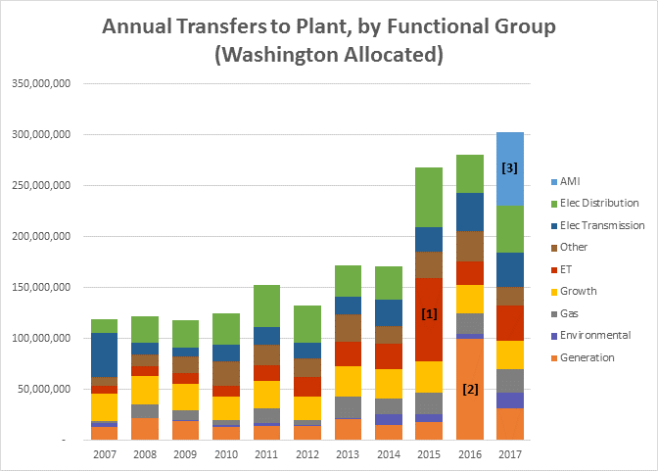
Chart No. 1

[1] Project Compass; [2] Spokane River Projects; [3] 2017 AMI
As can be seen from Chart No. 1, the lumpiness experienced by Avista, whether looking at by functional group or in total, in actual transfers to plant during the period 2007-2014 are nowhere near that experienced in the 2015-2017 period. Nor would the trended data for the 2007-2015 period capture the levels of plant expected in 2017. Chart No. 1, shows that in 2015 the Company had Project Compass [1]; in 2016 the Company has the Spokane River Projects [2]; and in 2017 the Company has AMI [3]. These projects are “lumpy” and the historical record does not accurately capture the characteristics that the pro forma adjustment or “after attrition Adjustments seeks to reflect.
Q. By including the After Attrition Adjustments as proposed by Avista and Staff within their respective electric and natural gas attrition studies, how does the level of plant in service proposed by Avista and Staff compare to that shown in Avista’s 2017 Cross Check Studies?
A. Chart No. 2 below shows Avista’s Washington electric total net plant in service.
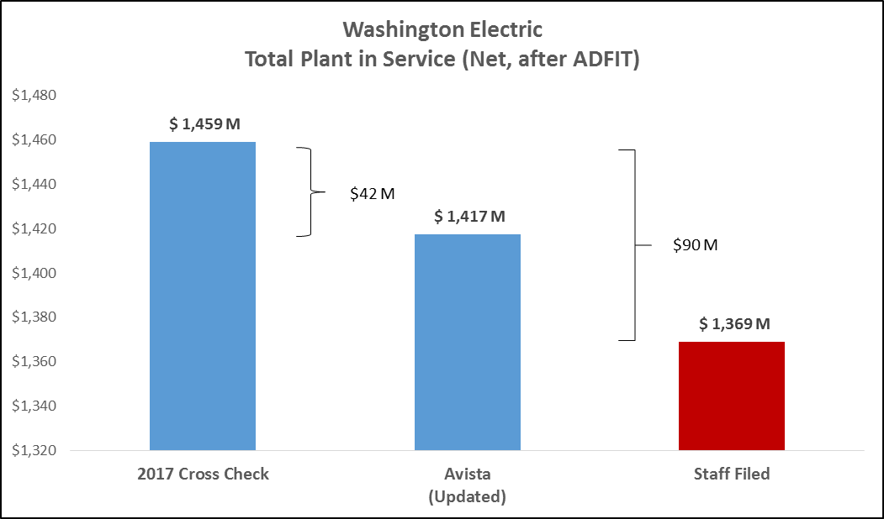
Chart No. 2

Chart No. 3 below shows Avista’s Washington natural gas total net plant in service.
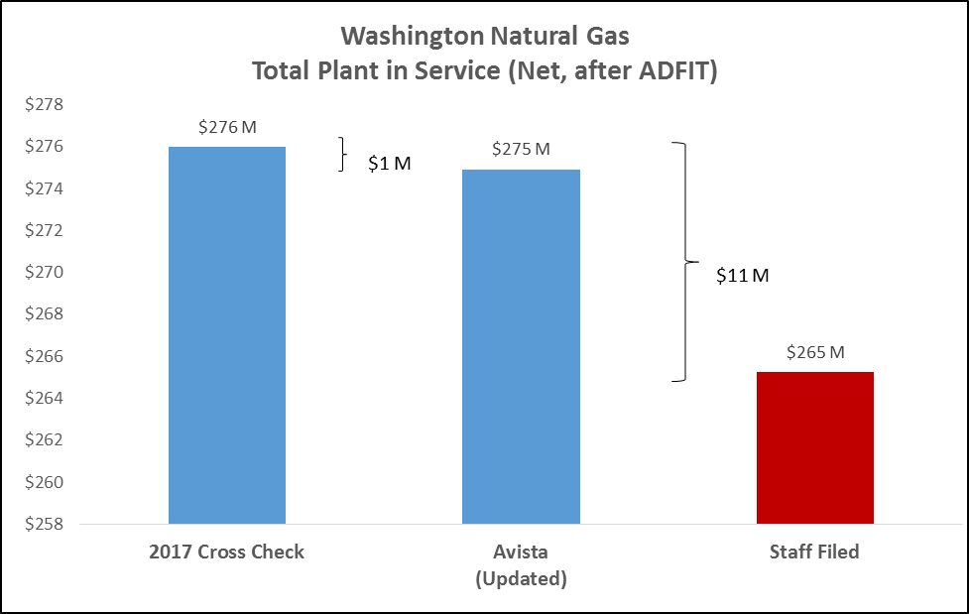
Chart No. 3

As can be seen from Chart Nos. 2 and 3 above, even with the After Attrition Adjustments proposed by the Company, the level of net plant (after ADFIT) included in its electric and natural gas 2017 Attrition Studies are still understated from that shown in Avista’s 2017 Cross Check Studies by $42 million electric and $1 million for natural gas. The Cross check studies reflect what the Company actually expects to occur for the rate period based on capital projects that are either already in progress or specifically planned for completion during the period.
Staff’s electric and natural gas 2017 Attrition Studies’ net plant balances are $90 million and $11 million understated, respectively, from that shown in Avista’s 2017 Cross Check Studies. Approving Staff’s level of net plant equates to over $12 million in understated revenue requirement for the Washington jurisdiction in 2017 alone.
In summary, Mr. Hancock stated a project included as an After Attrition Adjustment should attempt to capture plant addition amounts that are above and beyond what the historical trend suggests. It is evident from the actual transfers to plant balances, even only through July 2016, that the Spokane River Projects meets this guideline. The 2017 AMI project is also a “lumpy” project, well above what the historical trend suggests.
3) Regression Analysis
a) Granular Data
Q. Staff argues that a more granular level of escalation of sub-components results in more accurate estimations. Do you agree with this?
A. No. Staff, within both their electric and natural gas Attrition Studies, disaggregates cost categories for gross plant and accumulated depreciation by functional group, with a single ADFIT group (11 electric and 7 natural gas plant cost categories). By comparison, Avista used a single growth factor for all Net Plant After ADFIT. Avista’s approach is consistent with that proposed by Avista and Staff in its prior general rate case. Furthermore, whether the categories are analyzed separately or in the aggregate, the end result is essentially the same. Table No. 10 below shows the 2017 Washington electric total rate base trended results for both Avista and Staff.
Table No. 10

As can be seen from Table No. 10, it isn't the granularity which makes the study results different from another. For the electric trended results, where both Avista and Staff used the same years (2007-2015) and the same regression analysis (linear regression) consistent for all plant cost categories (Avista’s 1 versus Staff’s 11), the result is essentially the same. The difference in the natural gas studies between Avista and Staff, however, has more to do with Mr. Hancock’s use of linear and non-linear regression analysis, and inconsistencies I will discuss further below.
The Company is not opposed to additional levels of detail, however, we believe it is not necessary to provide reasonable results within the model itself. The analyses provided now are simple, straight forward, and produce a reasonable result. As the model exists now, the Commission and parties are able by functional group (i.e. production, transmission, distribution, general and intangible) and by cost (i.e. plant, A/D) to review individual cost categories within the model.
b) Natural Gas: Non-Linear versus Linear Regression Analysis
Q. You noted in the previous section that Mr. Hancock used both Linear and Non-Linear regression analysis within his natural gas Attrition Studies. What issues do you see with his analysis and what inconsistencies were noted?
A. Mr. Hancock uses a combination of linear and non-linear (polynomial) regression analysis to calculate his natural gas attrition growth rates. Avista has two concerns with the application of his regression analysis. First, due to his disaggregation of certain cost categories, his application of linear and non-linear (polynomial) regression is not consistent. And secondly, in some instances where a linear regression analysis was used, Mr. Hancock failed to recognize “kink points” which exist in the data. The figures below show, for illustrative purposes, examples of data series that are linear, non-linear, and linear with the existence of “kink points.”
Starting with Figure No. 1, a linear regression is used when the historical data set appears “linear,” as is the case for Avista’s electric historical data from 2007-2015 using the aggregated data proposed by Avista (or even the disaggregated data used by Staff).
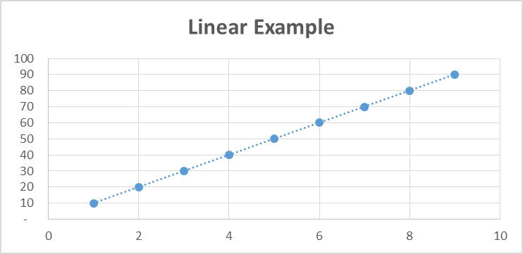
Figure No. 1 Linear Regression Analysis:

Next, Figure No. 2 shows when non-linear regression is appropriate to reflect the non-linear growth in costs (e.g. costs that increase faster over time). This is the case for Avista’s natural gas historical data from 2007-2015 using the aggregated data proposed by
Avista (and the majority of the disaggregated data used by Staff).
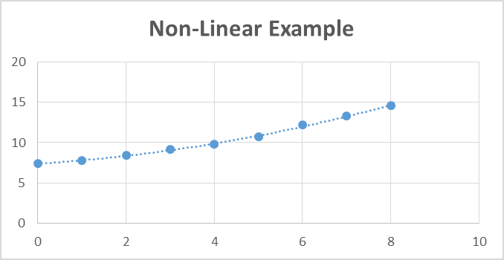
Figure No. 2 Non-Linear Regression Analysis:

Lastly, Figure No. 3 shows when linear regression analysis is appropriate, but “kink points” exist that must be recognized to reflect the change in costs at a particular point in time. The data series, however, is not non-linear as shown in Figure 2 above.
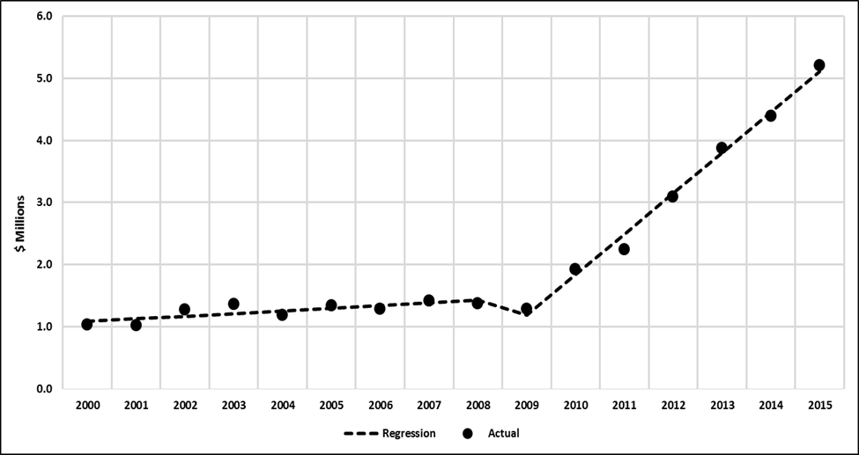
Figure No. 3 Linear Regression Analysis – with “kink points”:
Linear Example - with "kink points"
(see Dr. Forsyth rebuttal testimony Figure No. 4)

Addressing the first issue, as discussed further by Dr. Forsyth within his rebuttal testimony, although Mr. Hancock used the same 2007-2015 time period consistent with Avista, by using a more granular data set, Mr. Hancock chose a mix of linear and non-linear regression analyses to produce his natural gas attrition growth rates. At times he used a linear regression analysis for certain cost categories that are not strictly linear. For example, for natural gas General Plant and General Plant Accumulated Depreciation, Mr. Hancock applies a linear regression to expenditures that appear to have a non-linear time path. In contrast, he does apply non-linear regression to Underground Storage and Distribution Plant that do appear to have non-linear time paths.
Correcting just these two cost categories (General Plant and General Plant Accumulated Depreciation) to reflect an appropriate non-linear regression analysis would produce annual growth rates of 14.79% and 14.47%, respectively as shown in Table No. 11 below, as compared to those produced by Mr. Hancock of 8.39% and 7.63%, respectively.
Hancock’s Gas Expenditure Category | Hancock’s  Excel Tab | Corrected Annual Non-Linear Attrition Rate | Hancock’s Original Annual Linear Attrition Rate | Revenue Requirement Impact
General Plant | CSH - General Plant | 14.79% | 8.39% | $965,000
General Plant Accumulated Depreciation | CSH - General AccumDeprAmort | 14.47% | 7.63% | ($283,000)
Table No. 11

Revising Mr. Hancock’s model to reflect just these two revised growth rates, increases Mr. Hancock’s natural gas revenue requirement by $682,000 ($965,000-$283,000) for 2017.
Addressing the second issue, in cases where linear regression is applied, as Mr. Hancock has for certain natural gas cost categories, Dr. Forsyth explains that “kink points” must be considered when they exist or the resulting growth trend will not result in an appropriate growth rate. There are two specific regressions for natural gas where “kink points” should have been applied by Mr. Hancock to adjust for trend changes: 1) Distribution Depreciation and Amortization Expense and 2) General Depreciation and Amortization Expense.
Table No. 12 below shows how Dr. Forsyth adjusted the linear regression attrition rates using Mr. Hancock’s data. I have added the revenue requirement impact of these corrected rates to the table.
Table No. 12
Hancock’s Gas Expenditure Category | Hancock’s  Excel Tab | Kink Year in Adjusted Regression | Corrected Annual Attrition Rate | Hancock’s Original Annual Attrition Rate | Revenue Requirement Impact
Distribution Depreciation Exp. | UTC - DistrDeprAmorExp | 2012 | 7.61% | 4.91% | $506,000
General Depreciation and Amortization Exp. | UTC - GenrlDeprAmorExp | 2011 | 12.29% | 8.55% | $436,000

Correcting Mr. Hancock’s methodology for these two additional cost categories (Distribution and General Depreciation and Amortization expenses) to reflect the existence of “kink points” produces annual growth rates of 7.61% and 12.29%, respectively, as compared to those produced by Mr. Hancock of 4.91% and 8.55%, respectively. The impact of correcting these two additional growth rates has the effect of increasing Staff’s natural gas Attrition Study revenue requirement by $940,000 ($506,000+$436,000) for 2017.
In contrast to Mr. Hancock, the Company consistently applied non-linear regression analysis for its natural gas attrition studies across Avista’s cost categories, recognizing the non-linear growth in its costs. Avista’s methodology using non-linear regression is consistently applied, and consistent with that proposed by Staff in Avista’s prior 2015 general rate case and approved by this Commission. Further, the Company believes, even based on the disaggregated data proposed by Staff for the period 2007 – 2015, if Mr. Hancock’s methodology was corrected for the issues identified, his natural gas revenue requirement would result in amounts much closer to that proposed by Avista.
c) Other Revenue Growth
Q. Mr. Hancock proposes that a growth factor should be used for the “Other Revenues” cost category within the natural gas Attrition Studies. Do you agree with this statement?
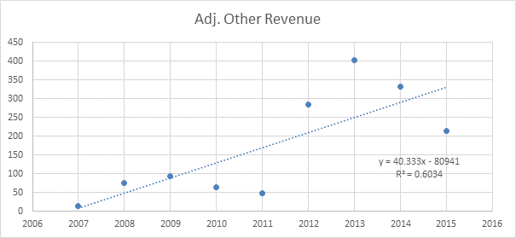
A. No. As noted by Mr. Hancock, Avista has chosen to not escalate the “Other Revenues” cost category because the irregular growth does not fit a linear or non-linear data pattern. These revenues are mainly related to sales of scrap metal and have generally been immaterial. Although it may be true, statistically speaking, the growth rate may not be zero, the result using the “line of best fit” suggested by Mr. Hancock also does not appear reasonable. One can see the issue with this cost category by reviewing Mr. Hancock’s chart produced in Exhibit No. _(CSH-5), page 19.

As can be seen from the data points above, there is no consistent pattern in the revenue. From 2007-2015 this revenue has ranged from $13,000 in 2007, to as high as $403,000 in 2013, and back down to $215,000 in 2015. So given the irregular pattern Avista applied a 0% growth rate, leaving the $215,000 of revenue in 2015 intact during the 2017 rate period.
Q. What growth rate did Mr. Hancock propose?
A. Mr. Hancock proposed an annual growth rate of 18.76%. However, he did not actually apply this growth rate within his natural gas Attrition models. As can be seen on page 1 of Exhibit No. _(CSH-5), he also actually applied a 0% growth rate. The impact of applying Mr. Hancock’s proposed 18.76% growth rate would have resulted in a reduction of $80,000 in revenue requirement.

V. MR. MULLIN’S ICNU/NWIGU ATTRITION MODELS
Q. Mr. Mullin’s, representing ICNU and NWIGU, provided electric and natural gas Attrition Study models. Did you review the results of these attrition studies?
A. Yes, I reviewed the results of Mr. Mullins’ Attrition Studies, and along with the methodological issues raised by Dr. Forsyth in his rebuttal testimony, concluded that his electric and natural gas attrition analyses, and resulting proposed reductions to Avista’s current rates are not reasonable. Approval of Mr. Mullins’ recommendations would not allow Avista an opportunity to earn a reasonable return, causing instead, Avista to significantly under-earn in the 2017 and 2018 rate period.
Q. What issues were found with Mr. Mullin’s electric and natural gas Attrition Studies?
A. As discussed further by Dr. Forsyth, Mr. Mullins has specific methodological issues and inconsistencies within his analysis related to his electric and natural gas Attrition Studies. The first issue relates to the years chosen by Mr. Mullins between the periods 2000-2015, which vary depending upon the specific category of cost he is trending. The second issue relates to his regression trending analysis applied to each category of cost, which is inconsistently and inappropriately applied across his electric and natural gas models.
Q. What comments do you have regarding Mr. Mullins’ use of historical data points between 2000 and 2015?
A. In the Company’s previous general rate case, this Commission reviewed the time periods appropriate to use within the Attrition Studies applied to Avista’s historical data. The Commission concluded that 2007-2014 was appropriate because of the “kink point” that existed in the data series from 2007 forward. Nothing significant has changed between the conclusion of that proceeding and this current case that would warrant a change or shift in the appropriate period of data to use within the attrition models being considered, namely 2007 and beyond, other than adding an additional historical year (2015) to the end of the previous historical time period as it became available.
As noted, Mr. Mullins varies the years he chooses to trend depending on the cost category. For electric, his data series by cost category ranges anywhere from 2005-2015, as is the case with “Distribution Taxes Other Than Income,” to only 2013-2015 for “Accumulated Deferred Income Taxes.” For Natural gas, however, he has several data series that range from 2000-2015, such as “Administrative and General Depreciation Expense,” to only 2012-2015 for “Administrative and General Expenses.” For natural gas “Accumulated Deferred Income Taxes”, he trends the 2009-2015 time period. However it is unclear why Mr. Mullins chooses these variations, and especially why he uses, in several instances, the entire time period for natural gas, but chooses to truncate the time period for electric.
As an example, of particular concern is his truncation for electric ADFIT of 2013-2015. With the exception of intangible net plant, Mr. Mullins uses the period 2007-2015 for his net plant categories. Mr. Mullins notes at Exhibit No. _(BGM-3), page 20, with regards to his 2013-2015 ADFIT range:
Upon review of the data [ADFIT], it appears that the rate of growth in this category of cost over the long-term has largely aligned with other categories of plant. In the short-term, however, the growth in this category of cost appears to have accelerated, potentially in relation to the Company’s increased levels of investments over the period. (emphasis added)

A “Repairs Allowance” related to ADFIT was recorded in 2014 which included prior period amounts for the periods 2011-2014, impacting the slope for the period 2013-2015. It would therefore, be inappropriate to simply include the 2013-2015 time period for the growth in ADFIT.
Mr. Mullins is mixing “apples to oranges” by using a 2007-2015 trend for net plant growth, but using a shorter 2013-2015 trend for ADFIT which is an offset to net plant growth. Especially when the 2013-2015 shortened trend for the ADFIT benefit is overstated due to a prior period adjustment.
Furthermore, with regards to Mr. Mullins’ use of more granular data and inconsistent use of years for trending, his model highlights exactly the concern I noted previously. He has trended dozens of different data categories within his attrition models, however, he has produced a model which is more complex and more susceptible to the issues and concerns addressed here and by Dr. Forsyth.
Q. What additional comments do you have regarding the Mr. Mullins’ regression trending analysis?
A. Dr. Forsyth noted that he also has particular concern with Mr. Mullins’ decision to ignore “kink points.” As shown within Mr. Mullins’ exhibits, “kink points” clearly exist over the 2000-2015 time periods Mr. Mullins has chosen to use for various cost categories. Mr. Mullins’ approach ignores recent data trends, which has the effect of understating the escalation factors used in his electric and natural gas models.
Q. Do you have any other comments regarding Mr. Mullins’ Attrition Studies?
A. Yes. Both Staff and Avista (within its Updated Attrition Studies) updated their Attrition Studies to reflect the most current information available. This included the use of December 31, 2015 CBR data as the base or starting point to begin the Studies, as well as updating the data which is trended through 2015. This approach is consistent with that
approved by the Commission in Avista’s prior general rate case, and is appropriate in this proceeding. Mr. Mullins did not include this updated 2015 information within his analysis. As noted earlier, updating Avista’s models, (including the impact on Avista’s growth factors) added approximately $3.5 million electric and $4.4 million natural gas to Avista’s revenue requirement need.

VI. MR. WATKINS’ DISTRIBUTION O&M AND A&G TESTIMONY
Q. Public Counsel witness Mr. Watkins expressed concerns over the rate of growth in distribution O&M and A&G from 2013 - 2015, coincident with the use of attrition allowances in ratemaking. What is your response to Mr. Watkins’ testimony?
A. Mr. Watkins chose selected subsets of data, related to limited portions of the Company’s operations, and then draws inferences from that data to suggest that the Company is not managing its business or controlling its costs. His analyses are inappropriate and misleading. As an example, Mr. Watkins’ Tables 9 and 10, on pages 13 and 14 of his testimony, show growth in Electric Distribution O&M Expenses of 12.9% from 2014 to 2015, and in Table 12, on page 16, he shows total growth in Electric Salary and Wage Expenses of 13.7% from 2014 to 2015.
If Mr. Watkins had “looked under the hood,” so to speak, he would have understood the specific circumstances that drove the higher growth in costs from 2014 to 2015 for those limited subsets of data. Furthermore, if he had looked at the change in Avista’s electric O&M and A&G expenses as a whole from 2014 to 2015, he would have found a growth rate of 3.9%, which is reasonable, and is dramatically below the 12.9% and 13.7% numbers he is presenting to the Commission.
Q. Did Mr. Watkins submit data requests to the Company or otherwise ask Avista to explain the reasons for the growth in those limited cost categories for the time periods for which he expressed concern?
A. No, he did not. As discussed by Company witness Mr. Norwood, following the Company’s filing in February 2016, Mr. Watkins had six months in which to ask Avista to explain the reasons for the cost increases in these subsets of data, either through discovery requests, a visit to Avista’s offices, or, like members of Staff or consultants for other parties have done, call Avista by phone to inquire. He did none of the above.
Q. Why do some of these cost categories show significant increases for the 2013 to 2015 period?
A. Let’s start with Mr. Watkins’ Table 12 on page 16 of his testimony. Here he represents growth in Salary and Wage Expenses from 2013 to 2015 of 9.36% per year, and a single-year increase from 2014 to 2015 of 13.71%. The Commission is fully aware of the November 2015 windstorm, when a severe windstorm struck Avista’s Eastern Washington service area and interrupted service to 178,210 customers; more customer outages than at any time in the Company’s 126 year history. If Mr. Watkins would have asked, he would have known that the 2015 numbers included the labor costs to restore service to our customers in late 2015, which included significant overtime. There are at least two significant problems with Mr. Watkins’ Table 12 that make it very misleading.
First, he represents the numbers as “expenses,” when in fact the numbers in the table include both labor expenses and capitalized labor costs. Avista was very specific in its response to Public Counsel’s data request No. 010 (the source for his table), that the information in the response “includes expense and capital amounts.” Second, the November storm was severe and caused a significant increase in labor costs for 2015 to restore our system. This was the primary driver for the significant growth in costs shown in Table 12, whether a comparison is made either from 2013 to 2015, or 2014 to 2015.
Q. Are there other specific circumstances that caused the growth percentages for distribution O&M and A&G in the 2013 – 2015 timeframe to be higher?
A. Yes. Two other specific items that affected the growth percentages for the 2013-2015 time period, for the selected subsets of data presented by Mr. Watkins, are provided below:
- Contract Employees becoming Avista Employees – Another driver for the increased labor expense Mr. Watkins shows in Table Nos. 11-14 of this testimony is related to an increase in full time employees resulting from the cancellation of a contract. Approximately 30 IS/IT personnel provided support for Avista’s operations under a third party contract, i.e., they were not employees of Avista. In 2014, Avista determined that it was more cost-effective to hire these employees directly, rather than pay a higher amount to the vendor. While overall Avista labor costs increased, overall net expense actually decreased with the cancellation of the contract. This accounts for approximately $2.0 million of increased labor costs in the tables presented by Mr. Watkins, however, there was a corresponding decrease of $3.0 million in contract expenses, saving customers approximately $1.0 million on a net basis. The $3.0 million reduction in expense (benefit) is not reflected in Mr. Watkins’ table, because those expenses are recorded in other accounts. This highlights the danger of selecting subsets of data, performing calculations, and then drawing inferences from the results; especially without asking questions about what is underneath the results.
Revised – October 11, 2016
- Atmospheric Corrosion (AC) Monitoring - The AC Inspection Program is a gas operations program required by the Code of Federal Regulations (CFR) 49 CFR 192.481. The code requirement states (CFR 192.481(a)): “Each operator must inspect each pipeline or portion of pipeline that is exposed to the atmosphere for evidence of atmospheric corrosion, as follows: Onshore-At least once every 3 calendar years, but with intervals not exceeding 39 months.” To enhance public safety and expand the program inspection requirements Avista moved to a contracted inspection service in 2007 that specialized in AC inspection, which has increased the costs of the program. Through 2015 this program had been administered every third year, in each jurisdiction, consistent with federal inspection requirements. Between 2007 and 2015, the costs for the operating and maintenance costs were occurring every third year. Washington’s costs in this period occurred and were recorded in 2009, 2012, and 2015. Therefore, a comparison of the growth in costs for the period 2013 to 2015 would show a higher increase in costs for this period (as shown in Mr. Watkins’ Tables 21 and 22), driven in part by the additional costs in 2015.

Q. Is it important to understand the reasons for certain increased costs before drawing conclusions?
A. Absolutely. There are understandable circumstances driving the higher growth in costs for the selected subsets of data presented by Mr. Watkins, if one were to ask. It is inappropriate for Mr. Watkins to use the results from a selected subset of data, and suggest that the results from that set of data are representative of the whole. As I have shown in other parts of my testimony and exhibits, Avista’s electric O&M and A&G expenses as a whole are reasonable, and there are specific, understandable reasons why the growth in some cost categories were higher.

VII. ALTERNATIVE OF DEFERRED ACCOUNTING TREATMENT FOR AMI
AND MONTANA LEASE

Q. Please explain the purpose of this portion of your testimony.
A. Mr. Norwood explains that Staff and other parties expressed concerns in their testimony related to reflecting in retail rates in this case the costs associated with Advanced Metering Infrastructure, and the costs associated with the long-term lease arrangement for the Montana riverbed issue. He briefly explains each of these issues, and why deferred accounting treatment would be a good solution to address the concerns of all parties, in the event the Commission does not approve the ratemaking treatment originally proposed by the Company in this case.
Revised – October 11, 2016
My testimony below explains the proposed accounting treatment of these items if the Commission were to approve deferred accounting treatment.
A. Advanced Metering Infrastructure (AMI)
Q. Please describe the deferred accounting treatment related to the AMI project.
A. The revenue requirement associated with the actual investment in AMI that transfers to plant in service between January 1, 2017 and June 30, 2018, would be deferred to preserve the opportunity for recovery in a future proceeding. This includes the costs of depreciation and the return on investment, including any related increases or reductions in O&M expenses. The deferral of the revenue requirement would begin in the month that the first transfers to plant of AMI investment occurs.
In the Company’s next general rate case, Avista would address the prudence of the costs incurred and request recovery of the deferred costs, including a carrying charge on the deferral at the authorized rate of return. At that time, the Company would also propose an amortization period to recover the costs from all Washington customers over a future period.
A summary of the accounting entries for the electric deferral follows:
Revised – October 11, 2016

The monthly accounting entries to record the electric amortization would be as follows:

The accounting entries for natural gas would be consistent with the entries described above for electric service.
B. Montana Riverbed Lease
Q. Please describe the deferred accounting treatment related to the Montana Riverbed Lease, in the event the Commission approves deferred accounting.
A. The Company would defer actual lease expenses incurred beginning in 2017 and beyond until conclusion of litigation or settlement resolving this matter. In its next general rate case following resolution of this matter, Avista would request recovery of any deferred costs, including a carrying charge on the deferral at the authorized rate of return. In the Company’s general rate case filing requesting recovery of these deferred costs, the Company would propose to amortize and recover the costs from all Washington customers over a future, to-be-determined, period.
The table below shows the accounts that would be used to record the deferral entries:

The monthly accounting entries to record the amortization would be as follows:

Q. Does that conclude your rebuttal testimony?
A. Yes, it does.

I will refer to each of the non-Company parties in these Dockets as follows: the Staff of the Washington Utilities and Transportation Commission (Staff), the Public Counsel Unit of the Washington Office of Attorney General (Public Counsel), the Industrial Customers of Northwest Utilities (ICNU), the Northwest Industrial Gas Users (NWIGU), and The Energy Project.
As of December 31, 2015, the electric normalized Commission Basis rate of return was 7.28%. See Exhibit No. _(EMA-7), page 5, column [A]. This is in contrast to the as-filed September 30, 2015 normalized Commission Basis rate of return shown on Exhibit No. __(EMA-2), page 5, column [A] of 8.34%. After the Company’s filed case it came to Avista’s attention it had inaccurately reflected the current authorized level of net power supply costs for the twelve month period ending September 30, 2015, resulting in an overstated ROR for that period.
Hancock Exhibit No. __(CSH-1T), page 29, lines 14-16.
Hancock Exhibit No. _(CSH-1T), page 31, lines 3-6.
This update is consistent with the approach approved by the WUTC within Order 05, Docket Nos. UE-150204 and UG-150205.
See page 4, column [D] of Exhibit Nos. _(EMA-7) and _((EMA-9).
This adjustment was also excluded by Mr. Hancock in Exhibit Nos. __(CSH-4) and __(CSH-6).
The one exception is the update to AMI discussed in item 3. d) “Update AMI in-service date and costs in 2017”, discussed below. This is new information not previously provided. Company witnesses Ms. Schuh and Ms. Rosentrater discuss the AMI update in more detail within their rebuttal testimonies.
These updates were also included by Mr. Hancock Exhibit Nos. __(CSH-4) and __(CSH-6).
Page 4 of Exhibit Nos. _(EMA-7) and _(EMA-9).
Id.
Id.
See pages 4 and 5 of Exhibit Nos. _(EMA-7) and _(EMA-9).
See pages 1 and 2 of Exhibit Nos. _(EMA-7) and _(EMA-9) for the updated Proposed Cost of Capital and the impact of this change on the Company’s revenue requirement.
See pages 4 and 5 of Exhibit Nos. _(EMA-7) and _(EMA-9).
The total updated amount of AMI investment for 2017 included in the Company’s “After Attrition Adjustment – AMI Capital Project” for 2017 is $8.8 million of net plant and $2.7 million in associated expenses. This equates to a total revenue requirement of $3.8 million.
As of December 31, 2015, the natural gas normalized Commission Basis rate of return was 6.14%. See Exhibit No. _(EMA-7), page 5, column [A]. This is in contrast to the as-filed September 30, 2015 normalized Commission Basis rate of return shown on Exhibit No. __(EMA-3), page 5, column [A] of 6.49%.
Staff included these updates. See Exhibit Nos. __(CSH-5) and __(CSH-7).
Item 2. b) Update AMI in-service date and costs in 2017 is new information not previously provided. Ms. Schuh and Ms. Rosentrater discuss the AMI update in more detail within their rebuttal testimonies.
See pages 1 and 2 of Exhibit Nos. _(EMA-8) and _(EMA-10) for the updated Proposed Cost of Capital and the impact of this change on the Company’s revenue requirement.
This update impacts column [N], pages 4 and 5 of Exhibit Nos. _(EMA-7) and _(EMA-9).
Hancock Exhibit Nos. _(CSH-4) and _(CSH-5).
Hancock Exhibit Nos. _(CSH-6) and _(CSH-7).
Hancock Exhibit Nos. _(CSH-2) and _(CSH-3).
Huang, Exhibit Nos. _(JH-2) and _(JH-3).
Avista’s models on rebuttal are similar conceptually with that filed in its direct case, with the exception of updated data such as the use of December 31, 2015 CBR data, and including any updates or corrections for known changes during the pendency of this case.
For example, the 2015 electric 12.2015 base column agrees between Staff and Avista showing Net Operating Income (NOI) of $169,746,000 and Total Rate Base of $1,326,643,000. The starting point prior to any proposed growth rates, pro forma power supply (electric) and after attrition adjustments, are in agreement between Avista and Staff. This is true for the natural gas attrition studies as well.
This is similar to the approach approved in Docket Nos. UE-150204 and UG-150205, whereby the Commission in Order 05, approved an electric and natural gas “After Attrition Adjustment” related to the Company’s Customer Information System “Project Compass.”
Staff’s second step calculated natural gas revenue requirement was only $67,000 for the January to June 2018 period.
Hancock, Exhibit No. _(CSH-1T), page 30, line 11-12.
Hancock, Exhibit No. _(CSH-1T), page 34, line 5-6.
Hancock, Exhibit No. _(CSH-1T), page 46, line 9-10.
Order 05, UE-150204, at 45 par. 123.
Exhibit No. _(GDF-1T), 14:13-16.
Exhibit No. _(GDF-1T), 14:19-22.
Hancock, Exhibit No. _(CSH-1T), 53:1-10.
Hancock, Exhibit No. _(CSH-1T), 53:16-23.
Hancock, Exhibit No. _(CSH-1T), 56:12-18.
Hancock, Exhibit No. _(CSH-1T), 42:19 – 43:1.
The majority of the difference between Ms. Huang’s total gross plant included of $59.3 million versus Avista’s $67.1 million for the Spokane River Projects, relate to the Nine Mile Redevelopment project trailing costs of $6.3 million to be completed in 2016. This project was moved into service in July 2016, is producing additional generation as a result of its upgrade and is included at 100% capacity within the Company’s Aurora model for the 2017 rate period.
Compare this to, as noted by Ms. Huang, to the three Spokane River Projects actual transfer to plant for this same seven-month period of $59.3 million. (Ms. Huang recognizes these projects on a full cost basis within her pro forma study.) If anything, the Company was conservative in its inclusion of only the three Spokane River Projects.
Dockets UE-090134, UG-090135& UG-060518, Order 10, page 36, paragraphs 80 and 81, where Staff, Parties and the Commission accepted the Noxon No. 3 upgrade as a pro forma adjustment even though it was to go into service 3 months after the start of the rate period in March of 2010. This project had added generation included in the Company’s power supply model (Aurora). This project was included on a pro rata basis (9/12 of the annualized value) because if its March 2010 rate period in-service date.
Hancock, Exhibit No. _(CSH-1T), 55:19-21.
As explained by Mr. Norwood in his rebuttal testimony, if the Commission does not approve recovery of the AMI costs for the rate period as proposed by the Company in this case, the unique circumstances surrounding AMI may warrant deferred accounting treatment as a solution to address the concerns expressed by the parties. This would also meet the needs of the Company. See Section IX of Exhibit No. __(KON-1T), starting at page 29.
Hancock, Exhibit No. _(CSH-1T), 55:3-6.
A kink point is a point in which the data in a series has a definite kink in the data series up or down from previous data points that should be recognized if a linear regression analysis is used. Dr. Forsyth discusses the existence and importance of kink points within his rebuttal testimony.
Mr. Mullins disaggregates Avista’s expense cost categories into multiple categories (10 electric, 11 natural gas) and separated ADFIT from Net Plant, producing multiple plant categories (6 electric, 4 natural gas).
Both Avista and Mr. Hancock for Commission Staff use the data period 2007 – 2015 within their attrition models.
The impact of correcting just this one growth rate related to ADFIT has the effect of increasing Mr. Mullins’ electric revenue requirement approximately $4.0 million.
Dr. Forsyth. Exhibit No. _(GDF-1T), 4:14-17.
Exhibit No.___(GAW-1T), p. 18:7-11.
The 2015 windstorm costs were removed from Avista’s December 31, 2015 test year “base” and for trending purposes within its 2017 and 2018 Attrition Studies.
Included as Exhibit No. __(EMA-11) is a copy of the “Hydropower Site Lease” and “Addendum to Hydropower Site Lease” agreements associated with the Montana Riverbed Lease.

