
David S. Valdez
Vice President
Public Policy & External Affairs
WA0101RA
1800 41st Street
P.O. Box 1003
Everett, WA 98201
Phone 425 261-5691
Fax 425 261-5262
November 7, 2005

Advice No. 3160

Ms. Carole Washburn, Executive Secretary
Washington Utilities and
Transportation Commission
1300 S. Evergreen Park Drive S.W.
Olympia, Washington 98504-7250

Dear Ms. Washburn:

Verizon Northwest Inc. submits for filing revisions to Advice No. 3160 that was filed with the Commission on September 27, 2005 in Docket No. UT-023003. The attached tariff sheets will become part of the Unbundled Network Element Tariff, WN U-21.

The Company submits revisions to Advice No. 3160 in compliance with the Commission’s 30th Supplemental Order in this docket. 2nd Revised Sheet 1, 1st Revised Sheet 1.1 and Original Sheet 1.2 in Section 5 should replace the tariff sheets that were filed in the original compliance filing (September 27, 2005). All sheets in Section 6 are additional sheets that should be added to Advice No. 3160. The proposed rates that have been revised have been shaded in the enclosed document entitled “Summary of Current Tariffed vs. Proposed Tariffed rates 110705.xls.”
The requested effective date for this filing is December 7, 2005.
A copy of the Public Notice is attached.

If there are questions, please contact Lin Fogg at (425) 261.6380.

Very truly yours,
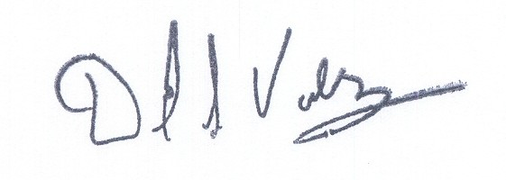

David S. Valdez

DSV:kad
Enclosures

c: Service List
Attachment A

Unbundled Network Element Tariff, WN U-21

Section 6

2nd Revised Sheet 1
1st Revised Sheet 1.1
Original Sheet 1.2

Section 6

1st Revised Sheet 1
1st Revised Sheet 2
1st Revised Sheet 3
Original Sheet 4

VERIZON NORTHWEST INC.
EVERETT, WASHINGTON

N O T I C E

Verizon Northwest Inc. submits for filing revisions to Advice No. 3160 that was filed with the Commission on September 27, 2005 in Docket No. UT-023003. The attached tariff sheets will become part of the Unbundled Network Element Tariff, WN U-21.

The Company submits revisions to Advice No. 3160 in compliance with the Commission’s 30th Supplemental Order in this docket. 2nd Revised Sheet 1, 1st Revised Sheet 1.1 and Original Sheet 1.2 in Section 5 should replace the tariff sheets that were filed in the original compliance filing (September 27, 2005). All sheets in Section 6 are additional sheets that should be added to Advice No. 3160. The proposed rates that have been revised have been shaded in the enclosed document entitled “Summary of Current Tariffed vs. Proposed Tariffed rates 110705.xls.”
The requested effective date for this filing is December 7, 2005.
A copy of this tariff is available for public inspection at the following Verizon Plus store locations:

189 Cascade Mall Drive 1402 SE Everett Mall Way
Burlington Everett
Burlington Verizon Plus Everett Verizon Plus

511 Valley Mall Parkway 18700 - 33rd Ave. West, Suite D
East Wenatchee Lynnwood
East Wenatchee Verizon Plus Alderwood Verizon Plus

Posted at ___________________
___________________
by ___________________

Post in above business offices.

