March 12, 2015

VIA U.S. MAIL AND EMAIL

Steven King – Executive Director/Secretary
Washington Utilities and Transportation Commission
1300 S. Evergreen Park Drive S.W.
P.O. Box 47250
Olympia, WA 98504-7250

RE: PREFILED TESTIMONY FOR TR-140382 and TR-14083

Dear Director King:

Enclosed please find originals and three copies of the following documents for each above-referenced docket/matter number:

- PREFILED REBUTTAL TESTIMONY OF AL PINKHAM W/ EXHIBIT

The documents, including this cover letter, have also been submitted electronically, and copies have been sent to all interested parties via electronic mail and U.S. Mail, and to the presiding administrative law judge via electronic mail.

Sincerely yours,
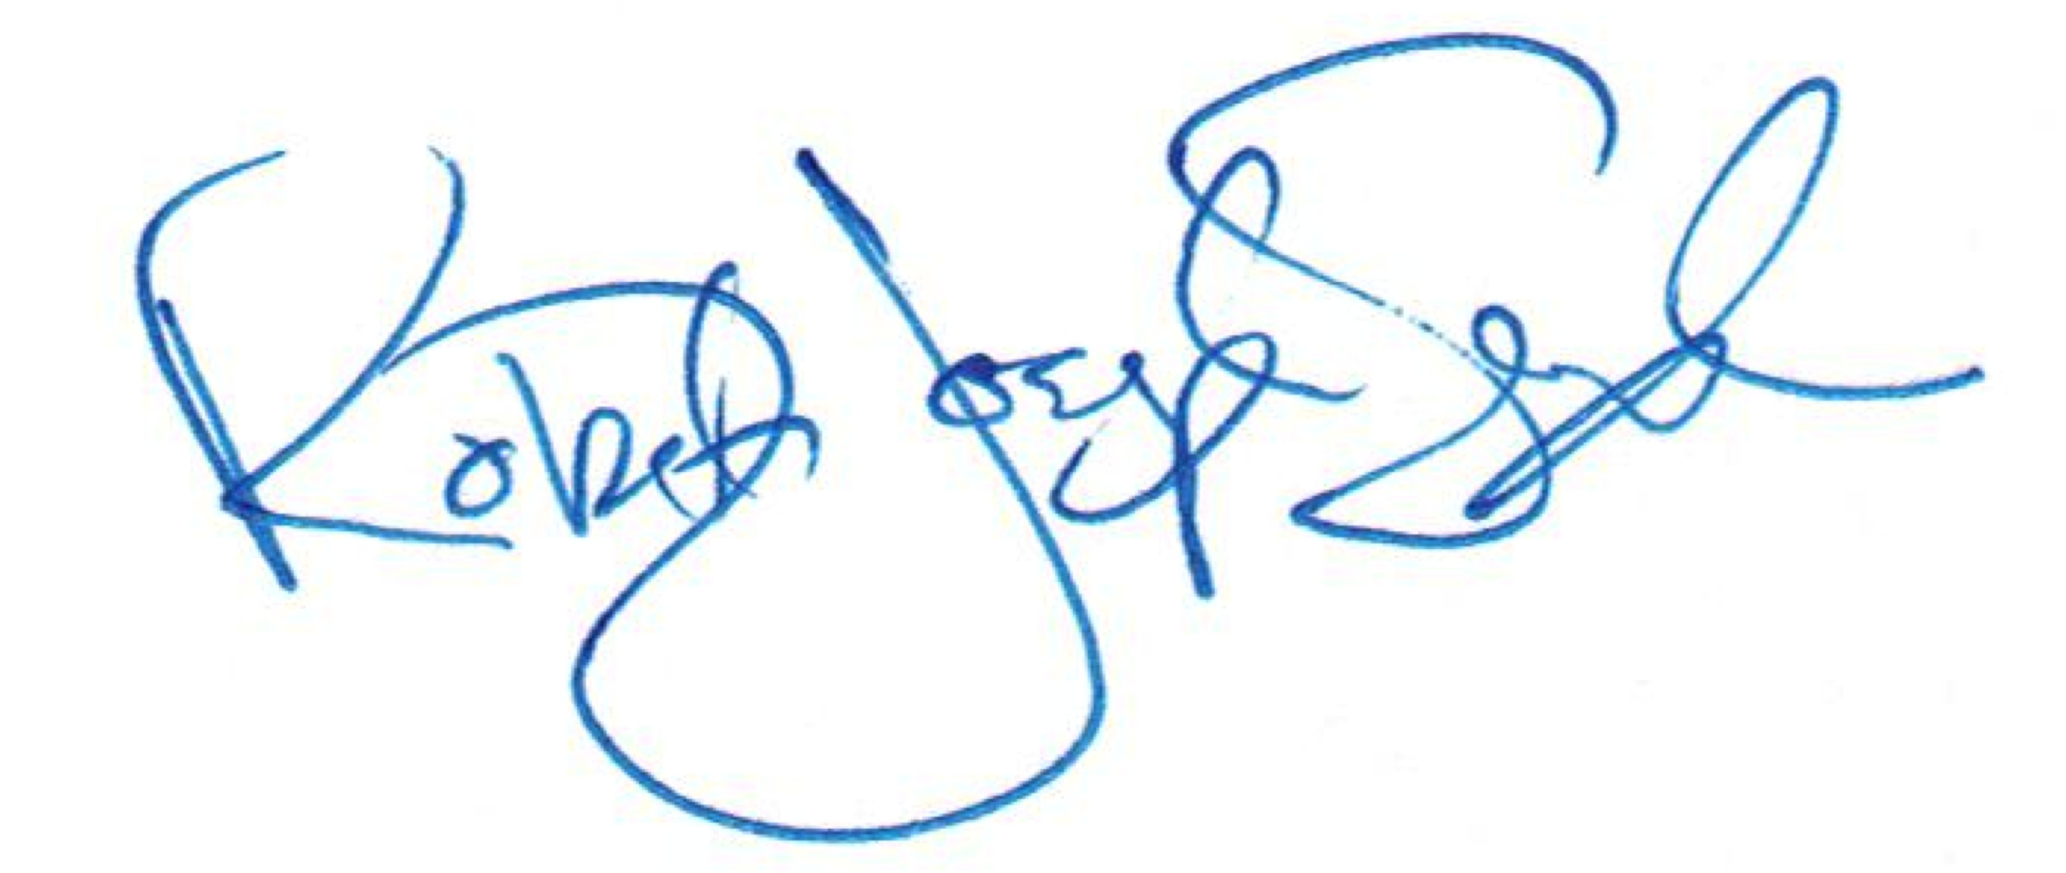

R. Joseph Sexton
Attorney at Law
joe@galandabroadman.com

Enclosures: Original Prefiled Testimony w/ Copies and Exhibit
cc: Yakama Nation Office of Legal Counsel, Petitioner, and Respondent

