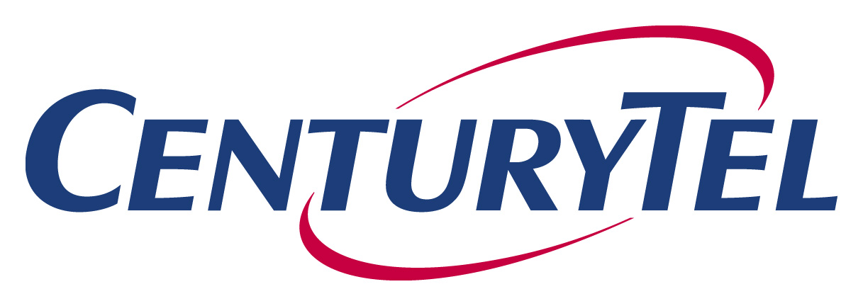
P.O. Box 9901
Vancouver, WA 98668-8701
Tel 360 905 5958
Fax 360 905 5953
calvin.simshaw@centurytel.com
Calvin K. Simshaw
Vice President
Associate General Counsel - Regulatory

March 21, 2003

Ms. Carole J. Washburn
Washington Utilities and Transportation Commission
1300 S. Evergreen Park Dr. SW
PO Box 47250
Olympia, WA 98504-7250

Re: In the Matter of the Petition for Arbitration of an Interconnection Agreement between Level 3 Communications, LLC and CenturyTel of Washington, Inc. Pursuant to 47 USC. Section 252. Docket No. UT-023043

Dear Ms. Washburn:

Enclosed for filing is the original and seven copies of CenturyTel’s Reply in Support of Motion to Amend Order Approving Interconnection Agreement in the above-referenced matter and docket number.

Very truly yours,

Calvin K. Simshaw
Assoc. General Counsel-
Regulatory

Enclosures

