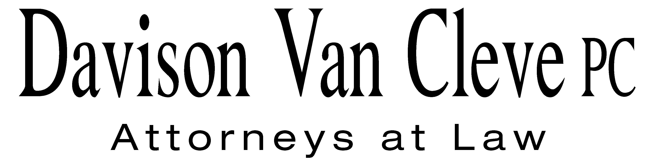
TEL (503) 241-7242 ● FAX (503) 241-8160 ● mail@dvclaw.com
Suite 400
333 SW Taylor
Portland, OR 97204

October 7, 2011

Via Email and Federal Express

Mr. David E. Danner
Secretary
Washington Utilities and Transportation Commission
PO Box 47250
1300 S Evergreen Park Drive SW
Olympia, WA 98504-7250

Re: In the matter of WUTC v. PacifiCorp.
Docket No. UE-111190

Dear Mr. Danner:

Enclosed please find an original and twelve (12) copies of the Confidentiality Agreements of Michael Gorman, Greg Meyer, and Chris Walters on behalf of the Industrial Customers of Northwest Utilities.

Thank you for your assistance.

Sincerely yours,

/s/ Sarah A. Kohler
Sarah A. Kohler
Enclosures

cc: Service List

CERTIFICATE OF SERVICE

I hereby certify that I have this day served the foregoing documents upon all parties of record in this proceeding by mailing a copy thereof in a sealed, first-class postage prepaid envelope to each individual’s last-known address, as listed below.
DATED this 7th day of October, 2011.
Davison Van Cleve, P.C.

/s/ Sarah A. Kohler
Sarah A. Kohler

JORDAN WHITE  PACIFIC POWER & LIGHT  1407 W NORTH TEMPLE ST  SALT LAKE CITY UT 84116  jordan.white@pacificorp.com | KATHERINE MCDOWELL  MCDOWELL & RACKNER P.C.  419 SW 11TH AVENUE STE 400  PORTLAND OR 97204  katherine@mcd-law.com
SIMON FFITCH  OFFICE OF THE ATTORNEY GENERAL  PUBLIC COUNSEL  800 FIFTH AVENUE STE 2000  SEATTLE WA 98104-3188  simonf@atg.wa.gov | SARAH A SHIFLEY  OFFICE OF THE ATTORNEY GENERAL  PUBLIC COUNSEL  800 FIFTH AVENUE STE 2000  SEATTLE WA 98104-3188  sarah.shifley@atg.wa.gov
GREG J TRAUTMAN  ASSISTANT ATTORNEY GENERAL  WUTC  ATTORNEY GENERAL SECTION  STATE MAIL STOP 40128  gtrautma@utc.wa.gov | IBEW LOCAL 125  TRAVIS ERI  BUSINESS MANAGER  17200 NE SACRAMENTO ST  PORTLAND OR 97230
BRAD M PURDY
ATTORNEY AT LAW
2019 N 17TH ST
BOISE ID 93702
bmpurdy@hotmail.com

