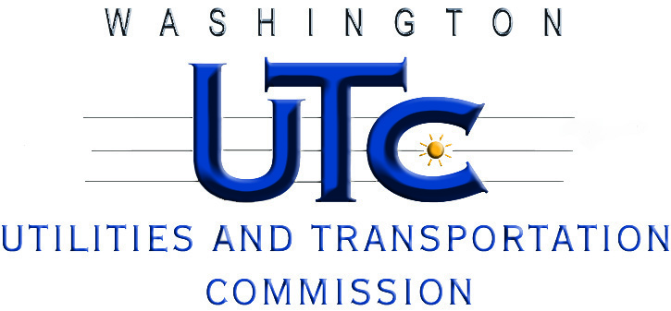

Fuel Surcharge Inquiry 2nd Workshop
Recessed Open Meeting Item

Docket T-101661

AGENDA

January 20, 2011

9:30 a.m. - 9:45 a.m. Introductions

9:45 a.m. – Noon General Discussion (all industries present)

- Recap of Workshop #1
- Industry’s Proposed Methods
  - SeaTac Shuttle – Company specific UPS / Fed Ex Style Index
  - Capital Aeroporter – Retain existing method, but remove 1% Band
  - Retain existing method
- Commission Staff’s Proposed Methods
  - Phase Out – Rate Cases or Single Item Adjustments via Petition
  - Rolling 12-month Average or rate case base, whichever is greater
  - Separate fuel cost component for all rates, fares and charges
- Next steps

Noon - 1:00 p.m. Lunch (on your own)

1:00 p.m. - 3:00 p.m. Additional time (if required)

